Finance

Guide

2025-2026

Contents
Welcome 2
Your Bank Account and Own Societies Money 2
Schedule of Allowances (SOA) 4
Budgets 6
Funding Requests 7
Expenditure Requests 9
Income 11
Sponsorship 12
Cash Handling 17
Charity Fundraising 19
Foreign Trips 21
Special Projects 24
l

Welcome
This Finance Handbook is here to help you understand the key processes involved in handling money as a UCC Society - from applying for funding and creating budgets to submitting expenditure requests and keeping clear financial records. Good financial management is essential to running a successful and sustainable Society, and this guide is designed to make it as straightforward as possible.

We’ve put this together to give you the tools and tips you need to stay organised, spend responsibly, and make the most of your Society’s resources.

The core steps and guidelines are all here - now it’s up to you to apply them to your Society’s plans and goals for the year ahead!

If you have any questions you are still unsure of, you can reach out to the
Societies President: Caoímhe Collins - president@uccsocieties.ie
or
Finance Officer: Molly Hickey - finance@uccsocieties.ie

Your Bank Account and Own Societies Money
Every UCC Society has its own bank account, managed through the Societies Guild. This account holds the Society’s own funds - money that belongs to the Society and can be spent at its discretion, independent of the Schedule of Allowances or funding rules - as well as any funding the Society receives.

At the beginning of each new Society year (June 1st), a Start-Up Grant is automatically applied to bring your Society's balance up to €500, but only if your account balance is between €0 and €499. If your Society has more than €500 in its account, or is in debt, you will not be eligible for this Start-Up Grant.
Examples of the Start-Up Grant in Action
On June 1st, societies have the following bank balances:
- The Cupcake Society has €120
  - Eligible for Start-Up Grant ✅
  - Receives €380 to bring total up to €500
- The Money Society has €0
  - Eligible for Start-Up Grant ✅
  - Receives €500
- The Dolphin Society has €460
  - Eligible for Start-Up Grant ✅
  - Receives €40 to reach €500

- The Flower Society has €505
  - Not eligible for Start-Up Grant ❌
  - No grant is issued because balance is over €500
- The Paper Society is in debt (€-100)
  - Not eligible for Start-Up Grant ❌
  - No grant is issued due to a negative balance
This grant is designed to give every Society a fair and equal footing at the beginning of the year, especially smaller or newer ones. Since these funds are your Society's own money, you can choose how to spend them - as long as spending is in line with UCC's general policies and your Society’s goals. You are not limited by the usual funding rules that apply to society funding requests.

Remember: keeping good records and monitoring your balance throughout the year is essential. It ensures your Society can make the most of this money and stay eligible for future support.

Schedule of Allowances (SOA)
The Schedule of Allowances (SOA) is a set of guidelines that outlines what your Society can apply for funding for, using Guild money (i.e. university-allocated funds). This is not your Society’s own money, but funding provided through the UCC Societies Executive to support the work and activities of societies throughout the year.

The SOA covers a wide range of eligible expenses - from guest speaker travel and venue hire to equipment, trips, and more. It also clearly states what cannot be funded (e.g. alcohol, personal clothing, charitable donations).

Key Points to Remember
- Guild funding is only for approved activities under the SOA. Your Society’s own money (e.g. sponsorships or Start-Up Grants) can be used more freely.
- If your Society is awarded funding but doesn’t use it, that money is returned to the Guild at the end of the year through Clawback.
- All Guild-funded spending requires receipts and proper documentation.
- Budget planning should be aligned with the SOA to maximise your chances of receiving funding.

✅ Examples of What Can Be Funded by the SOA
Category | Example
Guest Speakers | Travel and accommodation costs, tokens of appreciation, post-event dinner (within limits)
Workshops & Events | Room hire (with justification for non-UCC space) for non-ticketed events, photography
Trips & Travel | Partial travel costs, accommodation, registration/entry fees for society-related trips (Domestic, Abroad)
Publications | Society publications Magazines, up to €500 per year
Equipment | Banners, trophies, and essential equipment (subject to limits)
Safety/Instructor Clothing | 50% of cost for safety-related or instructor-identifying clothing (up to €150)
Affiliation Fees | 100% of society affiliation fees or 50% of individual member affiliation fees
Canva Pro | Up to €70 per year for premium Canva subscriptions for society use

❌ Examples of What Cannot Be Funded by the SOA
Category | Example
Alcohol & Member Food | Alcohol for any event, dinners and catering for attendees
Charity & Fundraising | Donations, costs for running fundraisers
General Socials | Bowling nights, escape rooms, social outings
Clothing | Hoodies, branded t-shirts, suits (unless for safety purposes)
Consumable Giveaways | Free equipment intended to be given to attendees, quiz prizes, competition rewards, raffle items
Refer to the Schedule of Allowances document for the full list and details of society funding limits and guidelines.

Budgets
Every Society is required to submit a budget at the start of the year. This is a key planning tool - not just for your Society, but also for the Societies Guild to secure enough funding from the University to support all societies for the year ahead.

Your budget should include the following:
- Income from the Schedule of Allowances (SOA):
This is university funding that can be requested for specific eligible expenses (e.g. events, materials, travel). It is not your Society’s own money, and is subject to the funding rules set out in the SOA document.

- Sponsorship Income:
If your Society is expecting to receive any external sponsorship (e.g. from businesses, alumni, etc.), include this as part of your projected income.

- Other Income:
Any planned income from events with ticket sales, fundraising, etc.

- Projected Expenditure:
Estimate all of your expected spending across the year. This can include events, equipment, promotions, travel, and more.

Important Principles
All SOA Income must have a matching Expenditure.
If you’re requesting €300 from the SOA for an event, your budget must show what that €300 will be spent on.

All Expenditure must have matching Income.
You can’t plan to spend money that you haven’t accounted for, either through SOA funding, sponsorship, or existing society funds.

Why Budgets Matter
Budgets aren’t just a paperwork exercise - they help ensure that:
- Your Society has a realistic financial plan for the year
- The Societies Guild can advocate for the right level of university funding
- Spending stays transparent, fair, and within the rules
Creating a solid budget at the start of the year will make it easier to manage your finances, apply for funding, and run your Society smoothly.

Funding Requests
To access Guild funding, all funding requests must be submitted through the Societies Portal, and must be done at least 2 weeks before the event or purchase.

Even if an item was approved in your Society’s budget, you still need to submit a separate funding request. Budget approval simply shows intent - it does not guarantee that funds will be released unless a formal request is submitted and approved.

Funding requests do not have to be included in your original budget - you can apply for new ideas throughout the year, as long as they fit within the Schedule of Allowances.

Key Guidelines
- Submit your request via the portal
Verbal or email requests are not accepted. Use the designated funding section on the Societies Portal.

- Submit at least 2 weeks in advance
Late requests may not be approved in time. Funding cannot be given retrospectively - if you’ve already spent the money, you won’t be reimbursed.

- Be as detailed as possible
Clearly explain what the funding is for, who it’s for, when it will take place, where your figures are from, and how it fits into your Society’s plans.

- Attach evidence
Always include quotes, screenshots, or links that show accurate costs. This helps the Finance Subcommittee assess your request fairly and efficiently.

Submitting a well-prepared funding request ensures quicker decisions and increases your chance of approval. If in doubt, reach out to the Finance Officer before submitting!

Expenditure Requests
An Expenditure Request is how your Society can reimburse committee members or the Societies Guild for money that’s been spent - whether it's from your Society’s own money or from an approved Guild funding request.

When submitting an expenditure request through the Societies Portal, you’ll need to specify where the money is coming from:
- Society’s Own Money (e.g. Start-Up Grant, sponsorship, etc)
- Approved Guild Funding (must have an approved funding request submitted beforehand to choose from)

If Committee Members Paid Out of Pocket
If a committee member paid for something themself and are looking for reimbursement:
- Need to be added as a payee in the system (BIC and IBAN needed)
- Make sure to select the correct person as the payee when submitting the request.

If the Societies Card was used
If the Societies Card was used to pay for something, the Society must send reimbursement immediately:
- Select ‘Socs Guild 1’ as the payee

If a company/person is being paid for a service
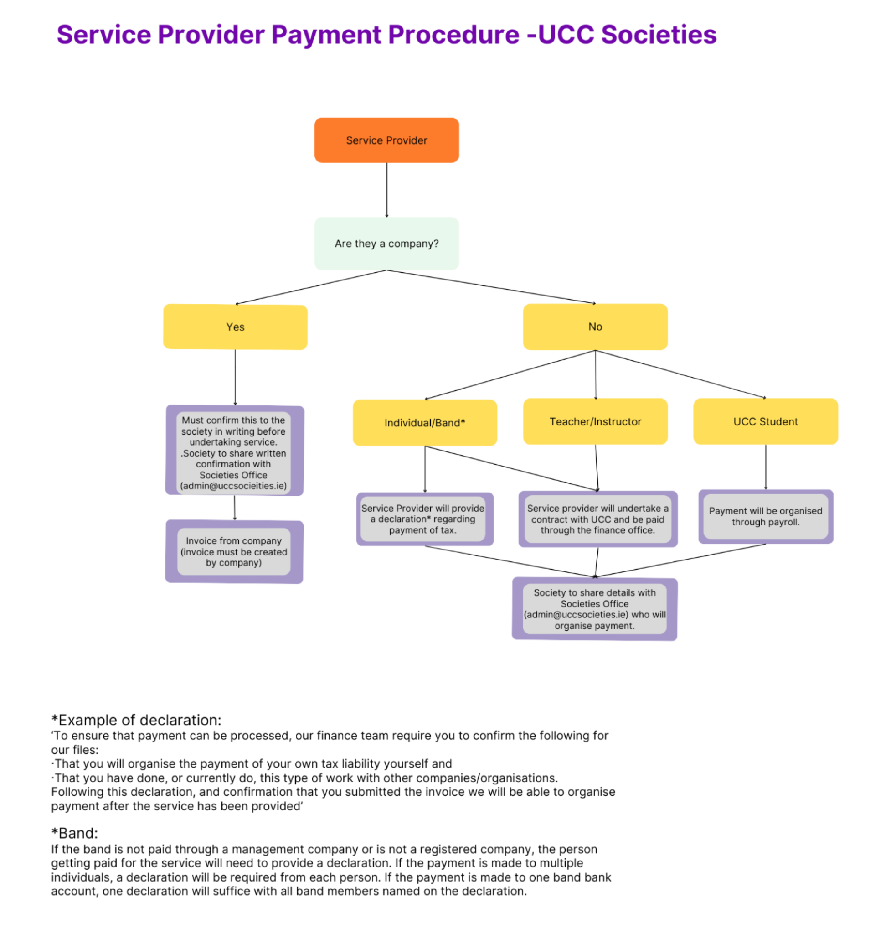
If a person or company is being paid for a service, check the following:
- If the provider is a registered company:
  - The company must confirm in writing that they are a registered business before the service is delivered.
  - The Society must forward this written confirmation to the Societies Office: admin@uccsocieties.ie
  - The company must issue an invoice, created by them.
- If they are a UCC Student:
  - Payment is made via UCC payroll.
  - The Society must send their details to the Societies Office (admin@uccsocieties.ie), who will handle the setup.
- If they are a Teacher/Instructor:
  - The provider will need to undertake a contract with UCC.
  - They will be paid through the UCC Finance Office.
  - The Society must provide their details to the Societies Office (admin@uccsocieties.ie) to initiate the process.
- If they are an Individual/Band (not operating as a company):
  - The provider must complete a declaration confirming:
    - They are responsible for their own tax obligations.
    - They currently do this type of work for other organisations.
  - Once the declaration and invoice are submitted, payment can be arranged after the service has been delivered.
Note for Bands: If not managed through a company, each band member being paid separately must submit their own declaration. If payment is made to one account, a single declaration with all names is acceptable.

What to Include
- A detailed explanation of what the expense was for
- Clear, enlarged photos or scans of all receipts. These must be itemised receipts showing what was purchased.
- Proof of costs, such as quotes, invoices, or screenshots

Income
Income refers to all money that is lodged into your Society’s bank account. This can come from several sources, including:
- Guild Funding (SOA-approved) – added once approved
- Sponsorship – any external support or donations
- Other Income – such as ticket sales (via SumUp or Ticketsolve) or fundraising events.

What You Need to Do
All non-SOA income (e.g. sponsorships, charity donations, member contributions etc.) must be added manually to the portal under the “Income” section.

Be sure to label the source of the income clearly and attach any relevant documentation (e.g. screenshots of transfers, receipts, or agreements). This helps keep your Society’s financial records accurate and ensures transparency.

Sponsorship
Many societies seek additional support from external companies and organisations alongside their Guild funding. This support can take many forms — from financial contributions and free pizza to prizes, equipment, or subsidised hoodies. Successful sponsorship is built on strong, mutually beneficial relationships, and this guide outlines a practical, adaptable approach for securing sponsorship for your society’s activities.

Students cannot sign sponsorship contracts on behalf of their society.
All sponsorship contracts must be submitted to the Societies Officer and the Head of Student Life, who will review and sign them on behalf of the society. No sponsorship agreement is valid without the appropriate signatories’ approval. Use the provided societies contract template to speed up the process of contract approval.

Finance Protocol - Sponsorship vs Donation
If the Society is obliged to provide a sponsor with a material benefit in return for sponsorship received, then the payment is liable for a VAT payment of 23%. This should be factored in when negotiating an amount for sponsorship.

Financial or other support in the form of a donation or gift is not liable to VAT provided they are freely given and secure no material benefit in return.

Identify the Benefits for Everyone Involved
Before reaching out to potential sponsors, think about what you can offer them — not just what you need. A good sponsorship deal benefits both parties. Companies are approached for sponsorship all the time, so consider why they should work with you.
Benefits for the sponsor might include:
- Raising awareness of their brand or products.
- Enhancing their public image.
- Achieving specific business objectives.
- Creating goodwill or contributing to community relations.
- Supporting student activities as part of their Corporate Social Responsibility (CSR) strategy.

Benefits for your society might include:
- Funding to support events, equipment, or other projects.
- Publicity through association with a well-known brand.
- Building relationships with potential future employers or industry partners.

Define What You’re Asking for
Be clear and professional before approaching any company. Prepare answers to:
- What are you seeking sponsorship for?
  - One-off events (socials, cultural nights, conferences).
  - Equipment or long-term projects.
  - Prizes or services in-kind (food, merchandise, raffle items).

- Why do you need sponsorship?
- What kind of support are you seeking? (Cash sponsorship, product donations, event hosting, etc.)

Use the SMART system to set clear, realistic objectives:
- Specific — What exactly do you want to achieve?
- Measurable — Can you measure success (e.g., attendee numbers, brand visibility)?
- Achievable — Is your goal do-able?
- Realistic — Will the company be interested and able to provide what you ask for?
- Time-bound — When do you need the sponsorship?

Consider offering multiple options to potential sponsors:
- Option 1: Sponsoring event publicity.
- Option 2: Sponsoring a competition prize.
- Option 3: Being the headline sponsor for a major event.

Identify Potential Sponsors
Use a mix of common sense, research, and networking:
- Obvious options
  - Existing contacts.
  - Your suppliers or businesses who want to engage with students.
  - Local businesses with a visible campus presence.

- Research companies related to your sector/area
  - Example: Law Firms for the Law Society
  - Local businesses that advertise in student or local media.
  - Companies known for community engagement.

- Widen your search
  - National companies with a local presence or CSR commitments.

- Narrow down to a contact person
  - Ask for names of relevant staff in Marketing, Corporate Affairs, or Community Relations.
  - Use your committee’s networks - someone may already have a contact.

- Identify a primary point of contact
  - One committee member should lead communications with each potential sponsor.

Prepare a Sponsorship Proposal
Your proposal should focus on what’s in it for the company. Tailor each proposal specifically for the organisation you’re approaching.
Your sponsorship proposal should include:
- A short profile of your society (membership numbers, events run, past successes).
- What you’re seeking sponsorship for and why.
- The benefits for the company.
- How you align with their business values and objectives.
- How their support will be used (include a simple, clear budget breakdown).
- A marketing/promotion plan.
- Contact information.

Top Tips
- Be clear, honest, and professional.
- Only promise what you can deliver.
- Highlight any previous achievements (STARS/BICS awards, notable events, media coverage).
- Avoid jargon — sponsors won’t know what "exec" or "BICS" mean, so give full titles/names

Approaching Potential Sponsors
Start with a phone call.
Ask to speak to the relevant person (e.g. Marketing Manager, Corporate Affairs). Be clear about the reason for your call and politely ask how they’d like to receive your sponsorship proposal. If they ask for details over the phone:
- Have a short pitch ready.
- Be prepared to explain your proposal clearly and concisely.
- Anticipate likely questions and have answers ready.

Ideal contacts within a company (in order of priority):
- Marketing Director
- Corporate Affairs or Community Relations
- General Manager or CEO (for small companies)

Keep a detailed record of all correspondence and phone calls. Note down the name of the person you spoke to and the date. This helps avoid miscommunication and keeps things organised.

Good sponsorship relationships are built on trust and clear, professional communication. Don’t over-sell or under-sell your society. Be honest about what you can offer and what you’re asking for. Always follow up with a thank you, whether they accept your proposal or not - you may work together in future.

Cash Handling
While societies are encouraged to minimise the use of cash, there are times when it’s unavoidable - especially for fundraising or in-person events. Proper cash handling is essential for safety, transparency, and accountability.

The Cash Handling Policy should be thoroughly reviewed prior to any events or cash handling taking place.

Important Notes
- Cash must never be used to pay for expenses directly.
All cash must be deposited first, then payments made through proper channels.
- Segregation of duties is essential.
No one person should collect, count, and lodge cash on their own.

Key Points
- Use Ticketsolve where possible
For payments from members (e.g. trips, events), Ticketsolve is preferred. It’s mandatory for events with turnover over €500. Only accept cash in exceptional cases.

- Fundraising cash
Read the Charity Collections Procedure to ensure a proper understanding of all processes for collecting money for charity, as they will differ from general cash handling. Notify the Societies Executive President and Societies Officer in advance of any fundraising plans. Afterward, let them know how much was raised.

- Always use a locked cash box
Keep collected cash secure and out of sight. The cash box key should be held by a designated committee member.

- Count cash with two people
Never handle or count cash alone. Two society members (not involved in collecting) must count it, using the cash count sheet, and sign it.

- Store cash securely
If not lodged immediately, cash should be stored in a locked box in a secure room. The maximum cash that can be stored is €2,000.

- Transport safely
Up to €1,000 → 2 society officers
€1,001–€2,000 → 3 society officers
Never carry more than €2,000 at once
Bank lodgements should be done as soon as possible after counting.

- Lodge cash promptly and record it
Deposit into your Society’s Bank of Ireland account and upload the lodgement to the Societies Portal within 24 hours. Keep the bank receipt.

Charity Fundraising
Societies play an important role in supporting charitable causes, but fundraising must follow UCC’s procedures to ensure security, transparency, and accountability. Be sure to read the Charity Fundraising Protocol in full before proceeding with any collections. You should complete the Charity Fundraising Planning form at the start of the academic year to indicate which charities you will fundraise for.

Before You Start
- Complete the Charity Fundraising Pre-Collection Form
- Collect sealed and numbered buckets and/or labelled SumUp machines from the Societies Office. These must be issued by the SEA or Admin Staff.
- Each item must be logged and linked to your Society’s event.

During the Collection
- Buckets must remain sealed at all times - do not open or tamper with them.
- Do not count or remove cash during the event.
- Keep the bucket and SumUp machine in your line of sight.
- For donations over €50, encourage use of the SumUp machine for security.
- All collectors should:
  - Wear Society-branded clothing and/or identification (if available)
  - Work in pairs if possible, especially at busy events
  - Stay alert and avoid leaving collection materials unattended

After the Collection
- Return all materials to the Societies Office as soon as possible.
- Two committee members (not involved in collecting) must open and count the bucket in a secure space.
- Use the official Cash Count Sheet and complete the Post-Collection Form.

Depositing Funds
- Lodge funds to the Society’s bank account as soon as possible.
  - This must be done at Bank Of Ireland in the Student Centre, which is only open on Wednesdays.
- If you cannot deposit the funds on the day of collection, Societies Office staff will store it in the office safe with your count sheet.
- Submit an Expenditure Request through the Portal to donate funds to the charity.
  - Do not donate money directly - this must go through your Society account first.
Important: Donations to charity must be completed before the end of the year (before June 1st).

Safety, Permissions & Guidelines
- Off-Campus Fundraising
  - Street/door-to-door collections require a Garda permit
  - Venue-based collections (e.g. shops, churches) need written permission from the venue’s management
- Security Tips:
  - Never collect alone - use the buddy system
  - Carry ID and wear identifiable Society clothing when possible
  - If there’s a theft, loss, or incident, report immediately to the Societies Office and the Gardaí

Online Charity Fundraising
- Use Ticketsolve for all online donations.
- Do not use platforms like GoFundMe, PayPal, or iDonate without prior approval.
- If Ticketsolve does not suit your needs, contact the Societies Office to discuss an alternative platform.

Foreign Trips
Each year, many UCC societies avail of the opportunity to take their members abroad for a variety of reasons. These trips can provide valuable cultural, educational, and social experiences for society members. However, to ensure the safety of all involved and to properly represent both UCC and your society, there are important procedures that must be followed when planning a foreign trip.
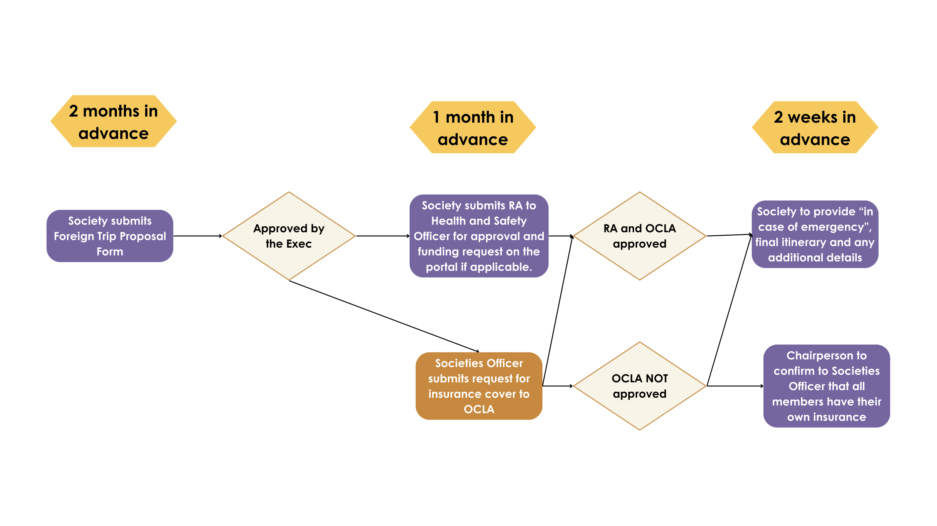

Foreign Trip Proposal (FTP)
Any society wishing to travel abroad must complete a Foreign Trip Proposal (FTP) form and submit it to the Societies President, Societies Officer, and Finance Officer at least two months prior to the proposed trip.

The FTP asks for details including:
- The purpose of the trip (which must be relevant to the society’s aims and contribute to its development)
- Number of members travelling
- Estimated costs
- Travel and accommodation plans
UCC Societies cannot support trips that lack a clear developmental purpose for the society and its members.

Once submitted, the Societies President will present the proposal to the Societies Executive for review. The Executive will vote to either approve or decline the proposal. The outcome will be communicated back to the society by the Societies President.

If approved:
- A Risk Assessment must be completed and sent to the Health and Safety Officer for Student Activities
- The Societies Officer will request Foreign Travel Insurance cover for the trip (if this is not approved, society members must arrange their own insurance and confirm this at least two weeks before departure)
- Any funding requests must be submitted through the portal according to the Schedule of Allowances.

Pre-Departure Requirements
Once the trip has full approval from the Societies Executive and Health & Safety Officer, trip planning can begin. Before final confirmation, the following must be submitted two weeks before departure:
- Final day-by-day itinerary
- Flight details
- Accommodation name, address, and contact number
- Details for the nearest embassy and hospital at the destination
- Screenshots confirming travelling members’ society membership on the portal, their contact numbers, and their ‘in case of emergency’ contact details
- The last four digits of the European Health Insurance Card (EHIC) for each EU citizen travelling (for trips within Europe). All non-EU students will be covered under UCC’s Foreign Travel Insurance — ensure you have the policy number before travelling.
Additionally:
- Check visa requirements for your destination and make arrangements if necessary.
- Ensure all passports are in date and remain valid for at least six months after arrival at your destination.
- Confirm if vaccinations are required for your destination and organise these in advance, ensuring documentation is carried by travellers.
- All students travelling on an overnight trip must complete a Student Health Declaration Form before departure. These must be kept confidential and returned to the Societies Office for shredding after the trip.

Funding for Foreign Trips
Funding may be available for foreign trips under the following conditions:

- Competitive trips: Societies may apply for funding from the Societies Executive Finance Committee in line with the Schedule of Allowances. Applications must be submitted at least one month before funding is needed.
- Non-competitive trips: Funding is available for up to seven trips per year or a total annual fund of €35,000, with each trip eligible to receive a maximum of €5000. The Executive is not obliged to approve funding and may withhold it if a trip does not merit support. Note that societies cannot apply for funding in consecutive academic years.

After the Trip
Following your trip, you must complete the Foreign Trip Feedback Form within 7 days of returning. This form is designed to capture the benefits of the trip, address any issues encountered, and provide recommendations for future trips.

Special Projects
Special Projects provide an opportunity for societies to apply for funding for events or initiatives that fall outside the standard funding categories provided in the Schedule of Allowances.

Application Process
- All Special Project applications will be considered on a case-by-case basis.
- Applications must be submitted via email to both the Finance Officer and the Societies President.
- The deadline for applications varies each year and will be announced by the Finance Officer and President once confirmed.

Application Requirements
- Applications must be heavily detailed and well justified, clearly outlining the purpose, expected outcomes, and relevance of the project to the society and UCC’s student community.
- If the proposed Special Project is intended to become an annual event, the application must also include a future funding and sustainability plan.

Important Notes
- A Special Project is expected to become self-sustaining after its initial run.
- Societies can therefore only apply for Special Project funding once for a particular project.
- The Societies Executive reserves the right to approve or decline funding based on the merits and feasibility of the application.

