Events

Guide

2025-2026

Table of Contents
1. Planning and Delegation 2
2. Risk Assessments & Health and Safety 3
3. Promo and Advertisement 4
4. Ticket Sales 5
5. Balls 6
6. Finances 7
7. Booking Equipment 8
8. Alcohol Policy 12
9. Wholesale Shopping 13
10. Room Booking 13
11. Policy 20
12. Foreign Trips 20
13. Public Liability/External Companies 21
14. Events Checklist 22

Planning and Delegation
Every good event starts with a purpose. Why are you running this event? What do you want people to walk away with? Having a clear aim makes everything else easier - from promotion to budgeting to measuring success afterwards.
Examples of purposes:
- A social (build community, welcome new members).
- An educational event (guest speaker, skills workshop).
- A fundraiser (for charity or society projects).
- A flagship event (ball, showcase, competition).

Planning
It is strongly recommended to organise a meeting with your committee exclusively to plan out the year’s events and bring in any ideas that the rest of the committee may have. This should take place either at the beginning of the academic year or maybe even during the summer coming up to the year.

Event Timeline
6–8 weeks before: brainstorm, confirm purpose, check calendar for clashes.
4 weeks before: draft and submit risk assessment, start sponsorship conversations if relevant.
3 weeks before: book rooms and equipment via portal, confirm any suppliers, performers, speakers, etc
2 weeks before: submit funding request, confirm promo plan, email members.
1 week before: finalise rota, print posters, post social media advertising.
Day of event: arrive early, walk through venue, assign roles, keep contacts handy.
After event: submit expenditure request, lodge cash, note what worked

Delegation
Your committee is there to help you run events and all aspects of organising them. Divide responsibilities early - e.g. Chair for approvals, PRO for advertising, Finance Officer for budget, Events Officer for logistics. It is not your job to do everything on your own - by delegating tasks to the necessary people on your committee, it can help prevent burnout or miscommunication.

Tip: Create a rota for bigger events. Having clear roles avoids confusion on the day.

Risk Assessments & Health and Safety
Risk Assessment Requirements
A risk assessment is required for every event - even meetings or coffee mornings.
- Must be submitted at least 2 weeks in advance.
- Room bookings cannot be approved without it.
- Be as specific as possible: highlight potential hazards, outline how risks will be managed.

Food Safety & Training
If you’re organising an event involving food prep (e.g. bake sale), at least one committee member must have food safety training. Include this in your risk assessment.

Always label allergens and provide vegetarian/vegan options where possible.
Full Health & Safety policy can be found in the Societies Policy Book.

Promo and Advertisement
Promotion is what makes sure people actually show up to the event you’ve worked hard on. Think about your audience: how will they find out? What will catch their attention? To ensure a successful event, it is important to have a pre-planned advertisement schedule in collaboration with your committee Public Relations Officer. Advertisements can range from posters to social media posts.

Working with your PRO
- Coordinate early with your society’s PRO.
- Decide what platforms you’ll use (Instagram, TikTok, posters, etc.)
- Create a content plan (what to post, when to post it).

Posters, Digital Screens & Social Media

- Posters must be approved and stamped by the Societies Office. You can print up to 12 per event. Only post on approved boards and ensure they are removed after the event (you can be fined!).
- Digital screens: Submit a 1920x1080px graphic to admin@uccsocieties.ie to utilise on-campus screens across UCC.
- Events Wall: Add your event to the calendar on the portal by Friday 1pm to be included in “What’s On This Week.” on the UCC Societies instagram.

Accessibility & Inclusive Event Advertising
- Including accessibility symbols in event advertising is mandatory
- Use clear fonts and high contrast on posters
- Add alt-text to all images, and captions to videos
- Avoid jargon/slang that not everyone may understand
- Aim to use venues that are wheelchair accessible

Ensure the PR Officer has been informed of the material and what you need advertised well in advance to ensure clear communication.

If you would like more information you can check out the PR Guide or reach out to the Societies PRO, pro@uccsocieties.ie.

Ticket Sales
Whether you’re running a ball, a concert, or a fundraiser, UCC provides two main ways to sell tickets: in person using SumUp machines, or online using Ticketsolve.

In-Person Ticket Sales
In-person ticket sales require more planning than online ticket sales. You will need:
- Approved risk assessment
- Room booking
- Equipment booking (SumUp machines)
- Committee members to help manage queues, sales, etc

There should always be at least two committee members staffing the ticket desk for security reasons.

We advise against taking cash for ticket sales, as this can leave societies with large amounts that cannot always be deposited straight away. This can leave the society at risk of cash being misplaced or mismanaged.

Online Ticket Sales
If you wish to sell tickets online for an event, this can be done through Ticketsolve. To submit a request for a Ticketsolve link, you will need to fill out this form, and send it to admin@uccsocieties.ie. You will then be emailed a link to your event ticket sales.

All money from online ticket sales will be transferred to the society’s bank account.

Balls
Balls are often the highlight of a society’s calendar, but they also require the most preparation. Because they involve contracts, alcohol, and large numbers of students, they come with additional policies and responsibilities.

To organise a ball, at least two of your committee members must attend Ball Training. This training covers everything from liaising with venues to managing contracts, ensuring health and safety, and complying with university alcohol policy. Without this training, your society cannot run a ball.

All contracts with venues, caterers, performers, or suppliers must be reviewed and signed by the Societies Officer or Head of Student Life. Students are not permitted to sign contracts themselves, as this exposes you to legal and financial risk.

Your risk assessment for a ball must be thorough and include alcohol service, crowd management, transport, and security arrangements.

Balls are a fantastic way to showcase your society, but they only succeed with careful planning, open communication with the Societies Office, and strict adherence to university policy.

Please find more information about the organisation of a ball in the Ball Manual. If you are thinking of organising a ball for the first time or have

Finances
Every event should have a budget. Even small events cost something - whether it is refreshments, printing or prizes - and bigger events can involve significant spending. Your Finance Officer should prepare a budget showing expected income and expenditure.

If you are applying for funding, you must submit a funding request through the portal at least two weeks before the event.
- Even if the expense is listed in your annual budget, a separate request is still required for approval.
- Supporting documents such as quotes or screenshots must be attached to show accurate costs.

Cash Handling
Cash handling must always follow the cash handling policy.
- Cash collected at an event should never be used directly to pay for expenses. It must first be lodged to the society’s account, and then expenditure can be claimed.
- If you are fundraising for charity, you must use sealed, numbered buckets or SumUp devices booked from the Societies Office.
- Once money has been collected, it must be lodged to the society account and then transferred to the charity through the official process. This ensures transparency and protects both you and the society.
- The full cash handling policy can be found here.

Sponsorship
Sponsorship can be a valuable way to support events, but strict rules apply.
- Students cannot sign sponsorship contracts themselves.
- All agreements must go through the Societies Officer and Head of Student Life.
- If a sponsor provides funding in exchange for visibility or other benefits, VAT applies.
- Pure donations without return benefits are VAT-free. Always check with the Societies Office before committing to a sponsorship arrangement.

More details about finance can be found in the Finance Guide or you can reach out to the Finance Officer, finance@uccsocieties.ie.

Booking Equipment
You can book equipment for society events through the Societies Portal as a committee member. It is recommended to do so as far out in advance as possible to ensure availability.

Note: Bookings should be made for the times the equipment will be collected and dropped off, not the actual times of your event. The Societies Office is open from 9.15am - 5pm, equipment can only be collected and dropped off between these hours.

Step 1: Log in to the Societies portal.
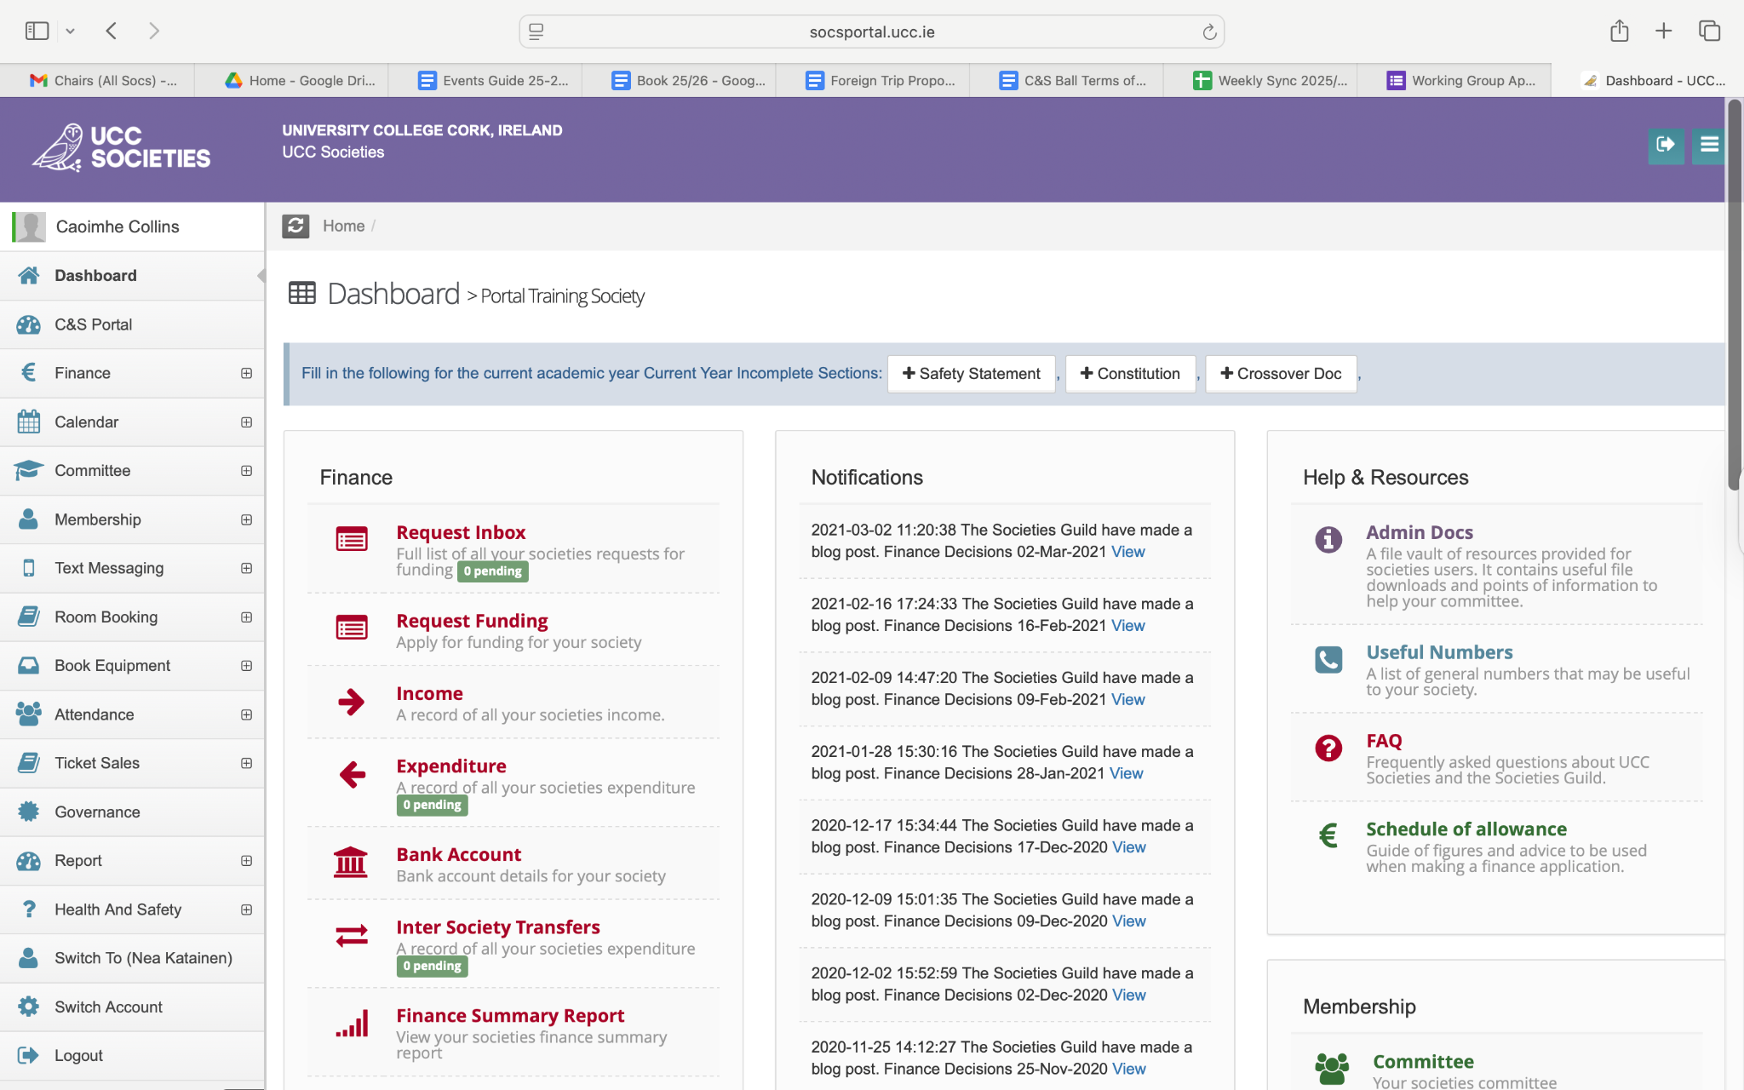

Step 2: Click ‘Book equipment’.
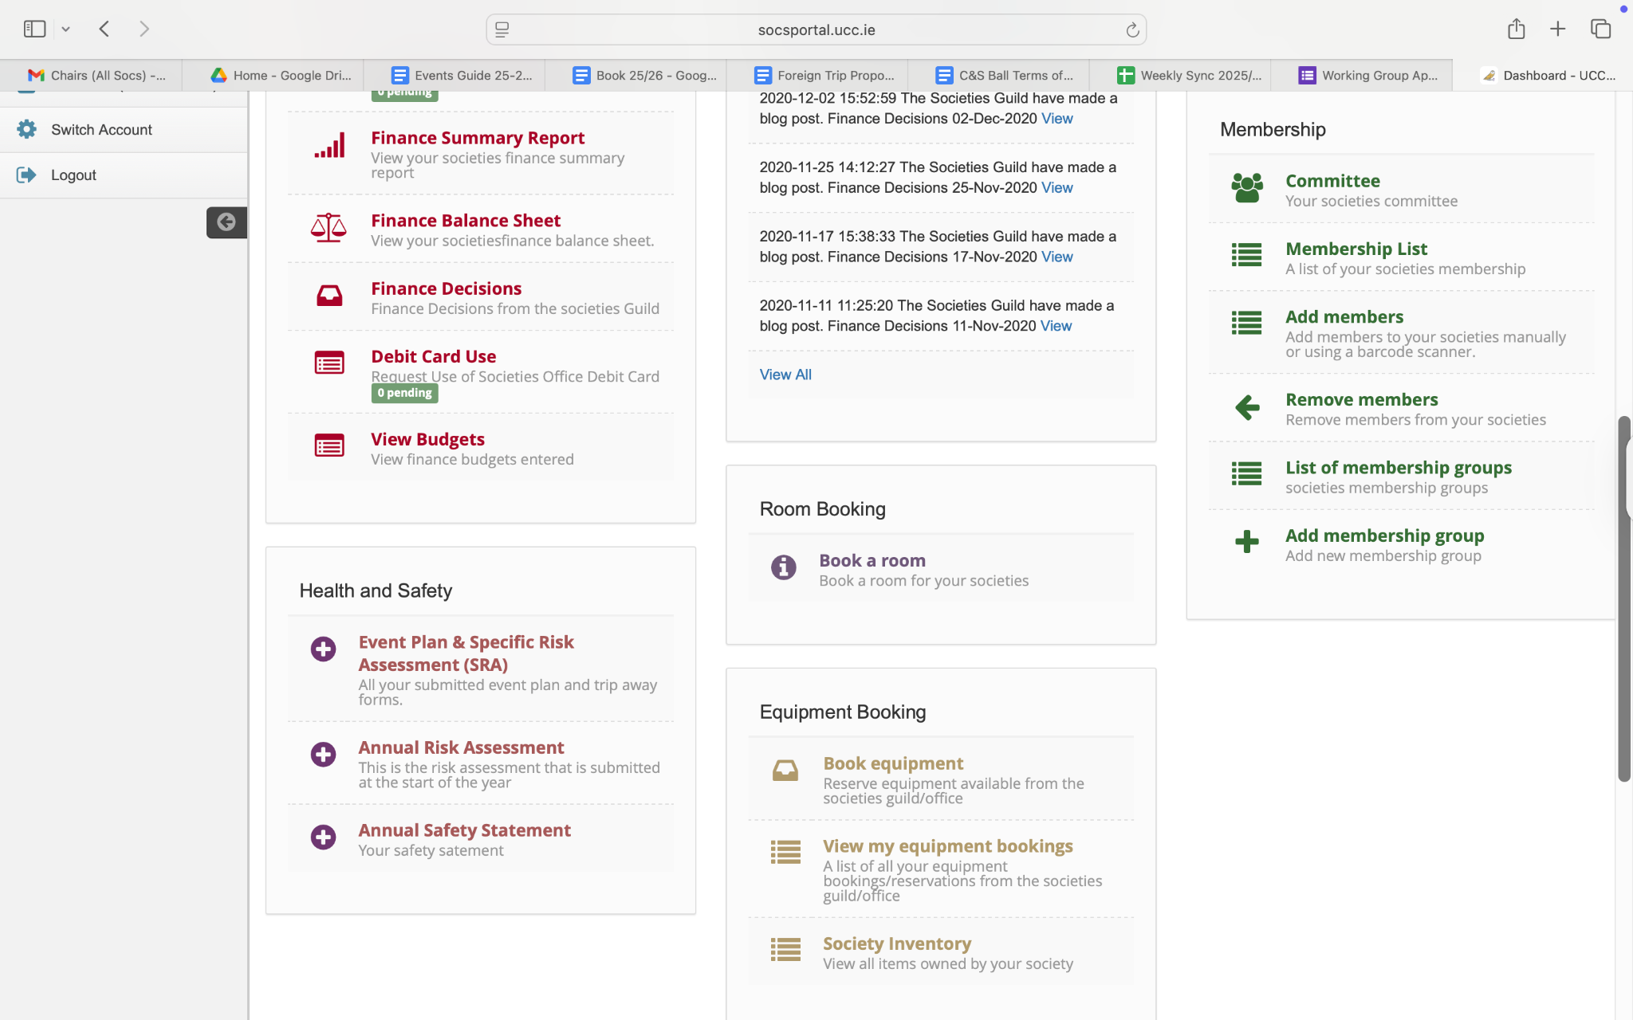

Step 3: Scroll down until you find what you are looking to book, and then click ‘Book item’ on the right hand side.
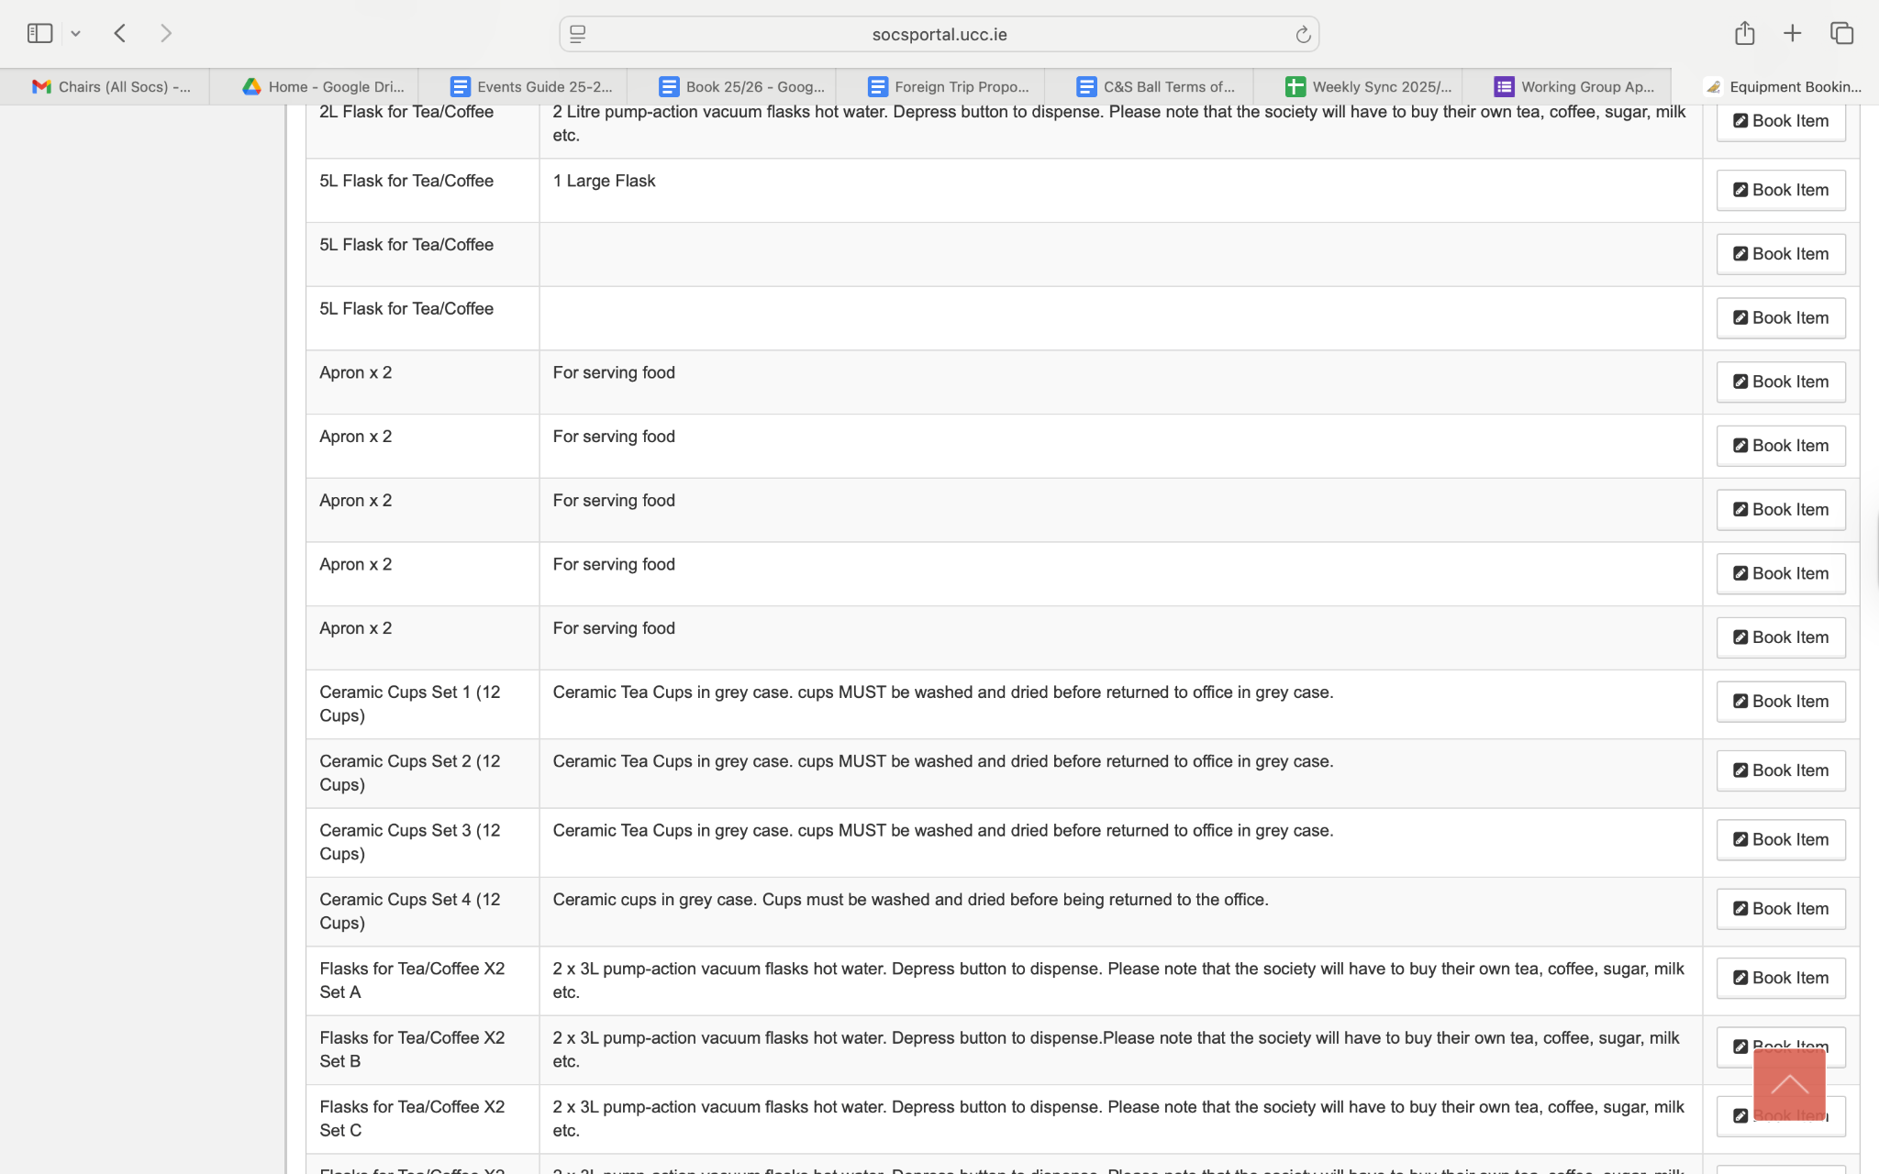

Step 4: Ensure there are no upcoming bookings at the time you wish to book the equipment, then proceed to fill in the requested information. Press ‘Save’ when you are ready to submit it.
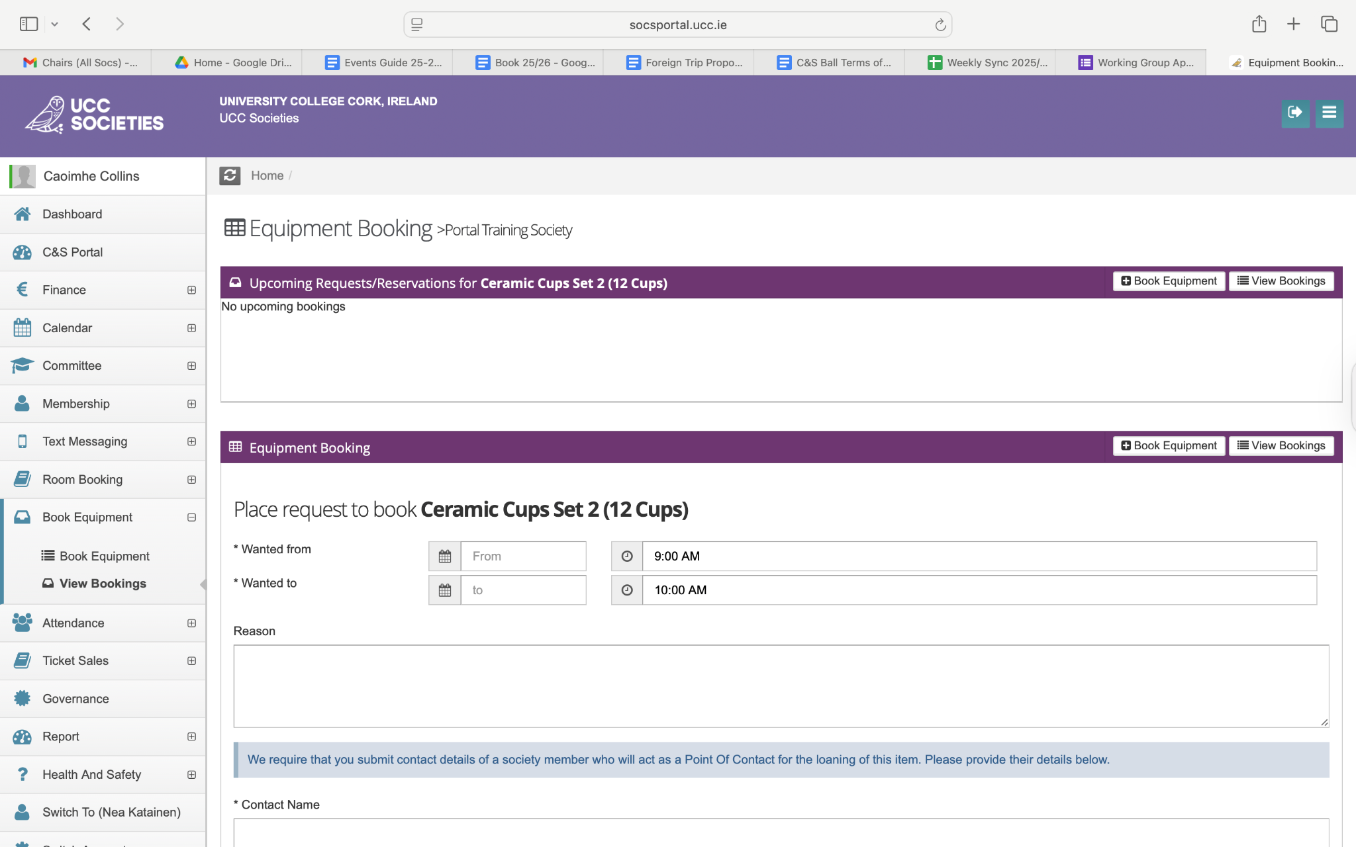
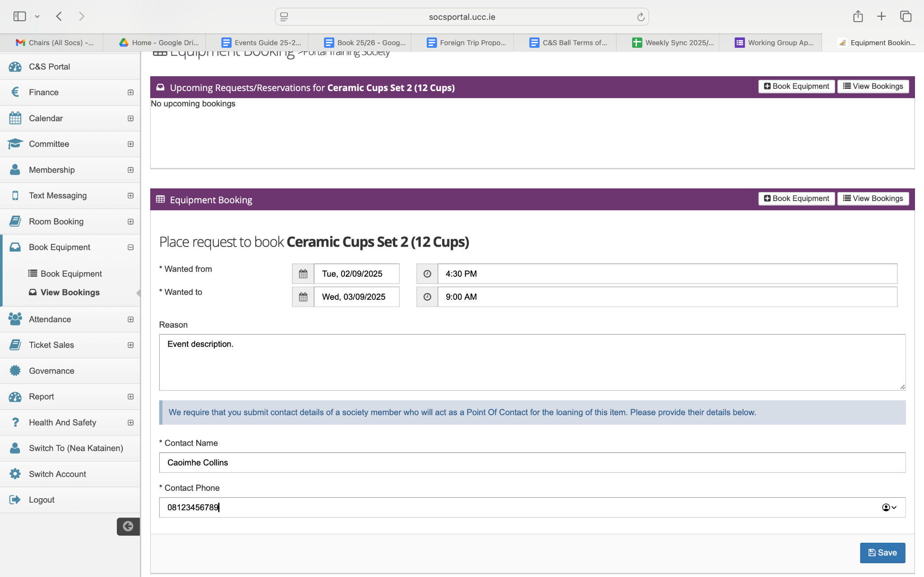

Step 5: Pending approval, this is what it should look like.
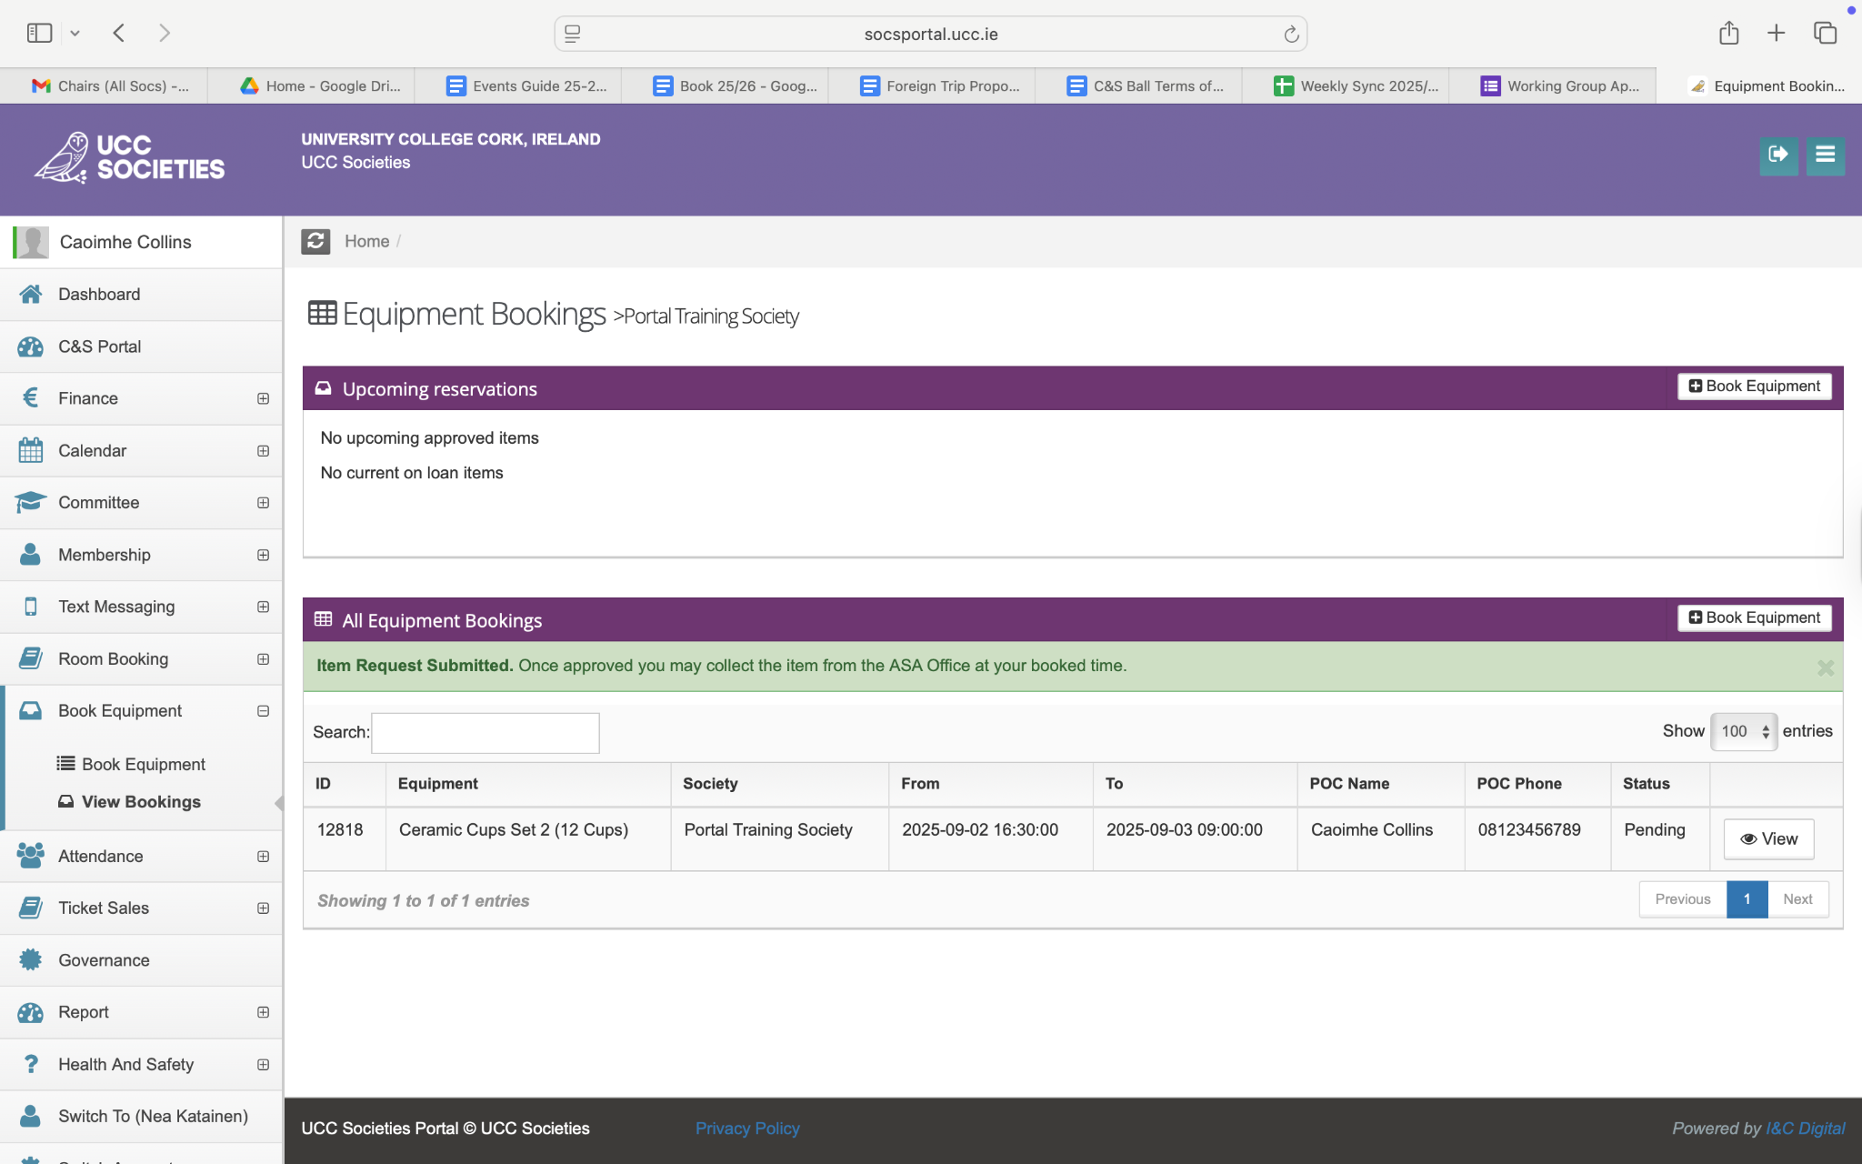

For transport, the Societies Van is available and the keys can be booked as equipment, but it may only be driven by authorised, insured drivers. Drivers can only be insured on the van if they have a full, clean license for 2 years and are a postgraduate student or Societies staff member. If you would like to be insured on the van, contact admin@uccsocieties.ie.

Alcohol Policy
UCC Societies have clear policies to ensure that all society events are safe, inclusive, and enjoyable for everyone. The alcohol guidelines are part of these policies - they’re not about stopping the fun, but about making sure events are run responsibly and in line with the standards and values of both the university and the Societies Guild.

Promoting Events – What You Can’t Do
- Don’t advertise drink deals – No “2-for-1 pints” or “free shots for the first 20 people” type promotions.
- Don’t use alcohol as a hook – Your event should be worth coming to for the activities, not the drinks.
- Be careful with language and imagery – Avoid anything that could be read as encouraging drinking or making it the main focus.
- No sponsorship from alcohol companies.
- Only name the product if relevant – You can reference a brand name if it’s part of the event title (e.g., Jameson Film Fest) but check with the Societies Executive if you’re unsure.
- Certain events are off the table – No pub crawls. No mystery tours.

Serving Alcohol – The Limits
If your society is providing alcohol at an event:
- Off campus – 1 drink per person.
- On campus – 2 drinks per person.
- Wine on campus must be provided by KSG catering.

Tip: If you’re providing alcohol, it’s a good idea to have plenty of non-alcoholic options and clearly signpost them.

If Things Go Wrong – Sanctions
If your society breaks the alcohol policy, the Societies Executive can apply sanctions:
- First time – You lose 10% of your society’s funds (either current balance or allocated funding).
- Second time – You lose 25% of your bank balance or funding and have to meet with the Societies President and others to discuss the breach.
- Third time – You’re on a “Restricted Activity” period until the end of the semester (no events).

Wholesale Shopping
If your event requires wholesale shopping for equipment or food, you can use the UCC Societies Guild Musgraves card to purchase these in bigger quantities. The card number allows access to the premises, however, payment will be made individually at the time of the purchase.

In order to gain access to this card and to receive approval for purchase, please email societiesofficer@uccsocieties.ie for further details.

Room Booking
Booking a space is an essential part of event planning, and there is a set process to make sure everything runs smoothly. This section walks you through how to book, who to contact, and what to expect.

- Get Your Risk Assessment Approved
Before you can request any booking, your event’s Risk Assessment
must be approved. This is a requirement - no risk assessment, no
booking.

- Booking Through the Societies Portal
Most UCC rooms can be booked for free through the Societies Portal.
Here’s what you need to know:
- Book early – Requests must be submitted at least 48 hours before your event, and certain rooms will be in high demand
- Check availability first – Use the UCC Web Timetables to see if your chosen room is free before submitting your request.
- Book the room for how long you need it - if you need setup time before the event and time to clear up after include that!
- Track updates – You’ll receive notifications in the portal and an email once your booking is confirmed.
- If denied – You’ll get an explanation; simply pick another space and submit a new request.

Sustainability Note: For energy saving and sustainability reasons, we ask societies not to book Boole Lecture theatre rooms outside of normal class hours unless they are going to be at capacity.

Special Spaces & Extra Approval
Some locations need additional clearance, so allow more time for processing.

Aula Maxima & Dora Allman Room
Request via the portal - do not email the bookings department directly.
High demand - book well in advance.

The Hub Atrium
Request via the portal.
Capacity guide for stands:
- Atrium: 22 stands (11 by the concrete wall, 11 inside red poles)
- Front of Áine Hyland Room: 3 stands
- Marquee outside: 10 stands

Mardyke Facilities (Pavilion, Studios, Pitch)
Request via the portal - hire charges apply.
Admin team will liaise with relevant staff to confirm.

UCC Community Garden
Book through the portal - office will liaise with Green Campus Greenshoots Coordinator. Note: Not wheelchair accessible.

SU/ORB Garden
Request via the portal — office will connect you with the SU admin team.

Spaces Requiring Direct Contact
Some areas must be booked by emailing the relevant contact directly.

Outside the Boole Library
Requires an approved risk assessment for stands or small outdoor events.
Once approved, contact John Murphy (Duty Manager, Aula Maxima) for a table, johnmurphy@ucc.ie or 021 490 2266. John will hold your student card while the table is on loan.

Note: This process is for normal term-time events, not Societies Day or Freshers Fest.

Students’ Union Common Room
Two floors, with casual seating, TV, pool table, and kitchen facilities.
Contact Carol Kennedy at c.kennedy@ucc.ie.

Student Centre
Contact arasoperations@ucc.ie to book the following areas of the student centre:
Devere Hall
Large, open-plan space (max seated: 432).
Projector, sound system available.
€210 set-up fee for all events
- Fund available to cover this, 1 use per society per year, email president@uccsocieties.ie.
€275 fee for ticketed events

Upstairs Café
Good for quizzes, talks, info nights.
Projector, screen, PA available from the information desk.

Hamish’s Student Bar
Good for quizzes, open mics, socials
Projector screen, microphone and sound system available

Áras na Mac Léinn Meeting Rooms
In order to book these rooms, societies must contact providing the name, committee position, and mobile number and society email for the 4 committee members who will be able to make bookings for the society.

How to book a room on the portal?
Step 1: Log in to the Societies portal.

Step 2: Click on ‘Book a Room’

Step 3: Click ‘Add New’
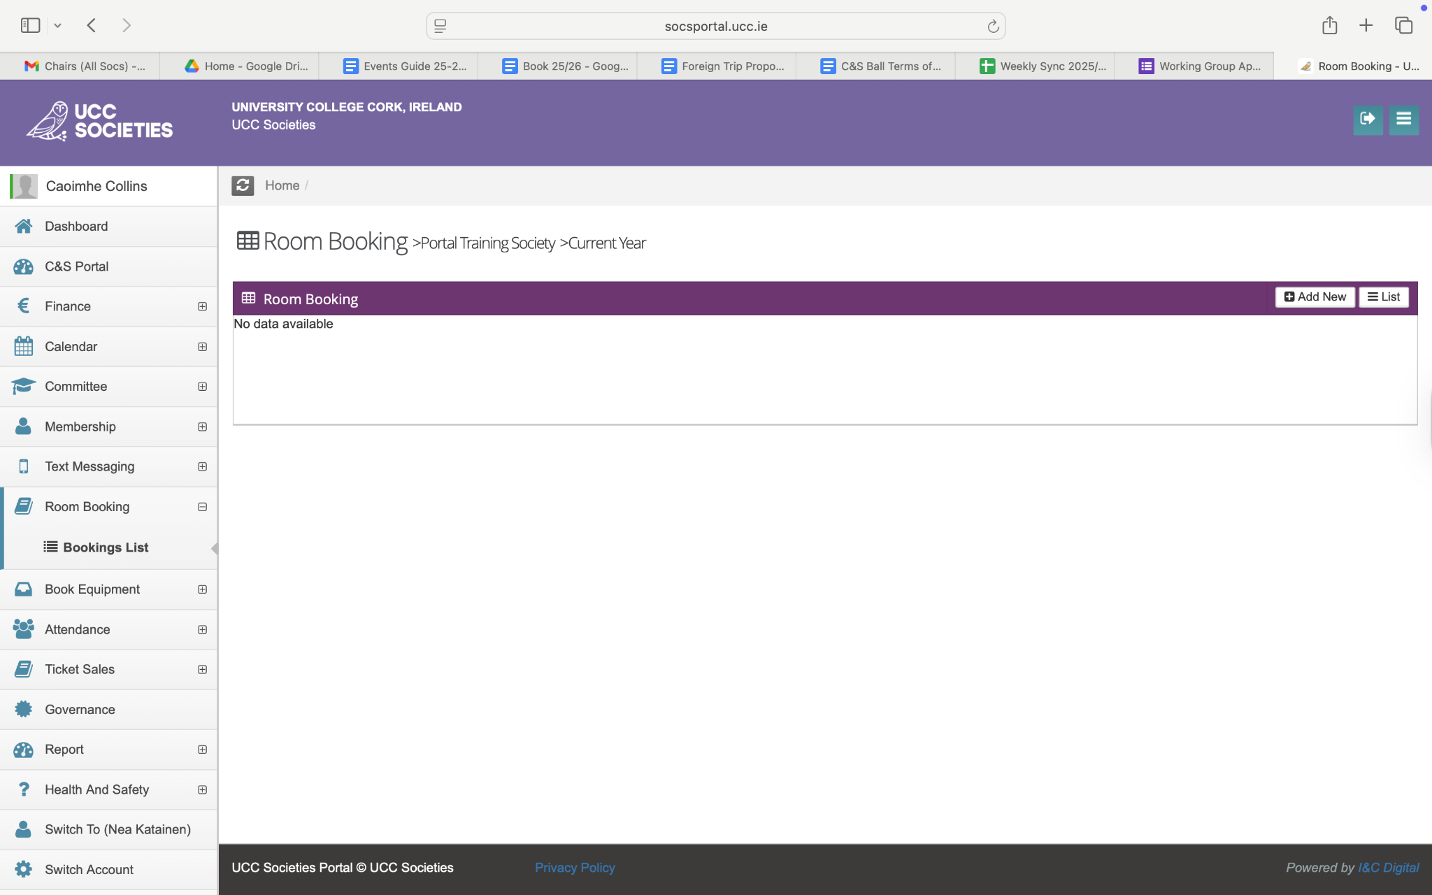

Step 4: Fill in the requested information.
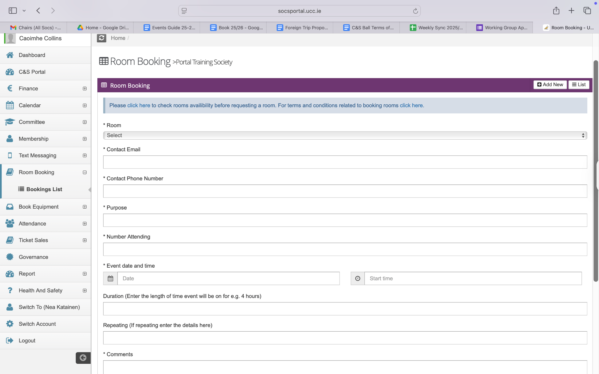
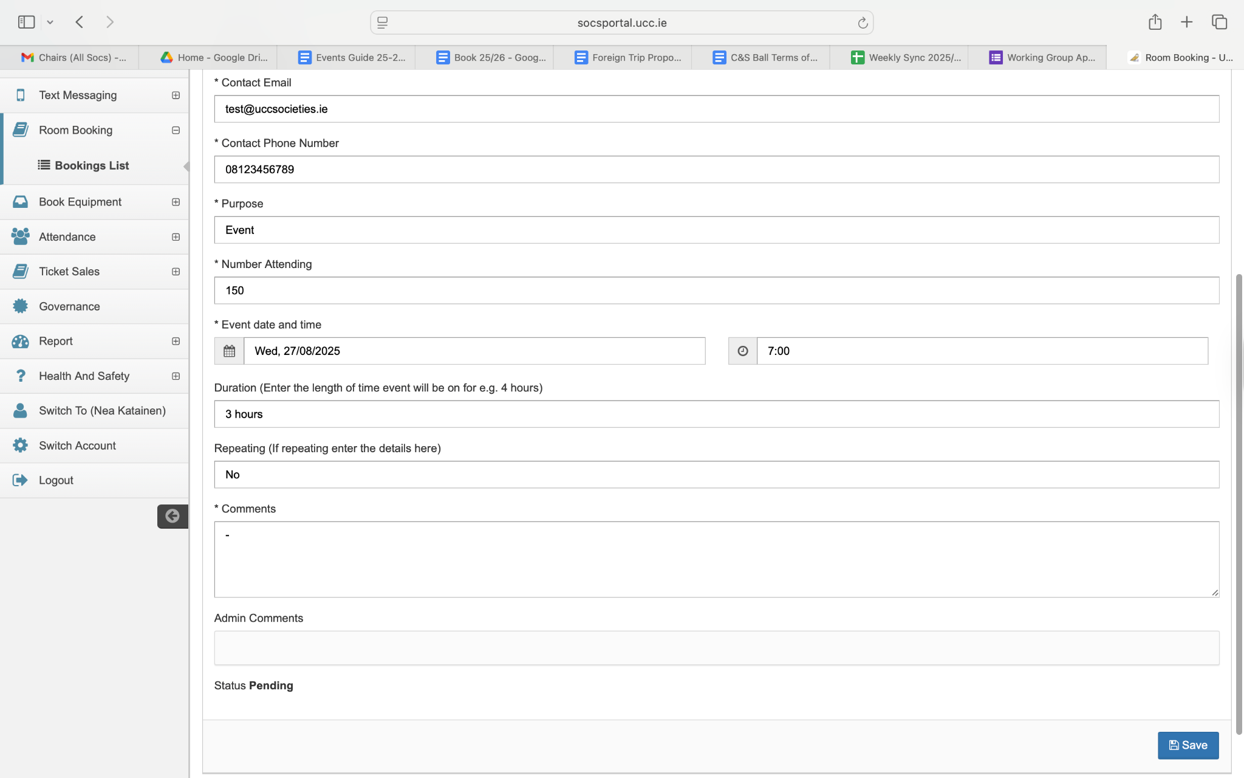

Step 5: Before the room booking has been approved, it should look like this.
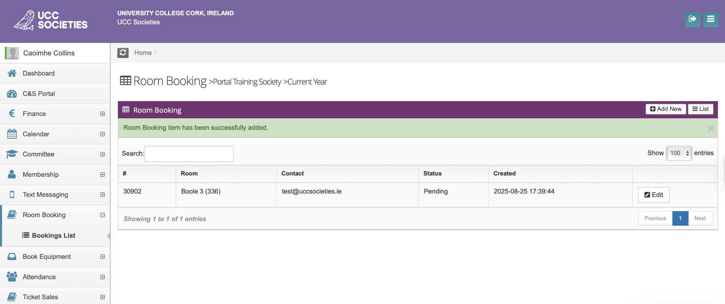

After approval, this is what the room booking should look like.
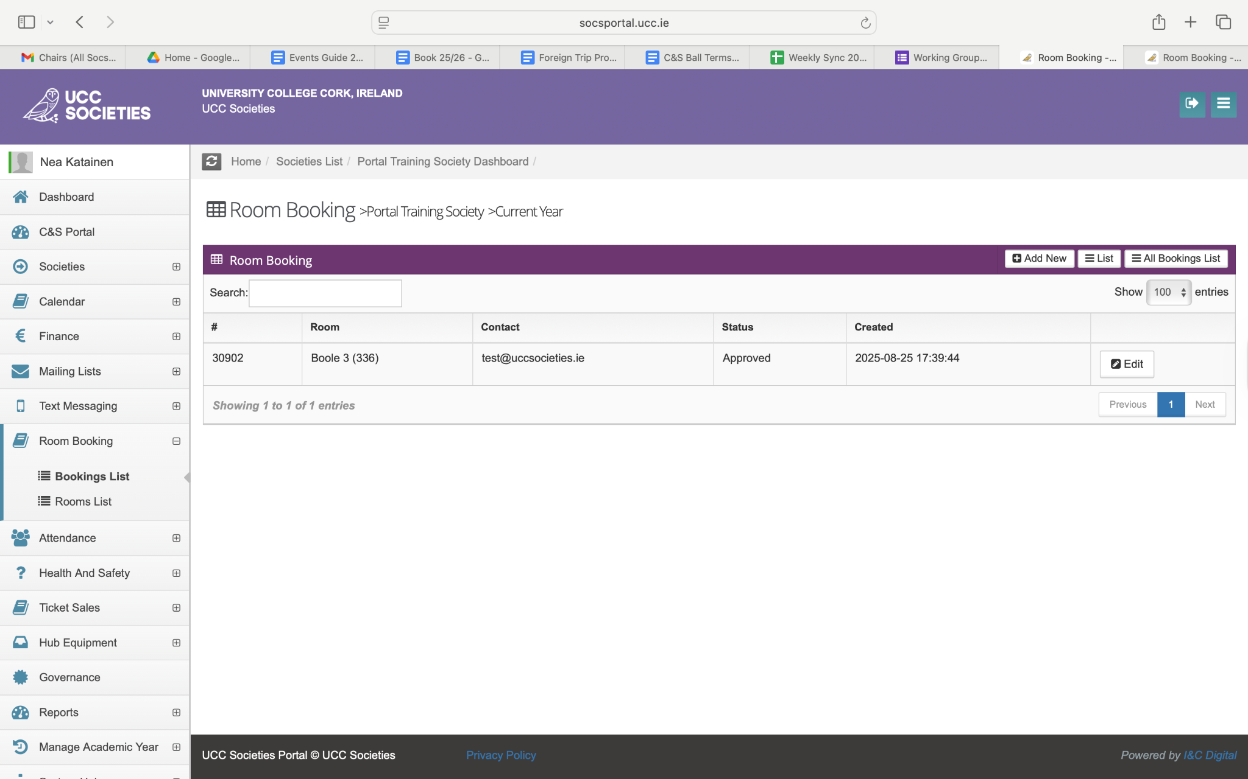
If you have any issues with booking rooms through the portal, you can contact the Societies Office, admin@uccsocieties.ie.

Policy
It is very important for the committee to be familiar with the UCC Student Rules and Regulations in addition to the UCC Societies Policies and Procedures. You can find a complete guide to our policies in the Policy Book.

Key areas in the Policy Book to pay attention to:
- 5. Events
- 8. Health and Safety
- 9. Emergency Guidelines Policy
- 10. Bullying and Harassment Policy
- 15. Social Media & Online Activity
- 16. GDPR, Alcohol Promotion & Sponsorship, & Child Protection
- 17. Sanctions

Foreign Trips
If your society wishes to organise a foreign trip (outside of ROI and NI), there is a specific application for this. The application form can be found here. This application will be reviewed by the Societies Executive, whether it is guild or independently funded.

Funding is available, but there are limits. Competitive trips can apply through the SOA, while non-competitive trips may receive up to €5,000, capped at seven trips per year or total €35k for trips across all societies, whichever is reached first. The same trip will not be funded in consecutive years and funding will be allocated on a first-come first-serve basis. If there are multiple foreign trip requests after all funding has been allocated, we are unable to help fund the trip.

All foreign trips organised by societies must be developmental to the society and proof of this must be in the application.

All foreign trip proposals must be submitted at a minimum of two months prior to the departure date, to ensure advanced notice of risk assessments, university insurance and funding requests.

It is important to note that a society will not receive funding from the Societies Guild for a foreign trip two years in a row. If you wish to organise foreign trips for many consecutive years, this will have to be independently funded.

At least two members on the committee attending the foreign trip must have attended consent training. This is to ensure safety of everyone attending the trip, and to make the attendees aware of consent and boundary setting.

Public Liability/External Companies
If you are using an external company from UCC for any event or any equipment or entertainment for an event, it is mandatory for the external company to have public liability insurance. Ensure you ask this information before making any definitive decisions.

If you are unsure about this, reach out to the Societies Officer, societiesofficer@uccsocieties.ie.

Events Checklist
- Create Event Plan
- Add event to portal calendar
- Draft & Submit RA
- Submit Room Booking
- Submit Finance request(s)
- Book equipment
- Draft Social Media Post
- Post on Instagram/FB etc.
- Send email to members
- Delegation of tasks on the day-of
- Submit expenditure request(s)

If you have any questions in regards to running events, you can reach out to the Events Officer, events@uccsocieties.ie.

