Accessible Symbols Handbook

2025-2026

Table of Contents
Foreword 1
What are the Accessibility Symbols? 1
How are they useful? 1
List of symbols 2
How to use them 8
Tips and Tricks 9

Foreword
This handbook was written by the original creator of the Accessibility Symbols, Julka Taylor in collaboration with the UCC Societies Executive. They were created in 2023 during their term as the Accessibility Officer of UCC LGBTQ+ (now known as Bród) Society.

What are the Accessibility Symbols?
They are a collection of symbols designed to help societies work towards further accessibility. Some symbols highlight an accessibility feature that could be present at an event. Others highlight elements of an event that would be useful for attendees to know beforehand. These symbols are to be used on promotional material for society events to inform attendees what elements will be present at said events.

As of Senate #1 of the 24/25 year all societies are now required to use accessibility symbols.

How are they useful?
- They allow Societies to be transparent with their members about accessibility. For example, if someone hard of hearing sees the closed captions symbol on a movie screening event, they are more likely to want to go knowing their accessibility requirements will be met
- They hold Societies accountable in terms of accessibility. For example, if you go to an event with the vegan options logo to find none of the food is suitable for vegans, you would have every right to complain!
- With societies having to choose which symbols go on each event, they are automatically evaluating each event in terms of accessibility. For example to know whether the wheelchair accessible symbol is appropriate, they will have to check if the venue the event is being held in actually is wheelchair accessible.
- The symbols are not meant to be a hindrance, quite the opposite! They are tools designed to help accessibility officers perform their roles in a simple yet effective manner.

List of symbols
The files for all these symbols, including in various colour palettes, are available here.
Symbol | Description
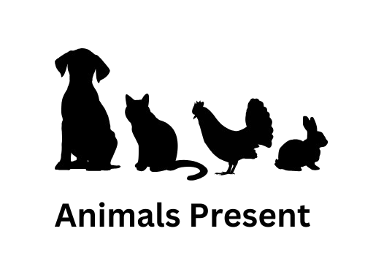 | This event will have animals in attendance.
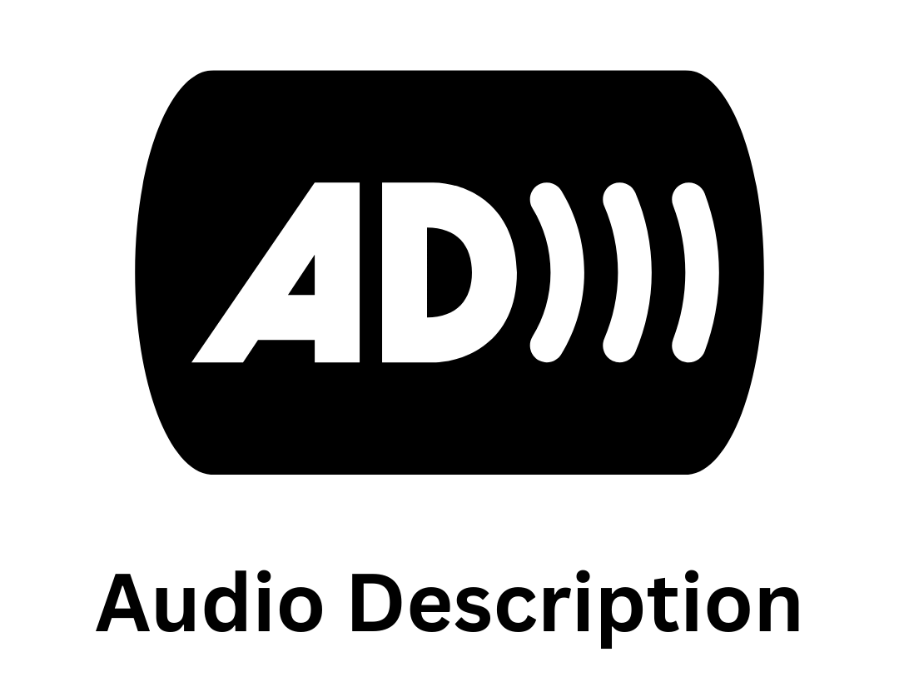 | The event will involve the use of audio description.
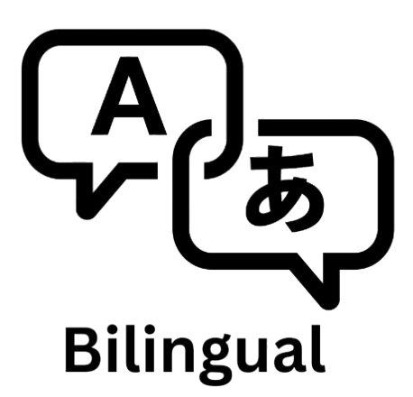 | This event will take place through 2 languages.
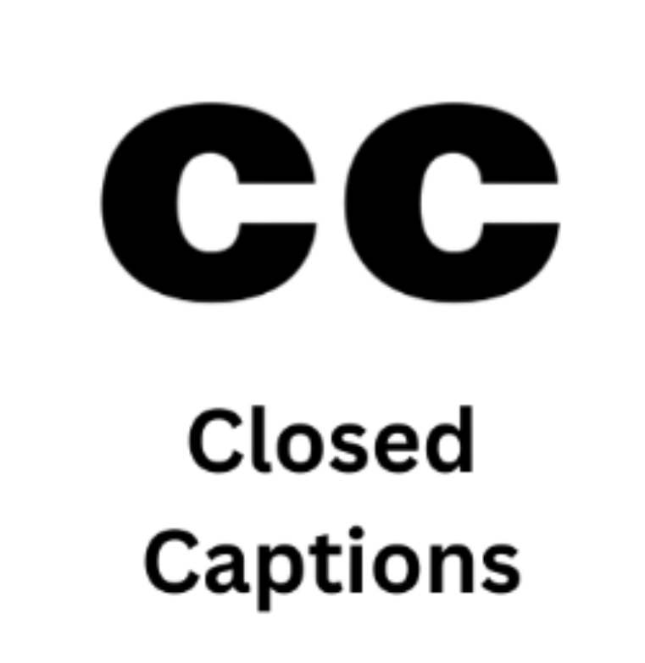 | This event will involve the use of closed captions or subtitles.
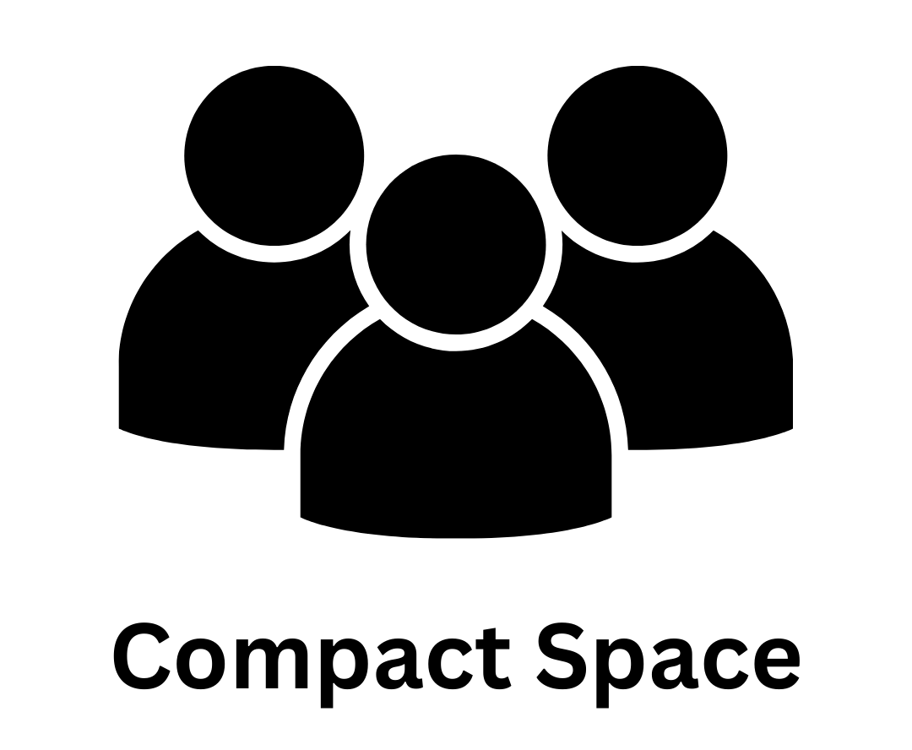 | This event may have a large crowd, or limited space.
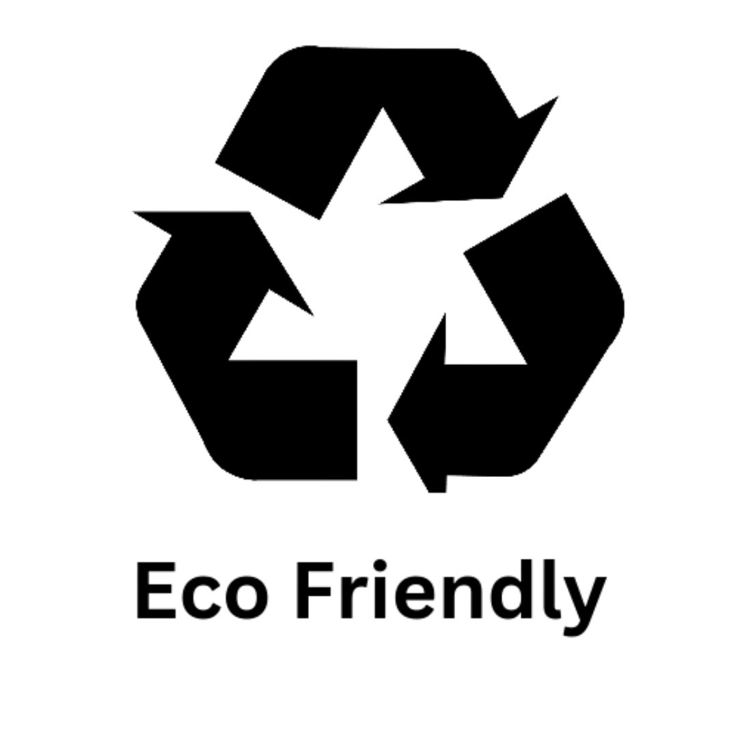 | Extra precautions have been made with this event to limit the amount of damage to the environment.
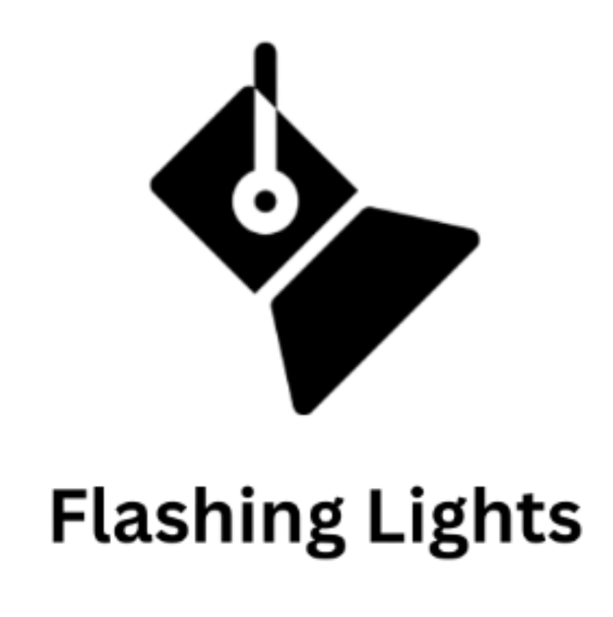 | This event will involve the use of flashing lights.
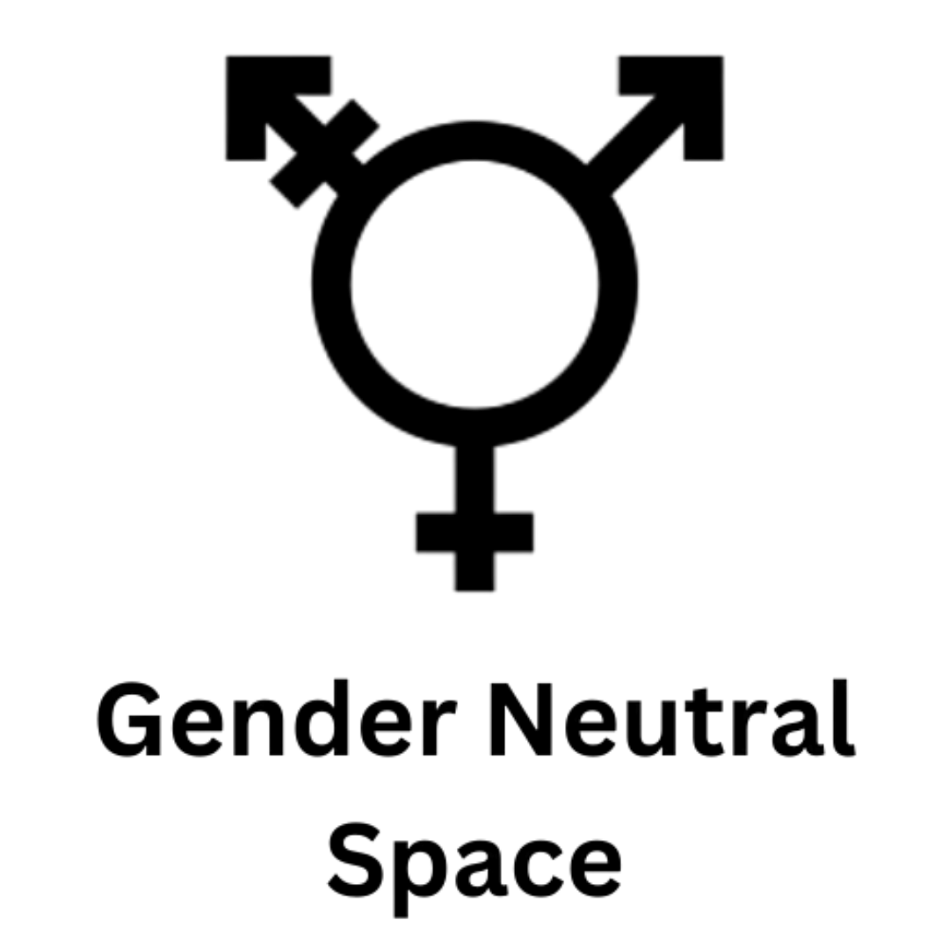 | This event can be accessed regardless of gender identity.
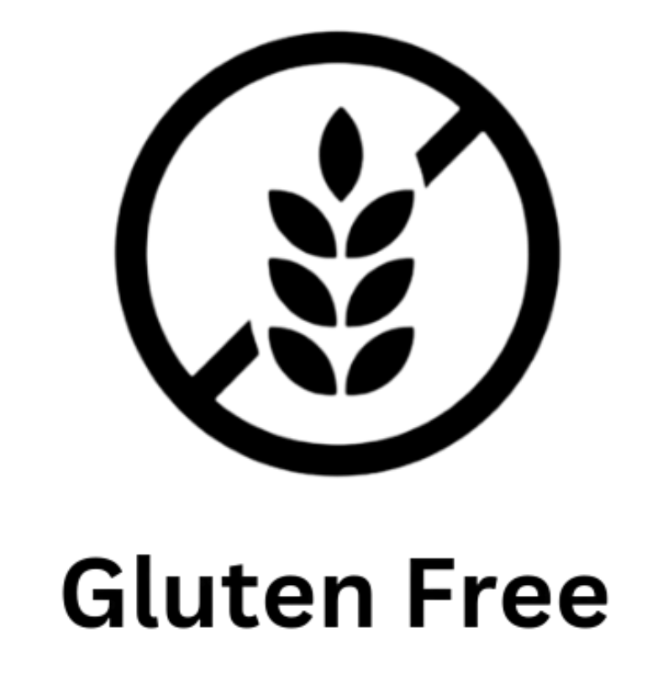 | The event will have snacks which don’t contain any gluten.
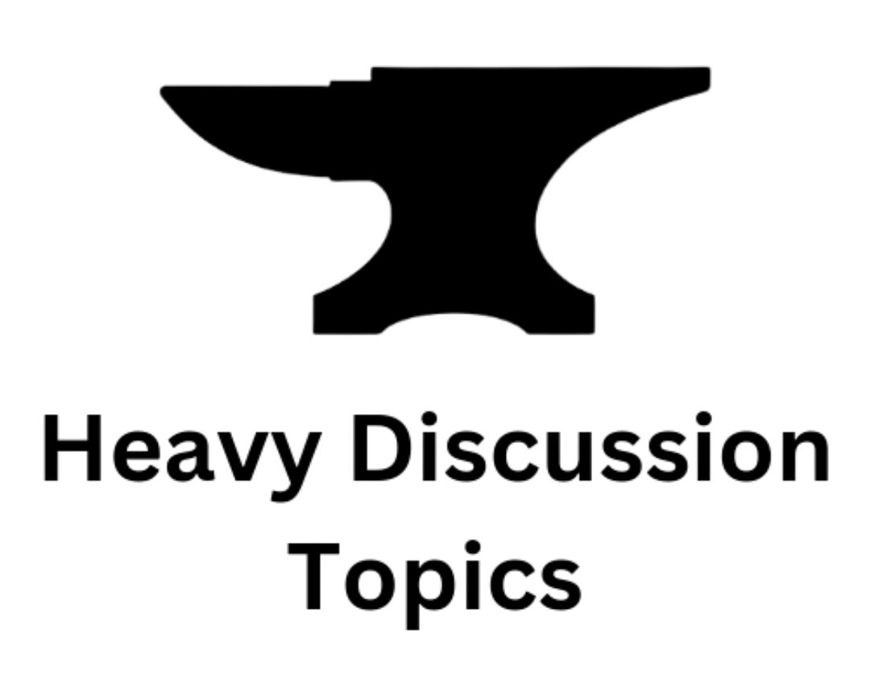 | Topics that may be triggering for some will be discussed at this event.
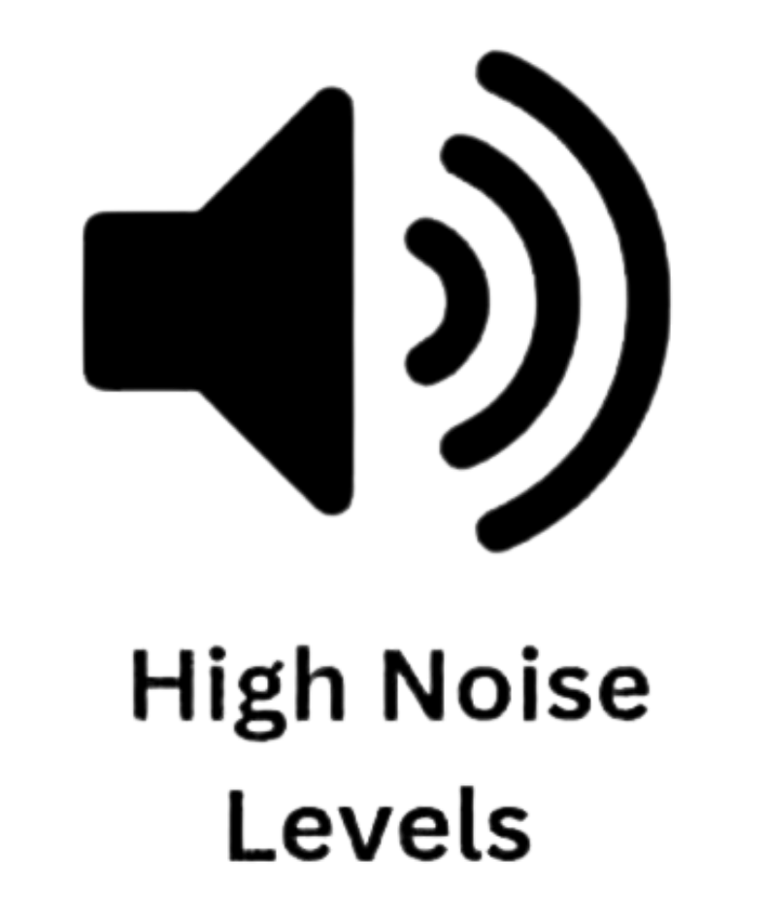 | This event may have loud volumes of noise.
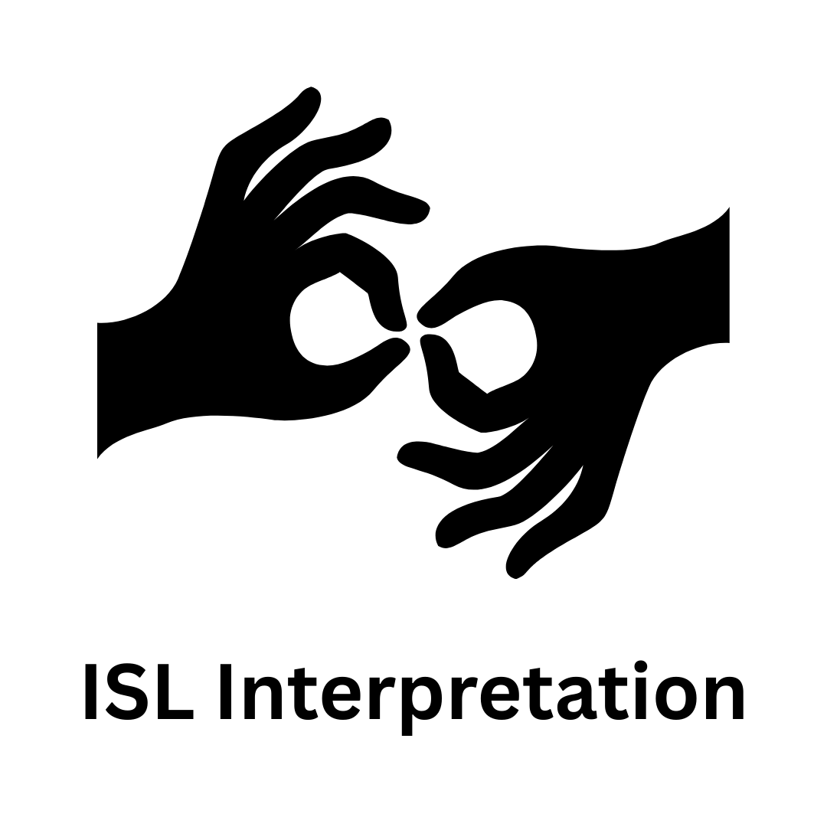 | This event will have Irish Sign Language (ISL) interpretation available.
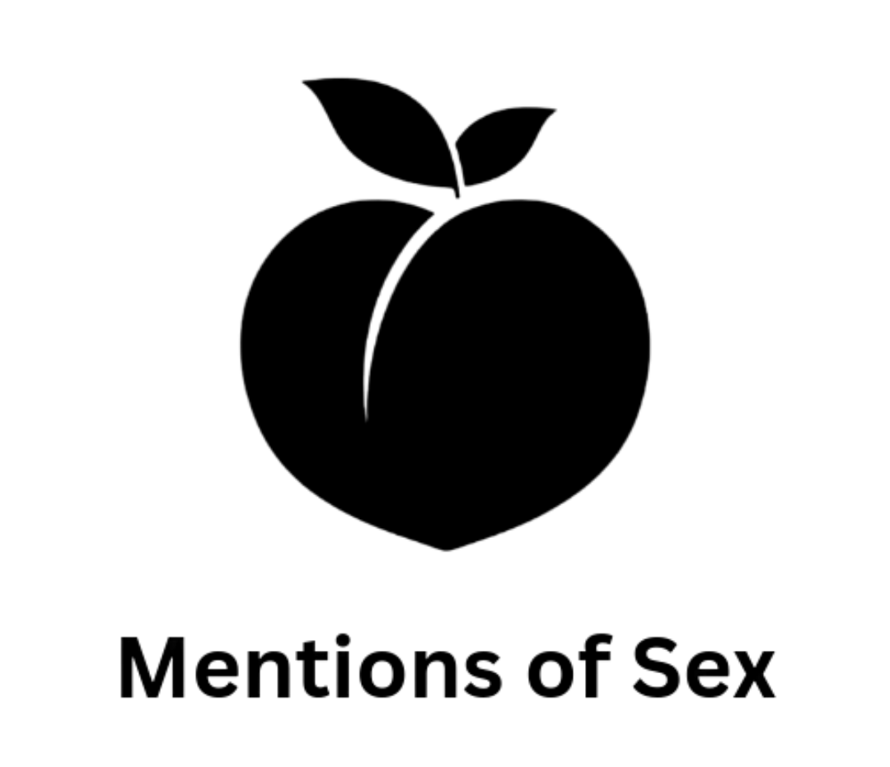 | This event will discuss/mention topics related to sex.
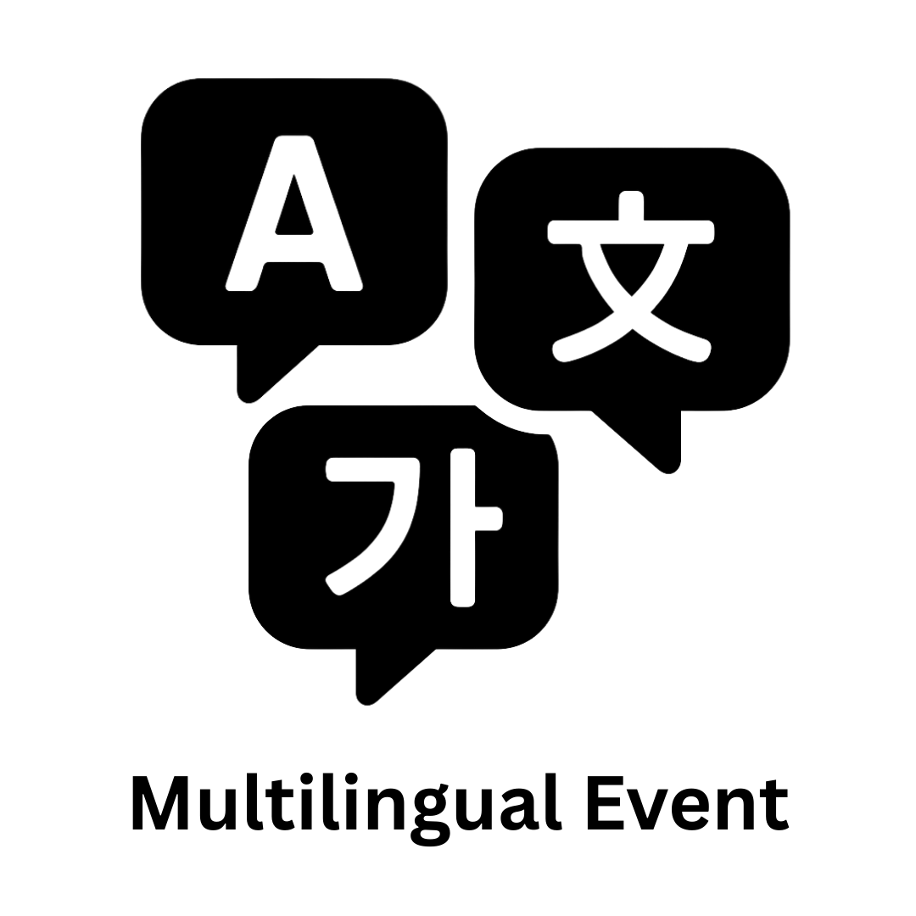 | This event will take place through multiple languages.
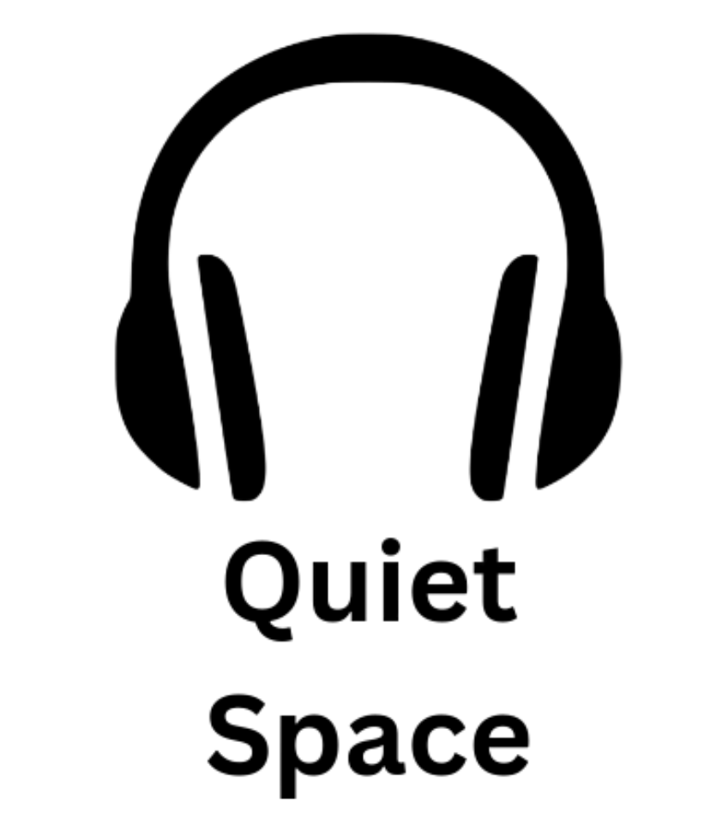 | This event will have a separate space where it will be less crowded and noise levels will be low.
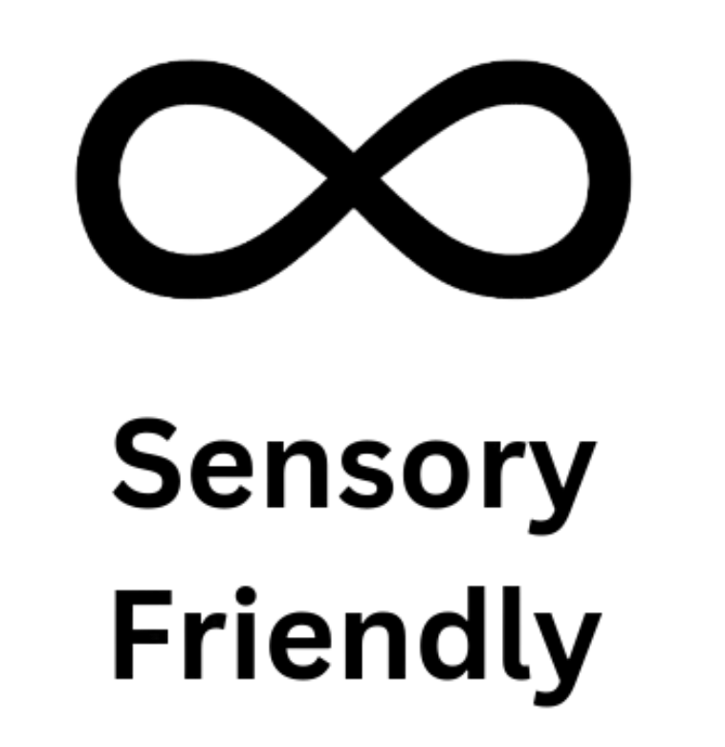 | This event has a space/will take extra precautions to make sure everyone’s sensory needs are met.
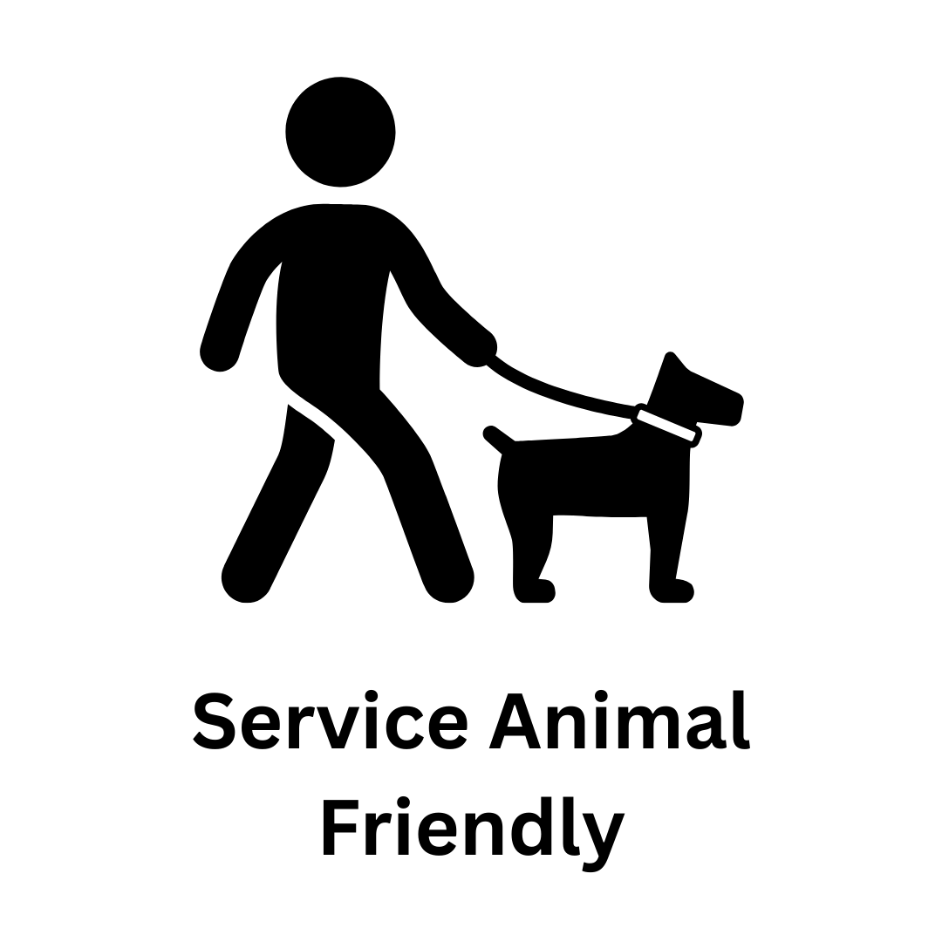 | This event is open to those with service animals.
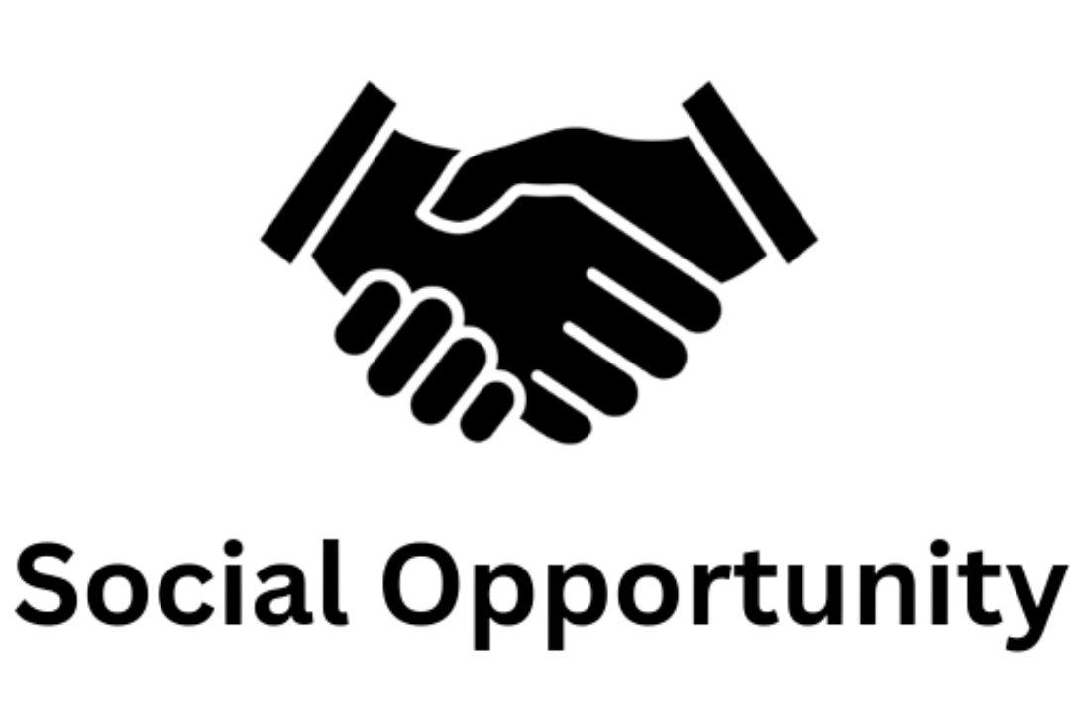 | This event will have opportunities to socialise with others.
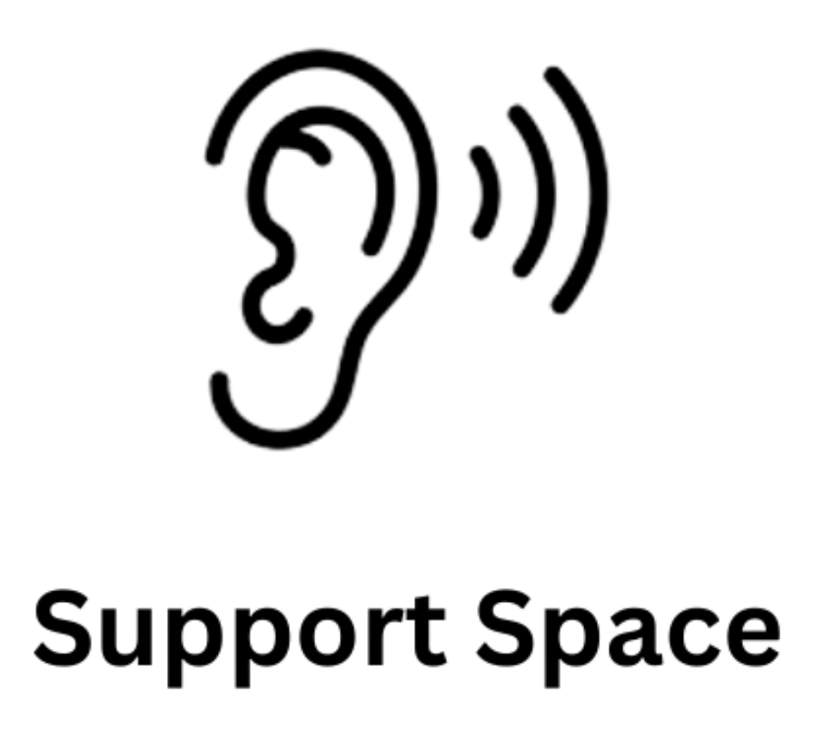 | The event is/has a space where you can express any problems you might be facing and will be supported where possible.
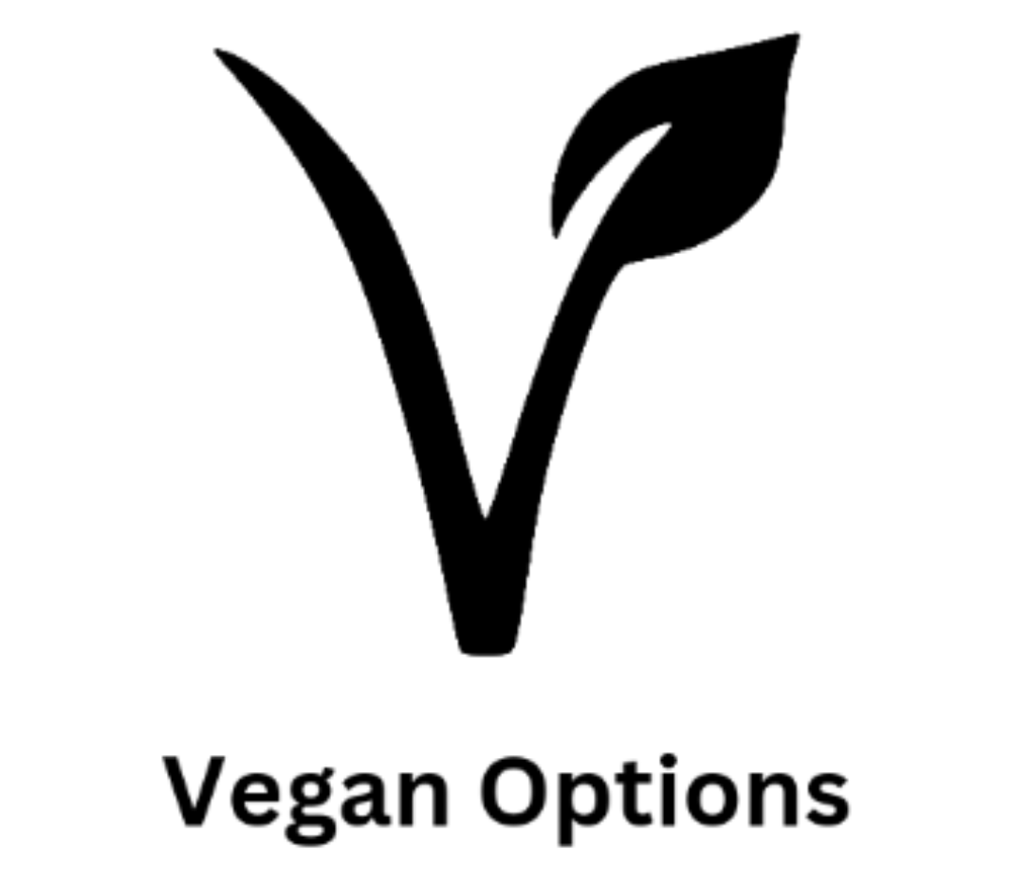 | The event will have snacks which are suitable for vegans.
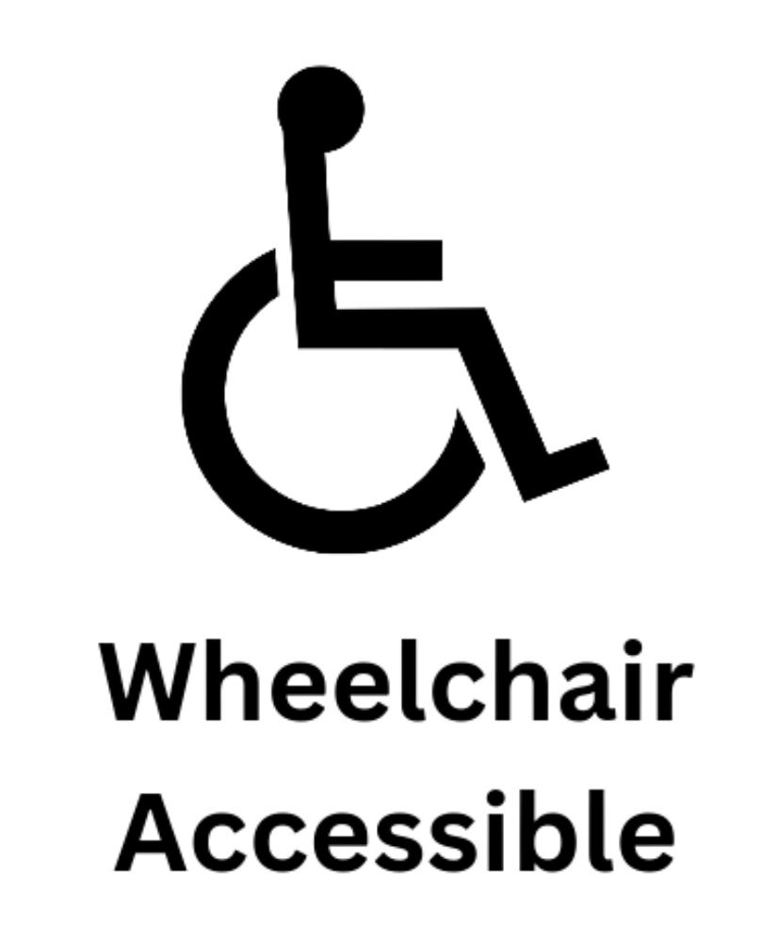 | This event will be held in a venue that is accessible for those in a wheelchair or other mobility aids.

This is not a finite list. If your society has a specific niche that could require a specific accessibility symbol, feel free to make one yourself! Or you could reach out to the Accessibility Officer (accessibility@uccsocieties.ie) and/or PR officer (pr@uccsocieties.ie) on the executive to help make it for you.

How to use them
- Your Accessibility Officer should be the one choosing the symbols! Not your PRO or anyone else. They are the committee member whose main responsibility is to prioritise accessibility, therefore the symbols are most effective when they determine which ones are used. Ensure the accessibility officer is communicating with your PRO/Graphic Design Artist on accessibility symbols.
- Go through each of the symbols and determine whether its description is accurate to the event. Refer back to the list if you are having trouble.
- If you are unsure if an accessibility symbol is applicable to the event or not, ask the event organisers if the element the symbol represents is present or not. By doing this you're giving the organisers an opportunity to check if these accessibility features are in place and if they aren't a chance to see if there's anything they can do to fix that. You're getting everyone thinking about accessibility!
- When putting the symbols on event promotional material, ensure the background colour they are being placed on contrasts well with the colour of the symbols. This ensures they are easily readable for colourblind people. Black, white, and fuchsia versions of the symbols are on the all societies drive, but you may change them to another colour that suits your society's branding.

Tips and Tricks
- The symbols you don't include on an event post are just as important as the ones you do include. Sometimes there are things outside our control that result in us not being able to ensure certain accessibility features are present, and that's OK. We have to be honest about it though. If someone knows a certain accessibility feature won't be present, they can put their own personal plan in place to still attend the event.
- With the heavy discussion topics symbol, it was designed with the idea that it would be impossible to design a symbol with every topic someone might be triggered or uncomfortable with. When using this symbol, if you know the specific heavy discussion topics beforehand ensure you put them somewhere such as the caption of the Instagram post.
- Take note of how often you are using each symbol to recognise if there's more you could be doing to include the accessibility elements they represent. For example, if you haven't used the wheelchair accessible symbol in awhile, maybe that's a sign you could be making more effort to book wheelchair accessible rooms and venues?
- The goal with the symbols should not be to make sure every symbol is on every post. Some contradict each other, so an event with all the symbols probably isn't that accessible.

If you are confused by anything, don't be afraid to ask the Accessibility Officer on the society's executive for help! An important aspect of accessibility is recognising when you don't have all the answers and need to listen to others, a philosophy these symbols were designed with. You can reach out to the Accessibility Officer at accessibility@uccsocieties.ie.

