

Societies Foreign Trip Proposal

This form must be completed and submitted at least two months prior to your departure for your trip to go ahead.

Please email a completed copy to both societiesofficer@uccsocieties.ie, finance@uccsocieties.ie and president@uccsocieties.ie for approval.

For a Foreign Trip under UCC Societies:

- It is very important that you justify the reason for your trip. There must be a developmental benefit of the trip to the society. Your proposal needs to show that you are operating at a high level domestically and wish to develop further by traveling abroad. It must show that you are bringing members who are invested and involved and whose knowledge/skills will be enhanced by the trip. The trip is not a holiday, you are always representing your society and UCC.
- You will be emailed once approved/rejected. This means that the trip has been passed by the Societies Executive and is approved in principle. If approved in principle, you must then submit the risk assessment to healthandsafety@uccsocieties.ie. This must be submitted at least one month prior to the travel date. It is advised that you provide the trip proposal & risk assessment in good time- the later the approval the later you get to book your flights/ferry, and this of course will result in higher prices. The trip is not officially approved until the risk assessment is approved.
- Upon official approval of the trip, the Societies Officer will consult with OCLA to determine if the trip is covered by insurance. If the trip is covered by the UCC Foreign Travel Insurance Policy, further information can be found on the policy in page 5. The Insurance Policy should only be used if a student must attend a private health clinic or hospital abroad where EHIC is not accepted. If the trip is not covered by UCC Foreign Travel Insurance Policy, you will be informed by the Societies Officer and society members will need to source travel insurance themselves. Confirmation of this will need to be provided by the Chairperson to the Societies Officer two weeks prior to your Foreign Trip.
- Two weeks prior to your Foreign Trip you will need to provide additional information including detailed itinerary and “in case of emergency” details (see page 4 for further details) to the Societies Officer (societiesoffier@uccsocieties.ie) and Societies President (president@uccsocieties.ie).

Process:

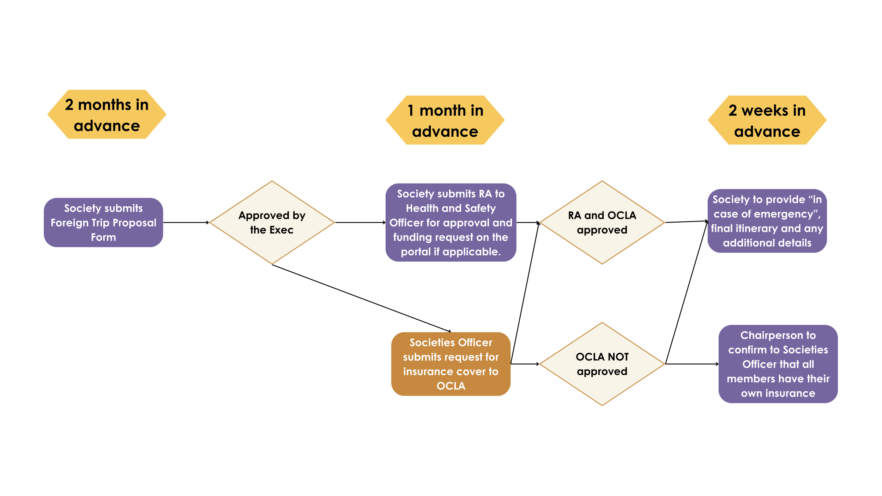

To reiterate - unless the above points are completed you will be travelling on an unsanctioned trip and to do so will result in the society being sanctioned heavily.

Part A – Trip Details
Name of Society
Dates for Trip
Number of students travelling
Trip Location
Justification for choosing this location
What is the developmental reason for this trip? | Member Development  Explain what specific knowledge, skills, or experience participants will gain and how this goes beyond what is achievable through domestic events.  Society Development  Explain how this trip contributes to the long-term development of the society, e.g.:  - New event ideas  - Committee training  - External relationships  - Increased credibility or reach  Other Areas
Overall cost of the trip  (Make sure to cover all necessary areas)  Totals must balance. If figures do not clearly reconcile, the proposal will be returned with feedback to be fixed.
  Category | Name/Title/Area | Total Cost (€) | Guild Funding (€) | Student Contribution  (€) | Source
  Flights / Transport
  Accommodation
  Local Transport
  Activities / Entry fees
  Other
  Cost per person (€)
  Total (€)
Quotes & Sources
Flights: provider, date quoted, screenshot/link attached

Accommodation: provider, room type, date quoted

Activities: rates (group or regular) confirmed Y/N
Method of fundraising for the trip (if applicable)
How will potential cost increases be handled?
Is this the first time this trip is proposed? Or is it an annual or biennial trip?
How will you advertise this trip?

How do people sign up for the trip?
Are there selection criteria/cap on the numbers travelling?

N.B. All the people going on this trip must be members of the society.
What is the breakdown (Undergrad/Postgrad) of the different membership types?
If the event is being run by another party/company, provide their details here.
Include links to the group, who they are, what they do, how they are overseeing, etc.
Detailed Travel Arrangements  and itinerary  A detailed, time-specific itinerary is mandatory. Applications without a minimum day-by-day itinerary will not be considered.  THIS IS NOT A HOLIDAY!  You must email the itinerary to all members going on the trip and it must include committee supervisor contact details. | Make sure that:  - Every day is accounted for  - Travel between locations is explained  - All meal times are accounted for  - Supervision/headcounts noted  - No large unstructured “free time” blocks without justification
  Date/Day | Time | Location | Activity | Developmental Purpose | Travel Method
What will happen if a key activity is cancelled/is there a contingency plan?
For overnight trips, a health declaration should be completed by each of the travelling party. The declarations should be stored confidentially for the duration of the trip and either returned to the relevant travelling parties or destroyed immediately after returning from the trip. This is the responsibility of the trip organiser. Please confirm your understanding - Y/N
UCC Student Activity Health Declaration Form

Part B – Initial Risk & Supervision Overview
Number of Committee Members Supervising:
Supervision Ratio (Committee : Members)
Number of First Aiders:
Number of members with Consent Training:
How headcounts will be managed:
Any high-risk activities? (Y/N + brief explanation)

Required ICE Details

At least 2 weeks prior to the trip, an email must be sent to your elected Societies President (president@uccsocieties.ie) and Societies Officer (societiesofficer@ucsocieties.ie).
Detailing:
- The finalised day-to day itinerary for the trip
- Flight/Ferry details, accommodation name, address and contact number
- Details of nearest Embassy and hospital
- Screenshots of the membership profiles and contact numbers of those travelling
- Emergency contact name and number for next of kin of each person travelling
- European Health Insurance Card (EHIC formally E111) for each person travelling
- Confirmation that Event Manager has Health Declaration Forms of all participants

To Note: We ask EU-born students to ensure they have the EHIC with them when travelling within the EEA as it is automatically recognised (faster treatment than any insurance policy). Any non-EU born students will be covered by UCC Foreign travel insurance if approved.

Part C – Trip Organisers Details
ROLE | NAME | CONTACT DETAILS | ROLE
Event Manager / Coordinator
Event Safety Coordinator (Responsible for Safety)
First Aider(s)
Consent Trained Member(s) (Minimum 2)

IMPORTANT: Please download the Insurance app prior to travel.
Foreign Travel – UCC Insurance App.
This is an App for easy access to the UCC travel insurance when away on Club/Soc/SU trips abroad. The app is red - AIG Travel Assistance
As trip leader, you should download it onto your phone prior to travel, in case of emergency.

I attach info regarding usage, but basically there is a red phone call icon on it which you can use if there is any emergency whilst abroad.

The details you need to log on are the society’s email address, the policy number: PAE61285 and it is Ireland - Lifeline Plus

Ensure the password is not personal as it will be used by other trip leaders in the future, but do not share it with anybody outside of trip leaders/Chairperson

Do not encourage other members of the group to download the app, it is just for the trip leader in case of emergency & only to be used for authorised UCC trips.

