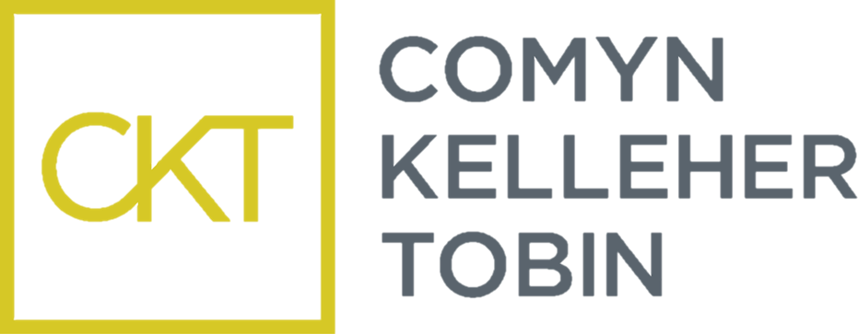

The Comyn Kelleher Tobin Scholarship – LLM Children’s Rights and Family Law

University College Cork
College of Business and Law
School of Law

APPLICATION FORM 2024/2025

Please note: Incomplete applications will not be considered. Please consult the Terms and Conditions of the Scholarship before completing this application form and submit via email to – d.odonovan@ucc.ie as a single PDF document on or before August 16th for the academic year 24/25.

- PERSONAL DETAILS:

Surname: |  | First Name(s):
Contact No: |  | Email:

- Please state HOW/WHERE YOU HEARD about this Scholarship:

- Applications will be based on both academic results and a personal statement in answer to the below questions. The scholarship will be advertised on the University Scholarship Awards and Prizes webpage (max. 500 words per question)

(i) What would receiving this scholarship mean to you?

(ii) Why have you chosen to study the LLM in Children’s Rights and Family Law?

(iii) Where do you see your career bringing you in 5 years’ time.

Attach your submission here:

- Checklist:

Application form

Submission of response to questions

2-page CV

DECLARATION BY APPLICANT

I declare that the above particulars are correct and understand that the circulated “Terms and Conditions” of this scholarship apply. I accept that failure to abide by the “Terms and Conditions” may disqualify me from this scholarship.

Signature of Applicant: Date:

