2020-2021 International Chinese Language Teachers
(Confucius Institute) Scholarship
Application Procedure
In order to support development of Confucius Institutes, facilitate Chinese language promotion and Chinese cultural transmission in the world, cultivate qualified Chinese language teachers and talented students of Chinese language, Confucius Institute Headquarters (Hanban) (hereinafter referred to as Hanban) launches the “Confucius Institute Scholarships” program for providing sponsorship to students, scholars and Chinese language teachers of other countries for pursuing a study in relevant universities in China (hereinafter referred to as “host institutions”).

Scholarship Types and Qualifications
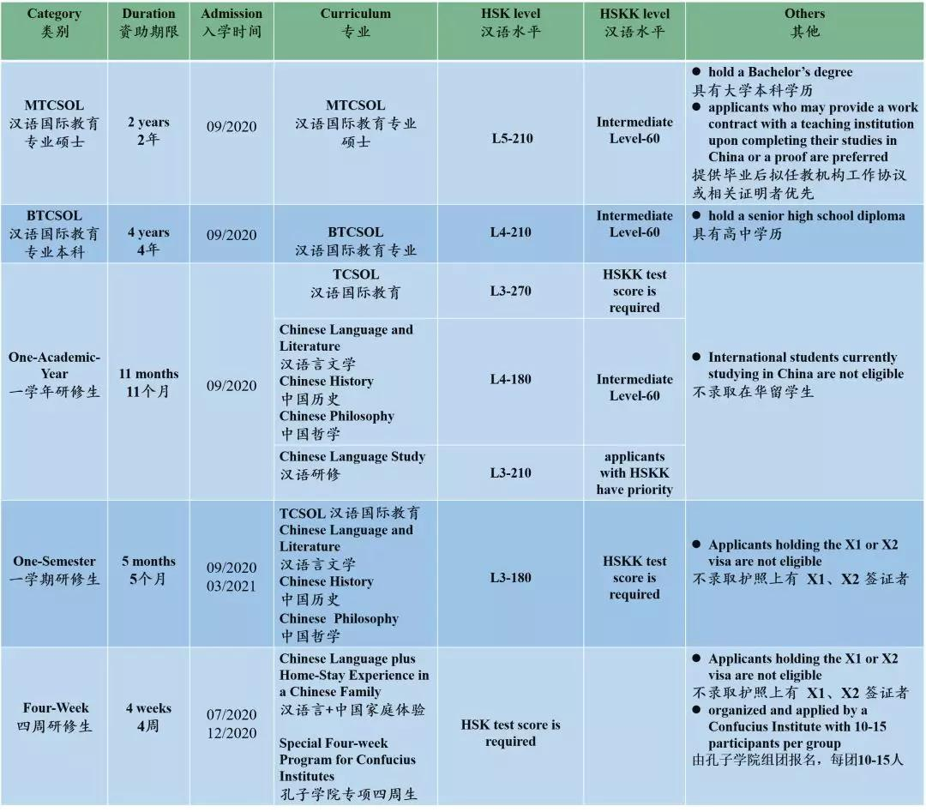

2020 UCC Confucius Institute HSK and HSKK Test Dates
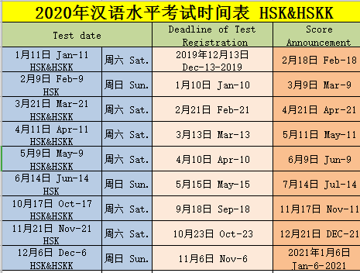

Application Procedures
Online registration will be available from March 1, 2020 on the international Chinese Language Teachers Scholarship (Confucius Institute Scholarship) application website: cis.chinese.cn

1.Please log into the Scholarship application website (cis.chinese.cn) and upload application materials online;
2.Recommending institutions review the application materials;
3.Host University reviews application materials;
4.Confucius Institute Headquarters will entrust an expert panel to review the applications. Decisions will be made based on HSK and HSKK scores and levels, and in consideration of country distribution as well as other factors. The results will be published about three months before the school entrance day specified;
5.Track the application progress, comments and result;
6.Host University sends Admission Notice to pre-admission applicants;
7.Pre-admission applicants register at Host University on the designated date as per letter of admission.

The Application Deadlines (Beijing Time)
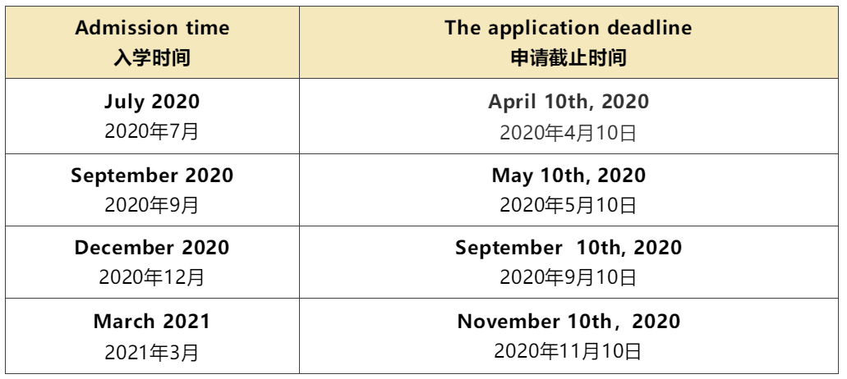

Application Documents
1. For all applicants：
·A scanned copy of passport with the page with personal information;
·A scanned copy of score reports of the HSK and HSKK tests (within the two-year validity);
·A recommendation letter by the head of the recommendation institutions.

2. For degree scholarship program applicants:
·Provide a certification of the highest education diploma (or proof of expected graduation) and an official school transcript;
·MTCSOL Students are required to provide 2 recommendation letters from professors or associate professors. Those who can provide a notarized employment agreement with teaching institutions are preferred.

3. In-service Chinese teachers shall submit certificate of employment and recommendation letters provided by institutes they work for.

4. Applicants under the age of 18 shall provide certified documents signed by their entrusted legal guardians in China.

Note：
①Documents in application materials other than Chinese or English must be accompanied by a Chinese/English translation of the notarization or issuing unit.

②Upload electronic files (PDF or JPG format) when applying for materials. Originals need to be provided for inspection upon arrival.

③Do not accept paper application materials.

Scholarship Coverage and Criteria
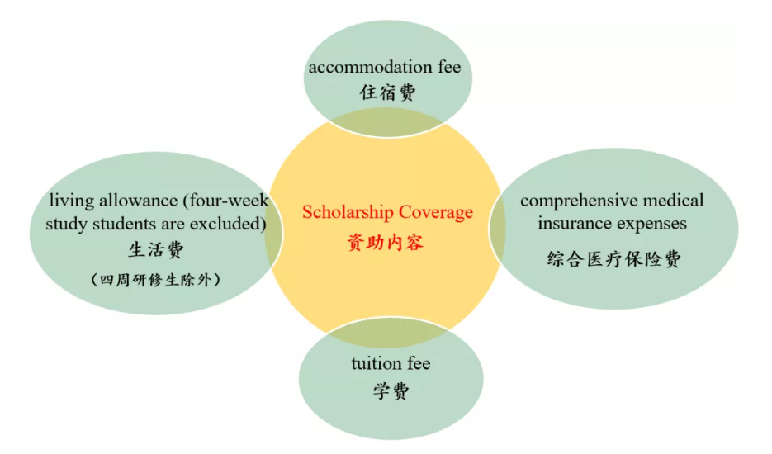
Criteria
1. Tuition fee for Confucius Institute Scholarship students are covered by Host University. The tuition fee does not cover the textbook expenses and tourist tickets.
2. Accommodation fee is under the overall planning and utilization of Host University to provide students with in-campus apartments (usually double rooms).
3. Living allowance is granted by Host University on a monthly basis. The monthly allowance for undergraduates, one-academic-year study students and one-semester students is 2,500 CNY per person. For MTCSOL students, the monthly allowance is 3,000 CNY per person.

Note：
①Students are required to complete enrollment procedures for every semester within stipulated period. Otherwise, their scholarship may be cancelled. Students who are enrolled before the 15th (or on the 15th) of the month are entitled to the full allowance of that month while those enrolled after the 15th of that month are only entitled to half of the amount.

②During the study period, for any student who is absent from China due to personal reasons for more than 15 days (excluding winter and summer holidays), the allowance during absence will be suspended.

③For students who suspend study or drop out of school for personal reasons, or who are given disciplinary punishment by the host institutions, allowance will be terminated on the date of such suspension, dropping out or when the decision of such punishment is announced.

④The living allowance for the month of graduation will be granted half a month after the date of graduation or expiration day of the study confirmed by host institutions.

4. Comprehensive medical insurance is purchased by Host University in accordance with relevant regulations of studying in China stipulated by the Ministry of Education of China. Insurance fee per person is 160 CNY for four-week study students, 400 CNY for one-semester students, and 800 CNY per year for students engaged in program longer than one academic year.

Others
a) Please contact host institutions for curriculum and course listings.
b) Applicants shall be familiar with the specific criteria and deadlines for registration, and submit necessary documents according to specific requirements.
c) Degree students are subject to the annual assessment according to the Annual Appraisal Procedures of Confucius Institute Scholarship.
d) Those who fail to register on time, fail to pass the health assessment, drop out midway and/or suspended from school will be deprived of their scholarship.

Contacts
UCC CONFUCIUS INSTITUTE
EMAIL: china@ucc.ie
WEB: https://www.ucc.ie/en/asian/confucius/

CONFUCIUS INSTITUTE SCHOLARSHIPS
EMAIL:scholarships@hanban.org
TEL: +86-10-58595727

