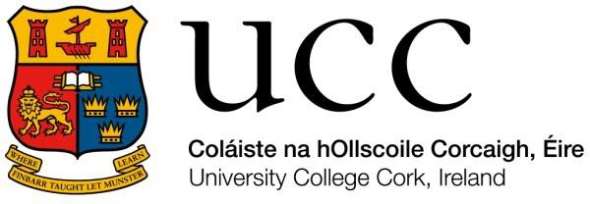
Staff Golf Society

Membership Subscription 2024
Dear Colleagues,

The annual subscription for the UCC Staff Golf Society is now due.
The membership fee is €30 (or €25 for members of the UCC Staff Sports & Social Club).
Payment can be made at our first outing on Sat 23rd March in Macroom, by funds transfer (see below for details), or directly to committee members Eddie McCarthy, Kevin Barrett, Conor McCarthy or John Nyhan together with this form (please complete) at your earliest convenience.
If you know of anybody who is interested in joining our Golf Society, and would like to become a member, please arrange for the completion & return of this form, or they can email e.mccarthy@ucc.ie

Yours sincerely,

Mary Hough (Secretary), 2024

Please remit €30 / €25 together with this completed form. To pay by funds transfer / cashless transactions please use the following details, and please include your name in the message field:
Name: UCC Staff Golfing Society
IBAN: IE31BOFI90969566327401
BIC: BOFIIE2D

Please do not send cash in the post.
Please tick the box if you are a member of UCC Sports and Social Club
Name:
Address:

Phone Number(s):

E-mail:

Current GUI Handicap (Exact):

Officers and Committee 2024
Andrew Lindsay (Captain),
Stephen O’Brien (Vice-Captain), Kevin Barrett (President), Mary Hough (Secretary),
Conor McCarthy (Treasurer), John Nyhan/Eddie McCarthy (Handicap and Competition Secretary),
Committee: Lorraine Crossan, George Nagle, Alan Morrisson, Esther O’Farrell, Aileen Finn.
Patrons: Willie Weir, Dan Walsh, John Nyhan

