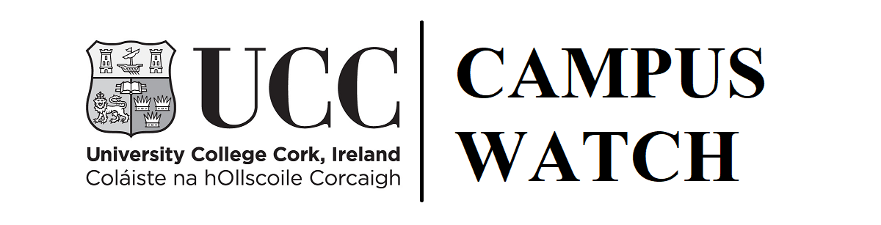

Complaint Form

University College Cork is committed to creating a safe and secure environment for UCC students and to foster a positive relationship between our students and the wider community. Campus Watch will respond to formal complaints from students, member of the community and other stakeholders, in relation alleged breaches of the UCC Standards of Conduct.

The University requires its students to conduct themselves in an appropriate and reasonable manner at all times to ensure:

- Dignity, honesty and integrity
- Respect for all members of Staff
- Respect for fellow Students
- Respect for and adherence to the Rules, Regulations and Policies of the University
- Compliance with the academic processes of the University
- That the University is not brought into disrepute
- Respect for local residents and other members of the general public
- That the views, values and beliefs of others are respected
- That no damage or injury is caused to any person or property
- That the University community is free from intimidation and discrimination

For further information on student rules please got to https://www.ucc.ie/en/studentexperience/

If you have witnessed a UCC student in breach of the above, please complete the following form and return it to UCC Campus Watch.

This completed form should be sent to:
UCC Campus Watch
South Lodge, College Road, UCC
Cork, Ireland
E-mail: campuswatch@ucc.ie
Tel: 021 490 3849

COMPLETE IN BLOCK CAPITALS

1. CONTACT DETAILS OF COMPLAINANT
Full Name: |  |  | Student ID No:  (if applicable)
Email Address:
Telephone Number:
Postal Address:
(Where there is more than one complainant, please attach a list of complainants on a separate sheet of paper. Include full name, address and contact details)

2. COMPLAINT DETAILS (please refer to UCC’s Student Rules for further information):
2.1 | Outline of your complaint, including the name of the student(s) about whom the complaint relates. Please; (a) send additional sheets, if necessary; and (b) attach any correspondence/documentation that you have had concerning your complaint.
2.3 | Please explain the steps you have taken, who you have approached, together with dates, to resolve your complaint (if any).
2.5 | Please indicate what outcome or further action you are seeking.
Please note that: (a) if the reason for your complaint is not clear this form will be returned to you with a request for clarification which must be answered within 14 days; and

(b) if you do need to send a lot of documents, please clearly mark the relevant parts. If you do not, we may return them and ask you to do this and you must send us copies as none of the document you send us shall be returned to you.

3. IF YOUR COMPLAINT RELATES TO A PROPERTY OCCUPIED BY UCC STUDENT(S) PLEASE CLARIFY THE FOLLOWING:
3.1 What is the address of the property?
3.2 Did you contact the Landlord? If so, please give further details
3.3 Did you contact the Gardai? If so, please give further details (name of station and Gardaí contacted, time and method of contact etc.)

3. DECLARATION
I confirm that the information given in this form is, to the best of my knowledge true, and that I would be willing to answer further questions relating to it if necessary.
I understand that UCC will need to disclose the details I have provided in this form in order to enable the student(s) I am complaining about to respond properly and to act upon any alleged breaches of the Student Rules.

Signed:_______________________________________

Date:____________________________

You have the right to ask for a copy of your personal data held by UCC (and UCC is entitled to charge a nominal administration fee for this). If you wish to avail of this right, you should submit a written request to: The Information Compliance Officer, University College Cork, Western Road, Cork or e-mail foi@ucc.ie. If any of your details are incorrect please let us know and we will amend them.

