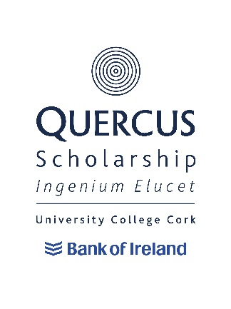
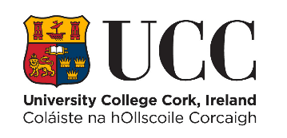

Quercus Sports Scholarships Retention & Discontinuation

1. Retention
To retain the Scholarship throughout the programme of study recipients must:
a) Meet the progression requirements of the programme of study.
b) Successfully pass the Annual Review Process and the specific Review Processes referred to in Appendix 1.
c) Attend the required Quercus events each academic year. These events will be communicated to Scholars by the Quercus Programme.
d) Fulfil, where required ambassadorial duties deemed appropriate, e.g. at RDS Higher Options and UCC Open Days.
e) Agree to and abide by the Quercus Terms of Reference and Memorandum of Understanding.
f) Act as ambassadors of the University and the Quercus Programme and behave in an appropriate and respectful manner at all times, aligned to the provisions of the UCC Student Rules and UCC’s Graduate Attributes and Values.
g) Demonstrate active engagement with the Quercus Programme.
h) The Scholar must annually complete the Quercus Programme End of Year Statement and Impact Form (Appendix 3). The Impact information from this may then be used when communicating with past, current and potential donors. It may also be used publicly by UCC and the Quercus Programme via their publications, websites and social media channels.
i) Fulfil any specific retention requirements stipulated by the Quercus Programme.

2. Discontinuation of Quercus Sports Scholarship
Discontinuation of a Quercus Sports Scholarship may occur where a Scholar is deemed no longer eligible, including where:
a) A Scholar withdraws from the University.
b) A Scholar has failed to pass the annual review.
c) A Scholar is found to be in breach of the Student Rules.
d) A Scholar does not meet the agreed progression requirements of the programme of study.
e) A Scholar is found to be in breach of the Quercus Terms of Reference.
f) A Scholar is judged not to meet the criteria set out in section 1 above (Retention).

2.1 Discontinuation Outside of Annual Review
Decisions to discontinue Quercus Scholarships may occur outside of the annual review process.
Examples for discontinuation are listed in, but not limited to, the scholarships Terms and Conditions document. Where it is brought to the attention of the Quercus Programme that a Scholar may no longer be eligible, the Review Group (see Appendix 1) will be asked to convene to make a decision regarding the student’s eligibility to continue as a Quercus Scholar. Scholars wishing to appeal the decision to discontinue a Quercus Scholarship should refer to the appeal process that is detailed in Appendix 2.

Appendix
Appendix 1: Annual Review Process:
a) An appropriate Review Group (“The Group”) will be established.
b) The Group will receive annual progress reports for each Scholar, compiled by the Performance Manager, made up of the scholar’s End of Year Statement and Impact Form and also, where required, additional information from sources such as UCC Sport, relevant academic departments, academic mentor, sports coach, UCC professional services, associated UCC sports club and other associated parties.
c) The annual review may include a discussion with the Quercus Sports Scholar where required, with the performance manager and/or the Quercus programme manager.
d) The Group will determine if the Quercus Sports Scholar has fulfilled the terms and conditions of membership, in particular related to sporting progress, academic progression and engagement with the Programme.
e) Scholars who, in the opinion of the Group, have not fulfilled the conditions of membership, will be informed of this in writing, and will be invited to attend a meeting with the Review Group.
f) Following that meeting there are two possible outcomes;
(f1) – the student remains on the programme,
(f2) – the student is exited from the programme.
g) Scholars who are exited will be notified of their right to appeal the decision of the Group, the procedure for lodging an appeal and the time limit for lodging an appeal.
h) A written record of the review meeting process shall be kept and submitted to the Appeals Committee where an appeal arises.

Appendix 2: Annual Review Appeals Procedures
Quercus Sports Scholars may appeal a decision of the Review Group to the Appeals Committee on specified grounds, see c) below.
a) The Appeals Procedure is not available to Scholars that have withdrawn from the University; or Scholars that have been suspended or excluded from the University; or where a Scholar returns a positive result to a drugs test and the relevant National Sports Governing Body has suspended an athlete.
b) An appeal may be made to the Appeals Committee within 10 working days from the date of issue of the Review Group’s decision.
c) Appeals may be made on the following grounds:
- New evidence: Information directly relevant to the decision, which for good reason was not available to the Review Group.
- Procedural irregularity: There is evidence that the procedures relating to a decision were not followed properly, which may have impacted on the Review Group’s decision.
d) The Student Appeals Committee may:
- Uphold the Appeal.
- Reject the Appeal.

Appendix 3: End of Year Statement and Impact Form
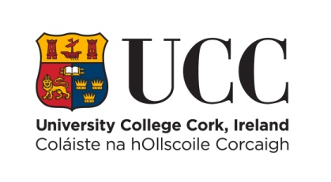
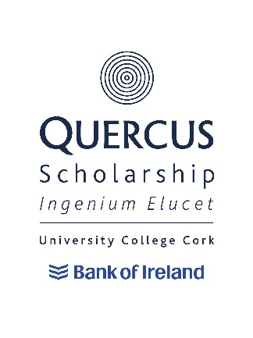

Quercus Sport End of Year Statement & Impact Form
NAME | enter text.
SPORT | enter text.
STUDENT NUMBER | enter text.
Programme of Study | enter text.
Are you on track to progress to the next year of your degree programme? (PLEASE TICK YES OR NO) | YES  ☐ | NO  ☐
Recent Exam Results  Please list most recent  college exams and include  subject and grade | enter text.

Have you played in any competitions since June 2022 (YES/NO)? | YES  ☐ | NO  ☐
Please list any competitions you have played in and results you have achieved since June 2022 | enter text.
Have you had any injuries since June 2022 (YES/NO)? | YES  ☐ | NO  ☐
If YES, please give further information | enter text.
Are you on track with your sports performance goals (YES/NO)? | YES  ☐ | NO  ☐
If NO, please state why | enter text.
Can you identify any key support(s) you have received and have found useful over the past 12 months? | enter text.

Do you feel you are at your optimum physical, mental and emotional levels (YES/NO)? | YES  ☐ | NO  ☐
If NO, please state why you think you are not | enter text.
Have you taken part in the following talks since September 2022 (YES/NO)? | Financial Planning YES☐ NO☐  Nutrition YES☐ NO☐  Sports Psychology YES☐ NO☐  Quercus Lecture Series YES ☐ NO☐  Quercus Workshops YES☐ NO☐
If NO to any of the above, then why | enter text.
Have you used the Silvercloud platform? | YES  ☐ | NO  ☐
If NO, please state why | enter text.

Please provide your rating on the following where 1 = Poor & 10 = Exceptional
How do your rate your current level of health and wellbeing? | enter text.
How do you rate your current level of fitness? | enter text.
How do you rate your quality of regular sleep? | enter text.
How do you rate your ability to manage stress and anxiety? | enter text.
How do you rate the quality of your diet and nutrition? | enter text.

What are your keys areas of improvement for next year
Sports Performance: rank the following in order of priority 1 – 3 with 1 being the highest priority | Strength and Conditioning Choose an item.  Nutrition Choose an item.  Sports Psychology Choose an item.
Lifestyle: rank the following in order of priority 1 – 3 with 1 being the highest priority | Time Management Choose an item.  Stress Management Choose an item.  Leadership/Communication Choose an item.

Reflective Statement
Please provide a short end of year reflective statement on your experience of the past year and the various impacts it may have had on your sporting performance (500 words maximum)
enter text.

Impact of Quercus Scholarship for you
Please outline the impact that the scholarship has had on you during the period September 2022 to May 2023 (300 words max) (The Impact information from this may then be used when communicating with past, current and potential donors. It may also be used publicly by UCC and the Quercus Programme via their publications, websites and social media channels.)

enter text.

Submit this form by xxxxxxxxxxxxxxx to Jeff Gomez xxxxxxxxxxxxxxx.

*All data collected under the application form will be subject to the data protection policy of UCC. A full copy of the policy is available on our website: http://ocla.ucc.ie/dataprotection/index.asp. All queries in relation to this policy and its provisions can be made to the Information Compliance Officer: catriona.osullivan@ucc.ie or 021-4903949

