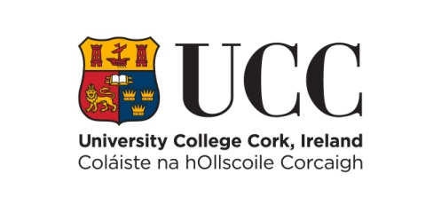

# **Quercus Sport End of Year Statement & Impact Form for the Period June 2024 – May 2025**

*All personal data collected under the application form will be processed in accordance with UCC’s Student Data Protection Notice and our Data Protection Policy. A copy of the Data Protection Notice is available on our website: [Student Data Protection Notice | University College Cork (ucc.ie)](https://www.ucc.ie/en/gdpr/dataprotectionnotices/student/). Any queries, requests or complaints relating to the processing of your personal data can be made to the Information Compliance Office, Office of Corporate & Legal Affairs, University College Cork, Western Road, Cork E: [gdpr@ucc.ie](mailto:gdpr@ucc.ie) . By checking this tick box you acknowledge that you have read and understood the Student Data Protection Notice 

## **Biographical Details**

Name: Click or tap here to enter text.

Sport: Click or tap here to enter text.

Student Number: Click or tap here to enter text.

**Are you on track to progress to the next year of your degree?** Yes  No

Recent Exam Results (Please list most recent college exams and include subject and grade): Click or tap here to enter text.

**Have you competed in any competitions since June 2024?** Yes  No

Please List any competition you have taken part in/played in and results you have achieved since June 2024: Click or tap here to enter text.

**Have you had any injuries since June 2024?** Yes  No

If yes, please give further information: Click or tap here to enter text.

**Are you on track with your sports performance gaols?** Yes  No

If no, please state why: Click or tap here to enter text.

**Can you identify any key support(s) you have received and have found useful over the past 12 months?** Click or tap here to enter text.

**Do you feel you are at your optimum physical, mental and emotional levels?** Yes  No

If no, please state why you think you are not: Click or tap here to enter text.

## **Have you taken part in the following talks since September 2024?**

Nutrition: Yes No

Sports Psychology Yes  No

Quercus Lecture Series Yes  No

Quercus Workshops Yes  No

If no to any of the above, then why? Click or tap here to enter text.

**Have you used the Silvercloud platform?** Yes  No

If no, please state why not? Click or tap here to enter text.

## **Please provide your rating on the following where 1 = Poor & 10 = Exceptional.**

How do you rate our current level of health and wellbeing: Choose an item.

How do you rate your current level of fitness? Choose an item.

How do you rate your quality of regular sleep? Choose an item.

How do you rate your ability to manage stress and anxiety? Choose an item.

How do you rate the quality of your diet and nutrition? Choose an item.

**What are your key areas of improvement for next year** (rank the following in order of priority 1 – 3 with 1 being the highest priority)?

### **Sports Performance**

Strength & Conditioning: Choose an item.

Nutrition: Choose an item.

Sports Psychology: Choose an item.

### **Lifestyle**

Time Management: Choose an item.

Stress Management: Choose an item.

Leadership/Communication: Choose an item.

**Reflective Statement** (Please provide a short end of year reflective statement on your experience of the past year and the various impacts it may have had on your sporting performance (500 words max):

Click or tap here to enter text.