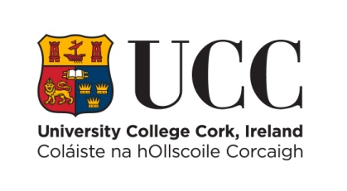

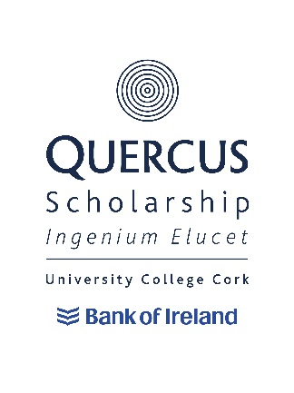

Quercus Innovation/Entrepreneurship Scholarships 2024/25
Criteria & Terms of Reference
2018/19
Criteria and Terms of Reference

- General Criteria

University College Cork is pleased to announce that up to 3 Quercus Scholarships for Innovation/Entrepreneurship will be awarded to students registered on an undergraduate/level 8 programme in 2024/25 who can demonstrate an exceptional level of excellence in that field and who have successfully been selected by the Scholarship Panel for a Quercus Scholarship.

Quercus Scholarships for Innovation/Entrepreneurship will be awarded by a Scholarship Panel composed of both internal UCC staff members and invited external experts.

Those applicants shortlisted for interview may submit a portfolio of their achievements in this field, submitted in any suitable format beforehand.
(Submitted materials may not be returned to applicant)

It is hoped that all interviews will take place in April/May 2024.

Scholarships will be offered to applicants who satisfy the Scholarship Panel (and in turn UCC) as to their suitability to the Quercus Talented Students’ Programme and who can demonstrate excellence in the field of Innovation/Entrepreneurship. The panel’s decisions will be final.

The Scholarship can be renewed for subsequent years subject to the Scholar meeting the requirements of the Retention and Discontinuation Document and progression to the next level of study in their academic programme.

Scholars may not hold a Scholarship during an academic year spent abroad or on work placement. Renewal will be decided upon at the end of the academic year prior to the year spent abroad or on work placement and will be “carried forward” to the year after the academic year spent abroad or on work placement.

Scholars will be expected to act as ambassadors for UCC in terms of their participation in Innovation/Entrepreneurship activities and in their participation in activities designed to promote the Quercus Talented Students’ Programme.

- Applying for a Quercus Scholarship

To apply for a Quercus Scholarship, you must:

- Be either a registered UCC student or apply through CAO for a place on an undergraduate/level 8 programme at University College, Cork in 2024/25.
- Read the Criteria and Terms of Reference of the Quercus Innovation/Entrepreneurship Scholarship.
- Complete the online Quercus Innovation/Entrepreneurship Scholarship application form and submit by 4:30pm on Wednesday 7th February 2024. Remember to include the two required references.

Successful applicants will:

- Meet the minimum entry requirements (matriculation) of their desired undergraduate/level 8 programme, while currently registered students will need to have attained higher honours in their end of year examinations to be eligible. Applicants do not need to be pursuing a related programme to be deemed eligible.
- Be able to provide evidence of sustained engagement in Innovative/Entrepreneurial activities.
- Have evidence of achievement and/or impact of an innovative or entrepreneurial nature.
- Have the potential to develop that excellence in their chosen field
- Have had recognition at local, regional, national, or international level.
- Be expected to act as ambassadors for UCC and the Quercus Programme in terms of their participation in their chosen field.

Where there are equivalent levels of excellence applicants deemed able to contribute most to UCC will be selected.

Please note that the Quercus Scholarships are open to students applying for any undergraduate/level 8 programme offered by UCC.

Please also note that an applicant will only be able to take up a Scholarship after accepting an offer of a place at University College Cork through the CAO.

Quercus Innovation/Entrepreneurship Scholarships
MEMORANDUM OF UNDERSTANDING

Scholars can expect:

- A letter confirming the award of this prestigious Scholarship.
- The opportunity to work with a mentor from within or outside the University to help the development of their unique talent.
- The opportunity to work with a mentor from within the University to help ensure that a healthy and appropriate lifestyle balance is maintained whilst at University College Cork.
- The renewal of the Scholarship on an annual basis (excepting years spent abroad or on a work placement) subject to your adherence to the terms and conditions below.

As a Quercus Scholar of UCC you must agree to abide by the following terms and conditions. Failure to abide by the following terms and conditions may result in your Scholarship being revoked with immediate effect.

Scholars will be required to:

- Engage with, and participate in, the activities of the Quercus Talented Students’ Programme as advised to them from time to time.
- Be available to meet potential undergraduate applicants at one University Open Day per academic year.
- Be available as a peer mentor where required.
- Support the University’s overall student recruitment strategy.
- Play an active role in UCC innovative or entrepreneurial activities where appropriate.
- Be a positive ambassador for UCC at all times including the promotion of UCC in any external interviews or publications associated with your field.

In order for the scholarship to be renewed, the scholar must fulfil their obligations as per the Retention and Discontinuation Document and must progress to the next level of study.

Withdrawal or Suspension of Studies and Repeat Years

Withdrawal

Scholars who withdraw from their scholarship commitments or from UCC will have all future scholarship payments/benefits cancelled.

If you withdraw, at any point during the teaching term, scholarship payments/benefits which have already been made will be reclaimed on a pro rata basis. Under exceptional circumstances, this decision can be reviewed by the Chair of the Panel and approval given for the student to retain any overpayments.

Suspension of Studies

Scholars who suspend their scholarship commitments or academic studies will have all future scholarship payments/benefits cancelled.

If you suspend your studies at any point during the teaching term, scholarship payments/benefits which have already been made will be reclaimed on a pro rata basis. Under exceptional circumstances, this decision can be reviewed by the Chair of the Panel and approval given for the student to retain any overpayments. Mitigating circumstances for the re-instatement of the scholarship may be put forward for consideration by the Chair of the Panel. The remaining yearly balance will become payable on resumption of academic and scholarship commitments.

Repeating an Academic Year

Scholars who are required to repeat an academic year will not receive scholarship payments/benefits during the repeat year of study. Scholarship payments/benefits would recommence once the recipient has progressed to the next level of study and is meeting their scholarship commitments.

Exceptional Circumstances

Students withdrawing from, suspending or repeating their studies, due to illness, bereavement or other exceptional circumstances will be dealt with on a case-by-case basis.

