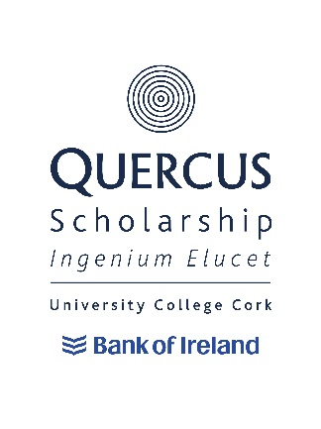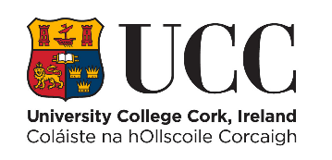

# **Quercus Innovation/Entrepreneurship End of Year Statement & Impact Form 2025/26**

*All personal data collected under the application form will be processed in accordance with UCC’s Student Data Protection Notice and our Data Protection Policy. A copy of the Data Protection Notice is available on our website: [Student Data Protection Notice | University College Cork (ucc.ie)](https://www.ucc.ie/en/gdpr/dataprotectionnotices/student/). Any queries, requests or complaints relating to the processing of your personal data can be made to the Information Compliance Office, Office of Corporate & Legal Affairs, University College Cork, Western Road, Cork E: [gdpr@ucc.ie](mailto:gdpr@ucc.ie) . By checking this tick box you acknowledge that you have read and understood the Student Data Protection Notice 

## **Biographical Details**

Name: Click or tap here to enter text.

Student Number: Click or tap here to enter text.

Programme of Study: Click or tap here to enter text.

Recent Exam Results (Please list most recent college exams and include subject and grade): Click or tap here to enter text.

## **Innovation/Entrepreneurship Experience 2024/25**

To be completed by all. Please give details of the innovation/entrepreneurship experience(s) that you have had over the past year from June 2024 to May 2025. In this section, please indicate also any awards you may have received over this time (300 words max):

Click or tap here to enter text.

## **How have you met the Terms and Conditions of being a Quercus Scholar**

Please give examples of how you have acted as a positive ambassador for UCC/Quercus in the period from September 2024 to May 2025, including, for example, the promotion of the University in any external interviews or publications (200 words max):

Click or tap here to enter text.

Please give examples of events that you have volunteered to do both for Quercus and for the University in the period September 2024 to May 2025 (200 words max):

Click or tap here to enter text.

Please indicate how you have contributed to the innovation/entrepreneurship culture of the University in the period September 2023 to May 2024 (200 words max):

Click or tap here to enter text.

Please list any collaborations that you have had with other Quercus Scholars in your strand or any other strand during the period September 2023 to May 2024 (200 words max):

Click or tap here to enter text.

## **Innovation/Entrepreneurship Plans**

To be completed by all applicants. Please outline your plans and ambitions for the next year regarding your innovation/entrepreneurship (300 words max):

Click or tap here to enter text.

## **Impact of the Quercus Programme**

To be completed by all applicants. Please outline the impact that the scholarship has had on you during the period September 2024 to May 2025 (The Impact information from this may then be used when communicating with past, current and potential donors. It may also be used publicly by UCC and the Quercus Programme via their publications, websites and social media channels.) 300 words max:

Click or tap here to enter text.

**Please submit this form by May 2024 at 4:30pm.**

**Contact Details:**

**✆353 21 4904877 🖂mpower@ucc.ie** [**www.ucc.ie/quercus**](http://www.ucc.ie/quercus)