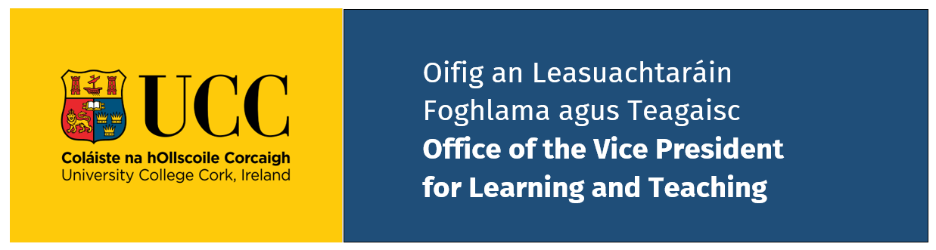

Lifetime Contribution Award for Excellence in Teaching 2025/26
THIS FORM IS TO BE COMPLETED BY THE NOMINATOR
DEADLINE FOR THE SUBMISSION OF NOMINATIONS
Monday 28th September 2026, 5pm

Please complete and submit this form by uploading via the following MS forms link.
Only UCC staff email addresses may access this form.
SUBMISSION OF NOMINATION FORM

Nomination Form

Section 1: Nominee Details
Name and Title: | Text here Text here | Text here | Text here
 | Title First | Last | Middle Initial(s)
School/Dept./Unit: | Text here
Position: | Text here
Email address: | Text here
Name and Title of Head of School/Dept.: | Text here

Section 2: Nominator Details
Full Name: | Text here Text here | Text here
 | Title First | Last
Role/Relationship to Nominee: | Text here
Email address: | Text here
This award is the highest recognition for teaching excellence in UCC. The Awards Review Committee may award one or more or no awards in this category in any given year.

Section 3: Contribution Summary (800 words)
Provide a comprehensive narrative describing the nominee's lifetime contribution to teaching and learning at UCC. Address the following:
- Sustained engagement in high quality teaching.
- Evidence of innovative and inclusive teaching and assessment practices over several years.
- Commitment to pastoral care and inclusive, student-centered education.
- Leadership roles within the teaching and learning community.
- And/or your proposed focus.
Word count declaration [800 max.]:

Section 4: Impact on Teaching and Learning Community (800 words)
Provide detailed evidence demonstrating the nominee's local, national and international influence in teaching and learning, including, but not limited to, some of the following prompts:
- Sustained commitment to disseminating and sharing practice.
- Leadership or membership of disciplinary national or international teaching and learning bodies.
- Significant funded teaching and learning projects or grants.
- Published scholarship influencing practice beyond UCC.
- Contribution to disciplinary national or international policy, standards, or accreditation work.
- Recognition through relevant awards.
- Other relevant evidence.
Word count declaration [800 max.]:

Section 5: Letters of Support
Attach two letters of support (max 300 words each) from colleagues, students, or external partners addressing their influence on the teaching and learning community and demonstrating their excellence in teaching.

Section 6: Declaration
I confirm that the information provided is, to the best of my knowledge, accurate and complete and that the nominee is aware of this nomination.
Signature: _________________________ Date: ____________

Applications (which must include all supporting evidence) must be submitted electronically, as a single file, via the MS FORM before Monday 28th September 2026, 5pm. Please note the upload file size restriction of 1 GB. Please use file naming convention: Surname_Initial First Name e.g. Murphy_A.doc or Murphy_A.pdf. For team applications use the name of the lead applicant.

COMPLETED NOMINATION FORMS FOR LIFETIME CONTRIBUTION AWARD ARE TO BE SUBMITTED BY 5PM 28th SEPTEMBER 2026

