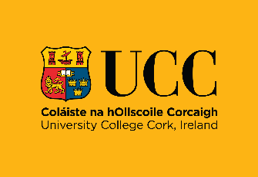

Nature of service

The University provides education, engages in research and provides other activities that involve children coming onto the campus including UCC’s Law Academy, Access Programme Easter School, Orientation Week, dental care for children and young people, school tours, and summer camps. The University admits some students under the age of 18.

UCC’s principles to safeguard children from harm

The key principle is that the welfare of the child is paramount and that children are protected, treated with respect, listened to and have their views taken into consideration. The University has a detailed Child Safeguarding Policy developed in line with requirements under the Children First Act 2015, as amended and the Children First: National Guidance for the Protection and Welfare of Children” (issued by the Department of Children and Youth Affairs) in 2017, Tusla’s Child Safeguarding: A Guide for Policy, Procedure and Practice and the Addendum to the Children First National Guidance for the Protection and Welfare of Children (Online Safety – January 2019) which sets out the University’s principles and procedures to safeguard children, available at Policies | University College Cork.

Risk assessment

The University assesses potential harm to children while availing of the services provided by the University. The University’s Child Safeguarding Policy requires any University Member to risk assess any new child-related activity having regard to the University’s risk assessment policy and procedures at Risk Assessments | University College Cork, in conjunction with the Child Safeguarding Risk Assessment and checklist for potential hazards in the Child Safeguarding Policy.

Reporting framework

The University’s Child Safeguarding Policy (Section 7) includes a reporting framework for child protection concerns. The University has appointed a Designated Liaison Person (DLP), and Deputy Designated Liaison Persons (DDLPs) in line with the 2017 guidance on making child protection concern reports to Tusla as follows:

Contact | Name | Contact details
Designated Liaison Person  (Relevant Person) | Nora Geary, Corporate Secretary | nora.geary@ucc.ie
Deputy Designated Liaison Person | Ruth Horgan Černy | r.horgan@ucc.ie
Deputy Designated Liaison Person | Gareth Morgan | garethmorgan@ucc.ie
Deputy Designated Liaison Person  (Dental School) | Niamh O’Callaghan | nocallaghan@ucc.ie
Deputy Designated Liaison Person (Student Counselling) | Sandie Rumley | srumley@ucc.ie

The University maintains links with Tusla and An Garda Síochána in order to promote child protection and welfare policies and practices and safeguard children from harm.

Tusla Contact Details | Telephone number | Website
Child & Family Agency Referrals Section, Floor 2  Blackpool, Cork | 021-4927190 | http://www.tusla.ie/

The follow table summaries where Children may avail of the services provided by the University and the list of procedures for managing these risks:

UCC Activity | Risk of Harm | Procedures/ Protocols in place to address the risk of harm identified with reference to the relevant section of the UCC Child Safeguarding Policy
Children visiting the UCC campus | Risk of harm/ abuse to children  Risk of harm to a child due to a child protection or welfare concern not being recognised.  Risk of harm/ abuse to children from UCC staff, UCC students, volunteers, visitors, and members of the public including risks related to online activities and/or through the inappropriate taking of or sharing of images | Procedure for the safe recruitment and selection of staff, students and volunteers to work with children (Section 6.2)  Procedure for the provision of and access to child safeguarding training and information, including the identification of the occurrence of harm (Section 6.3)  Procedure in relation to Research Activities involving children (Section 6.4)  Procedure in relation to allegations of Child Abuse on Placement (Section 6.9)  Procedure for appointing a Relevant Person (Section 6.5)  Procedure for maintaining a list of the persons (if any) in the relevant service who are Mandated Persons (Section 6.6)  Procedure in relation to disclosure by a child of suspected child abuse to a University Member in a University-related capacity (Section 6.7)  Procedure in relation to a disclosure of suspected child abuse by a third party to a University Member (Section 6.8)  Procedure for retrospective disclosure of child abuse by an adult (Section 6.10)  Procedure for allegations of child abuse against a student of the University (Section 6.11)  Procedure for the management of allegations against staff (Section 6.12)  24-hour campus security in place. Security is always available/ contactable. CCTV monitoring in place on campus. CCTV in use signage erected on-site.  UCC IT Acceptable Usage Policy is in effect and all staff and students are provided with the policy.
Research involving children
Students on work placements that involve children e.g. teachers, nurses etc.
School visits by UCC staff
Dental services involving children
Risk of harm to a Child through University Members’ use of ICT and social media

Implementation

The University recognises that implementation is an ongoing process and is committed to the ongoing review of UCC’s Child Safeguarding Policy and Statement to keep children engaging with the University safe. This Safeguarding Statement will be reviewed every two years, or as soon as practicable after there has been a material change in any matter to which the statement refers. For queries in relation to this statement, please contact the Office of Corporate and Legal Affairs at corporatesecretary@ucc.ie

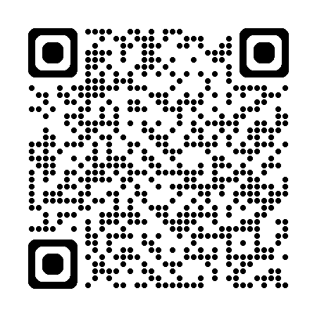

Next scheduled review date June 2028

