University College Cork

Child Protection Risk Assessment Guide
Version 1.1

Table of Contents

Background 3
Step 1: Establish the Context 4
Step 2: Identify the Risks 4
Step 3: Risk Analysis 5
Assess Impact 5
Assess Likelihood 6
Score the Risk 7
Step 4: Evaluate the Risk 7
Current Controls and Further Actions 7
Step 5: Treat the Risk 7
Communicate, Consult, Monitor and Review 8
Appendix 1: Blank Risk Register for Child Safeguarding – contact Mairéad Loughman, UCC Risk Manager for EXCEL version 9

Background
On 11th December 2017, the Government gave effect to the Children First Act 2015. This places the Children First National Guidance for Protection and Welfare of Children 2017 on a statutory footing.
UCC, including its subsidiary companies, that provide services to children, is a service provider within the meaning of the Act and has 3 months from that date (i.e. by 10th March 2018) to comply with the Act. UCC, including its subsidiary companies, is required to identify activities where staff and others would have access to children and to ensure that a risk assessment is carried out for these activities. In short, the risk assessment should examine whether a child could be harmed from receiving services from the organisation/company and document measures to mitigate this risk.
It is advised that the following document from Túsla be reviewed before starting the Risk Assessment http://www.tusla.ie/uploads/content/QA_Org_Risk_Management.pdf
All UCC risk assessments follow the UCC Risk Management policy which may be viewed at
https://www.ucc.ie/en/media/support/ocla/riskmanagement/UCC-RM-Policy-APPROVED-GB140616.pdf
The UCC Risk Management policy follows the ISO31000 standard for Risk Management and the process may be presented graphically as follows:

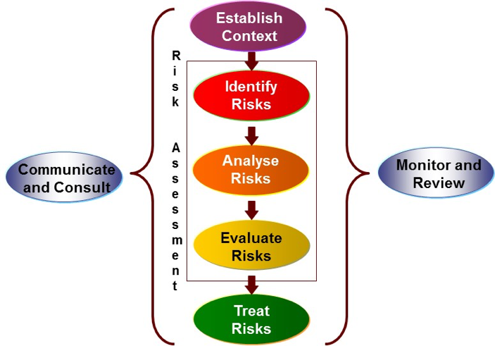

Step 1: Establish the Context
Establishing the context sets the framework within which risk assessment is undertaken. It begins with listing the activities provided by UCC and/or its subsidiary companies.
Different types of activity carry varying degrees and types of risk. The risk assessment must be appropriate to the activity. When performing a risk assessment, the following are useful questions to ask:
- What could go wrong?
- How likely is it to happen?
- What would the impact be of it happening?
- What should be or is being done to reduce the risk, i.e. current controls?
- Does anything else need to be done to mitigate the risk i.e. future actions?
- Who owns the risk? Who is ultimately responsible for the activity and related risks?

Step 2: Identify the Risks
Identify the potential risks that may arise (what could go wrong?).
Think about things like:
- What are the sources of risk or threat – what activities or factors might have inherent potential to harm or facilitate harm?
- What could happen – events or incidents where the source of risk or threat could have an impact on the activity’s objectives
- How could it happen – the manner of method in which a risk even or incident could occur
- Where could it happen – risky location or circumstances?
- When might it happen – specific times or time periods when the risk event is likely to occur or have a higher impact
- Why could it happen– direct or indirect factors that could create a source of risk or threat
- What might be the overall impact were this risk to materialise – what would be the impact on the University’s objectives, reputation? What parts of the organisation would be most impacted and what stakeholders might be involved or impacted?
Page 9 of http://www.tusla.ie/uploads/content/QA_Org_Risk_Management.pdf is particularly useful in identifying sources of risk.
Risks may be listed under different categories along with the possible consequences of the risk materialising. Categories might include some of the following:

Events  Technology/communications  Children with Vulnerabilities/Special Needs  Reporting  Physical health  Mental health | General daily activities  Extra-curricular activities  Teaching and learning activities  Recruitment  Staff (caused by)  Students (caused by)

Step 3: Risk Analysis
Having identified the risks, it is then necessary to analyse the risks to assess which are going to pose the greatest threat by considering both the likelihood of the risk occurring and the impact that might result. Multiplying likelihood by impact provides the overall risk rating or risk score.
Before risk analysis takes place, it is important to consider the controls that are in currently place to mitigate against the risk occurring. Controls may include pre-existing processes, policies, practices or people that minimise the likelihood of a negative risk occurring or enhance positive outcomes. Controls may also be applied to impact if the risk does occur. It is important to ask the following questions when considering the Controls.
- Is the control ‘fit for purpose’?
- Is the control relevant?
- Does the control work as intended?
- Is the control documented?
- Is the control being used?
- Is the control up-to-date?
- Is the risk under good control?

Assess Impact
Assess the impact of each risk (what would the impact be of it happening?) using the following matrix as a guide. This matrix contains examples of impact of lack of Child Safeguarding. Please note this list is not exhaustive. Units organising activities involving children should develop and tailor this matrix to reflect the types of activity undertaken in their area.

RATING | SCORE | POSSIBLE IMPACT OF THREAT
 |  | Strategic & Operational | Reputation
Severe | 5 | Achievement of strategic and operational goals in the medium term jeopardised.  Existence of the University, Colleges/Schools, Service, Project under threat. | Loss of confidence in the University.  Reputation and standing of the University adversely affected nationally /internationally.  Serious public outcry and or international coverage.  Reputation adversely impacted with majority of key stakeholders.  Significant breakdown in strategic and or business partnerships.
Major | 4 | Significant effect on operational performance will require operational resource reallocation (financial, assets and or people) to manage and resolve in the medium term to avoid non achievement of strategic goals. | Loss of confidence in a College/School or service.  Sustained adverse national media and public coverage.  Reputation adversely impacted with a significant number of stakeholders.  Breakdown in strategic and or business partnership.
Moderate | 3 | Some impact on the University’s Colleges / Schools, Service, Project or operational performance.  Less impact on strategic goals in the medium term. | Community concern.  Adverse national media coverage and external criticism.  Reputation adversely impacted with some stakeholders  .
Minor | 2 | Disruption to operations with no permanent or significant effect on the University, College / School, Service, Project. | Issue raised by local press.  Adverse local public or media attention and complaints.  Reputation is adversely affected by a small number of affected people.  Internal matter.
Insignificant | 1 | Some localised inconvenience, but no impact to the University, College/School, Service or Project.  Absorbed with Colleges/Schools/Service running costs. | Issue resolved promptly by operational management processes.  Minimal or no stakeholder interest.  Individual grievances

If an activity is judged to be high-risk it does not mean that the activity cannot proceed. However, additional controls/actions may be required.

Assess Likelihood
Assess the likelihood, i.e. the chance or probability of each risk occurring (how likely is it to happen?) using the five-point scale which is shown in the table below. Likelihood scoring is based on the expert judgement, knowledge and experience of the group doing the scoring and is based on likelihood of future occurrence.
RATING | SCORE | LIKELIHOOD OF THREAT OCCURRING
Almost Certain | 5 | Expected to occur or a common occurrence  80% or above chance of occurrence
Likely | 4 | Will probably occur in most circumstances  70-79% or above chance of occurrence
Possible | 3 | Might occur at some point  40-69% or above chance of occurrence
Unlikely | 2 | Small chance of occurring at some point  10-39% or above chance of occurrence
Rare | 1 | Only in exceptional circumstance  Less than 10% chance of occurrence

Score the Risk
Calculate the risk score by multiplying the impact by the likelihood. The total is the risk score. The following table shows the severity of the risk according to the risk score e.g. a risk with likelihood 3 and impact 5 would score 15. This makes it an Amber-High risk.

Red | Extreme | 20 - 25
Amber | High | 15 - 19.99
Yellow | Medium | 8 - 14.99
Green | Low | 1 - 7.99

Step 4: Evaluate the Risk
Risk Evaluation is about deciding whether risks relating to a particular activity are acceptable or not acceptable. Based on the scoring and the adequacy of existing controls in place, an evaluation is made on whether to accept the risk or whether it may be necessary to put in additional controls or actions in order to mitigate the risk. This evaluation also enables risks to be ranked, thereby identifying management priorities.
Whether a risk is deemed acceptable or unacceptable relates to the willingness of the organisation to tolerate the risk; i.e., to accept the risk after it has been treated (with controls and actions), in order to achieve objectives and desired outcomes. The significance of the risk, measured against the importance of the policy, program, process or activity, needs to be considered in deciding whether a risk is acceptable or not.

Current Controls and Further Actions
For each risk identified, identify and implement the management controls to mitigate the risk (i.e. to reduce the likelihood or impact of a risk or both).
Future Actions, strategies or activities may also be identified, developed, implemented and documented in order to further mitigate the risk. Actions may become controls after it has been fully implemented and deemed effective in modifying the risk to an acceptable level.

Step 5: Treat the Risk
The four main ways to manage risk are:
- Treat: use of controls and actions, training, supervision, risk awareness and planning etc.;
- Transfer: transfer or share the risk via insurance, outsourcing, partnerships, sub-contracting etc.;
- Tolerate: accept the risk;
- Terminate: avoid by withdrawing i.e. the organisation is no longer prepared to take the risk.

Communicate, Consult, Monitor and Review
The completion of Risk Assessments should involve those who manage, carry out or might be affected by the actions under consideration. It is the responsibility of such risk owners to ensure that risks and related control measures are communicated to those who may be affected by the activities. Good communication is paramount in developing a positive risk culture. Engaging with others serves to embed risk management as a normal part of the way services are provided at UCC or its subsidiary companies. Communication must be focused on consultation and a two-way flow of information between decision-makers and stakeholders.

Few risks remain static. New issues and risks are likely to emerge and existing risks may change. Having identified the risks assessed them and put control measures in place, it is essential that they are routinely monitored.

The University has adopted a standard format for the recording of risks University-wide, including subsidiary companies. The Risk Register is the dynamic management tool which captures important information about the risk(s) or opportunity(ies) and provides a high level overview of the services/activities. Risk Management is a continual process and the Risk Register is a ‘live’ document. New risks may be identified, some may be terminated, and control measures will need to be adapted in response to changing internal and external events or factors.

Appendix 1: Blank Risk Register for Child Safeguarding –
contact Mairéad Loughman, UCC Risk Manager for EXCEL template or download from https://www.ucc.ie/en/ocla/risk/

UCC Risk Register

Risk Owner: UCC

Risk ID | Risk Description | Consequences | Risk Owner | Current internal Controls  (provide details of how you currently manage the risk) | Assessment of Risk |  |  | Describe further Actions you will take to reduce the Impact/Likelihood and mitigate the risk.  State who is the risk owner for each action. | Review Dates
 |  |  |  |  | Impact  (1,2,3,4,5) | Likelihood (1,2,3,4,5) | Score |  | RMC | UMT0 /  UMTS

