Insurance Referral Check Process
This document explains the Travel Insurance Referral Check Process, and how travel insurance referrals work.

What is the Travel Insurance Referral Check?
The Travel Insurance Referral Check is a short online form that helps you determine whether your trip needs to be reviewed by the University’s travel insurers before you travel.

All staff and students must complete this step before booking travel to ensure your trip can be considered under the University’s travel insurance policy (in line with policy terms and conditions).

Important to understand:
- This form does not approve your travel - It only checks whether insurance review is required
- All other University travel, safety, and risk management requirements must still be followed.
- This check is based primarily on your travel destination and duration. It does not assess other risk factors such as high-risk activities, large group travel, or specific trip circumstances, which must be considered separately as part of your risk assessment

Even if insurance cover is confirmed, this does not mean your travel is approved. Approval remains the responsibility of your School/Department, in line with University procedures.

Good to know
- You do not need to include airport stopovers where you remain in the airport
- Travel advice and risks can change — you must check these again before you travel

Complete the Travel Insurance Referral Check
All staff and students including postgraduate students travelling overseas on University business must complete the Travel Insurance Referral Check before booking travel.
👉 Travel Insurance Referral Check form

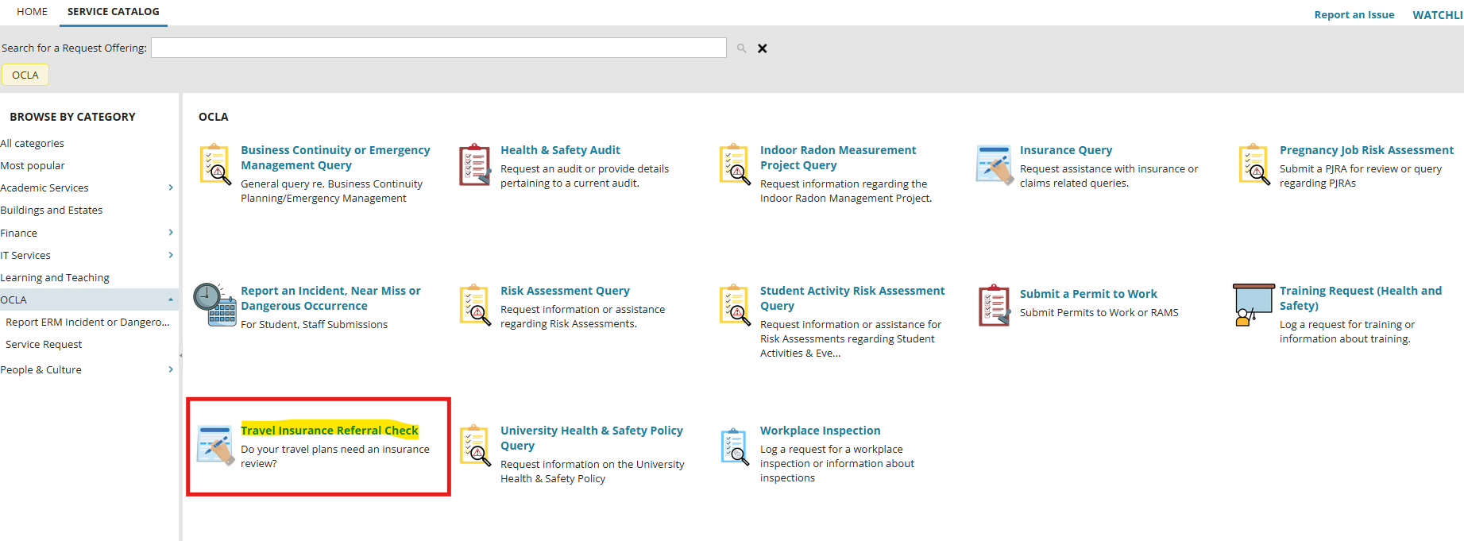
How to complete the form:
STEP 1: Check your Destination
Select your destination country or territory from the list shown in the form.
- If your destination is listed, select it
- If not, select “Country Not Listed”
(Countries listed in the form are identified by insurers as higher-risk destinations. Travel to these locations will require referral and may be subject to restrictions or may not be covered.)
STEP 2: Check DFA travel advice
- Go to the DFA Travel Advice website:
👉 https://www.ireland.ie/en/dfa/overseas-travel/advice/
- Find your destination and check the overall travel advice level shown at the top of the page:
  - Level 1 – Normal Precautions
  - Level 2 – High Degree of Caution
  - Level 3 – Avoid Non-Essential Travel
  - Level 4 – Do Not Travel
- Select the relevant level in the Portal form.

Important:
- DFA travel advice must always be checked before travel.
- DFA advice can change at short notice.
- If advice changes prior to travel, the referral check must be completed again and a referral to insurers may be required.
- You must follow all DFA guidance before and during travel.
STEP 3: Confirm trip duration
- Indicate whether your trip will last more than 90 days.

What Happens After You Complete the Form?

Based on your responses the form will advise you whether a referral to insurers is required or not:

You will need an insurance referral if any of the following apply:
- Your destination is on the restricted country list
- DFA advice is Level 3 or Level 4
- Your trip duration is more than 90 days

If none of the above apply → no referral is required

✅ If No Referral Is Required
- No further action needed at this time - You do not need to submit the form
- Insurance cover applies in accordance with the standard terms and conditions of the policy.
Please Note:
- Insurance confirmation does not approve travel, Travel approval is responsibility of your school or department and risks assessments may still be required.
- DFA travel advice must continue to be monitored before and during travel.

🚨 If a Referral Is Required
You must complete the following steps:
- Download and complete the Disturbed Area Questionnaire
👉 Disturbed Area Questionnaire
- Upload completed Disturbed Area Questionnaire to the form
- Click Review and Submit
Important:
- Submit your referral at least 6–8 weeks before travel
- Insurance cover is not confirmed until the referral has been reviewed by insurers.

Insurers may:
- Restrict the scope of cover
- Decline to provide cover
- Apply additional premiums or conditions
If insurance restrictions apply:
- These must be documented in the local risk assessment
- The risk assessment must be updated, reviewed and signed off again at department level
- The Head of School / Unit must ensure residual risk aligns with the University’s risk appetite

