- FOREWORD

Modern occupational health and safety legislation requires the University and its constituent departments, to develop and maintain, authentic pro-active safety management systems. Reactive safety management systems are incompatible with both the spirit and requirements of Irish & EU Legislation.
Under Irish Legislation, it is mandatory for employers to have a written and up to date ‘Safety Statement’. The term statement does not accurately reflect the nature, extent or duration of what is required.

Safety Statements are both an on-going, evolutionary, process and an envelope for formulating and recording the safety management system of the organisation and it’s constituent departments. Essentially Safety Statements are the living safety management system which provides:
- a vehicle for implementing legislation and required changes ( attitude/ behaviour, physical, work organisation and systems of work)
- a facility for achieving and sustaining legislative compliance and an authentic safety culture.
- for the integration of safety responsibilities into all levels of the management structure and all day to day operations,
- for initial and on-going hazard identification/ risk assessment, risk elimination/ controls,
- for the evaluation of risks arising from new buildings, building adaptations, new equipment purchases and new work/ research activities. (Additionally for ensuring that all new element meet current safety requirements).
- for documenting essential maintenance programmes
- initial and on-going training
- accident/ dangerous occurrence prevention, internal reporting and evaluation of incidents, mandatory reporting of three days lost time accidents and other designated incidents to The Health and Safety Authority..
- mechanisms for providing information, training and consultation with staff and staff elected safety representatives.
- periodic evaluation and monitoring of the effectiveness of all of the above.

A sample e-template for the School/Department Safety management system as captured in the legally required vehicle of a Safety Statement is available on the Health and Safety Office website at: https://www.ucc.ie/en/occupationalhealthandsafety/managinghealthsafety/safetystatements/appsclinks/#volume-1-s-university-safety-management-system-2021-2022.

Dept. Safety Statement Template - 3 models
There are three (3) template model types available: Humanities (H), Admin Offices only (H-A) or Applied Scientific and Service Depts. (S) -depending on the scale and type of School/departmental activities.‌
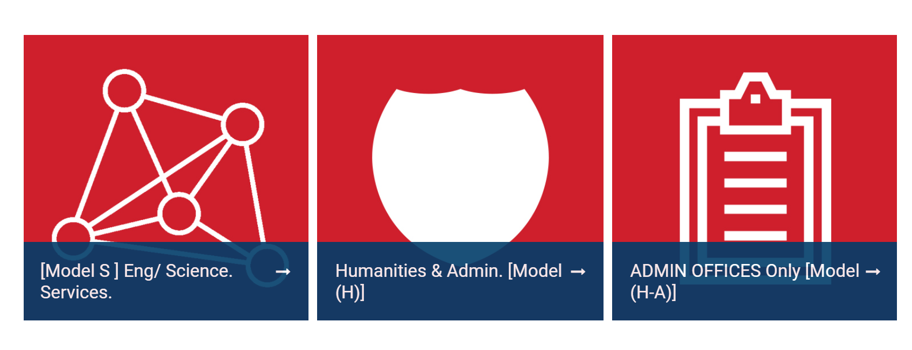
Model (S) is the most comprehensive in scope. Each model contains individual downloadable documents which school and department management must efficiently adapt and utilise to populate and keep their local safety statements and risk assessments up to date.
Schools Departments must alter /reset the template dates and revision numbers to reflect their own document generation and revision history.’’ This is also reflected in the relevant word document dealing with revisions etc.

It is the responsibility of School/Department management to keep their safety statements up to date and specific. Generic and out of date documents will not satisfy the scrutiny of a H.S.A inspector.

Note:
The content of Model (H), which is necessarily more limited in scope, is contained as standard content within Model (S).‌ Model (H-A) added in December 2015 is a subset of H and is focused toward ADMIN ONLY OFFICES.

Office Administration only departments may only need to use 70% of the H model. (Hence the reduced content H-A Model) - In circumstances where they have firstly ascertained that their staff do not undertake work activities such as:
Organising of events or conferences either on or off Campus; organising field work or walking tours; supervision of students; student placements; engagement of contractors to maintain equipment; use of vehicles for work, organising deliveries by large vehicles, use of noise generating equipment etc.

The Safety statement template ( and the required School Safety management system output resulting), is arranged into 4 discrete volumes. Example as below from the Scientific safety statement template.

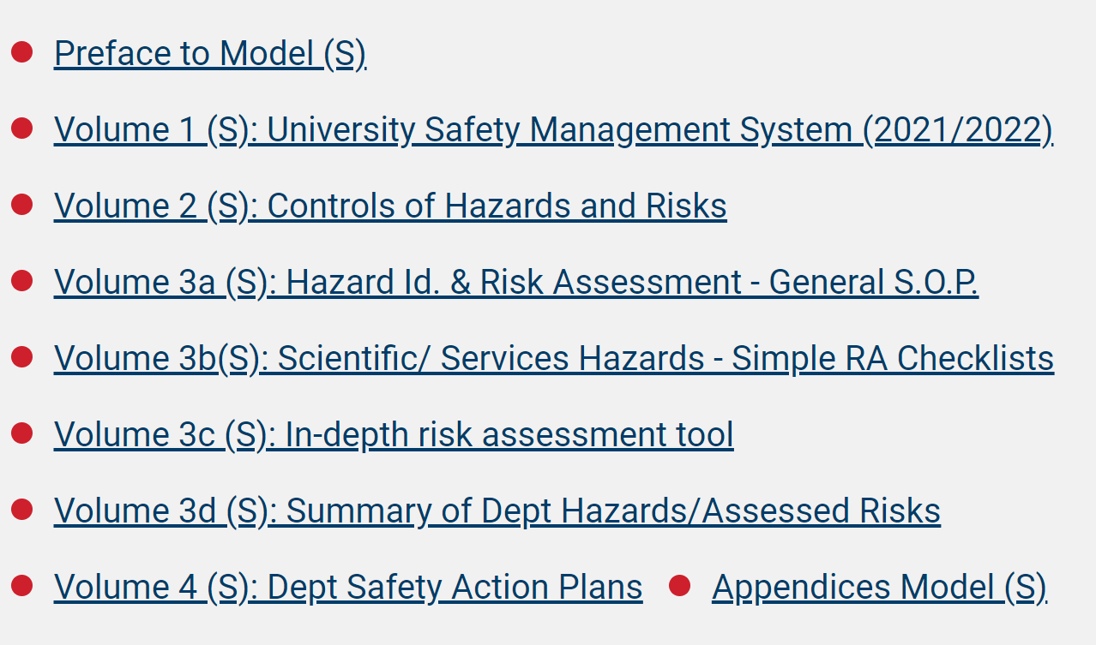

For content details see further at the following link https://www.ucc.ie/en/occupationalhealthandsafety/managinghealthsafety/safetystatements/appsclinks/

Current master e-template revisions are as per the date indicated on each sub-document and document link within Volumes 1-4 on the H&SO web page (note: various dates apply). In cases of new sections or sections with content revision, the year of revision is now included in both the download link and within the associated document title name (e.g. Doc XYX Year). This allows users and department management to quickly identify what they will need to review and change out in their school/department safety statement and incorporate into the operation of their local safety management systems.

The Safety statement template is intended only as an aid/ guide to departments with regard to producing/customising their own Department Safety Statements, to a professional standard.

The Appendices of the e-safety statement templatel contain extracts from Legislation/University documents, worked examples of Risk Assessments, supplementary information on requirements which have been referred to in the main body of the above sections and extracts from guidance notes issued by the Health and Safety Authority. (All of which will be applicable/ of use to many Colleges \ Schools \ Departments\ Centres \ Units in producing their own Department Safety Statement). The e-template is not intended as a legal interpretation of the Legislation outlined in the following sections. Its purpose is to give general guidance to ensure compliance with the requirements of current legislation.

This ‘e- safety statement template’ establishes the structure/format and typical contents, which Colleges \ Schools \ Departments \ Centres \ Units should adopt. The ‘e-safety statement template’ contains numerous documents, which may be adopted in full or altered to suit the individual School/Department. These documents can then become the body of the Colleges \ Schools \ Departments \ Centres \ Units own safety statement merely by filling in the section identifying the name of dept staff responsible for specific tasks – the latter, which is a requirement of legislation.

A cover page should be created to match the name of the College \ School \ Department \ Centre \ Unit in question, with the designation Dept. Safety Statement: Working Copy/Draft./ Final copy as necessary and dated. Its contents must be made available to staff.

In all cases it must be noted that the rev# and dates on these work manual templates are for tracking the template only. Each College \ School \ Department \ Centre \ Unit must changes these dates and #s to reflect their own document generation / amendment dates.

It must be emphasised that whilst the scope and content of this ‘e-safety statement template’ is, by necessity, reasonably comprehensive, it does not purport to be 100% exhaustive or comprehensive. It cannot cover every aspect of the University’s or a College \ School \ Department \ Centre \ Unit’s activities. Each constituent College \ School \ Department \ Centre \ Unit must initially identify and continually update the unique hazards encountered in their sphere of activity. Hazards thus identified and not covered by the e-safety statement template must be included by the College \ School \ Department \ Centre \ Unit in question and should be catered for by revising and/or devising new sections.

Colleges \ Schools \ Departments \ Centres \ Units also have to adapt the contents of the e-safety statement template manual, in particular ‘Arrangements and Controls’, to the circumstances in their own school/department.

College \ School \ Department \ Centre \ Unit’s may alter, amend any section to simplify and take account of its circumstances/work practices, as long as it does not diminish, (a) Legal requirements or College \ School \ Department \ Centre \ Unit responsibilities, (b) Best Practice requirements as established in Codes of Practice, Building Regulations, Ec/National Standards, HSE/HSA Guidelines, Guidelines produced by Expert Advisory Committee’s at National level/in the University Sector or University specialist safety sub-Committees.

Each College \ School \ Department \ Centre \ Unit must changes the templates dates and #s to reflect their own final document generation / amendment dates.

Colleges \ Schools \ Departments \ Centres \ Units shall take cognisance of new safety legislation and keep abreast of HSE/HSA Guidance and future safety developments. Where applicable, new or revised codes of practice or safety guidelines issued by established institutions, national/international bodies etc., should also be incorporated, by Colleges \ Schools \ Departments \ Centres \ Units, into their Department Safety Statement, as soon as it is available/in force. Colleges \ Schools \ Departments \ Centres \ Units are advised to form a small representative-working group to prepare a dept. safety statement, using the e-safety statement template.

2.2 REVIEW OF SCHOOL/DEPT. SAFETY STATEMENTS & SAFETY PERFORMANCE

To give effect to the objective set out in the foreword above, each of the four documents that constitute a finalised department/ unit/centre safety statement should be reviewed regularly and at least annually. (In addition, as a result of reporting, monitoring and feed-back, the forms utilised for record keeping may need to be amended or revised).

This section outlines what is required by way of an annual review, the procedure to be adopted when altering sections of the School/Department Safety Statement.
- The Safety Statement will be reviewed by the Head of College \ School \ Department \ Centre \ Unit, in consultation with the FA/School or Dept. Safety Officer or directly engaged consultants. (The accuracy, relevance and scope of the document will be reviewed in relation to current legislative requirements, the activities of the department, the resources available to the College \ School \ Department \ Centre \ Unit and the premises occupied by the College \ School \ Department \ Centre \ Unit. An assessment will also be undertaken with regards to compliance with the provisions of the Department Safety Statement).

In addition, other events that may trigger an amendment of the School/ Department Safety Statement may include:
- Accidents, Dangerous Occurrences.
- Advice from the Health and Safety Authority, University Safety Officer
- Representations made by Safety Representatives, employees and students
- Safety performance and training arising from benchmarking consultant feedback reports on FA annual safety reports compiled on a year on arrears basis and recent years completion update data. ( all sources).
- New processes introduced or proposed or new rooms or premises or new equipment or room adaptations

Note: Any remedial action initiated may necessitate an amendment of the School/Dept. Safety Statement, either at the time or at the next formal review.

The College \ School \ Department \ Centre \ Unit Head will initiate a review, at least annually, in conjunction with the School/Dept. Safety Officer of:
- Sections 1 to 17: Dept. Safety Management System, to ensure that it accurately reflects the University & College \ School \ Department \ Centre \ Unit ethos, College \ School \ Department \ Centre \ Unit management structure and in particular, is up to date with respect to names, titles and safety responsibilities of all persons at a level of responsibility within the College \ School \ Department \ Centre \ Unit.
- Section 18: Requirements for the Control of Hazards and Risks, to ensure that it reflect the reality of the specific hazards and risk controls that apply within the College \ School \ Department \ Centre \ Unit and the requirements of current legislation .
- Section 19: Hazards, Risk Assessments and Hazard Checklists: to ensure that they adequately reflect the requirements of legislation and the specific work hazards that exist within the department.

- Section 20 to 21. Safety Action Plan. The College \ School \ Department \ Centre \ Unit’s progress in implementing the prioritised short, medium and long term actions/improvements as formulated in the School/Department’s Safety Action Plan, as developed by the College \ School \ Department \ Centre \ Unit in Document No.4.

Notes:
- The Dept. Safety Statement may also require to be amended or extended when alterations are made to any premises occupied by the department, if new premises are acquired, if new activities are embarked upon , if new equipment is purchased, or if staff leave or join the department.
- Under UCC Corporate governance , each Head of Functional Area is required to report annually to the President and Governing body on the implementation of University Safety Policy and adherence to legal and university safety requirements within their area of responsibility. This includes having an up to date Safety Statements in each of the Schools/Departments under their control and on implementing the provisions of same.

  - AMENDMENT AND REVISION PROCEDURES
Documents adapted by Schools/Departments will require continual revision, review, additions and amendments to take account of changing circumstances, research activities and work methods.
The following amendments and procedures are outlined below:
- All recommendations that are made and approved, arising either from the annual review of the School/Department Safety Statement or a monthly School/Department staff meetings and which necessitate the revision or amendment of any document must be recorded in a master document.
- Copies of all significant revisions to any section or the addition of newly created sections by a School/Department Safety Statement should be sent to the University Safety Officer, for information purposes.

The following personnel in this College \ School \ Department \ Centre \ Unit have the above mentioned responsibilities for creating, maintaining and updating a School or Department safety statement ( please enter) :

Name  1  2  3  4  5  6  7  8  9  10  11  12  13 | Title | Areas of Responsibility

