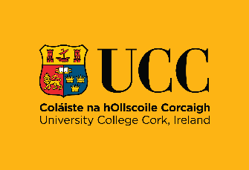

Consent form for Photography/Filming/Audio Recording
University College Cork

I consent to University College Cork using photographs, audio and/or video recordings including images of me for the purpose(s) of [please specify purpose e.g. school handbook].

I also consent to these images/recordings being used internally and externally to promote the University. These images/recordings could be used in print and digital media formats including print publications, websites, e-marketing, posters, banners, advertising, film, social media, podcasts, teaching and research purposes.

I understand that my participation is entirely voluntary and there is no obligation upon me to give consent to have my voice or image captured.

I understand that images on websites and on social media can be viewed throughout the world and not just in the Republic of Ireland and that some overseas countries may not provide the same level of protection to the rights of individuals as EU legislation provides. I understand that I may not be able to seek effective erasure of my image/audio once it has been circulated.

I understand that some images or recordings may be kept permanently once they are published and be kept as an archive of University life.

I understand that any intellectual property, including copyright and image rights, which arises in the photograph(s) and/or audio recordings and/or video recordings belongs to University College Cork.

By signing below, I confirm that I have read and understand the conditions and consent to my images being used as described.

Print Name
Signature
Date

Parental Consent for Minors (under 18):

By signing below, I confirm that I have read and understand the conditions and consent to images of my child _____________________________ [insert name] being used as described.

Print Name
Signature
Date

University College Cork is committed to processing information in accordance with the General Data Protection Regulation (GDPR). The personal data collected on this form will be held securely and will only be used for the purposes outlined in this form.

Your rights:
You have the right to request to see a copy of the information we hold about you and to request corrections or deletions of the information that is no longer required. You can ask the University to stop using your images at any time, in which case it will not be used in future publications but may continue to appear in publications already in circulation.

You have the right to lodge a complaint against the University regarding data protection issues with the Data Protection Commission (www.dataprotection.ie).

Contact details:
If you have any questions relating to this consent form or the way we are planning to use your information please contact: [insert contact details of department taking photos]

If you have any questions relating to data protection, please contact the University’s Information Compliance Manager: Email: gdpr@ucc.ie or telephone 021 4903949.

