University Collge Cork
Procedure for establishing and using an official university social media account
Version 1
7/1/2013
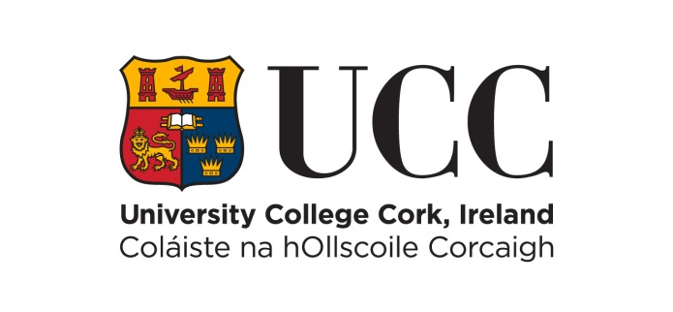

The purpose of the document is to information a member of the UCC community on how to establish and use an official university social media account.

Document Location
Revision History
Date of this revision: 20/12/2012 | Date of next review: 31/10/2013

Version Number/Revision Number | Revision Date | Summary of Changes
0.1 | 31/10/2012 | Draft created by Maurice Ryder, EPU
0.2 | 20/12/2012 | Updated by Noelette Hurley IT Services
1 | 01/07/2013 | Final Approved Version

Consultation History
Revision Number | Consultation Date | Names of Parties in Consultation | Summary of Changes

Approval
This document requires the following approvals:
Name | Title | Date
John Fitzgerald | Director of Information Services
Trevor Holmes | Vice-President for External Relations
Michael Farrell | Corporate Secretary

These procedures shall be reviewed and updated on an annual basis.

Table of Contents
1 Purpose 4
2 Supporting Policies, Standards and Procedures 4
3 Establishing and using an official university social media account. 4
4 Official university social media accounts. 4

Purpose
This procedure outlines the steps required in order to establish and use an official university social media account. It should be read in conjunction with the supporting documents listed below.

Supporting Policies, Standards and Procedures
- UCC IT Documentation Policy
- Acceptable Usage Policy (Hereto referred to as AUP)
- Social Media Policy
- Procedure for notice and take down

Establishing and using an official university social media account.
Users are encouraged at all times to use social media sites in a responsible manner having due regard to the rights and reputation of the University and of others.
- The office of media and public relations and the office of marketing and communications shall maintain the official university social media account on any given social media platform.
- Only the president, the vice-president of external relations (or their nominee) may set up an official social media account on behalf of the university.
- The operation of some official university social media accounts may be devolved, with permission from the vice-president for external relations, to an office other than the office of media and public relations or the office of marketing and communications.
- All official university social media accounts shall be operated within the rules established in the Social Media Policy.
- All official university social media accounts shall contain a link (where feasible) to the social media policy and this procedure.

Official university social media accounts.
The following is a list of official social media accounts:
- Twitter: http://twitter.com/UCC (or @UCC)
- Facebook: http://facebook.com/universitycollegecork
- YouTube: http://www.youtube.com/uccireland
- LinkedIn: http://www.linkedin.com/company/8798?trk=NUS_CMPY_TWIT

The University reserves the right at any time to revise the terms of this procedure. Any such revisions will be notified to you and by continuing to use the relevant social media sites following such notification you will be deemed to have accepted the revised terms of this procedure.

