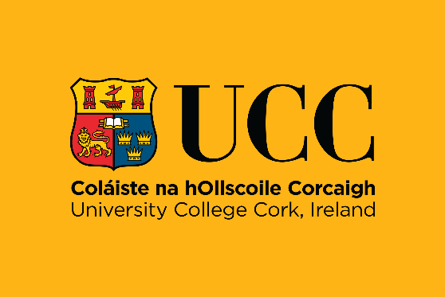


Staff Orientation and Onboarding Policy

University College Cork (UCC)

1. Introduction
This policy sets out University College Cork’s approach to orientation and onboarding of new staff. It reflects our commitment to fostering a welcoming, inclusive, and supportive environment where all colleagues can begin well, feel a sense of belonging, and become effective and confident in their roles.
UCC recognises that the early experiences of new staff are key to individual success, team integration, and the delivery of our strategic objectives. Our orientation and onboarding procedures are designed to support new colleagues ensuring consistency of experience for all new staff to the University.

2. Scope
This policy applies to all new employees of University College Cork, including academic, research, professional, administrative, technical, and support staff.

3. Principles
This policy is underpinned by the key principles of Beginning, Belonging, and Becoming
Beginning: We are committed to creating a confident and informed start for every employee through clear communication and structured orientation.
Belonging: We seek to foster an inclusive community and connection through relationship building, local culture, and shared purpose.
Becoming: We are supportive of enabling professional growth, development, and contribution through effective onboarding and integration.

4. Key Definitions
Orientation
Orientation is a time-limited process focused on introducing new staff to UCC’s organisational structures, culture, values, policies, together with providing information on university services. Orientation includes both centrally delivered and locally provided information, usually within the first few months of employment. In addition to central orientation, specific orientation sessions are held annually for academic and research staff to ensure new staff are well equipped to contribute to UCC’s academic and research goals.

Onboarding
Onboarding encompasses a broader, longer-term process designed to integrate new staff into their role, team, and the wider University. Onboarding may span the first 3 to 12 months and includes training, mentoring, goal setting, performance discussions, and social integration.

5. Policy Objectives
- To provide a welcoming, supportive, and informative start for all new staff.
- To ensure consistency of orientation and onboarding experiences across UCC.
- To support the early development of role clarity, confidence, and collaboration.
- To embed inclusive practices that enhance retention, satisfaction, and belonging.

6. Responsibilities
Department of People & Culture
- To deliver UCC wide orientation events and resources (e.g. Central Orientation, Academic Orientation, Research Orientation, Orientation for New Heads and Managers, The Presidents Orientation Café and web-based information).
- To develop and enhance onboarding guidance and tools for managers and staff.
- To oversee new staff experiences in onboarding and orientation.
- To contact new starters and advise of dates for upcoming orientation events, key resources relevant to starting at UCC including how mentoring works.
- To provide information, advice and guidance to Managers as to the range of training programmes, resources and workshops available.
- To develop a Workvivo space to enable new staff to connect and engage with each other and to colleagues in People & Culture for the purposes of gathering useful insights, information, addressing queries and ultimately enhancing their new staff experience.
- To provide opportunities for new staff to network and meet new colleagues and encourage a sense of belonging for all.

Heads of School/Unit and Line Managers
- To ensure local orientation is provided, including team introductions, health and safety, which should include the local Safety Statement, risk assessments, emergency arrangements and training, and role-specific information in addition to signposting the new staff member to dedicated training resources, activities, programmes, and workshops.
- To lead and monitor onboarding activities, including goal setting, training, and regular check-ins.
- To appoint a buddy in line with the local orientation process to help the new staff member settle in.
- To support the new staff member and ensure that in-person orientation, knowledge gathering and skill development is prioritised together with engagement with appropriate initiatives depending on career development stage.
- To encourage inclusive practices within the school/unit that promote team integration and wellbeing.

New Employees
- To actively engage with both central and local orientation information, materials, and events. To communicate openly about training and support needs.
- To participate in feedback processes to enhance future onboarding practices.
- To engage in Mentoring and attend a Mentoring briefing to support a successful mentoring relationship

7. Procedures
7.1 Pre-Arrival Preparation
The Department of People & Culture sends a pre-arrival welcome email with links to the onboarding portal.
The relevant Line manager contacts the new employee with a personalised welcome and first-day information.
7.2 Day One and First Week – New Staff Member Orientation Focus
Each new staff member has access to the Onboarding webpages which includes videos, checklists, information, and key resources.
The new staff member contacts:
- People and Culture Central Services to arrange ID card and complete outstanding starter paperwork
- The ERM Helpdesk to be added to the health and safety e-learning system

The relevant Line Manager will arrange a local welcome meeting with team introductions including a tour of facilities and health and safety briefing and an introduction to the local buddy in accordance with the ‘Manager Checklist’.
The relevant Line Manager will arrange for orientation to take place, predominantly on campus, for the first few weeks with the new starter being supported onsite by colleagues.
The People and Culture Department, Staff Wellbeing & Development unit will notify new staff of forthcoming dates for orientation in addition to providing useful information for new staff including how to engage with mentoring.
7.3 First Three Months – Onboarding Begins
- Staff Member to attend Central Orientation,
- Dedicated academic and research orientation sessions are held annually.
- Hourly occasional staff can avail of local orientation
- New Starter probation goals agreed with Line Manager and recorded.
- Academic staff discuss the probation and establishment process with their Head
- Staff member is introduced to their mentor by their Head and attends mentoring briefing.
- Any role-specific training and support is undertaken or scheduled as identified with Line Manager.
- The first formal review meeting is scheduled to take place within 4–6 weeks.

7.4 First Six to Twelve Months – Further Onboarding
- Staff member participates in university-wide development opportunities.
- The second formal review meeting is scheduled (mid-probation) to identify any further support and development requirements.
- The end-of-probation review takes place, and the Line Manager submits relevant probationary administration requirements on request.
Staff Wellbeing & Development will track feedback from new starters including completion of central orientation participation.
8. Related Documents and Resources
- Staff Onboarding website
- Managers Onboarding Toolkit (Managers are invited contact Staff Wellbeing and Development for access)
- Employee pre & on arrival checklists
- Hourly Occasional | University College Cork
- Manager’s Onboarding Checklist
- UCC Staff Online Handbook
- Probation & Establishment Scheme (Academic Staff)

9. Policy Review
This policy will be reviewed every three years or sooner if required. The Department of People and Culture is the owner of this Policy.
ENDS
Version | Date | Description | Author
1 |  |  | UCC People and Culture
2

