STAFF COMMON ROOM
UNIVERSITY COLLEGE CORK
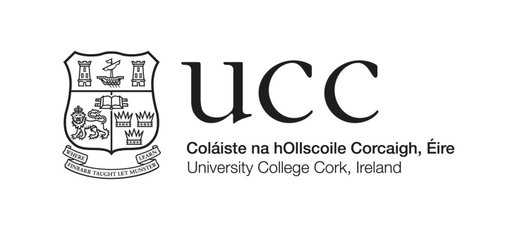
University College Cork Staff Common Room is a centrally located resource for all employees of the University.Providing a variety of snacks and light meals in congenial surroundings, the Staff Common Room is a place to meet friends and colleagues and escape from the pressures of work for a short while. The Staff Common Room also runs a number of events throughout the year for members.

Membership of the Staff Common Room is open to all staff on payment of a subscription (currently €7.00 per
month, salary deductible). As the Staff Common Room has a bar licence, it is necessary for new members to be
proposed and seconded by an existing member. A full list of members is available for consultation in the Common Room or you may contact any of the Staff Common Room Committee in order to establish current member’s names.

MEMBERSHIP APPLICATION
Name: Mr/Mrs/Ms/Dr/Prof______________________________________________________________

Department/Centre/Unit:_________________________ Extension No: ________________________

Staff Number:_________________________________ Email:_______________________________

Proposer:
Name: _______________________________________

Department/Centre/Unit:_________________________ Extension No: _______________________

Staff Number: _________________________________ Email:________________________________

Seconder:
Name:_______________________________________

Department/Centre/Unit: ________________________ Extension No:__________________________

Staff Number: _________________________________ Email:________________________________

I hereby authorise the Finance Office, UCC to deduct the Staff Common Room subscription monthly from
my salary commencing on the date of my admission to membership.
Signed:………………………………………………… Date: …………………………………………

Please return completed form to:
UCC Staff Common Room Membership Secretary, Ryan Fitzgerald, Office of Corporate & Legal Affairs,
1.30 East Wing (ryan.fitzgerald@ucc.ie)

The names of existing members of the Staff Common Room Committee are available from Kevin Barrett,
Manager, in the Staff Common Room, North Wing, Main Quadrangle.

For Office Use Only: Start Deduction From ____ / ____ / ____

