Structured process where experienced individual (mentor) helps another person (mentee) to develop his/her goals & skills through time limited (12 months), confidential one to one conversations (approx.6).
PRINCIPLES
Mentee led i.e. owns & drives process | Confidential process
Goal oriented | No hidden agendas & non judgemental
No line management relationship between mentee & mentor | Environment of openness, trust & mutual support

ROLE OF MENTOR
- Provide guidance & support in addressing identified development needs
- Help mentee clarify their goals
- Create new perspectives & different ways of thinking
- A figure with whom mentees can discuss their aspirations and concerns; who will listen and act as a soundboard; provide constructive feedback, challenge as appropriate, motivate and encourage
- See positives in mentee that they may be unaware of
- Introduce mentee to peers & colleagues as relevant to assist them become familiar with & integrate into the wider University

BENEFITS FOR MENTOR
- Opportunity to develop and practice a more personal style of leadership
- Broaden perspectives by seeing things from a different point of view
- Further develop one’s own communication skills, especially one’s active listening skills
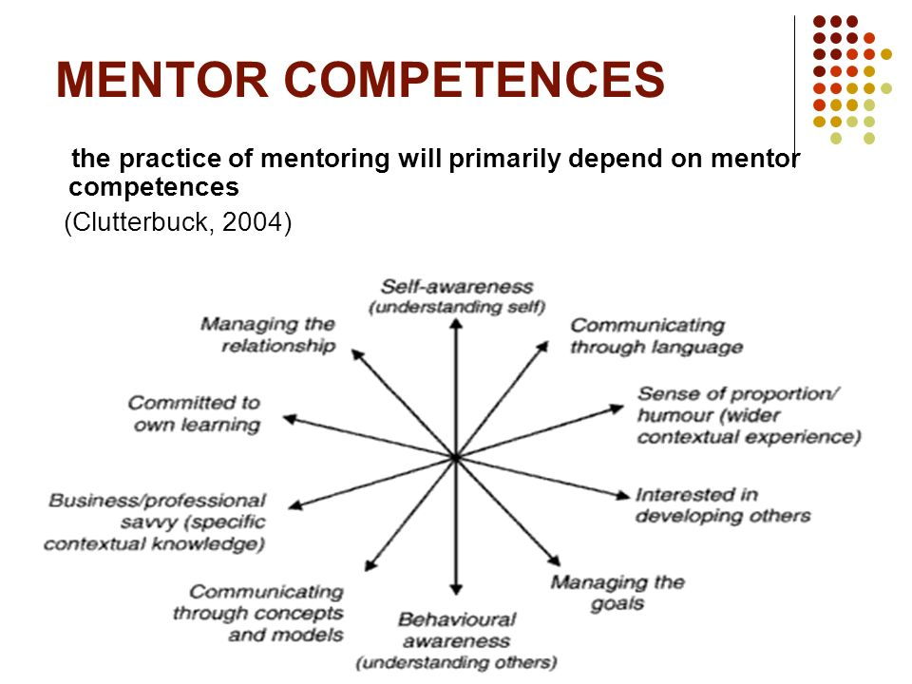
KEY POINTS
- All discussions are confidential. Confidentiality is only broken if one has concerns regarding their well-being.
- Once one agrees to be a mentor, allocate sufficient time (approx. 1 hour) per meeting, giving your mentee your full attention.
- In meeting one, work with your mentee to clarify their aims for the mentoring relationship.
- Everybody can be a mentor…….
Contact traininganddevelopment@ucc.ie to find out about our mentoring briefings

