How to Register Your Employment with UCC / Avoid Emergency Tax

Step One: Register on MyAccount on Revenue.ie
To register you will need:
- PPS Number (if you do not have one, you will need to apply for one via the Department of Social Protection. Please visit www.welfare.ie to start to the process)
- Date of Birth
- Mobile/Home number & Email address
- Home address

If this is your first time making contact with Revenue, a password for your MyAccount will be posted out to your home address. Once you receive your password, you can log in using this, your PPSN and your date of birth.

Step Two: Register your UCC Employment
On the MyAccount homepage under PAYE services, you will click Update Job or Pension Details
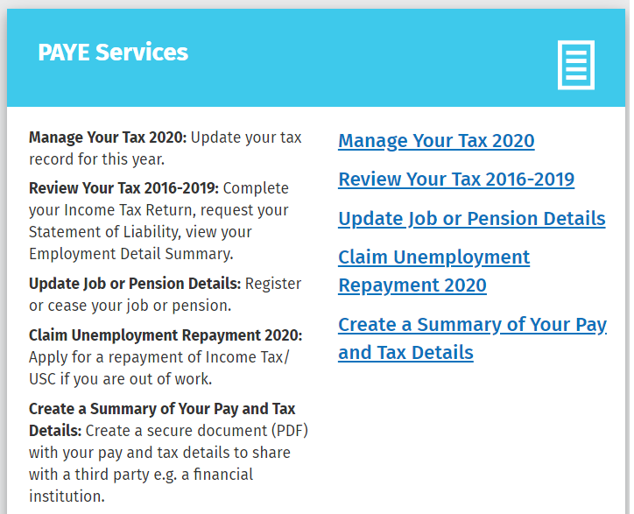

You will need:
- The UCC registration Number: 0006286E
- Start date of your new job
- Frequency of your salary e.g. monthly
- Estimate of overall income for the year
- Staff number

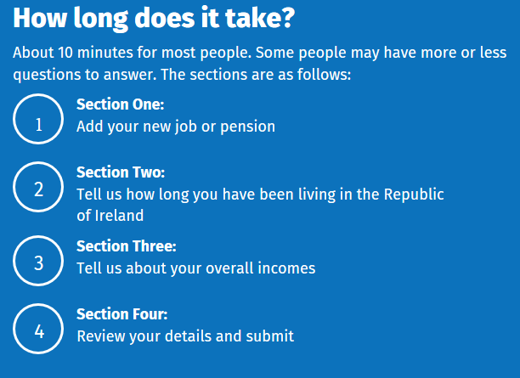
Once you have completed registration, a tax credit certificate will be issued to you in a few days, and an electronic copy will be sent to UCC. (This is now referred to as an “RPN”) You can view this tax cert when you click “Manage Your Tax 2020”
If you have paid emergency tax within the tax year (January to December inclusive), you may be entitled to receive a refund the next time you are paid. For previous years, you can apply for Statement of Liability, clicking the option “Review Your Tax 2016-2019” for direct refunds.

Please note that P60s are no longer issued by the Payroll Office, and will be available on MyAccount as Statements of Liability.
Revenue Phone Number: 01 7383636

