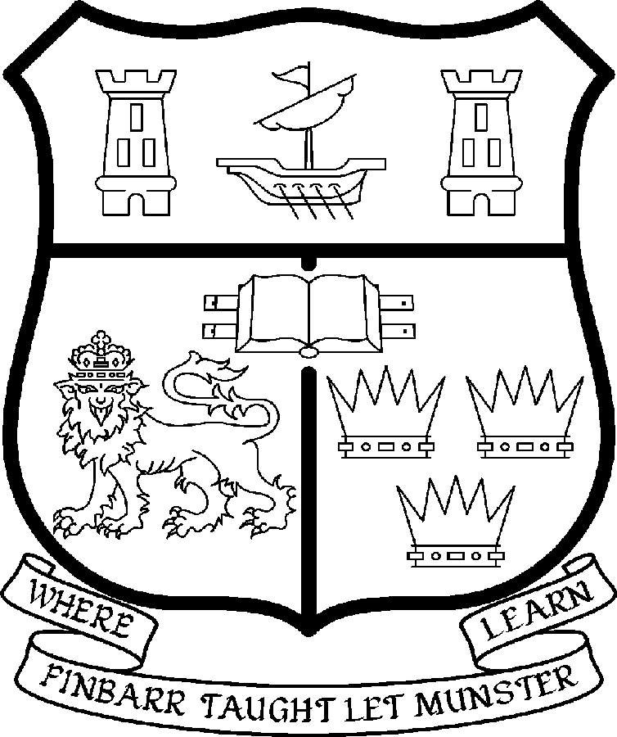 | UNIVERSITY COLLEGE CORK  Coláiste na hOllscoile Corcaigh
POST OF LECTURER IN MUSIC (ETHNOMUSICOLOGY)

Particulars of Post

1. The Lecturer in Music is a permanent and whole-time post, based in the Department of Music in the College of Arts, Celtic Studies and Social Sciences.

The current remuneration – [new entrants] – is as detailed below. The appointment to the post of Lecturer in Music will be made at a point on the following scale in accordance with qualifications and experience to date.

 | € |  | €
Minimum | 35,610 | Eighth Point | 50,396
Second Point | 37,674 | Ninth Point | 52,640
Third Point | 40,036 | Tenth Point | 54,348
Fourth Point | 42,068 | Eleventh Point | 56,095
Fifth Point | 44,203 | Maximum | 57,847
Sixth Point | 46,453
Seventh Point | 48,246

The salary includes a premium of 1/19th for pensionable staff paying contributions. Class A1 rate of Pay Related Social Insurance (PRSI) applies to the post which is currently 4% with an earnings ceiling of €50,700.

- Duties of the Post:

The duties of the Lecturer shall be to lecture in Music under the direction of the Head of the Department of Music for all degrees, diplomas and certificates of the University. He/she shall, in addition, discharge such other duties (including examining) appropriate to the office as shall be assigned to him/her by the Head of the Department of Music. In particular, the post holder shall be required to undertake the following responsibilities:

- He/she will plan, design and teach lecture and seminar courses for undergraduate students, under the supervision of the Head of the Department of Music.
- He/she will act as supervisor to undergraduate students preparing dissertations or other major-study options in his/her areas of expertise.
- He/she will teach portions of the MA in Ethnomusicology.
- He/she will act as supervisor to postgraduate students engaged in his/her areas of expertise.
- He/she will examine for the various programmes and courses he/she teaches and (where a double-marking scheme applies) for other courses as prescribed by the Head of the Department of Music.
- He/she will participate in staff committees and undertake administrative duties as assigned by the Head of the Department of Music.
- He/she will pursue research, and the publication of research, which may include specialised performance and/or composition work, so as to contribute to the Department’s research profile.

The above listing is not exclusive or exhaustive and the post holder may be required to undertake any such duties as may reasonably be expected. All staff are required to be flexible and co-operative and professional within the needs of the post and the Department, College and University. The University is undertaking a major reform of its internal structures which may necessitate possible future changes in the organisation of its activities.

3. Selection Criteria:

Decisions made at shortlisting, presentation and interview will be based on the following criteria:

Essential Criteria
The candidate will be expected:

- To hold a PhD (or an equivalent doctoral degree) in an area, or areas, of ethnomusicological research, or to show evidence of having submitted their doctoral thesis for examination by the time of application.
- To have been productive, and to remain actively engaged, in ethnomusicological research in his/her area(s) of expertise.
- To show a viable plan for producing research publications over the next few years, which may include specialised performance and/or composition work.
- To be self-motivated and demonstrate good communication skills.
- To have the ability to work effectively in a multidisciplinary staff team.

Desirable Criteria:

- Research expertise in Irish traditional music may an advantage.
- Performance expertise in Irish traditional music may be an advantage.
- An interest in developing performance studies in connection with the candidate’s field(s) of expertise may be an advantage.
- Existing research publications, which may include specialised performance and/or composition work.
- Prior experience of teaching at a university may be an advantage.
Candidates are requested to make a personal assessment of these criteria against their own qualifications, skills and abilities to assess whether they should apply for the post.

Presentations
Shortlisted candidates will be expected to give short seminar-style presentations during the day prior to the day of the interviews. Each candidate will give a 20-minute presentation on their research (or an aspect of their research), prepared as if the audience comprised final-year undergraduates and new postgraduates, and take questions from the audience afterwards (maximum 10 minutes).

Sample publications
Shortlisted candidates will also be expected to submit, in advance of the interviews, two samples of their recent research publications (which may include specialised performance and/or composition work). In the case of a candidate who has not yet published, the samples may be publications in press or in preparation, or unpublished material (e.g. a chapter from their doctoral thesis).

- The normal Statutory or other provisions relating to full-time Lectureships and Senior Lectureships shall apply to the post.

- Each candidate must complete an application form, which can be downloaded at
http://www.ucc.ie/en/hr/FormsContractDocuments/DocumentFile,35042,en.doc

- Candidates for posts shall be required to appear in person before a Board of Assessors in Cork, in which case travelling and subsistence expenses at approved rates will be paid.

- A successful candidate will be required to submit a birth certificate, documentary evidence confirming academic qualifications, and to undergo a medical examination.

- References will be sought in relation to all candidates invited to attend for interview

- An offer of appointment to a candidate who is not EU nationality is subject to the granting of a Work Permit by the Department of Enterprise Trade & Employment.

- Candidates may be required to produce documentary evidence to support any statements made by them on their application form or any supporting documentation. Candidates should note that any inaccurate information will invalidate their application.

- Completed application forms must reach Recruitment Office, Department of Human Resources, University College, Cork, Ireland, on or before 4th of April 2008. Tel: +353-21-4902671 Email: recruitment@per.ucc.ie. Fax. +353-21-4276995.

UNIVERSITY COLLEGE CORK IS AN EQUAL OPPORTUNITIES EMPLOYER
GENERAL INFORMATION FOR CANDIDATES

Introduction to University College Cork

University College Cork, a constituent University of the National University of Ireland, is a collegiate, progressive, dynamic research-led university developing a reputation as a world class regional university, built on the history of significant achievements in teaching and learning and research, and strong academic and professional leadership.

The University has a current enrolment of over 17,000 students with a strategic objective of 21,000 by 2011. UCC currently has 1,400 academic and research staff within a total staff compliment of 2,500.

Founded in 1845, as Queen’s College, Cork, UCC is one of Ireland’s oldest institutions of higher learning. The rich history and tradition of UCC is reflected in the imposing limestone buildings of the Main Quadrangle and the mature grounds. UCC’s scenic city centre campus, boasting award-winning architecture, provides a pleasant and vibrant learning environment, which is given an international dimension by the presence of 2,000 international students and many staff from over 75 countries around the world.

UCC is one of the premier research institutions in the State and its research income is consistently one of the highest in the country. The University earns peer-reviewed research income in excess of €60m per annum, has strategic research partnerships with leading multinationals in the agri-food, microelectronics, and pharmaceutical sectors, and is home to 5 of Ireland’s 8 ISI Most Highly Cited authors. The university’s research reputation spans across the broad range of disciplines, strategically built around a number of internationally-recognised Research Institutes, Centres and Departments.

UCC is fully committed to the development of 4th level training and research through the introduction of Graduate Schools and structured PhD programmes and the provision of a wide range of generic and discipline-specific modules supporting the research activity of PhD students. The University offers an innovative, research-led curriculum, taught by world-class academics who consistently attract a quality student intake.
Recent institutional reorganisation has established four Colleges; Arts, Celtic Studies and Social Sciences; Business and Law; Medicine and Health; Science, Engineering and Food Science. The Colleges offer over 120 degree and professional programmes that consistently attract the highest proportion of top school leavers in the country and supports a rapidly growing postgraduate and international student body.

The University has embarked on a programme of development for UCC to firmly establish it as a world-class regional university building on the guiding principles in the University’s Strategic Framework 2006-2011 of excellence in teaching, learning, research and contribution to community and society. UCC will focus on research performance, the quality of the student experience and the manner in which the institution discharges its regional role.

Having twice being designated as the Sunday Times “Irish University of the Year” in the past four years, UCC is also a recent proud recipient of the “Excellence Through People” Gold Standard.

The last five years have seen exceptional growth in student numbers, award winning capital developments supporting science, technology and the arts and significant success in winning research funding, making it in that time the most research active institution in the country.

UCC enjoys excellent links with local business and enterprise along with strong partnerships with some of the world’s most highly valued companies. Relationships with professional and public bodies across a wide range of disciplines are equally a key feature of the University.

Internationalisation of the campus continues to be a key strategic objective of UCC. International enrolment at UCC is among the highest in the sector creating a multi- cultural and ethnically diverse student body and measures taken by UCC to enhance conditions for international student recruitment are regarded as among the best practices by peer institutions. UCC also provides opportunities for Irish students to study overseas making them competitive in a global market. In recent years new exchange opportunities include academic placements in a diverse range of European, US, Canadian and Australian universities, with new developments targeting China.

Staff are essential to the achievement of our mission and UCC places a special emphasis on quality improvement strategies in Human Resource Management. A key objective of the UCC Strategic Framework 2006-2011 is to attract, develop and retain outstanding staff through the development and implementation of best practice HR policies and procedures. We seek to develop staff capable of keeping the University at the forefront in all that it does. The University has committed to establishing a supportive working environment in which the needs of all staff are recognised and their contributions valued and rewarded.

Web Links
UCC website
http://www.ucc.ie/en/

UCC Strategic Plan 2006-2011
http://www.ucc.ie/en/PresidentsOffice/UCCsStrategicPlan/DocumentFile,1005,en.pdf

University College Cork is an Equal Opportunities Employer

Information on the Department of Music at University College Cork (UCC)

The Department of Music at UCC is committed to the cultivation through creativity in teaching, research, composition and performance of a dynamic learning community dedicated to an interdisciplinary and cross-cultural understanding of music.

The Department today, and its mission

UCC's Department of Music is a highly successful department, much in demand as a destination for international students as well as students from all over the island of Ireland. Confident in its outlook, it continues to build on its long-standing tradition of pioneering innovative approaches to the study of music and creativity in music. As reflected in its Mission Statement, quoted above, the Department has a vision in which creativity and exploration are the primary characteristics of all that it does, a vision in which the Department inhabits a dynamic place, both actual and virtual, in which disciplines concerning music and culture intersect and inform each other. It is an Irish department with a world perspective – a fact reflected in its staffing and in the breadth and diversity of its curriculum. At the heart of our degree programmes is the fundamental view that all kinds of music are equally valid. All are worthy of study; all are worthy of performance. If it is right to study Western music, then it is equally right to study non-Western music. Since it is right to study the music of Ireland, it is equally right to study music beyond Ireland. We make the same claim for today’s music and music of the past; for types of popular music, art music and traditional music; and for music that is notated, or not notated, or which requires modern technologies for its existence. Naturally, no programme of study has time enough for all that music offers, but the breadth of our curriculum ensures that our students will regard the subject with broad horizons.

In recent years the Department has grown considerably – not only physically (its relocation in 2000 to larger premises) but also in its recruitment of students and the expansion of its mission and activities. This has included growth and development in areas of our curriculum and research, notably ethnomusicology (and a reorientation, within the discipline of ethnomusicology, of studies in traditional Irish music); jazz and other kinds of popular music; composition and new music; music technology and information technology; film music; and early-music studies.

In 2004-5 the Department underwent a Quality Review (mandatory every six years), achieving an excellent outcome. In that review, the following were acknowledged to be among the strengths of the Department:

- The Department exists in a tradition of reflection and innovation, providing leadership and an unique voice in Ireland’s university sector.
- An excellent staff team, diversely skilled yet united in approach; a team that is creative, open to new ideas, and caring of its students.
- A rich, diverse curriculum and highly flexible system of course options, delivering teaching informed by staff-members’ experience in research, professional performance and composition.
- A department that is friendly and welcoming, good at communicating with students and the public.
- Good management structures and information systems.

The primary aims of the Department of Music are to achieve excellence in teaching/learning, scholarship, performance and composition; and to live up to the commitment in its Mission Statement. To those may be added the Department’s aims that are particular to its students and staff and the other constituencies it serves:

- For its students: to provide a sound and stimulating learning environment that is safe and encouraging for exploration.
- For its staff: to provide a working environment that is professional and friendly, and a research environment that is vibrant and supportive.
- For the university: to provide an educational model of curricular diversity and innovation, contributing to intellectual leadership in the arts and humanities.
- For the discipline of music: to develop and disseminate new ideas and practices in the study and realization of music.
- For society locally and at large: to be a flagship for the understanding of music, culture and human creativity, and for positive integration at this time of changing demographics.

The Music Building

In May 2000, the Department moved to a large, extensively refurbished building: the former St Vincent’s Monastery on Sunday’s Well Road, commanding panoramic views over the river Lee, the west of the city and UCC’s main campus. This relocation has provided excellent accommodation, including a recital hall, lecture and teaching rooms, an ensemble room and practice rooms, archives devoted to traditional music and traditional dance, a sound studio and other rooms dedicated to computing and audio-visual facilities. The appointment in 2002 of a full-time IT technician was part of a significant expansion in the Department’s commitment, following that relocation, to providing improved computing and internet facilities for all students and staff (including a major development of online services), and to developing further its sound studio for creative work and specialized projects in music technology.

Students, Programmes, Staff

The Department admits over seventy students a year to its undergraduate degree programmes, and in 2007-8 has over 200 students taking Music to degree level through the four-year BMus programme or through the various paths of the three-year BA Arts-Music and BA Arts programmes. In addition, approximately 250 international visiting students per year take some modules in Music. The Department also offers postgraduate degrees in research and composition (MPhil and PhD), the MA in Ethnomusicology, the Higher Diploma in Arts (Music) and the Diploma in Irish Traditional Music. New MA programmes are being introduced in 2008: an MA in Music and Cultural History, and an MA in Composition. The current staffing of the Department includes twelve lecturers (variously fulltime and part-time), a fulltime administrator, a fulltime technician and a large number of part-time tutors.

Music making

Students of the Department participate in a rich variety of music making, including performance on the Javanese gamelan, sessions of traditional Irish music, early music (focussing principally on vocal and instrumental chamber music of the period 1500-1700), weekly evenings of jazz, improvisation workshops, and composition showcases. The Department possesses numerous instruments that students may avail of, including keyboard instruments (pianos, harpsichords, organs), drum kits and other percussion, traditional Irish instruments, some baroque instruments, some African and Indian instruments, and, uniquely in Ireland, a digital carillon and a full Javanese gamelan.

In addition to arranging for the numerous performances that take place within degree programmes, the Department promotes public events as a service both to the university and to the community at large. Two series of weekly lunchtime concerts run throughout the main terms of the academic year, one in Irish music, the other in various kinds of music. A number of concerts are given each year by the university’s ensemble-in-residence, the RTÉ Vanbrugh String Quartet.

The Department also hosts conferences and promotes occasional festivals of music. In May 2005, for example, it hosted the annual conference of the Society for Musicology in Ireland, dovetailing this with a weekend festival of music. Planned for 2009 is a major conference on improvisation.

Ethnomusicology at UCC

Ethnomusicology has been taught at UCC for more than twenty years. In the 1980s, ethnomusicology emerged within the Department’s vision as the natural academic foundation for a nascent scholarship in Irish traditional music that we had long been developing. Since that time the study of ethnomusicology has undergone significant development at UCC and the university is now the leading centre for ethnomusicological research and teaching in Ireland. The Department currently employs three ethnomusicologists and promotes research, teaching and performance of music in its cultural, aesthetic and historical contexts. The Department offers graduate and undergraduate modules in the history, theory and practice of ethnomusicology. Staff offer area-studies courses with primary geocultural concentrations in Ireland, Indonesia, India, North Africa and the Arab world. Fulltime staff work alongside a team of tutors and visiting artists to present a wide range of solo and ensemble performance options at graduate and undergraduate level, including Irish traditional music ensembles and solo performance, Javanese gamelan, West African drumming, South Indian solkattu and Afro-Cuban music. The Department offers a one-year fulltime taught MA in Ethnomusicology and MPhil and PhD research degrees in the area.

To find further information about the Department, visit www.music.ucc.ie
For informal discussion about the post being appointed, contact the Head of Department, Dr Paul Everett, tel. +353 21 490 4530, email p.everett@ucc.ie

