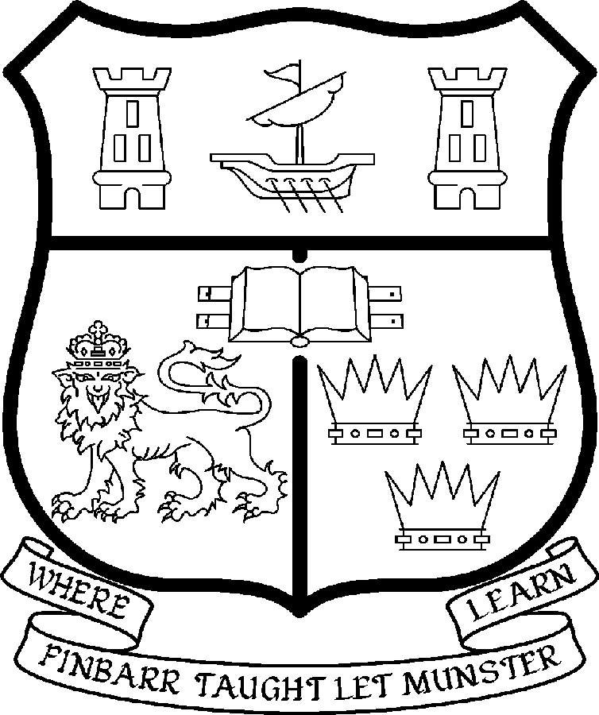 | UNIVERSITY COLLEGE CORK  Coláiste na hOllscoile Corcaigh
PROFESSORSHIP OF HISPANIC STUDIES

Particulars of Post

- The Professorship of Hispanic Studies is a permanent whole-time office. The current annual stipend of the Professorship – [new entrants] - is as follows:

€
Minimum 111,286
Second Point 117,666
Third Point 124,046
Fourth Point 130,428
Fifth Point 136,810
Maximum 143,193

- The salary includes a premium of 1/19th for pensionable staff paying contributions. Class A1 rate of Pay Related Social Insurance (PRSI) applies to the post. The rate is currently 4% on the first €50,700 of annual earnings.

- Duties of the Post: The duties of the Professor shall be to lecture in Hispanic Studies for all relevant degrees, diplomas and certificates of the University under the direction of the Head of the Department of Hispanic Studies. In addition the Professor of Hispanic Studies will be expected:

- To be responsible for providing leadership in the development of the discipline of Hispanic Studies;

- To play a significant role in the development of postgraduate studies (especially at PhD level) within the College of Arts, Celtic Studies and Social Sciences at UCC;

- To represent the discipline both inside and outside the university;

- To act as a role model for colleagues and support them in their teaching and research;

- To undertake research in the subject;

- To interact with the teaching and research activities of the School of Languages, Literatures and Cultures, the College of Arts, Celtic Studies and Social Sciences and elsewhere in the University as appropriate, relevant to his/her academic expertise;

- To serve as Head of Department/discipline subject to relevant legislation, university statutes and management requirements;

- To examine in Hispanic Studies for the university and carry out other duties appropriate to the post that may be assigned by the Head of the School of Languages, Literatures and Cultures in the College, and within the discipline of Hispanic Studies, to carry out such duties as may be assigned by the head of discipline/school.

The above listing is not exclusive or exhaustive and the post holder may be required to undertake any such duties as may reasonably be expected. All staff are required to be flexible and co-operative and professional within the needs of the post and the Department/School, College and University. The University is undertaking a major reform of its internal structures which may necessitate possible future changes in the organisation of its activities.

- Selection Criteria

The successful candidate will be expected to have:

- A doctoral qualification in a relevant field;

- An internationally established scholarly and research reputation in an area of Hispanic Studies as evidenced by a distinguished record of publications;

- The ability to provide vision and leadership in the development of the discipline of Hispanic Studies within the strategic frameworks of the College of Arts, Celtic Studies and Social Sciences and the university;

- Interpersonal skills commensurate with working with a team of committed academic and administrative colleagues in the College of Arts, Celtic Studies and Social Sciences;

- A successful record of postgraduate supervision to doctorate level;

- An outstanding record of teaching and curriculum development and a willingness to contribute to a broad range of the topics taught by the department at undergraduate and postgraduate levels;

- The capacity to serve as head of department/discipline or head of school together with the requisite communication, management, administrative and leadership skills;

- The skills to represent the department and the discipline both inside and outside the university;

- Ability to participate in and contribute to the overall intellectual life of the College of Arts, Celtic Studies and Social Sciences, the university and where relevant the wider community;

- Ability to represent the discipline as appropriate at national and international level;

- Ability to communicate effectively and evidence of appropriate competence in spoken and written English.

The appointee will be expected to have native or near native fluency in Spanish and/or in another Hispanic language.

It is also desirable for candidates to have an ability to generate research income.

Candidates are requested to make a personal assessment of these criteria against their own qualifications, skills and abilities to assess whether they should apply for the post.

General Provisions

- The “Statutory and other provisions relating to full-time Professorships” as set out in the attached shall also apply to the post.

- The University is undertaking a major reform of its internal structures which may necessitate possible future changes in the organisation of its activities.

- Each candidate must complete an application form, which can be downloaded at:
http://www.ucc.ie/en/hr/FormsContractDocuments/DocumentFile,35042,en.doc

- Candidates for this post shall be required to appear in person before a Board of Assessors in Cork, in which case travelling and subsistence expenses at approved rates will be paid.

- A successful candidate will be required to submit a birth certificate and documentary evidence confirming academic qualifications, and to undergo a medical examination.

- References will be sought in relation to all candidates invited to attend for interview.

- An offer of appointment to a candidate who is not of EU nationality is subject to the granting of a Work Permit by the Department of Enterprise Trade & Employment.

- Candidates may be required to produce documentary evidence to support any statements made by them on their application form or any supporting documentation. Candidates should note that the submission of any inaccurate information will invalidate their application.

- Completed application forms must reach Recruitment Office, Department of Human Resources, University College, Cork, Ireland, on or before Friday 9th May 2008. Tel: +353-21-4902671 Email: recruitment@per.ucc.ie. Fax. +353-21-4276995.

UNIVERSITY COLLEGE CORK IS AN EQUAL OPPORTUNITIES EMPLOYER

GENERAL INFORMATION FOR CANDIDATES

Introduction to University College Cork

University College Cork, a constituent University of the National University of Ireland, is a collegiate, progressive, dynamic research-led university developing a reputation as a world class regional university, built on the history of significant achievements in teaching and learning and research, and strong academic and professional leadership.

The University has a current enrolment of over 17,000 students with a strategic objective of 21,000 by 2011. UCC currently has 1,400 academic and research staff within a total staff compliment of 2,500.

Founded in 1845, as Queen’s College, Cork, UCC is one of Ireland’s oldest institutions of higher learning. The rich history and tradition of UCC is reflected in the imposing limestone buildings of the Main Quadrangle and the mature grounds. UCC’s scenic city centre campus, boasting award-winning architecture, provides a pleasant and vibrant learning environment, which is given an international dimension by the presence of 2,000 international students and many staff from over 75 countries around the world.

UCC is one of the premier research institutions in the State and its research income is consistently one of the highest in the country. The University earns peer-reviewed research income in excess of €60m per annum, has strategic research partnerships with leading multinationals in the agri-food, microelectronics, and pharmaceutical sectors, and is home to 5 of Ireland’s 8 ISI Most Highly Cited authors. The university’s research reputation spans across the broad range of disciplines, strategically built around a number of internationally-recognised Research Institutes, Centres and Departments.

UCC is fully committed to the development of 4th level training and research through the introduction of Graduate Schools and structured PhD programmes and the provision of a wide range of generic and discipline-specific modules supporting the research activity of PhD students. The University offers an innovative, research-led curriculum, taught by world-class academics who consistently attract a quality student intake.
Recent institutional reorganisation has established four Colleges; Arts, Celtic Studies and Social Sciences; Business and Law; Medicine and Health; Science, Engineering and Food Science. The Colleges offer over 120 degree and professional programmes that consistently attract the highest proportion of top school leavers in the country and supports a rapidly growing postgraduate and international student body.

The University has embarked on a programme of development for UCC to firmly establish it as a world-class regional university building on the guiding principles in the University’s Strategic Framework 2006-2011 of excellence in teaching, learning, research and contribution to community and society. UCC will focus on research performance, the quality of the student experience and the manner in which the institution discharges its regional role.

Having twice being designated as the Sunday Times “Irish University of the Year” in the past four years, UCC is also a recent proud recipient of the “Excellence Through People” Gold Standard.

The last five years have seen exceptional growth in student numbers, award winning capital developments supporting science, technology and the arts and significant success in winning research funding, making it in that time the most research active institution in the country.

UCC enjoys excellent links with local business and enterprise along with strong partnerships with some of the world’s most highly valued companies. Relationships with professional and public bodies across a wide range of disciplines are equally a key feature of the University.

Internationalisation of the campus continues to be a key strategic objective of UCC. International enrolment at UCC is among the highest in the sector creating a multi- cultural and ethnically diverse student body and measures taken by UCC to enhance conditions for international student recruitment are regarded as among the best practices by peer institutions. UCC also provides opportunities for Irish students to study overseas making them competitive in a global market. In recent years new exchange opportunities include academic placements in a diverse range of European, US, Canadian and Australian universities, with new developments targeting China.

Staff are essential to the achievement of our mission and UCC places a special emphasis on quality improvement strategies in Human Resource Management. A key objective of the UCC Strategic Framework 2006-2011 is to attract, develop and retain outstanding staff through the development and implementation of best practice HR policies and procedures. We seek to develop staff capable of keeping the University at the forefront in all that it does. The University has committed to establishing a supportive working environment in which the needs of all staff are recognised and their contributions valued and rewarded.

Web Links
UCC website
http://www.ucc.ie/en/

UCC Strategic Plan 2006-2011
http://www.ucc.ie/en/PresidentsOffice/UCCsStrategicPlan/DocumentFile,1005,en.pdf

Department of Hispanic Studies Website
http://www.ucc.ie/en/hispanicstudies/

University College Cork is an Equal Opportunities Employer
Information on the Department of Hispanic Studies

The Department of Hispanic Studies is one of the constituent disciplines of the School of Languages, Literatures and Cultures within the College of Arts, Celtic Studies and Social Sciences. It should be noted that, in line with the strategic framework of University College Cork, the title of the Department will change shortly to that of the Discipline of Hispanic Studies. The other modern languages represented within the School are French, German and Italian. There are strong links between the Department and other Schools within the College, such as those of History, Irish and Celtic Studies, English, History and Human Environment. Generally, there is a strong ethos of support for foreign languages within the College as evidenced, for example, by the recent establishment of Chinese Studies.

The main strategic objective of the Department of Hispanic studies is to maintain its status as a centre of excellence for the study of Hispanic languages and cultures and to build on its growing national and international reputation. The Department offers a diverse range of modules to undergraduate and postgraduate students, modules to undergraduate and postgraduate students, covering virtually all areas of the discipline from medieval and Golden-Age literature, to contemporary Peninsular literature and culture, Latin-American, particularly Mexican, culture and politics, Film Studies, the history of the Spanish language and linguistics. Particular emphasis is placed on high-quality language teaching. In addition to core modules on the Spanish language, the Department also offers optional modules in Portuguese, Catalan and Galician.

The Department is currently staffed by four academic lecturers and four language teachers all of whom offer a range of modules reflective of their particular areas of expertise. Students take Hispanic Studies under a number of degree programmes, including BA (Arts), BA (Language & Cultural Studies), BA (European Studies), B Commerce (International), BA (Applied Psychology), BA (Drama and Theatre Studies), BA (Chinese Studies). Student numbers for each programme vary but the average overall first-year intake is 150 students (beginners and non-beginners) with about half of that number normally taking the subject to degree level.

The Department is committed to developing its expanding postgraduate studies programme. Currently (2007-2008) nine students are registered for the MA (one-year taught programme), one for the MPhil and there are eight PhD students. In accordance with the strategic plan of the College of Arts, Celtic Studies and Social Sciences, it is envisaged that postgraduate programmes will undergo significant development and expansion.

The Department of Hispanic Studies is very conscious of the growing need to make its courses available to what may be considered ‘non-traditional’ learning constituencies. Consequently, in the last few years, a number of outreach initiatives have been developed. These include the introduction in 2003 of a two-year Post-Graduate Teaching Diploma and the expansion of Evening Courses in Spanish and Portuguese.

The Department is actively involved in several Interdisciplinary programmes such as the MA (Film Studies) and the MA (Women’s Studies) and the MA (Drama and Theatre Studies), as well as both co-ordinating and teaching on a generic postgraduate Research Methods module. The Department also offers Spanish as part of the ‘Languages for All’ programme in UCC. Currently, under this programme, there are four groups taking Spanish at beginners’ level and two more advanced groups, with approximately 120 students from Food Business, Engineering, Government, Computer Science, Social Science and Law.

The Department of Hispanic Studies maintains active links with the Instituto Cervantes, the Institut Ramon Llull, the Xunta de Galicia, the Hispanic Society of America, and the Royal Galician Academy. Exchange-partner universities under the Socrates programme include the Universities of Alicante, Burgos, Deusto (Bilbao), Barcelona (Central), Alcalá, Santiago de Compostela, A Coruna. Also, via its European Studies programme, students are sent to Universities of Cádiz, Salamanca and Valladolid. Under an agreement with the Government of Mexico, an exchange programme with the Universidad de Guadalajara has recently been established.

http://www.ucc.ie/en/hispanicstudies/

