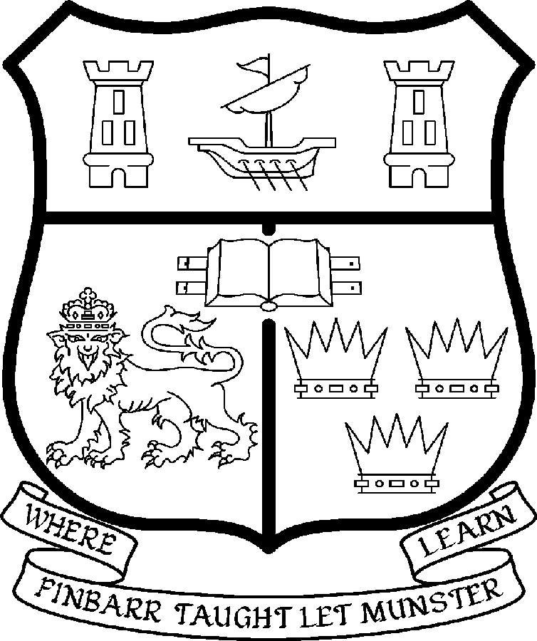 | UNIVERSITY COLLEGE CORK  Coláiste na hOllscoile Corcaigh
POST OF Lectureship in Medieval History

Particulars of Post

1. The Lectureship in Medieval History is a permanent and whole-time post, based in the Department of History in the College of Arts, Celtic Studies and Social Science (CACSSS). The appointee shall work under the direction of the Head of the Department of History and shall discharge such duties as shall be assigned to him/her by the said Head.

The current remuneration – [new entrants] – is as detailed below. The appointment to the post of Lectureship in Medieval History will be made at a point on the following scale in accordance with qualifications and experience to date.

 | € |  | €
Minimum | 35,610 | Eighth Point | 50,396
Second Point | 37,674 | Ninth Point | 52,640
Third Point | 40,036 | Tenth Point | 54,348
Fourth Point | 42,068 | Eleventh Point | 56,095
Fifth Point | 44,203 | Maximum | 57,847
Sixth Point | 46,453
Seventh Point | 48,246

The salary includes a premium of 1/19th for pensionable staff paying contributions. Class A1 rate of Pay Related Social Insurance (PRSI) applies to the post which is currently 4% with an earnings ceiling of €50,700.

- Duties of the Post:

Teaching
- To teach and examine on existing courses at the undergraduate (from first to final year) and postgraduate level;
- To supervise undergraduate and postgraduate students;
- To engage in student assessment;
- To engage in the regular evaluation and development of modules in terms of content, delivery and assessment;
- To develop new courses and teaching materials;

Research
- To engage actively in research and publish the research results in appropriate peer reviewed professional journals;
- To engage in individual research, participate in the Department’s research activities and contribute to interdisciplinary research programmes where appropriate;
- To engage in initiatives in generating research income;

Contribution
- To contribute to the administrative duties of the department and the academic life of the College;
- To act as a member of such committees as may be required;
- To develop professional links with outside bodies where appropriate.

The above listing is not exclusive or exhaustive and the post holder may be required to undertake any such duties as may reasonably be expected. All staff are required to be flexible and co-operative and professional within the needs of the post and the Department, College and University. The University is undertaking a major reform of its internal structures which may necessitate possible future changes in the organisation of its activities.

3. Selection Criteria

Decisions made at shortlisting, presentation and interview will be made based on the following criteria:

  - Essential Criteria:
The successful candidate will:
- Have a doctorate in History;
- Have a research specialism in European cultural and religious history within the 12th to the 15th centuries;
- Complement the existing research strengths in the department and extend them into late Continental Medieval Europe;
- Have a strong publication record and a clearly-defined body of research;
- Have a proven undergraduate teaching record;
- Be willing to contribute to the teaching of existing courses and programmes;
- Be capable of teaching on a range of material outside of her/his area of specialisation;
- Have proven communication skills and have demonstrated the ability to work as a member of a team.

3.2 Desirable Criteria:
- Proven administrative experience;
- Commitment to the long term development of the discipline in UCC;
- Proven ability or demonstrated potential to attract funding through competitive research grants;
- Willingness to contribute to the existing Departmental research projects and programmes in the medieval field.

Candidates are requested to make a personal assessment of these criteria against their own qualifications, skills and abilities to assess whether they should apply for the post.

- The normal Statutory or other provisions relating to full-time Lectureships and Senior Lectureships shall apply to the post.

- Each candidate must complete an application form which can be downloaded at
http://www.ucc.ie/en/hr/FormsContractDocuments/DocumentFile,35042,en.doc

- Short-listed candidates for posts shall be required to appear in person before a Board of Assessors in Cork, in which case travelling and subsistence expenses at approved rates will be paid.

- The successful candidate will be required to submit a birth certificate, documentary evidence confirming academic qualifications, and to undergo a medical examination.

- References will be sought in relation to all candidates invited to attend for interview

- An offer of appointment to a candidate who is not EU nationality is subject to the granting of a Work Permit by the Department of Enterprise Trade & Employment.

- Candidates may be required to produce documentary evidence to support any statements made by them on their application form or any supporting documentation. Candidates should note that any inaccurate information will invalidate their application.

- Completed application forms must reach Recruitment Office, Department of Human Resources, University College, Cork, Ireland, on or before Friday, 18th April 2008. Tel: +353-21-4902671 Email: recruitment@per.ucc.ie. Fax. +353-21-4276995.

UNIVERSITY COLLEGE CORK IS AN EQUAL OPPORTUNITIES EMPLOYER
GENERAL INFORMATION FOR CANDIDATES

Introduction to University College Cork

University College Cork, a constituent University of the National University of Ireland, is a collegiate, progressive, dynamic research-led university developing a reputation as a world class regional university, built on the history of significant achievements in teaching and learning and research, and strong academic and professional leadership.

The University has a current enrolment of over 17,000 students with a strategic objective of 21,000 by 2011. UCC currently has 1,400 academic and research staff within a total staff compliment of 2,500.

Founded in 1845, as Queen’s College, Cork, UCC is one of Ireland’s oldest institutions of higher learning. The rich history and tradition of UCC is reflected in the imposing limestone buildings of the Main Quadrangle and the mature grounds. UCC’s scenic city centre campus, boasting award-winning architecture, provides a pleasant and vibrant learning environment, which is given an international dimension by the presence of 2,000 international students and many staff from over 75 countries around the world.

UCC is one of the premier research institutions in the State and its research income is consistently one of the highest in the country. The University earns peer-reviewed research income in excess of €60m per annum, has strategic research partnerships with leading multinationals in the agri-food, microelectronics, and pharmaceutical sectors, and is home to 5 of Ireland’s 8 ISI Most Highly Cited authors. The university’s research reputation spans across the broad range of disciplines, strategically built around a number of internationally-recognised Research Institutes, Centres and Departments.

UCC is fully committed to the development of 4th level training and research through the introduction of Graduate Schools and structured PhD programmes and the provision of a wide range of generic and discipline-specific modules supporting the research activity of PhD students. The University offers an innovative, research-led curriculum, taught by world-class academics who consistently attract a quality student intake.
Recent institutional reorganisation has established four Colleges; Arts, Celtic Studies and Social Sciences; Business and Law; Medicine and Health; Science, Engineering and Food Science. The Colleges offer over 120 degree and professional programmes that consistently attract the highest proportion of top school leavers in the country and supports a rapidly growing postgraduate and international student body.

The University has embarked on a programme of development for UCC to firmly establish it as a world-class regional university building on the guiding principles in the University’s Strategic Framework 2006-2011 of excellence in teaching, learning, research and contribution to community and society. UCC will focus on research performance, the quality of the student experience and the manner in which the institution discharges its regional role.

Having twice being designated as the Sunday Times “Irish University of the Year” in the past four years, UCC is also a recent proud recipient of the “Excellence Through People” Gold Standard.

The last five years have seen exceptional growth in student numbers, award winning capital developments supporting science, technology and the arts and significant success in winning research funding, making it in that time the most research active institution in the country.

UCC enjoys excellent links with local business and enterprise along with strong partnerships with some of the world’s most highly valued companies. Relationships with professional and public bodies across a wide range of disciplines are equally a key feature of the University.

Internationalisation of the campus continues to be a key strategic objective of UCC. International enrolment at UCC is among the highest in the sector creating a multi- cultural and ethnically diverse student body and measures taken by UCC to enhance conditions for international student recruitment are regarded as among the best practices by peer institutions. UCC also provides opportunities for Irish students to study overseas making them competitive in a global market. In recent years new exchange opportunities include academic placements in a diverse range of European, US, Canadian and Australian universities, with new developments targeting China.

Staff are essential to the achievement of our mission and UCC places a special emphasis on quality improvement strategies in Human Resource Management. A key objective of the UCC Strategic Framework 2006-2011 is to attract, develop and retain outstanding staff through the development and implementation of best practice HR policies and procedures. We seek to develop staff capable of keeping the University at the forefront in all that it does. The University has committed to establishing a supportive working environment in which the needs of all staff are recognised and their contributions valued and rewarded.

Web Links
UCC website
http://www.ucc.ie/en/

UCC Strategic Plan 2006-2011
http://www.ucc.ie/en/PresidentsOffice/UCCsStrategicPlan/DocumentFile,1005,en.pdf

University College Cork is an Equal Opportunities Employer

Information on the Department of History

The Department has a strong research ethos covering specialisations from early Ireland to the twentieth-century. The research profile, which can be accessed on the departmental website, displays the breadth and range of topics being actively researched by the staff in Irish, European and international history.

The publication record of the Department is very strong. A list of the recent monographs and edited works may be found on the website.

A number of departmental staff have been the recipients of international awards and fellowships including IRCHSS, Fulbright, Woodrow Wilson Centre and other awards.

The research and teaching excellence of the Department has been acknowledged in a recent quality review. That report may also be found on the college website.

The teaching staff of the Department of History normally includes two professors, and twenty two full-time and part-time lecturers. In recent years about 350 students have taken History as one of four subjects in the first year of the three-year BA Degree, and about 260 have continued into the two-subject second and third year, including up to 400 ‘non-traditional’ students. In addition, about 30 students have pursued a four-year BA Evening Degree. The Department also participates in the teaching of the following four-year degree programmes:

- European Integration Studies
- Language and Cultural Studies

Departmental staff also contribute to the teaching of the degree subjects:

- History of Art
- Politics
- Diplomas in Adult and Continuing Education
- The Department of History coordinates the subject Politics.

At Postgraduate level, the Department offers MPhil, MA and PhD programmes in the following areas:

- European Integration Studies
- Government & Politics in Twentieth-Century Ireland
- History of Irish Media and Journalism
- State, Culture and Identity in Ireland, 1500-1900
- The United States, Latin America and Europe
- History of the Irish Diaspora and Settlement
- International Relations
- Medieval History
- Local History

Departmental staff also participate in MA programmes in:

- Women Studies
- Medieval Monastic Culture
- Politics

Staff in the Department of History also run:

The Irish National Institute for Historical Research (INIHR).

The activities of the institute builds upon the fine traditions and practice of research and innovation within the Department. Set up by Professor Dermot Keogh, its initial programme has focused upon:

- Irish Identity and Ireland in the International System
- Imagining Ireland
- Tolerance, Intolerance and Sectarianism
- Aliens, Minorities and Outsiders in Irish History
- Hidden Histories
- Servants and Subverters of Empire
- History of Irish Migration

The INIHR also hosts conferences and helps extend the network of contacts with countries within the enlarged EU, India, the United States and Latin America.

The ArCH project, which will produce facsimiles of great Irish manuscripts together with commentaries, is also situated in the History Department.

In recent years, there have been about 50 MA students, 20 MPhils and 30 PhDs in any given year (plus 10 MA in Politics students in 2007). Graduate teaching and supervision therefore absorb a high proportion of staff time.

Apart from the personal contacts of staff members, many of whom have taught or researched abroad, the Department has a wide range of institutional international contacts. It was a founder member of the ERASMUS European Credit transfer System, which links it with more than twenty other European Universities. A year abroad in an appropriate university in France, Spain, Germany or Italy is a required part of the European Integration Studies Degree. The Department also participates in other Socrates/Tempus programmes, and in the Junior Year Abroad programmes of several American universities. Usually each year about 400 foreign students from fifteen countries attend our courses.

All staff are expected to engage in regular research and publication, as well as to foster the research interests of students. As core courses rely on team teaching, and as all staff are required to participate in joint teaching in seminars, an ability to cooperate with colleagues ranks as a high departmental priority.

As a Department of this size and complexity generates a great deal of administrative work, all members are expected to contribute to, and cooperate in, departmental administration, as well as participate in accordance with the policy of the university in relevant College and extra-collegial activities.

Prof. Dermot Keogh.

http://www.ucc.ie/academic/history/

