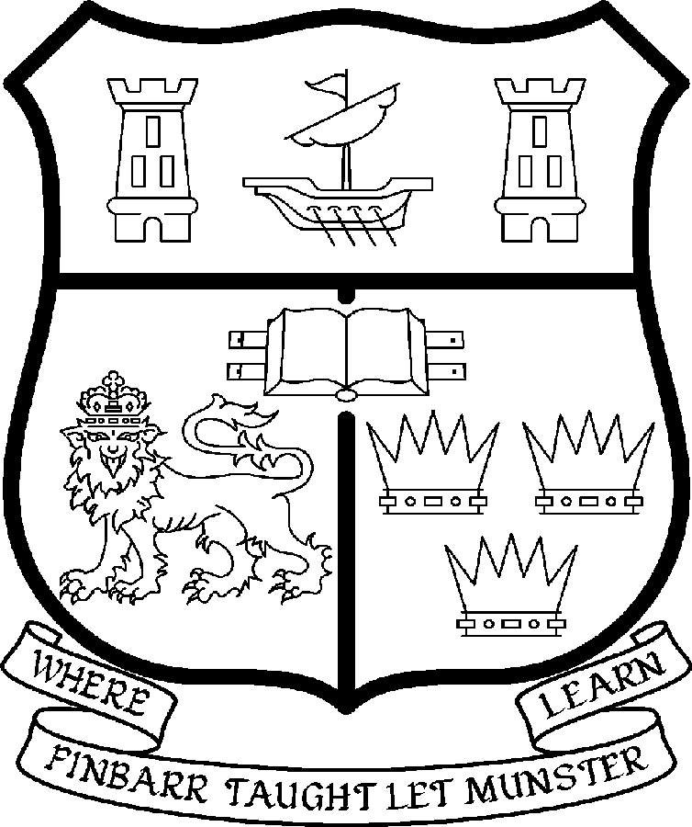 | UNIVERSITY COLLEGE CORK  Coláiste na hOllscoile Corcaigh
SENIOR LECTURER/LECTURER IN CLINICAL PHARMACY

Particulars of Post

The post is full-time and permanent. This Senior Lectureship/Lectureship is a joint appointment between the School of Pharmacy, UCC and the Townview Pharmacy Group Ltd, Mallow. The appointee to the post shall work under the direction of the Head of the School of Pharmacy and shall discharge such duties as shall be assigned to him/her by the said Head.

- The current remuneration – (new entrants) is detailed below both at Senior Lecturer and Lecturer levels. The appointment may be made at Senior Lecturer level only if a candidate merits appointment at this level on the basis of a distinguished research contribution. If no candidate achieves this standard in research, an appointment may be made at lecturer level.

The current remuneration – (new entrants) at Senior Lecturer level [new entrants] – is as detailed below. Appointment will be made on the following scale in accordance with qualifications and experience to date.

Senior Lecturer

Point | €
1 | 70,035
2 | 74,199
3 | 78,369
4 | 82,562
5 | 86,740
6 | 90,912
7 | 95,092
8 | 99,233

Should an appointment be made at the level of Lectureship, salary placement will be made at a point on the following scale in accordance with qualifications and experience to date. For appointments made below the BAR, there is provision for subsequent progression beyond the BAR in accordance with the terms of the Academic Promotions Scheme to a salary scale segment with a maximum of €85,592– [new entrants]

Point | €
1 | 36,500
2 | 38,616
3 | 41,037
4 | 43,120
5 | 45,308
6 | 47,614
7 | 49,452
8 | 51,656
9 | 53,956
10 | 55,707
11 | 57,497
12 | 59,293

BAR

Point | €
1 | 64,974
2 | 69,450
3 | 73,934
4 | 78,400
5 | 85,592

- The salary includes a premium of 1/19th for pensionable staff paying contributions. Class A1 rate of Pay Related Social Insurance (PRSI) applied to the post. The rate is currently 4% on the first €50,700 of annual earnings.

- Job Responsibilities

The duties of the appointee shall include undertaking teaching and examining under the direction of the Head of the School of Pharmacy as agreed with the Managing Director, Townview Pharmacy Group, Mallow. They shall, in addition, discharge other duties as shall be assigned to him/her. In particular, the post-holder shall be required to undertake the following responsibilities-:

- To teach and examine on existing courses at undergraduate and postgraduate level in Clinical Pharmacy.

- To develop an active research group.

- To supervise undergraduate/postgraduate students.

- To engage in research, publish the research results in appropriate professional journals and generate research income.

- To develop links with professional bodies and external agencies where possible.

- To contribute to the administrative duties in the School.

- To undertake role of Practice Development Pharmacist undertaking clinical research projects, of mutual interest and benefit to both Townview Pharmacy Ltd Group and the School of Pharmacy, University College Cork. This will comprise of 30% of the position. Exact details of how this commitment is to be fulfilled, is a matter for agreement between the successful candidate, the Managing Director, Townview Pharmacy Ltd and the Associate Professor of Clinical Pharmacy, within the overall knowledge and approval of the Head of the School of Pharmacy UCC. Clinical work may include patient contact for which the Townview Pharmacy Group Ltd, Mallow will provide clinical indemnity cover through the Clinical Indemnity Scheme. Clinical work will specifically NOT include dispensing duties within the pharmacy nor any rostered pharmacy duties.

The above is not exclusive or exhaustive and the post holder maybe required to undertake any such duties as may reasonably be expected. All staff are required to be flexible and co-operative and professional within the needs of the post and the School, College and University.
4. Selection Criteria:

Decisions made at shortlisting, presentation and interview will be made based on the following criteria:
- Applicants must have a Bachelor’s (Undergraduate) Degree in Pharmacy and a postgraduate qualification is essential.

- Previous experience in hospital/community practice will be expected and experience in teaching at third level is desirable.

- Applicants should be eligible for application to register with the Pharmaceutical Society of Ireland.

- Strong evidence of achievement in research including refereed publications is required.

- Proven ability to attract research funding.

- Excellent interpersonal skills.

- Good administrative skills.

- A clear vision for the new School of Pharmacy at UCC and the role of Clinical Pharmacy in the community.

- Evidence of ability to work on personal initiative.

- Evidence of a strong commitment to appropriate teamwork.

- Evidence of willingness to liaise with professional bodies.

Candidates are requested to make a personal assessment of these criteria against their own qualifications, skills and abilities to assess whether they should apply for the post.

5. The normal Statutory or other provisions relating to full-time Lectureships and Senior Lectureships shall apply to the post.

6. Each candidate must complete an application form, which can be downloaded at:
http://www.ucc.ie/en/hr/FormsContractDocuments/DocumentFile,35042,en.doc

- Candidates shortlisted for the post shall be required to appear in person before a Board of Assessors in Cork, in which case travelling and subsistence expenses at approved rates will be paid.

- A successful candidate will be required to submit a birth certificate, documentary evidence confirming academic qualifications, and to undergo a medical examination.

- References will be sought in relation to all candidates invited to attend for interview

- An offer of appointment to a candidate who is not EU nationality is subject to the granting of a Work Permit by the Department of Enterprise Trade & Employment.

- Candidates may be required to produce documentary evidence to support any statements made by them on their application form or any supporting documentation. Candidates should note that any inaccurate information will invalidate their application.

- Applications should be accompanied by an outline research programme (limited to two A4 pages).

- For informal discussion contact Professor Caitriona O’Driscoll, Head of School of Pharmacy. Email: pharmacy@ucc.ie Tel +353 21 490 1396
Or
Professor Peter Weedle Managing Director, Townview Pharmacy Group Ltd, Mallow, pweedle@iol.ie or phone (+353) 022 21343

- Completed application form must reach the Recruitment Office, Department of Human Resources, University College Cork, Ireland, on or before Friday 20th June 2008. Tel: +353-21-4902671 Email: recruitment@per.ucc.ie. Fax. +353-21-4276995.

UNIVERSITY COLLEGE CORK IS AN EQUAL OPPORTUNITIES EMPLOYER
GENERAL INFORMATION FOR CANDIDATES

Introduction to University College Cork

University College Cork, a constituent University of the National University of Ireland, is a collegiate, progressive, dynamic research-led university developing a reputation as a world class regional university, built on the history of significant achievements in teaching and learning and research, and strong academic and professional leadership.

The University has a current enrolment of over 17,000 students with a strategic objective of 21,000 by 2011. UCC currently has 1,400 academic and research staff within a total staff compliment of 2,500.

Founded in 1845, as Queen’s College, Cork, UCC is one of Ireland’s oldest institutions of higher learning. The rich history and tradition of UCC is reflected in the imposing limestone buildings of the Main Quadrangle and the mature grounds. UCC’s scenic city centre campus, boasting award-winning architecture, provides a pleasant and vibrant learning environment, which is given an international dimension by the presence of 2,000 international students and many staff from over 75 countries around the world.

UCC is one of the premier research institutions in the State and its research income is consistently one of the highest in the country. The University earns peer-reviewed research income in excess of €60m per annum, has strategic research partnerships with leading multinationals in the agri-food, microelectronics, and pharmaceutical sectors, and is home to 5 of Ireland’s 8 ISI Most Highly Cited authors. The university’s research reputation spans across the broad range of disciplines, strategically built around a number of internationally-recognised Research Institutes, Centres and Departments.

UCC is fully committed to the development of 4th level training and research through the introduction of Graduate Schools and structured PhD programmes and the provision of a wide range of generic and discipline-specific modules supporting the research activity of PhD students. The University offers an innovative, research-led curriculum, taught by world-class academics who consistently attract a quality student intake.
Recent institutional reorganisation has established four Colleges; Arts, Celtic Studies and Social Sciences; Business and Law; Medicine and Health; Science, Engineering and Food Science. The Colleges offer over 120 degree and professional programmes that consistently attract the highest proportion of top school leavers in the country and supports a rapidly growing postgraduate and international student body.

The University has embarked on a programme of development for UCC to firmly establish it as a world-class regional university building on the guiding principles in the University’s Strategic Framework 2006-2011 of excellence in teaching, learning, research and contribution to community and society. UCC will focus on research performance, the quality of the student experience and the manner in which the institution discharges its regional role.

Having twice being designated as the Sunday Times “Irish University of the Year” in the past four years, UCC is also a recent proud recipient of the “Excellence Through People” Gold Standard.

The last five years have seen exceptional growth in student numbers, award winning capital developments supporting science, technology and the arts and significant success in winning research funding, making it in that time the most research active institution in the country.

UCC enjoys excellent links with local business and enterprise along with strong partnerships with some of the world’s most highly valued companies. Relationships with professional and public bodies across a wide range of disciplines are equally a key feature of the University.

Internationalisation of the campus continues to be a key strategic objective of UCC. International enrolment at UCC is among the highest in the sector creating a multi- cultural and ethnically diverse student body and measures taken by UCC to enhance conditions for international student recruitment are regarded as among the best practices by peer institutions. UCC also provides opportunities for Irish students to study overseas making them competitive in a global market. In recent years new exchange opportunities include academic placements in a diverse range of European, US, Canadian and Australian universities, with new developments targeting China.

Staff are essential to the achievement of our mission and UCC places a special emphasis on quality improvement strategies in Human Resource Management. A key objective of the UCC Strategic Framework 2006-2011 is to attract, develop and retain outstanding staff through the development and implementation of best practice HR policies and procedures. We seek to develop staff capable of keeping the University at the forefront in all that it does. The University has committed to establishing a supportive working environment in which the needs of all staff are recognised and their contributions valued and rewarded.

Web Links
UCC website
http://www.ucc.ie/en/

UCC Strategic Plan 2006-2011
http://www.ucc.ie/en/PresidentsOffice/UCCsStrategicPlan/DocumentFile,1005,en.pdf

School of Pharmacy
http://www.ucc.ie/en/pharmacy/

