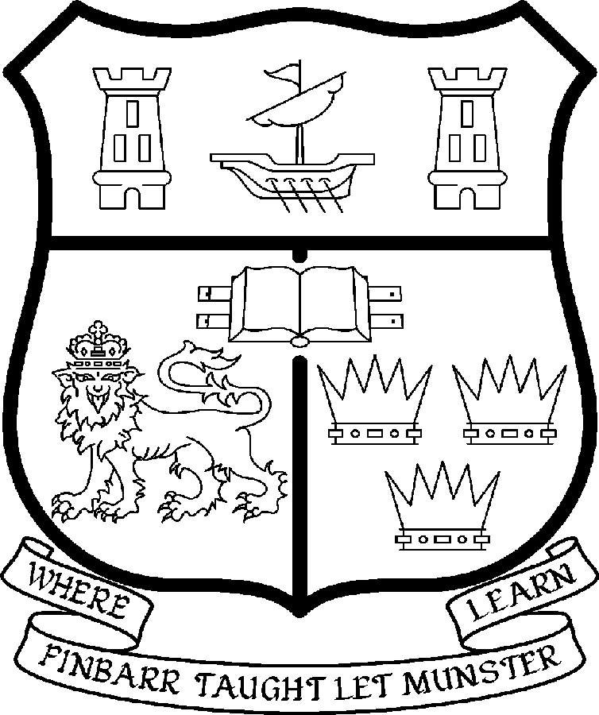 | UNIVERSITY COLLEGE CORK  Coláiste na hOllscoile Corcaigh
LECTURESHIPS IN ACCOUNTING/CORPORATE FINANCE (3 POSTS)

DEPARTMENT OF ACCOUNTING, FINANCE & INFORMATION SYSTEMS
College of Business and Law
Particulars of Post

- The post is whole time and fixed term up to a maximum of 3 years. The appointee to the post shall work under the direction of the Head of the Department of Accounting, Finance & Information Systems and shall discharge such duties as shall be assigned to him/her by the said Head.

- The current remuneration – [new entrants] – is as detailed below. The appointment of the post of Lectureship in Accounting/Corporate Finance will be made at a point, below the bar, on the following scale in accordance with qualifications and experience to date.

BAR

Minimum 36,500 Seventh Point 49,452
Second Point 38,616 Eighth Point 51,656
Third Point 41,037 Ninth Point 53,956
Fourth Point 43,120 Tenth Point 55,707
Fifth Point 45,308 Eleventh Point 57,497
Sixth Point 47,614 Maximum 59,293

- The salary includes a premium of 1/19th for pensionable staff paying contributions. Class A1 rate of Pay Related Social Insurance (PRSI) applies to the post which is currently 4% with an earnings ceiling of €50,700.

- Duties of the Post
The duties of the Lecturer shall include lecturing of students in Accounting/Corporate Finance under the direction of the Head of Department. The Lecturer shall, in addition, discharge such other duties, including examining, appropriate to the post and shall be assigned by the Head of Department. In particular, the post holder shall be required to undertake the following responsibilities:

- To teach and examine at undergraduate and postgraduate level
- To supervise student projects and research dissertations in relevant areas
- To develop new courses and teaching materials
- To supervise postgraduate research students
- To engage in research and generate research income
- To undertake a programme of research leading to publications in refereed Accounting journals
- To develop links with industry
- To contribute to the administrative duties of the Department

The above listing is not exclusive or exhaustive and the post holder may be required to undertake any such duties as may reasonably be expected. All staff are required to be flexible and co-operative and professional within the needs of the post and the Department and University.

- Selection Criteria
Decisions made at shortlisting, presentation and interview will be made based on the following criteria:

Essential criteria
A postgraduate degree in Accounting or Corporate Finance
Teaching experience in a third level institution

Desirable criteria
Have, or be in the process of completing a PhD in a relevant area.
Demonstration of a future research agenda.
Relevant administrative experience.
Ability to work on own initiative.
Evidence of a strong commitment to appropriate teamwork.
Professional experience in Accounting/Finance.

- The "Provisions relating to posts as Lecturer" as set out in the attached document also apply to the post.

- Each candidate must complete an application form, which can be downloaded at: http://www.ucc.ie/en/hr/FormsContractDocuments/DocumentFile,35042,en.doc.

- Candidates shortlisted for interview shall be required to appear in person before a Board of Assessors in Cork, in which case travelling and subsistence expenses at approved rates will be paid.

- A successful candidate will be required to submit a birth certificate and documentary evidence confirming academic qualifications.

- References will be sought in relation to all candidates invited to attend for interview.

- An offer of appointment to a candidate who is not EU nationality is subject to the granting of a Work Permit by the Department of Enterprise Trade & Employment.

- Candidates may be required to produce documentary evidence to support any statements made by them on their application form or any supporting documentation. Candidates should note that inaccurate information will invalidate their application.

- Completed application forms must reach Recruitment Office, Department of Human Resources, University College, Cork, Ireland, on or before Friday, 20 June 2008. Tel: +353-21-4902671 Email: recruitment@per.ucc.ie. Fax. +353-21-4276995.

GENERAL INFORMATION FOR CANDIDATES

Introduction to University College Cork

University College Cork, a constituent University of the National University of Ireland, is a collegiate, progressive, dynamic research-led university developing a reputation as a world class regional university, built on the history of significant achievements in teaching and learning and research, and strong academic and professional leadership.

The University has a current enrolment of over 17,000 students with a strategic objective of 21,000 by 2011. UCC currently has 1,400 academic and research staff within a total staff compliment of 2,500.

Founded in 1845, as Queen’s College, Cork, UCC is one of Ireland’s oldest institutions of higher learning. The rich history and tradition of UCC is reflected in the imposing limestone buildings of the Main Quadrangle and the mature grounds. UCC’s scenic city centre campus, boasting award-winning architecture, provides a pleasant and vibrant learning environment, which is given an international dimension by the presence of 2,000 international students and many staff from over 75 countries around the world.

UCC is one of the premier research institutions in the State and its research income is consistently one of the highest in the country. The University earns peer-reviewed research income in excess of €60m per annum, has strategic research partnerships with leading multinationals in the agri-food, microelectronics, and pharmaceutical sectors, and is home to 5 of Ireland’s 8 ISI Most Highly Cited authors. The university’s research reputation spans across the broad range of disciplines, strategically built around a number of internationally-recognised Research Institutes, Centres and Departments.

UCC is fully committed to the development of 4th level training and research through the introduction of Graduate Schools and structured PhD programmes and the provision of a wide range of generic and discipline-specific modules supporting the research activity of PhD students. The University offers an innovative, research-led curriculum, taught by world-class academics who consistently attract a quality student intake.
Recent institutional reorganisation has established four Colleges; Arts, Celtic Studies and Social Sciences; Business and Law; Medicine and Health; Science, Engineering and Food Science. The Colleges offer over 120 degree and professional programmes that consistently attract the highest proportion of top school leavers in the country and supports a rapidly growing postgraduate and international student body.

The University has embarked on a programme of development for UCC to firmly establish it as a world-class regional university building on the guiding principles in the University’s Strategic Framework 2006-2011 of excellence in teaching, learning, research and contribution to community and society. UCC will focus on research performance, the quality of the student experience and the manner in which the institution discharges its regional role.

Having twice being designated as the Sunday Times “Irish University of the Year” in the past four years, UCC is also a recent proud recipient of the “Excellence Through People” Gold Standard.

The last five years have seen exceptional growth in student numbers, award winning capital developments supporting science, technology and the arts and significant success in winning research funding, making it in that time the most research active institution in the country.

UCC enjoys excellent links with local business and enterprise along with strong partnerships with some of the world’s most highly valued companies. Relationships with professional and public bodies across a wide range of disciplines are equally a key feature of the University.

Internationalisation of the campus continues to be a key strategic objective of UCC. International enrolment at UCC is among the highest in the sector creating a multi- cultural and ethnically diverse student body and measures taken by UCC to enhance conditions for international student recruitment are regarded as among the best practices by peer institutions. UCC also provides opportunities for Irish students to study overseas making them competitive in a global market. In recent years new exchange opportunities include academic placements in a diverse range of European, US, Canadian and Australian universities, with new developments targeting China.

Staff are essential to the achievement of our mission and UCC places a special emphasis on quality improvement strategies in Human Resource Management. A key objective of the UCC Strategic Framework 2006-2011 is to attract, develop and retain outstanding staff through the development and implementation of best practice HR policies and procedures. We seek to develop staff capable of keeping the University at the forefront in all that it does. The University has committed to establishing a supportive working environment in which the needs of all staff are recognised and their contributions valued and rewarded.

Web Links
UCC website
http://www.ucc.ie/en/

UCC Strategic Plan 2006-2011
http://www.ucc.ie/en/PresidentsOffice/UCCsStrategicPlan/DocumentFile,1005,en.pdf

University College Cork is an Equal Opportunities Employer

