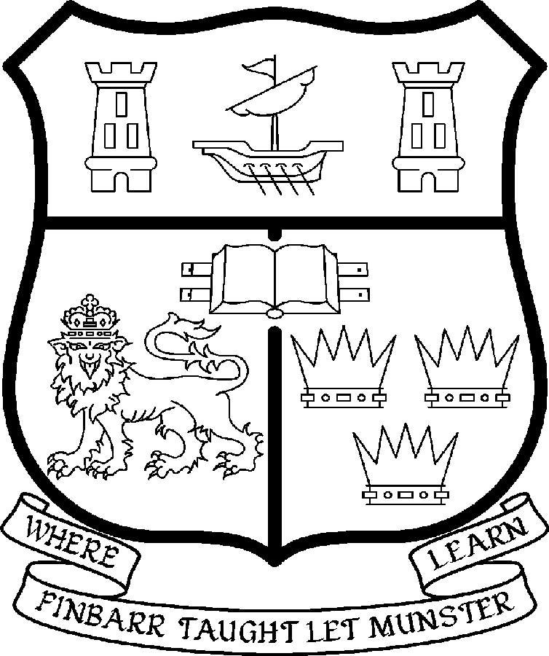 | UNIVERSITY COLLEGE CORK  Coláiste na hOllscoile Corcaigh
LECTURESHIP IN CIVIL & ENVIRONMENTAL ENGINEERING
(BUILDING SERVICES ENGINEERING)

Particulars of Post

1. The Lectureship in Civil & Environmental Engineering (Building Services Engineering) is a permanent and wholetime post, based in the College of Science, Engineering & Food Science. The appointee shall work under the direction of the Head of Department of Civil & Environmental Engineering and shall discharge such duties as shall be assigned to him/her by the said Head.

The current remuneration – [new entrants] – is as detailed below. The appointment to the post of Lectureship in Civil & Environmental Engineering (Building Services Engineering) will be made at a point on the following scale in accordance with qualifications and experience to date. For appointments made on the following salary scale up to and including the twelfth point below the bar, there is provision for subsequent progression beyond the BAR in accordance with the terms of the Academic Promotions Scheme to a salary scale segment with a maximum of €83,504 (new entrants).

 | € |  | €
First Point | 35,610 | Eighth Point | 50,396
Second Point | 37,674 | Ninth Point | 52,640
Third Point | 40,036 | Tenth Point | 54,348
Fourth Point | 42,068 | Eleventh Point | 56,095
Fifth Point | 44,203 | Twelfth Point | 57,847
Sixth Point | 46,453
Seventh Point | 48,246

BAR

First point above the bar | 63,389 | Fourth point above the bar | 76,488
Second point above the bar | 67,756 | Fifth point above the bar | 83,504
Third point above the bar | 72,131

The salary includes a premium of 1/19th for pensionable staff paying contributions. Class A1 rate of Pay Related Social Insurance (PRSI) applies to the post which is currently 4% with an earnings ceiling of €50,700.
Principal duties of the Post:

Teaching
- To teach and examine on existing courses at the undergraduate and postgraduate level in Building Services Engineering;
- To supervise undergraduate and postgraduate students;
- To engage in student assessment;
- To engage in the regular evaluation and development of modules in terms of content, delivery and assessment;
- To develop new courses and teaching materials;

Research
- To engage actively in research and publish the research results in appropriate peer reviewed professional journals;
- To maintain existing research commitments in Building Services Engineering (BSE) in both Architecture and Civil and Environmental Engineering;
- To engage in individual research, participate in the Department’s research activities and contribute to interdisciplinary research programmes where appropriate;
- To engage in initiatives in generating research income;
It should be noted that a generous start up fund is available for research in the area of Carbon Neutral Buildings.

Contribution
- To contribute to the administrative duties of the department and the academic life of the College;
- To act as a member of such committees as may be required;
- To develop professional links with industry where appropriate.

The above listing is not exclusive or exhaustive and the post holder may be required to undertake any such duties as may reasonably be expected. All staff are required to be flexible and co-operative and professional within the needs of the post and the Department/School, College and University. The University is undertaking a major reform of its internal structures which may necessitate possible future changes in the organisation of its activities.

3. Selection Criteria:

Decisions made at shortlisting, presentation and interview will be made based on the following criteria:

Essential Criteria
- Primary Degree in Engineering, Architectural Engineering or a cognate area;
- Specialisation in Building Services Engineering and an ability to contribute to undergraduate teaching on a range of material outside area of specialisation;
- Teaching experience or demonstrated teaching potential;
- Evidence of a personal contribution and commitment to excellence in teaching;
- Evidence of appropriate research achievement as indicated by published work and/ or work in preparation;
- Evidence of ability to work on personal initiative as well as part of a team;
- Ability to communicate effectively and evidence of competence in spoken and written English;

Desirable Criteria
- Doctorate in Building Services Engineering or Architectural Engineering or a cognate area;
- Evidence of Research or Design experience in Energy in Buildings;
- Proven ability or demonstrated potential to attract funding through competitive research grants;
- Demonstrated ability and willingness to work in a collaborative environment;
- Commitment to the long term development of the discipline in UCC.

Candidates are requested to make a personal assessment of these criteria against their own qualifications, skills and abilities to assess whether they should apply for the post.

- The normal Statutory or other provisions relating to full-time Lectureships and Senior Lectureships shall apply to the post.

- Each candidate must complete an application form, which can be downloaded at:
http://www.ucc.ie/en/hr/FormsContractDocuments/DocumentFile,35042,en.doc

- Candidates for posts shall be required to appear in person before a Board of Assessors in Cork, in which case travelling and subsistence expenses at approved rates will be paid.

- A successful candidate will be required to submit a birth certificate, documentary evidence confirming academic qualifications, and to undergo a medical examination.

- References will be sought in relation to all candidates invited to attend for interview

- An offer of appointment to a candidate who is not of EU nationality is subject to the granting of a Work Permit by the Department of Enterprise Trade & Employment.

- Candidates may be required to produce documentary evidence to support any statements made by them on their application form or any supporting documentation. Candidates should note that any inaccurate information submitted will invalidate their application.

- The University is undertaking a major reform of its internal structures which may necessitate possible future changes in the organisation of its activities.

- Completed application forms must reach Recruitment Office, Department of Human Resources, University College, Cork, Ireland, on or before Friday, 02nd May 2008. Tel: +353-21-4902671 Email: recruitment@per.ucc.ie. Fax. +353-21-4276995.

UNIVERSITY COLLEGE CORK IS AN EQUAL OPPORTUNITIES EMPLOYER
GENERAL INFORMATION FOR CANDIDATES

Introduction to University College Cork

University College Cork, a constituent University of the National University of Ireland, is a collegiate, progressive, dynamic research-led university developing a reputation as a world class regional university, built on the history of significant achievements in teaching and learning and research, and strong academic and professional leadership.

The University has a current enrolment of over 17,000 students with a strategic objective of 21,000 by 2011. UCC currently has 1,400 academic and research staff within a total staff compliment of 2,500.

Founded in 1845, as Queen’s College, Cork, UCC is one of Ireland’s oldest institutions of higher learning. The rich history and tradition of UCC is reflected in the imposing limestone buildings of the Main Quadrangle and the mature grounds. UCC’s scenic city centre campus, boasting award-winning architecture, provides a pleasant and vibrant learning environment, which is given an international dimension by the presence of 2,000 international students and many staff from over 75 countries around the world.

UCC is one of the premier research institutions in the State and its research income is consistently one of the highest in the country. The University earns peer-reviewed research income in excess of €60m per annum, has strategic research partnerships with leading multinationals in the agri-food, microelectronics, and pharmaceutical sectors, and is home to 5 of Ireland’s 8 ISI Most Highly Cited authors. The university’s research reputation spans across the broad range of disciplines, strategically built around a number of internationally-recognised Research Institutes, Centres and Departments.

UCC is fully committed to the development of 4th level training and research through the introduction of Graduate Schools and structured PhD programmes and the provision of a wide range of generic and discipline-specific modules supporting the research activity of PhD students. The University offers an innovative, research-led curriculum, taught by world-class academics who consistently attract a quality student intake.
Recent institutional reorganisation has established four Colleges; Arts, Celtic Studies and Social Sciences; Business and Law; Medicine and Health; Science, Engineering and Food Science. The Colleges offer over 120 degree and professional programmes that consistently attract the highest proportion of top school leavers in the country and supports a rapidly growing postgraduate and international student body.

The University has embarked on a programme of development for UCC to firmly establish it as a world-class regional university building on the guiding principles in the University’s Strategic Framework 2006-2011 of excellence in teaching, learning, research and contribution to community and society. UCC will focus on research performance, the quality of the student experience and the manner in which the institution discharges its regional role.

Having twice being designated as the Sunday Times “Irish University of the Year” in the past four years, UCC is also a recent proud recipient of the “Excellence Through People” Gold Standard.

The last five years have seen exceptional growth in student numbers, award winning capital developments supporting science, technology and the arts and significant success in winning research funding, making it in that time the most research active institution in the country.

UCC enjoys excellent links with local business and enterprise along with strong partnerships with some of the world’s most highly valued companies. Relationships with professional and public bodies across a wide range of disciplines are equally a key feature of the University.

Internationalisation of the campus continues to be a key strategic objective of UCC. International enrolment at UCC is among the highest in the sector creating a multi- cultural and ethnically diverse student body and measures taken by UCC to enhance conditions for international student recruitment are regarded as among the best practices by peer institutions. UCC also provides opportunities for Irish students to study overseas making them competitive in a global market. In recent years new exchange opportunities include academic placements in a diverse range of European, US, Canadian and Australian universities, with new developments targeting China.

Staff are essential to the achievement of our mission and UCC places a special emphasis on quality improvement strategies in Human Resource Management. A key objective of the UCC Strategic Framework 2006-2011 is to attract, develop and retain outstanding staff through the development and implementation of best practice HR policies and procedures. We seek to develop staff capable of keeping the University at the forefront in all that it does. The University has committed to establishing a supportive working environment in which the needs of all staff are recognised and their contributions valued and rewarded.

Web Links
UCC website
http://www.ucc.ie/en/

UCC Strategic Plan 2006-2011
http://www.ucc.ie/en/PresidentsOffice/UCCsStrategicPlan/DocumentFile,1005,en.pdf

Department of Civil & Environmental Engineering Website
http://www.ucc.ie/academic/civil/

University College Cork is an Equal Opportunities Employer

