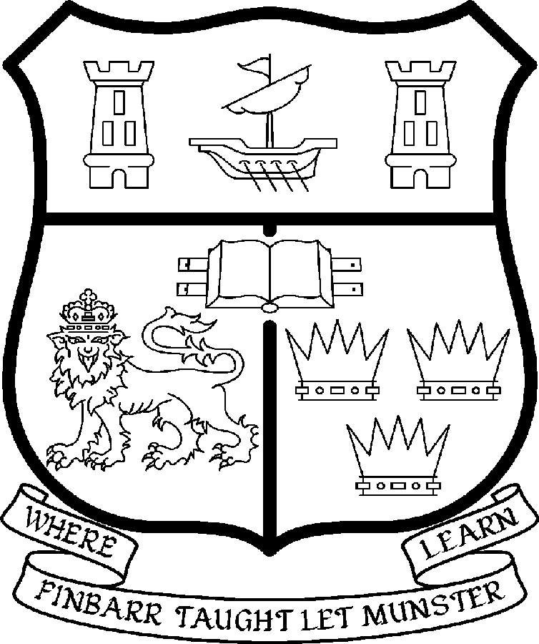 | UNIVERSITY COLLEGE CORK  Coláiste na hOllscoile Corcaigh
SENIOR LECTURESHIP IN HISTORY OF ART

Particulars of Post

- The Senior Lectureship in History of Art is a full-time and permanent post. The current remuneration – [new entrants] - is as detailed below. The appointment to the post of Senior Lectureship in History of Art will be made at the point on the following scale in accordance with qualifications and experience:
€
Minimum 65,036
Second Point 68,903
Third Point 72,776
Fourth Point 76,669
Fifth Point 80,549
Sixth Point 84,423
Seventh Point 88,305
Maximum 92,150

- The salary includes a premium of 1/19th for pensionable staff paying contributions. Class A1 rate of PRSI applies to the post. Class A1 rate of Pay Related Social Insurance (PRSI) applies to the post which is currently 6.0% with an earnings ceiling of €46,600, 2% is payable on the balance.

- Duties of the Post:

The duties of the appointee under the direction of the Head of the department of History for all degrees, diplomas and certificates of the University. They shall, in addition, discharge such other duties (including examining) appropriate to the office as shall be assigned to them by the Head of the department of History. In particular, the post-holder shall be required to undertake the following responsibilities-:

- To teach and examine on existing courses at undergraduate (from 1st year to final year) and postgraduate level.

- To develop and co-ordinate the new Fourth Level Ireland PhD 4-year programme as well as relevant teaching materials.

- To supervise undergraduate/postgraduate students.

- To develop new courses and teaching materials.

- To engage in research and to generate research income.

- To undertake research and publish the research results in appropriate professional journals.

- To develop links with professional bodies and external agencies where possible.

- To contribute to the administrative duties in the Department.

The above is not exclusive or exhaustive and the post holder maybe required to undertake any such duties as may reasonably be expected. All staff are required to be flexible and co-operative and professional within the needs of the post and the Department, College and University.

- Selection Criteria.
Decisions made at shortlisting, presentation and interview will be made based on the following criteria:

  - Candidates shall have a Doctorate

  - A strong record of published research

  - Candidates should have a specialisation in Modern/Contemporary History of Art

  - Candidates should be able to contribute to undergraduate teaching in the 19^{th-} and 20th-Century art

  - Candidates should have a demonstrated ability to teach at postgraduate level

  - Candidates should contribute to the above in the development of the postgraduate programme

  - Candidates must demonstrate that they have successfully undertaken management functions, or previously taken on a leadership role

  - Candidates should have proven administrative experience

  - Candidates will be required to continue to develop interdisciplinary initiatives

  - It is desirable for candidates to demonstrate a commitment to the long term development of the Department

- The normal Statutory or other provisions relating to full-time Senior Lectureships shall apply to the post.

- Each candidate must complete an application form.

- Completed application forms must reach Academic Appointments, Department of Human Resources, University College, Cork, Ireland, on or before Friday 9th March 2007.

The desired start date for this post is 1st Oct 2007, however this date is negotiable

