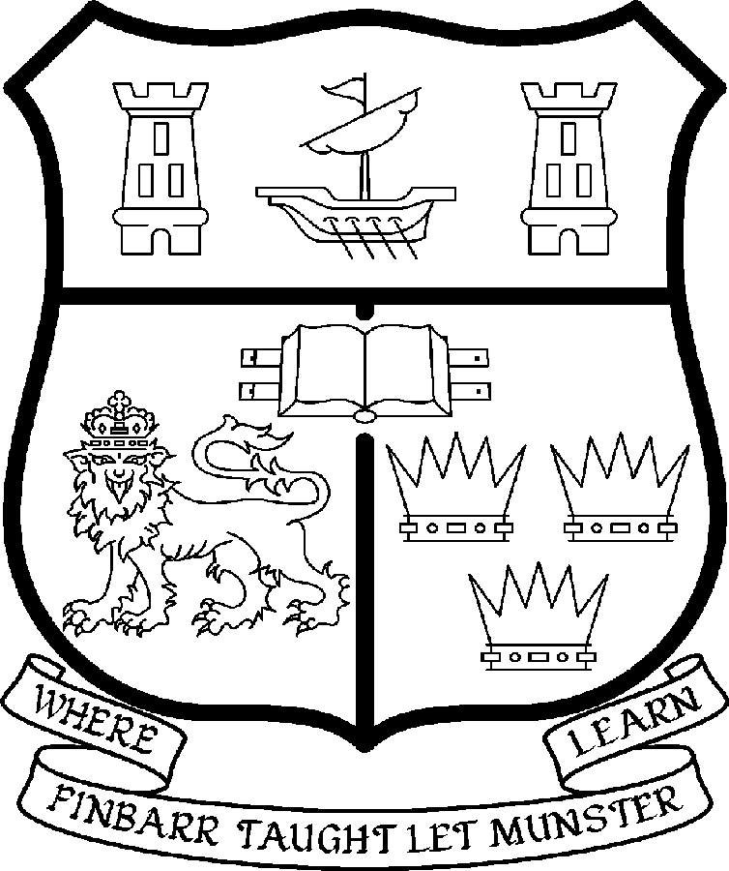 | UNIVERSITY COLLEGE CORK  Coláiste na hOllscoile Corcaigh
SENIOR LECTURER IN SPORTS AND EXERCISE MEDICINE (Part-Time)

Particulars of Post

- The post is part-time, constituting a .5 FTE and permanent. The appointee to the post will work with the Course Director and under the direction of the Head of the Medical School and shall discharge such duties as shall be assigned to him/her by the said Head.

- The current remuneration – [new entrants] – is as detailed below. The appointment to the post of Senior Lectureship in Sports and Exercise Medicine will be made at 50% of a point on the following scale in accordance with qualifications and experience to date.

€
Minimum 65,036
Second Point 68,903
Third Point 72,776
Fourth Point 76,669
Fifth Point 80,549
Sixth Point 84,423
Seventh Point 88,305
Maximum 92,150

- The salary includes a premium of 1/19th for pensionable staff paying contributions. Class A1 rate of Pay Related Social Insurance (PRSI) applies to the post which is currently 6% with an earnings ceiling of €46,600, 2% is payable on the balance.

- Job Responsibilities:

The duties of the Senior Lecturer shall be to organise and develop the Masters Programme for Sports and Exercise Medicine in conjunction with the Course Director. The work would involve organising the curriculum, examinations and supervising the programme. The post-holder will also be expected to contribute to student mentoring and engage in research.

They shall, in addition, discharge such other duties (including examining) appropriate to the Office as shall be assigned to them by the Head of the Medical School. In particular, the post holder shall be required to undertake the following responsibilities-:

- Organise and develop the curriculum for the Masters in Sports and Exercise Medicine and work in conjunction with relevant departments of the Medical School to ensure that the curriculum reflects accepted international standards.

- To ensure consistency in techniques of assessment and examination throughout the Medical School Masters in Sports and Exercise Medicine Programme.
- Participate in the Student Mentoring Programme in the School of Medicine.

- Contribute to curricular content and delivery in the area of Sports and Exercise Medicine in Medical School curricula.

The above listing is not exclusive or exhaustive and the post holder may be required to undertake any such duties as may reasonably be expected. All staff are required to be flexible and co-operative and professional within the needs of the post and the School and University.

5. Selection Criteria:
Decisions made at shortlisting, presentation and interview will be made based on the following criteria:

Essential Criteria
- Be medically qualified with full Medical Council registration, hold a Postgraduate Diploma or Degree in Sports and Exercise Medicine and demonstrate significant experience in both the clinical practice and teaching of Sports and Exercise Medicine.
- Have a proven record of involvement in Sports and Exercise Medicine and have an established record as a lecturer in this field;
- Show evidence of an active engagement in Healthcare Education;
- Show evidence of experience of course development in tertiary education;
- Demonstrate evidence of organisational and leadership skills;
- Have experience of student mentoring and supervision;
- Show evidence of a clear understanding of the Medical School’s curricular strategy.

Desirable Criteria
- Possess requisite IT skills
- Demonstrate evidence of strong interpersonal skills

- The "Provisions relating to posts as Lecturer" as set out in the attached document also apply to the post.

- Each candidate must complete an application form for the post. Please indicate clearly on the application form, which post is being applied for.

- Informal enquiries concerning this post may be made to Dr M. Molloy; Mobile no: 086 8032150; email mgmmolloy@eircom.net

- Completed application forms must reach the Recruitment Office, Department of Human Resources, University College, Cork, Ireland, on or before 28 February 2007

