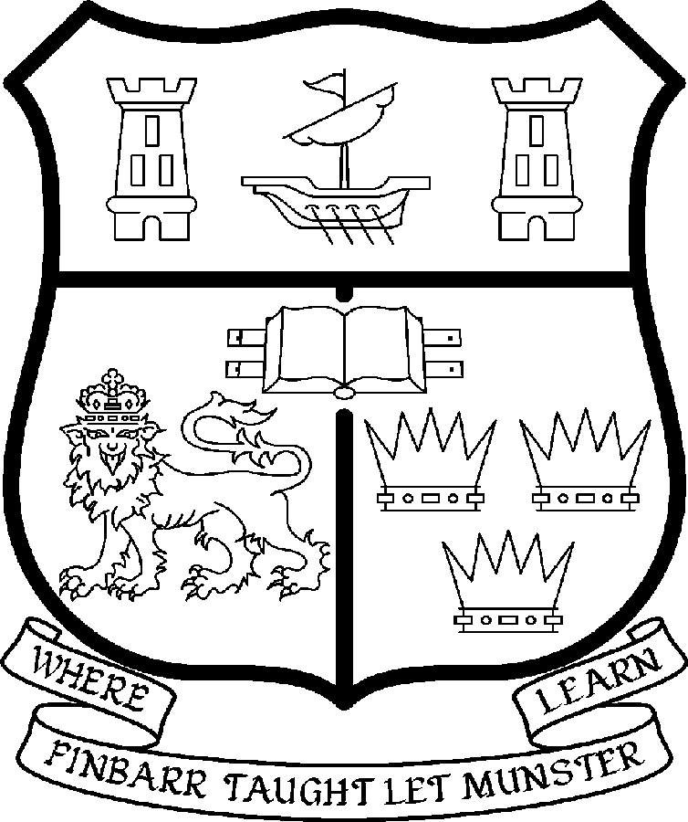 | UNIVERSITY COLLEGE CORK  Coláiste na hOllscoile Corcaigh
LECTURESHIP/SENIOR LECTURESHIP IN HISTORY OF ART

Particulars of Post

- The Lectureship/Senior Lectureship in History of Art is a full-time and permanent post.

The appointment may be made at Senior Lecturer level only if a candidate merits appointment at this level on the basis of a distinguished research and scholarly contribution. If no candidate achieves this standard in research, an appointment may be made at lecturer level.

The current remuneration at the grade of Senior Lecturer – [new entrants] – is as detailed below. Should an appointment be made at this senior grade, it will be made on the following scale in accordance with qualifications and experience to date.

Senior Lectureship Scale [New entrants]
€
Minimum 66,987
Second Point 70,970
Third Point 74,959
Fourth Point 78,969
Fifth Point 82,965
Sixth Point 88,956
Seventh Point 86,956
Maximum 94,915

Should an appointment be made at the level of Lectureship, salary placement will
be made at a point below the bar on the following scale in accordance with
qualifications and experience to date.

For those appointed to the salary segment below the bar, there is provision
for subsequent progression beyond the BAR in accordance with the terms
of the Academic Promotions Scheme to a salary segment with a maximum
of €81,867

Lectureship Scale [New entrants]

 | € |  | €
Minimum | 34,912 | Eighth Point | 49,408
Second Point | 36,935 | Ninth Point | 51,608
Third Point | 39,251 | Tenth Point | 53,282
Fourth Point | 41,243 | Eleventh Point | 54,995
Fifth Point | 43,336 | Maximum | 56,713
Sixth Point | 45,542
Seventh Point | 47,300

BAR

First Point | 62,146 | Fourth Point | 74,988
Second Point | 66,427 | Maximum | 81,867
Third Point | 70,717

- The salary includes a premium of 1/19th for pensionable staff paying contributions. Class A1 rate of Pay Related Social Insurance (PRSI) applies to the post which is currently 6% with an earnings ceiling of €48,800.

- Duties of the Post:

The duties of the appointee under the direction of the Head of the department of History for all degrees, diplomas and certificates of the University. They shall, in addition, discharge such other duties (including examining) appropriate to the office as shall be assigned to them by the Head of the department of History. In particular, the post-holder shall be required to undertake the following responsibilities-:

- To teach and examine on existing courses at undergraduate (from 1st year to final year) and postgraduate level.

- To develop and co-ordinate the new Fourth Level Ireland PhD 4-year programme as well as relevant teaching materials.

- To supervise undergraduate/postgraduate students.

- To develop new courses and teaching materials.

- To engage in research and to generate research income.

- To undertake research and publish the research results in appropriate professional journals.

- To develop links with professional bodies and external agencies where possible.

- To contribute to the administrative duties in the Department.

The above is not exclusive or exhaustive and the post holder maybe required to undertake any such duties as may reasonably be expected. All staff are required to be flexible and co-operative and professional within the needs of the post and the Department, College and University.

- Selection Criteria.
Decisions made at shortlisting, presentation and interview will be made based on the following criteria:

  - Candidates shall have a Doctorate

  - Candidates should have a strong record of published research in the History of Art

  - Candidates should have a specialisation in Modern/Contemporary History of Art

  - Candidates should be able to contribute to undergraduate teaching in the 19th and 20th Century

  - Candidates should have a demonstrated ability to teach at postgraduate level

  - Candidates should contribute to the above in the development of the postgraduate programme

  - Candidates should have proven administrative experience

  - Candidates will be required to continue to develop interdisciplinary initiatives

  - It is desirable for candidates to demonstrate a commitment to the long term development of the Department

- The normal Statutory or other provisions relating to full-time Lectureships and Senior Lectureships shall apply to the post.

- Each candidate must complete an application form.

- Completed application forms must reach Academic Appointments, Department of Human Resources, University College, Cork, Ireland, on or before Friday 11th May 2007.

The desired start date for this post is 1st September 2007, however this date is negotiable

