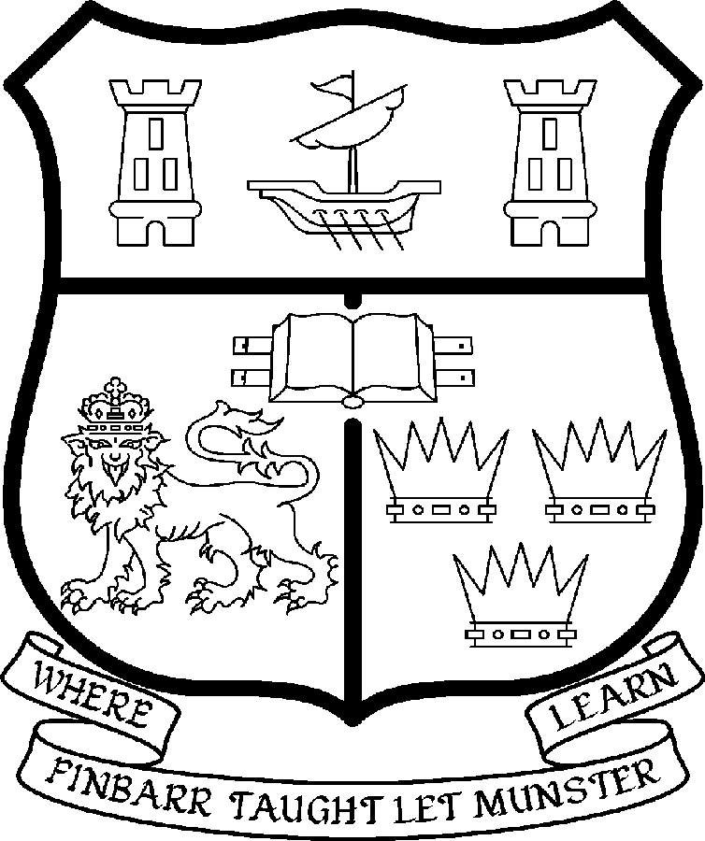 | UNIVERSITY COLLEGE CORK  Coláiste na hOllscoile Corcaigh
PROFESSORSHIP OF RENAISSANCE STUDIES

Particulars of Post

- The Professorship of Renaissance Studies is a permanent full-time office. The current annual stipend of the Professorship – [new entrants] - is as follows:

€
Minimum 109,104
Second Point 115,359
Third Point 121,614
Fourth Point 127,871
Fifth Point 134,127
Maximum 140,385

- The salary includes a premium of 1/19th for pensionable staff paying contributions. Class A1 rate of Pay Related Social Insurance (PRSI) applies to the post. The rate is currently 6% on the first €46,600 of annual earnings and 2% on the balance.

- Duties of the Post: The duties of the Professor shall be to lecture in Renaissance Studies for all relevant degrees, diplomas and certificates of the University under the direction of the Heads of Department of Classics and History. S/he shall examine in Renaissance Studies, Classics and History for the University and shall carry out such other duties appropriate to the post. In addition the Professor of Renaissance Studies will be expected:

- To be responsible for providing leadership in the development and the discipline of Renaissance Studies and the Departments of Classics and History;

- To lead the establishment of a PhD training programme in early modern studies with NUIG and TCD (see further see http://www.tcd.ie/English/staffandresearch/ for English research at TCD, see http://www.tcd.ie/history/ for History research at TCD; see http://www.nuigalway.ie/mooreinstitute/content.php?id=6 for the Moore Institute in NUI Galway; see http://www.ucc.ie/academic/classics/ for Classics research at UCC, http://www.ucc.ie/academic/history/.for History research at UCC and http://www.ucc.ie/acad/classics/CNLS/index.html.for Neo-Latin Studies research at UCC)

- To take a leading role in the development of postgraduate studies (especially at PhD level) within UCC

- To represent the discipline both inside and outside the University;

- To support and inspire departmental colleagues;

- To undertake research in the subject;

- To act as Head of Department subject to relevant legislation, University Statutes and management requirements;

- Selection Criteria. The successful candidate will be expected to have:

- A doctoral qualification in Classics, History or Renaissance Studies, with formal qualifications in Greek, Latin and palaeography, and an interest in intellectual history (preferably of the Mediterranean, the New World or Central Europe) between c. 1450-1700;

- The ability to provide strategic vision and leadership in the development of the discipline of Renaissance Studies;

- Interpersonal skills commensurate with leading and supporting a team of committed academic and administrative colleagues in the Departments and in the partner Universities (NUIG, TCD)

- An internationally established scholarly and research reputation, as evidenced by a record of publications, including publications in peer reviewed journals;

- Proven ability to generate research income;

- A successful record of postgraduate supervision to doctorate level;

- An outstanding record of teaching and curriculum development and a willingness to contribute to a range of the topics taught by the Department at undergraduate and postgraduate levels;

- The capacity to act as Head of Department together with the requisite communication, management, administrative and leadership skills;

- The skills to represent the Department and the discipline both inside and outside the University, including interaction with professional accreditation bodies;

- Willingness to participate in and contribute to the overall life of the College of Arts, Celtic Studies and Social Sciences and the University.

- The “Statutory and other provisions relating to full-time Professorships” as set out in the attached shall also apply to the post.

- Each candidate must complete an on line application form for the post. The website address is www.ucc.ie/hr

- Applications must reach the Recruitment Office, Department of Human Resources University College, Cork or E-mail at recruitment@per.ucc.ie on or before 5pm on March 23rd 2007

UNIVERSITY COLLEGE CORK IS A EQUAL OPPORTUNITIES EMPLOYER

Department of Classics

The Department of Classics teaches programmes in Greek, Latin and Greek and Roman Civilisation. Special emphasis is placed on provision of opportunities for learning Latin and Greek, not only within the standard programmes, but also through the annual International Summer School (see http://www.ucc.ie/academic/classics/ and click Summer School) and the follow-up one-year Diploma courses which take graduate students from scratch to Joint Honours BA level in 12 months (see http://www.ucc.ie/academic/classics/ and click Diploma). The Department has an active research culture, with publishing specialists in Roman History, Greek Drama, Later Greek Literature, Greek History, the Greek Novel, Renaissance Studies, Neo-Latin and Reception Studies (see http://www.ucc.ie/academic/classics/ and click on Staff). The Department has been the recipient of eight IRCHSS awards for research over the last five years (2 PhD, 3 Post-Doctoral, 1 Major Project Grant [with History], 1 Research Fellowship and 1 Senior Research Fellowship). In particular, the attention of candidates is drawn to the Centre for Neo-Latin Studies, its current publishing projects (see further below), and its weekly seminar on Irish Neo-Latin writing.

Department of History

The Department has a strong research ethos covering specialisations from early times to the twentieth-century. The research profile, which can be accessed on the departmental website, displays the breadth and range of topics being actively research by the staff in Irish, European and international history. The publication record of the Department is very strong. A list of the recent monographs and edited works may be found on our website (http://www.ucc.ie/academic/history). A number of staff in the Department of History at UCC have been the recipients of international fellowships including IRCHSS, Fulbright and other awards. UCC has also recognised the research and teaching excellence of members of the Department. The chair in Renaissance Studies will build on our already formidable strength in the Late Medieval and Early Modern area. Drs Morgan and Edwards work on Renaissance and Reformation Ireland whilst Dr Harris is an expert on the cultural and intellectual history of the Low Countries in the Reformation period. All three are co-workers with the Department of Classics in a project to research and publicise the work of Irish Neo-Latin writers. Furthermore we have in Dr Flavio Boggi, part of our recently established History of Arts programme, a scholar of Renaissance Italian Art.

General Information on the Department of History

The teaching staff of the Department of History normally includes three professors, and twenty eight full-time and part-time lecturers. In recent years about 350 students have taken History as one of four subjects in the first year of the three-year BA Degree, and about 260 have continued into the two-subject second and third year, including up to 400 ‘non-traditional’ students. In addition, about 30 students have pursued a four-year BA Evening Degree. The Department also participates in the teaching of the following four-year degree programmes:

- European Integration Studies
- Language and Cultural Studies.

Departmental staff also contribute to the teaching of the degree subjects:

- History of Art
- Politics
- Diplomas in Adult and Continuing Education

At Postgraduate level, the Department offers MPhil, MA and PhD programmes in the following areas:

- European Integration Studies
- Government & Politics in Twentieth-Century Ireland
- History of Irish Media and Journalism
- State, Culture and Identity in Ireland, 1500-1900
- The United States, Latin America and Europe
- History of the Irish Diaspora and Settlement
- International Relations
- Medieval History
- Local History

Departmental staff also participate in MA programmes in:

- Women Studies
- Medieval Monastic Culture
- Politics

In recent years, there have been about 40 MA students, 25 MPhils and 25 PhDs in any given year. Graduate teaching and supervision therefore absorb a high proportion of staff time.

Apart from the personal contacts of staff members, many of whom have taught or researched abroad, the Department has a wide range of institutional international contacts. It was a founder member of the ERASMUS European Credit transfer System, which links it with more than twenty other European Universities. A year abroad in an appropriate university in France, Spain Germany or Italy is a required part of the European Integration Studies Degree. The Department also participates in other Socrates/Tempus programmes, and in the Junior Year Abroad programmes of several American universities. Usually each year about 400 foreign students from fifteen countries attend our courses.

All staff are expected to engage in regular research and publication, as well as to foster the research interests of students. As core courses rely on team teaching, and as all staff are required to participate in joint teaching in seminars, an ability to co-operate with colleagues ranks as a high departmental priority.

As a Department of this size and complexity generates a great deal of administrative work, all members are expected to contribute to, and co-operate in, departmental administration, as well as participate in accordance with the policy of the university in relevant College and extra-collegial activities.

Centre for Neo-Latin Studies

This (see http://www.ucc.ie/academic/classics/ and click Centre for Neo-Latin Studies) is an inter-disciplinary and inter-departmental research centre with a strong focus on philology and historical contextualisation. It has run a weekly seminar (during term) for the last nine years on Irish Latin writers of the 16th and 17th centuries, which will shortly produce a number of collaboratively written editions (in the new series Officina NeoLatina from Brepols Publishers, Turnhout). The Centre is also about to produce the first collection of scholarly essays on this field (Making Ireland Roman: Latin writing in Early Modern Ireland, Cork University Press). In hand also is the Handbook of Irish Neo-Latin, a survey of the published Irish Latin of the period c1500-1800 (with detailed bibliography), to be published by Cambridge University Press (projected 2008). The Centre has received financial support from private bodies (Atlantic Philanthropies) and from state institutions (PRTLI, IRCHSS) and currently has one post-doctoral researcher and two PhD students attached to it. Its activities are managed by two full-time staff in Classics, and three in History, and supported also by members of the Departments of English and Old and Medieval Irish. The management board also contains Dr. Anthony Harvey (Director of the Dictionary of Medieval Latin from Celtic Sources at the Royal Irish Academy) and Professor Colm Lennon (Department of History, NUI Maynooth).

