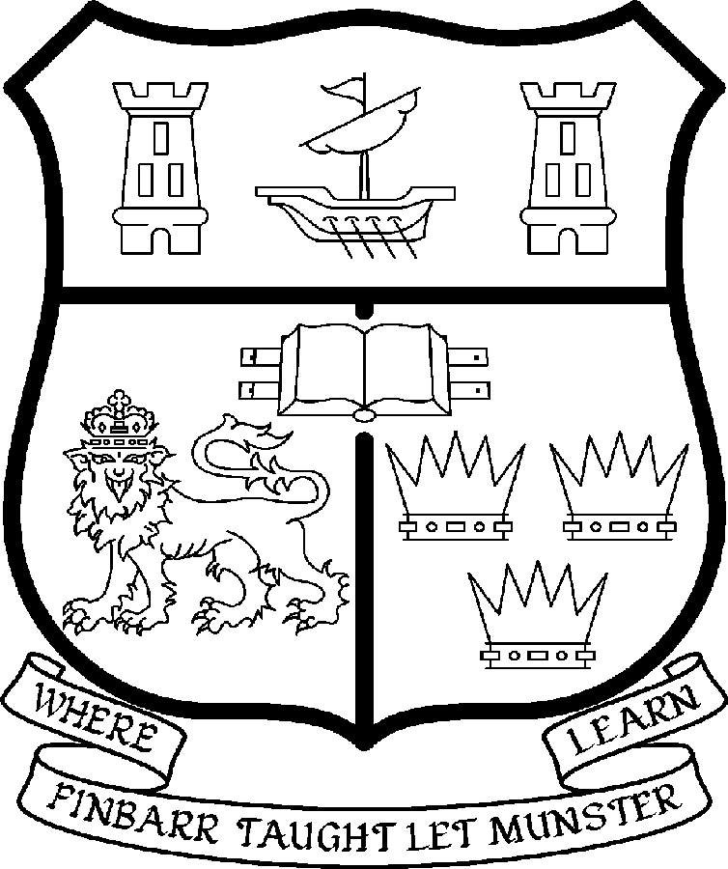 | UNIVERSITY COLLEGE CORK  Coláiste na hOllscoile Corcaigh
PROFESSORSHIP OF OCCUPATIONAL THERAPY

University College Cork (UCC) is a dynamic University comprising some 3000 staff and over 16,000 students. Within the University, the College of Medicine and Health is responsible for the education and training of a range of Health Care professionals. The Departments of Occupational Therapy and Speech and Hearing Sciences comprise the School of Clinical Therapies, which is one of five Schools within the College, the others being Medicine, Dentistry, Pharmacy, and Nursing and Midwifery.

The Department of Occupational Therapy provides a four year honours BSc programme in Occupational Therapy which commenced in 2003, and the first student cohort is set to graduate in the summer of 2007. The Department also hosts a MSc in Advanced Healthcare Practice, a modular course designed to cater for qualified and experienced Speech and Language Therapists, Physiotherapists, as well as Occupational Therapists. The Department offers in addition a professional doctorate, and supervison for postgraduate research at MSc and PHD level. The School of Clinical Therapies is based in the Brookfield Health Sciences Centre and has purpose-built state of the art teaching and clinical facilitites and has dedicated staff in the Brookfield library. (See the Department’s website for further information: http://www.ucc.ie/en/DepartmentsCentresandUnits/OccupationalTherapy)

The College research activity is organised into thematic areas and collaboration for the purposes of attracting major funding is fostered within the framework of these themes, although the College also recognises and supports staff in establishing their own research interests within their particular disciplines. Research activity is supported by a Research Officer based in Brookfield.

Particulars of Post

- The Professorship of Occupational Therapy is a permanent full-time office. The current annual stipend of the Professorship – [new entrants] - is as follows:

€
Minimum 105,296
Second Point 111,999
Third Point 118,072
Fourth Point 124,147
Fifth Point 130,220
Maximum 136,296

- The salary includes a premium of 1/19th for pensionable staff paying contributions. Class A1 rate of Pay Related Social Insurance (PRSI) applies to the post. The rate is currently 6% on the first €46,600 of annual earnings and 2% on the balance.

Duties of the Post: The duties of the Professor shall be to lecture in Occupational Therapy for all degrees, diplomas and certificates of the University. S/he shall examine in Occupational Therapy for the University and shall carry out such other duties appropriate to the post. In addition the Professor of Occupational Therapy will be expected:

- To lead the Department of Occupational Therapy in research and curriculum development at undergraduate and postgraduate level;
- To lead the department’s teaching and research and contribute to the disciplinary and professional development of the subject nationally and internationally;
- To supervise Masters and Doctoral students to successful and timely completion of their degrees;
- To contribute to the professional development of occupational therapists;
- To act as Head of Department and fulfil other leadership roles, subject to relevant University legislation, University Statutes and management requirements;

- Selection Criteria. It will be essential for the successful candidate to have:

- A PhD. or Professional Doctorate
- A strong research profile as illustrated by publication and research funding record in Occupational Therapy or a related area;
- An outstanding record of teaching and curriculum development and a commitment to excellence in teaching;
- An international reputation in Occupational Therapy;
- Experience of supervising research students at Masters and Doctoral level to successful completion;
- The vision to lead curriculum development and to enhance research in the Department;
- An appreciation for the management of an academic unit together with evidence of the requisite communication, administrative and leadership skills;
- The capacity to relate effectively with other professional stakeholders both nationally and internationally;

- The “Statutory and other provisions relating to full-time Professorships” as set out in the attached shall also apply to the post.

- Each candidate must complete an application form.

- Completed application forms must reach the Department of Human Resources, University College, Cork, Ireland, on, or before 31st January 2007.

***********

