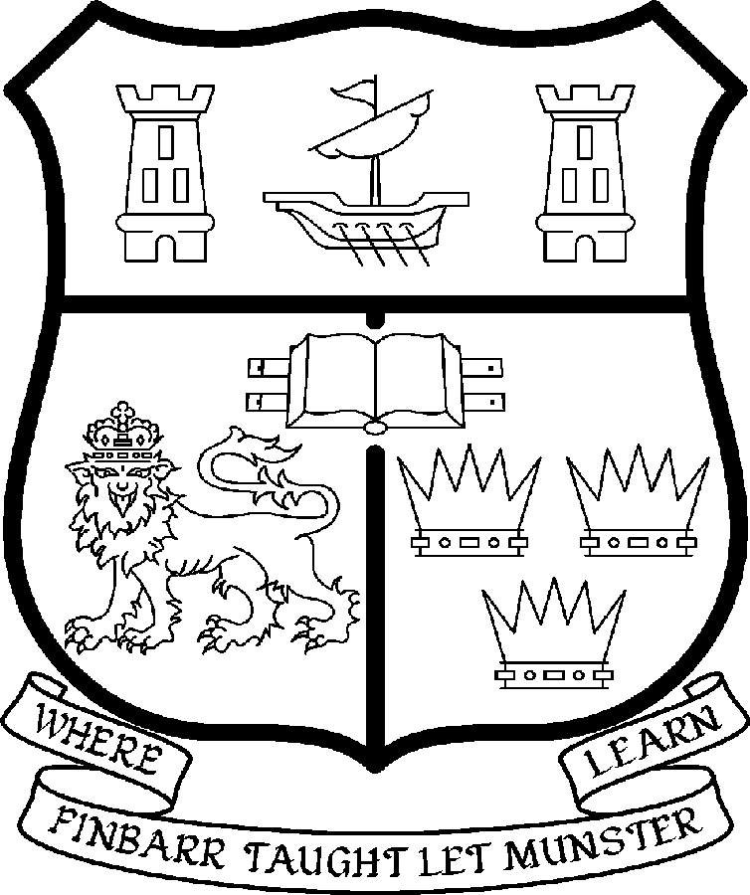 | UNIVERSITY COLLEGE CORK  Coláiste na hOllscoile Corcaigh
PROFESSORSHIP OF MARKETING

Particulars of the Post

1. The Professorship of Marketing is a permanent full-time office. The current annual stipend of the Professorship – [new entrants] - is as follows:

€
Minimum 109,104
Second Point 115,359
Third Point 121,614
Fourth Point 127,871
Fifth Point 134,127
Maximum 140,385

2. The salary includes a premium of 1/19th for pensionable staff paying contributions. Class A1 rate of Pay Related Social Insurance (PRSI) applies to the post. The rate is currently 4% on the first €48,800 of annual earnings.

3. Duties of the Post: The duties of the Professor shall be to lecture in Marketing for all relevant degrees, diplomas and certificates of the University. S/he shall examine in Marketing for the University and shall carry out such other duties appropriate to the post. In addition, the Professor of Marketing will be expected:

- To be responsible for providing leadership in the development of the Marketing discipline

- To represent Marketing both inside and outside the University;

- To act as a role model for colleagues and support them in their teaching and research;

- To undertake research in the subject;

- To contribute to the ongoing development of all Departmental programmes, research initiatives and other activities;

- To serve as Head of Department of Management and Marketing subject to relevant University Statutes. The Headship of the Department will normally revolve between the Full Professors of the Department.

4. Selection Criteria: The successful candidate will have:

- A significant and respected international academic profile in Marketing

- An outstanding research and publications record, as evidenced by a record of scholarly publications in leading, international refereed journals.

- Commitment and skills to lead a team of business academics and serve as Head of Department in a highly multi-disciplinary environment;

- Commitment to teaching and curriculum development and a willingness to contribute to a range of modules and programmes taught by the Department at undergraduate, postgraduate levels and executive development levels;

- Ability to generate research and consultancy income

- Strong linkages with organisations and business professionals involved in marketing

- A commitment to postgraduate supervision to doctorate level;

- Willingness to participate in and contribute to the overall life of the University and its relevant Faculties and Colleges.

The above listing is not exclusive or exhaustive and the post holder may be required to undertake any such duties as may reasonably be expected. All staff are required to be flexible, co-operative and professional, commensurate with the needs of the post and with Departmental, College and University needs

5. The “Statutory and other provisions relating to full-time Professorships” as set out in the attached shall also apply to the post.

- Each candidate must complete an application form for the post. Please indicate
clearly on the application form, which post is being applied for.

Candidates may be required to produce documentary evidence to support any statements made by them on their application form or any supporting documentation. Candidates should note that any inaccurate information will invalidate their application.

- Completed application forms must reach the Recruitment Office, Department of Human Resources, University College, Cork, Ireland, on or before 14 September 2007. Tel: 021 4903073/ Fax 021 4276995 Email: recruitment@per.ucc.ie.

UNIVERSITY COLLEGE CORK IS A EQUAL OPPORTUNITIES EMPLOYER

