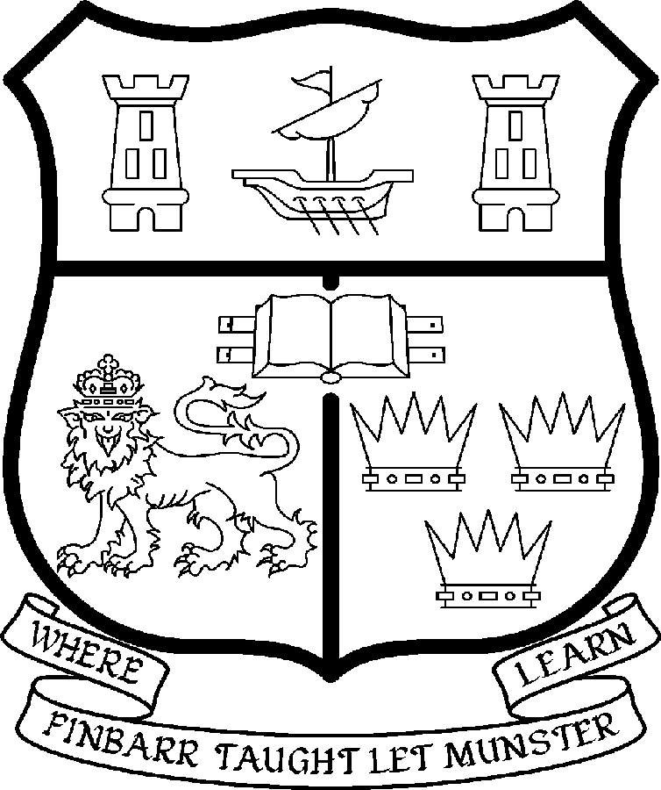 | UNIVERSITY COLLEGE CORK  Coláiste na hOllscoile Corcaigh
PROFESSORSHIP OF FOOD BUSINESS & DEVELOPMENT

Particulars of the Post

1. The Professorship of Food Business & Development is a permanent full-time office. The current annual stipend of the Professorship – [new entrants] - is as follows:

€
Minimum 109,104
Second Point 115,359
Third Point 121,614
Fourth Point 127,871
Fifth Point 134,127
Maximum 140,385

2. The salary includes a premium of 1/19th for pensionable staff paying contributions. Class A1 rate of Pay Related Social Insurance (PRSI) applies to the post. The rate is currently 6% on the first €48,800 of annual earnings.

3. Duties of the Post: The duties of the Professor shall be to lecture in Food Business (including Food Economics, Management & Marketing), Co-operative Organisation (including Credit Union and Social Enterprise) and Development (including rural, local and international development) for all relevant degrees, diplomas and certificates of the University. S/he shall examine in Food Business & Development for the University and shall carry out such other duties appropriate to the post. In addition the Professor of Food Business & Development will be expected:

- To be responsible for providing leadership in the development of the cognate disciplines of Food Business, Co-operative Organisation and Development and the Department of Food Business & Development.

- To represent Food Business & Development both inside and outside the University;

- To act as a role model for colleagues and support them in their teaching and research;

- To undertake research in the subject;

- To serve as Head of Department subject to relevant legislation, University Statutes and management requirements (when a member of staff other than the Professor of Food Business & Development serves as Head of Department, the Professor will undertake his/her teaching duties under the general direction of the Head);

4. Selection Criteria: The successful candidate will be expected to have:

- A PhD in any area related to food business, co-operative organisation or development;

- A significant international academic profile in Food Business, Co-operative Organisation or Development (ideally one that links to the multi-disciplinary research and teaching interests of the Department);

- An outstanding research and publications record, as evidenced by a record of scholarly publications in books, refereed journals, end-user reports, monographs and the building of productive research teams;

- Proven ability to provide strategic vision and leadership in the development of a multi-disciplinary perspective in the areas of food business, co-operatives and development;

- A strong commitment to teaching and learning, including distance education and e-learning as well as adult/continuing education, lifelong learning and continuing professional development;

- Proven ability to generate research income and have strong linkages with food business and development type organisations including co-operatives;

- A successful record of postgraduate supervision to doctorate level;

- An outstanding record of teaching and curriculum development and a willingness to contribute to a range of topics taught by the Department at undergraduate and postgraduate levels, including distance education and e-learning which involve some Saturday and evening work;

- Interpersonal skills commensurate with leading and supporting a team of committed academic and administrative colleagues in a highly multi-disciplinary environment;

- The capacity to serve as Head of Department together with the requisite communication, management, administrative and leadership skills as evidenced by appropriate and substantive experience;

- Willingness to participate in and contribute to the overall life of the University and its relevant Faculties and Colleges.

The above listing is not exclusive or exhaustive and the post holder may be required to undertake any such duties as may reasonably be expected. All staff are required to be flexible, co-operative and professional, commensurate with the needs of the post and with Departmental, College and University needs

5. The “Statutory and other provisions relating to full-time Professorships” as set out in the attached shall also apply to the post.

- Each candidate must complete an application form for the post. Please indicate clearly on the application form, which post is being applied for.

- Candidates may be required to produce documentary evidence to support any statements made by them on their application form or any supporting documentation. Candidates should note that any inaccurate information will invalidate their application.

- Completed application forms must reach the Recruitment Office, Department of Human Resources, University College, Cork, Ireland, on or before Friday, 22 June 2007. Tel: 021 4903073/ Fax 021 4276995 Email: recruitment@per.ucc.ie.

9. Short-listed candidates will be invited to make a short presentation on “My Food Business & Development Education and Research Agenda: Past, Present & Future.

UNIVERSITY COLLEGE CORK IS A EQUAL OPPORTUNITIES EMPLOYER

---------------------------------------------------------------------------------------------

About the Department

The Department of Food Business & Development undertakes teaching, examining and research in Food Business (including Food Economics, Management & Marketing), Co-operative Organisation (including Credit Union and Social Enterprise) and Development (including Local, Rural and International Development). The Department’s three complementary cognate disciplines are in turn supported by two Centres – the Centre for Co-operative Studies and the Centre for Sustainable Livelihoods – in which Food Business & Development academic staff may opt to conduct some or all of the research activity. The Department is a primary member of the Faculty of Commerce/ College of Business & Law (BL) and the Faculty of Food Science & Technology / College of Science, Engineering and Food Science (SEFS).

Department Mission

The overall mission of the Department of Food Business & Development is to promote, through its educational, research and outreach activities, the development and continuing effectiveness of Ireland’s food businesses, with particular emphasis on the well-being of indigenous agriculture, the sustainability of rural and local development, the central role of co-operatives of all kinds (including credit unions) and the sustainability of livelihoods in the developing world.

Success to Date

Since 1990, the Food Business & Development entity has witnessed significant growth with staff increasing from two to sixteen, and student numbers rising to approximately 350 FTE’s. It has a strong Postgraduate research focus (10 PhD’s completed in the past year) and has pioneered highly innovative distance learning programmes, facilitated by e-learning technologies, e.g., BSc Rural Development (in SEFS) and BSc Mutual and Credit Union Business (in BL). This multi-disciplinary entity is integrated into extensive sectoral, regional, national and international networks, which reinforce all its activities and have attracted significant funding to UCC. Since 2000, Food Business has attracted about €1 million in research funding, while Co-operative Business and Development have each attracted about €750,000 to give a departmental total of about €2.5 million.

Programmes of Study

The Department of Food Business & Development is one of the leading international providers of third and fourth level education and research in its field. Programmes include the following:

- BSc Food Business
- BSc International Development & Food Policy
- BSc Mutual & Credit Union Business (Distance Learing)
- BSc Rural Development (Distance Learning)
- Postgraduate Diploma in Co-operative Organisation,Food Marketing & Rural Dev.
- MSc in Co-Operative Organisation, Food Marketing & Rural Development
- MBS Co-operative & Social Enterprise (e-learning)
- MBS Food Marketing
- MSc Food Business
- MSc Rural Development (Joint degree with Mekelle University, Tigray, Ethiopia),
- MSocSc in Third Sector Management (in partnership with the Department of Applied Social Studies)
- Diploma in Rural Development
- Diploma in Credit Union Studies
- Diploma in Social Integration & Enterprise
- Diploma in Food Retailing
- Diploma in Supply Chain Management
- PhD awarded in all three areas of departmental concentration.

In addition, the Department contributes actively to several “programmatic” degrees in BL [e.g. BComm, BComm(International), MBA] and in SEFS [e.g. BSc(Food Sciences), BSc(Environmental Studies)]

