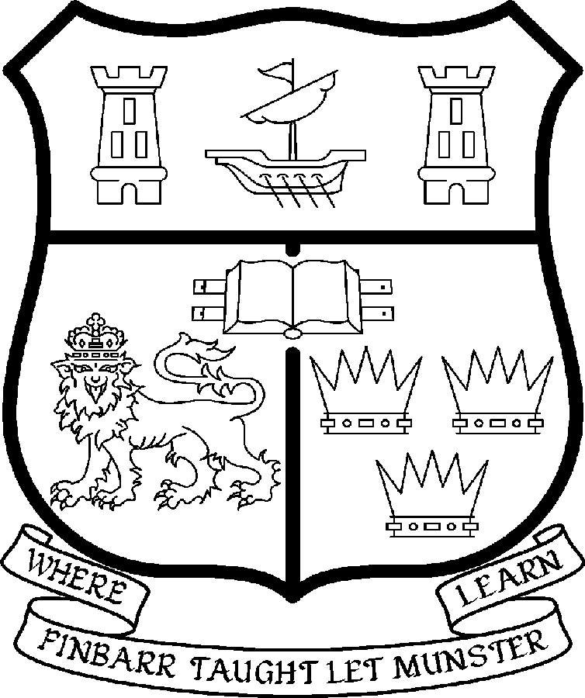 | UNIVERSITY COLLEGE CORK  Coláiste na hOllscoile Corcaigh
 | LECTURESHIPS IN LAW

PARTICULARS OF POST

- There are two permanent posts. The appointee to the post shall work under the direction of the Head of the Department of Law and shall discharge such duties as shall be assigned to him/her by the said Head.

2. The current remuneration – [new entrants] – is as detailed below. The appointment to the post of Lecturer will be made at a point below the bar on the following scale in accordance with qualifications and experience to date. There is provision for subsequent progression beyond the BAR in accordance with the terms of the Academic Promotions Scheme to a salary scale segment with a maximum of €81,867 – [new entrants]

 | € |  | €
Minimum | 34,912 | Eighth Point | 49,408
Second Point | 36,935 | Ninth Point | 51,608
Third Point | 39,251 | Tenth Point | 53,282
Fourth Point | 41,243 | Eleventh Point | 54,995
Fifth Point | 43,336 | Maximum | 56,713
Sixth Point | 45,542
Seventh Point | 47,300

BAR

- The salary includes a premium of 1/19th for pensionable staff paying contributions. Class A1 rate of Pay Related Social Insurance (PRSI) applies to the post. The rate is currently 6% on the first €48,800 of annual earnings.

- Responsibilities of the Post:

The duties of the Lecturers shall be to lecture in Law under the direction of the Head of the Department of Law for all degrees, diplomas and certificates of the University. They shall, in addition, discharge such other duties (including examining) appropriate to the office as shall be assigned to them by the Head of the Department of Law. In particular, the post-holder shall be required to undertake the following responsibilities-:

- To teach and examine on existing courses at undergraduate and postgraduate level;

- To participate fully in the work of the Department, including postgraduate supervision, and in Departmental administration;

- To engage in individual research, participate in the Department’s research activities and have an active role in generating research income;

- To carry out other duties as appropriate, including administration and participate in the running of the Department and Faculty of Law.

The above is not exclusive or exhaustive and the post holder may be required to undertake any such duties as may reasonably be expected. All staff are required to be flexible and co-operative and professional within the needs of the post and the Department, College and University.

5. Selection Criteria:
Decisions made at shortlisting, presentation and interview will be made based on the following criteria:

- Applicants must hold a post-graduate qualification in law.

- Candidates should demonstrate:

- A research profile in any major field of law, relevant to the department.

- A commitment to excellence in teaching at all levels.

- Administrative skills and an ability to represent the Department, both inside and outside the University.

- An ability to strengthen existing programmes at undergraduate and postgraduate level, and to contribute to the development of new programmes.

Candidates are requested to make a personal assessment of these criteria against their own qualifications, skills and abilities to assess whether they should apply for the post.

- The "Provisions relating to full-time posts as Lecturer" as set out in the attached document also apply to the post.

- Each candidate must complete an application form for the post. Please indicate clearly on the application form which post is being applied for.

- Candidates may be required to produce documentary evidence to support any statements made by them on their application form or any supporting documentation. Candidates should note that any inaccurate information will invalidate their application.

- Completed application forms must reach the Recruitment Office, Department of Human Resources, University College, Cork, Ireland, on or before 20th April 2007.

Further information on the department can be found online on www.ucc.ie/law

Application forms and further details of above post are available from:
http://www.ucc.ie/en/hr/EmploymentOpportunities/AcademicVacancies/
or

Department of Human Resources,
University College Cork
Cork
Ireland
Tel: +353 21 4902671/ Fax: +353 21 4276995/ Email: recruitment@per.ucc.ie

University College Cork is an Equal Opportunities Employer

