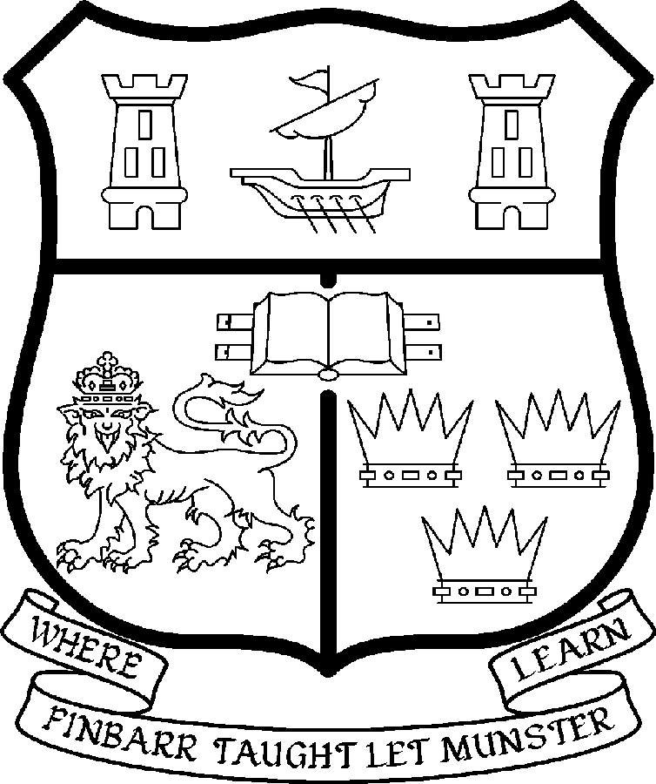 | UNIVERSITY COLLEGE CORK  Coláiste na hOllscoile Corcaigh
LECTURESHIP IN
TWENTIETH CENTURY CHINESE HISTORY

Particulars of the Post

The Lectureship in the Institute of Chinese Studies and Department of History is a full-time, permanent post. The current remuneration – [new entrants] - is as detailed below. The appointment to the post will be made at the point on the following scale in accordance with qualifications and experience:

Scale: €34,912 - €56,713

The salary includes a premium of 1/19th for pensionable staff paying contributions. Class A1 rate of Pay Related Social Insurance (PRSI) applies to the post which is currently 6.0% with an earnings ceiling of €46,600, 2% is payable on the balance.

Duties of the Post:

The appointee will work jointly with the Director of the Irish Institute of Chinese Studies and the Head of the Department of History.

The successful candidate will be expected to develop and contribute to research and teaching in Chinese history and culture areas. S/he will be expected to:

- Develop, teach and examine courses at undergraduate and postgraduate level in the area of twentieth century Chinese history
- Contribute to survey courses on the History of China
- Undertake supervision of postgraduate research students working in the area of twentieth century Chinese history
- Engage in relevant areas of research in Chinese Studies and develop research programmes and generate research income
- Develop links with professional and academic bodies and external agencies
- Cooperate with other academic units to help promote and develop research and teaching links in UCC and Chinese partners to enhance the international profile of UCC
- Contribute to administrative and other duties as directed by the Heads of the Institute and Department.

The above is not exclusive or exhaustive and the post holder may be required to undertake any such additional duties as may reasonably be expected. All staff are required to be flexible and co-operative and professional within the needs of the post and the Institute, Department, College and University.

Selection Criteria
The successful candidate will have to meet the following criteria:

- Hold a PhD in twentieth century Chinese history
- Have a strong record of published research in the area of twentieth century Chinese history
- Have demonstrated ability to teach and supervise students both at undergraduate and postgraduate level
- Evidence of a high level of spoken and written language proficiency in Mandarin Chinese and English.

The normal provisions relating to full-time College Lectureships shall apply to the post.

Candidates must submit, in English, a
- Letter of application
- Detailed academic CV
- Completed application form

Completed applications must reach Academic Appointments, Department of Human Resources, University College, Cork, Ireland, on or before 23rd March, 2007.

The start date for this post is 15th September 2007.

