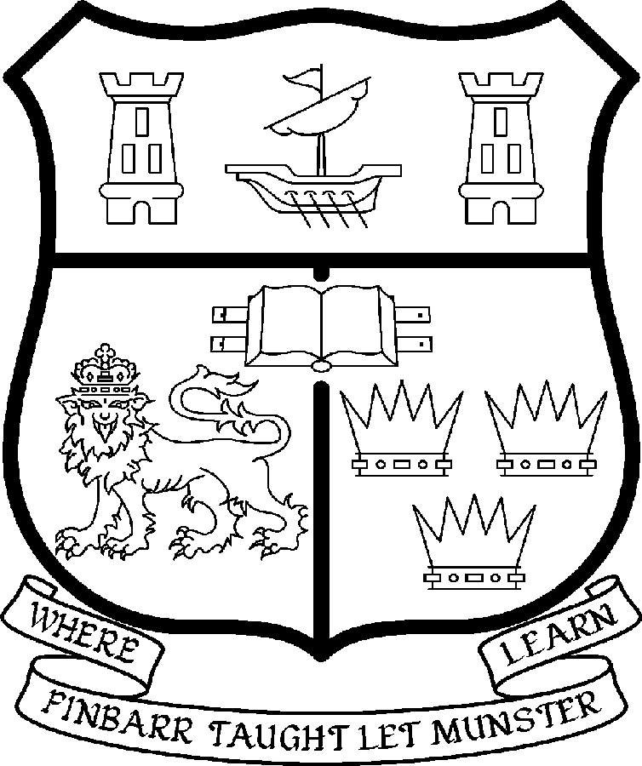 | UNIVERSITY COLLEGE CORK  Coláiste na hOllscoile Corcaigh
LECTURESHIP IN MODERN CHINESE HISTORY

Particulars of Post

The Lectureship in the Institute of Chinese Studies and Department of History is a full-time, permanent post. The start date for this post is 15th September 2007.

The current remuneration – [new entrants] - is as detailed below. The appointment to the post will be made at the point on the following scale in accordance with qualifications and experience. There is provision for subsequent progression beyond the BAR in accordance with the terms of the Academic Promotions Scheme to a salary scale segment with a maximum of €81,867 (new entrants)

 | € |  | €
Minimum | 34,912 | Eighth Point | 49,408
Second Point | 36,935 | Ninth Point | 51,608
Third Point | 39,251 | Tenth Point | 53,282
Fourth Point | 41,243 | Eleventh Point | 54,995
Fifth Point | 43,336 | Maximum | 56,713
Sixth Point | 45,542
Seventh Point | 47,300

BAR

- The salary includes a premium of 1/19th for pensionable staff paying contributions. Class A1 rate of Pay Related Social Insurance (PRSI) applies to the post. The rate is currently 6% on the first €48,800 of annual earnings.

- Job Responsibilities

The appointee will work jointly with the Director of the Irish Institute of Chinese Studies and the Head of the Department of History.

The successful candidate will be expected to develop and contribute to research and teaching in Chinese history and culture areas. S/he will be expected to:

- Develop, teach and examine courses at undergraduate and postgraduate level in the area of twentieth century Chinese history
- Contribute to survey courses on the History of China
- Undertake supervision of postgraduate research students working in the area of twentieth century Chinese history
- Engage in relevant areas of research in Chinese Studies and develop research programmes and generate research income
- Develop links with professional and academic bodies and external agencies
- Cooperate with other academic units to help promote and develop research and teaching links in UCC and Chinese partners to enhance the international profile of UCC
- Contribute to administrative and other duties as directed by the Heads of the Institute and Department.

The above is not exclusive or exhaustive and the post holder may be required to undertake any such additional duties as may reasonably be expected. All staff are required to be flexible and co-operative and professional within the needs of the post and the Institute, Department, College and University.

5. Selection criteria

Decisions made at shortlisting, presentation and interview will be made based on the following criteria:

- Hold a relevant PhD
- Have a record of published research in the area of twentieth century Chinese history
- Have demonstrated ability to teach and supervise students both at undergraduate and postgraduate level
- Evidence of proficiency in Mandarin Chinese and English.

Candidates are requested to make a personal assessment of these criteria against their own qualifications, skills and abilities to assess whether they should apply for the post.

The normal provisions relating to full-time College Lectureships shall apply to the post.

Each candidate must complete an application form for the post. Please indicate clearly on the application form which post is being applied for. An application form must be completed and is available from http://hr.ucc.ie/forms.php.

Certificates and Testimonials: These documents should not be sent with the application. Candidates who are selected for interview will be requested to submit the necessary documentation.

Note: Candidates may be required to produce documentary evidence to support any statements made by them on their application form or any supporting documentation. Candidates should note that any inaccurate information will invalidate their application.

Completed application forms should be returned to

Department of Human Resources, University College, College Road, Cork

Tel: 021 4903073/ Fax 021 4276995
Email: recruitment@per.ucc.ie

Completed applications must reach Department of Human Resources, University College Cork, Ireland, on or before 11 May 2007.

UCC IS AN EQUAL OPPORTUNITIES EMPLOYER

