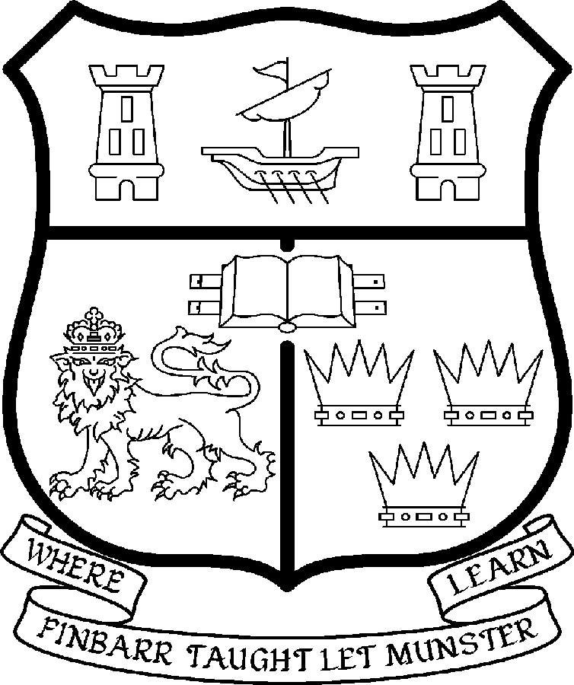 | UNIVERSITY COLLEGE CORK  Coláiste na hOllscoile Corcaigh
CHAIR IN ANATOMY

Particulars of Post

- The Professorship of Anatomy is a permanent full-time office. The current annual stipend of the Professorship – [new entrants] - is as follows:

€
Minimum 109,104
Second Point 115,359
Third Point 121,614
Fourth Point 127,871
Fifth Point 134,127
Maximum 140,385

- The salary includes a premium of 1/19th for pensionable staff paying contributions. Class A1 rate of Pay Related Social Insurance (PRSI) applies to the post. The rate is currently 4% on the first €48,800 of annual earnings.

Duties of the Post: The duties of the Professor shall be to lecture in Anatomy for all degrees, diplomas and certificates of the University. S/he shall examine in Anatomy for the University and shall carry out such other duties appropriate to the post. In addition the Professor of Anatomy will be expected:

- To lead the Department of Anatomy in research and curriculum development at undergraduate and postgraduate level;
- To lead the Department’s contribution to the disciplinary and professional development of Anatomy and Neuroscience nationally and internationally;
- To supervise Masters and Doctoral students to successful and timely completion of their degrees;
- To contribute to the professional development of students in the College of Medicine and Health;
- To contribute to the professional development of BSc Neuroscience students
- To act as Head of Department, subject to relevant University legislation , University Statutes and management requirements;

- Selection Criteria. The successful candidate will be expected to have:

- A PhD. or equivalent qualification;

- A strong research profile based on an outstanding record of achievement in Neuroscience or a related area;

- An outstanding record of teaching and curriculum development and a commitment to excellence in teaching;

- An international reputation in Neuroscience or a related area;

- Experience of supervising research students at Masters and Doctoral level to successful completion;

- Evidence of an ability to attract research funding;

- A demonstrated awareness of educational issues both nationally and internationally;

- The vision to lead curriculum development within the context of UCC and to enhance research in the department;

- The capacity to act as Head of Department together with the requisite communication, management, administrative and leadership skills;

- The capacity to relate effectively with other professional stakeholders both nationally and internationally;

- The ability to contribute to the continuing education of clinical and scientific stakeholders ;

- The skills to convey effectively the Department’s vision and distinctive character and expertise to a range of audiences including students, the educational profession and the wider community;

- A medical degree is desirable but not essential

- The “Statutory and other provisions relating to full-time Professorships” as set out in the attached shall also apply to the post.

- Each candidate must complete an application form.

- Completed application forms must reach the Department of Human Resources, University College, Cork, Ireland, on, or before 24th August 2007
***********

