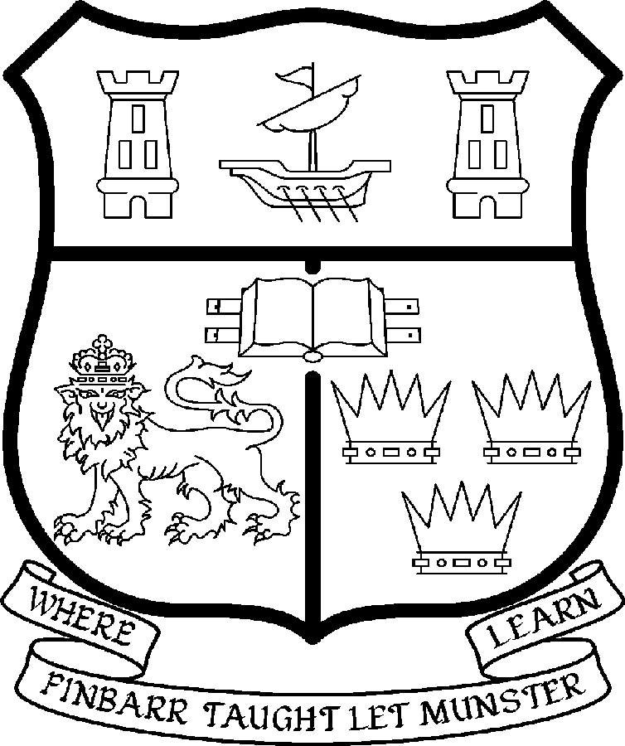 | UNIVERSITY COLLEGE CORK  Coláiste na hOllscoile Corcaigh  Professorship in Energy Engineering

Particulars of Post

- The Professorship in Energy Engineering is a new wholetime post. The current annual stipend of the Professorship – [new entrants] - is as follows:
€
Minimum 111,286
Second Point 117,666
Third Point 124,046
Fourth Point 130,428
Fifth Point 136,810
Maximum 143,193

- The salary includes a premium of 1/19th for pensionable staff paying contributions. Class A1 rate of Pay Related Social Insurance (PRSI) applies to the post. The rate is currently 4% on the first €50,700 of annual earnings.

Responsibilities of the Post: The duties of the Professor shall be to lecture in Energy Engineering for all degrees, diplomas and certificates of the University under the direction of the Head of Department of Civil & Environmental Engineering as agreed with the Head of the Department of Electrical & Electronic Engineering. He/she shall examine in Energy Engineering for the University and shall carry out such other duties appropriate to the post. In addition the Professor of Energy Engineering will be expected:

- To provide leadership and to foster excellence in teaching and research within the discipline.
- To have the ability to strengthen and develop existing teaching programmes and to initiate new programmes.
- To be available for appointment as Head of Department and to represent the interests of the departments and Faculty both inside and outside the University and to foster links with other institutions and professional bodies.
- To develop postgraduate programmes in energy engineering and related disciplines.
- To provide academic leadership particularly in the area of research in energy engineering
- To generate research income and develop links with Industry.

The above listing is not exclusive or exhaustive and the post holder may be required to undertake any such duties as may reasonably be expected. All staff are required to be flexible and co-operative and professional within the needs of the post and the Department/School, College and University. The University is undertaking a major reform of its internal structures which may necessitate changes in the organisation of its activities.

- Selection Criteria. The successful candidate will be expected to have:

  - A doctoral qualification in Engineering or a cognate discipline;

  - A proven record of internationally recognised independent research accomplishments in the field of energy engineering;

  - Significant experience of working at a senior level within a university department and/or an internationally leading research institute or industrial environment;

  - The ability to provide strategic vision and leadership in the development of energy engineering;

  - Evidence of successfully raising substantial research funding;

  - Demonstrated potential to deliver programmes of study at undergraduate and postgraduate level in professional engineering degree programmes and a commitment to excellence in teaching;

  - Demonstrated potential to teach, inspire and supervise students;

  - Demonstrated ability and willingness to work in a collaborative environment;

  - Ability to communicate effectively and evidence of competence in spoken and written English;

  - Willingness to participate in and contribute to the overall mission of the College of Science, Engineering and Food Science and the University;

Additional Desirable Criteria

  - Experience of working with industry;

  - A successful record of postgraduate supervision to doctorate level;

Candidates are requested to make a personal assessment of these criteria against their own qualifications, skills and abilities to assess whether they should apply for the post.

- The “Statutory and other provisions relating to full-time Professorships” as set out in the attached shall also apply to the post.

- The University is undertaking a major reform of its internal structures which may necessitate changes in the organisation of its activities. The successful candidate may be expected to adapt his/her work practices and/or reporting relationships to facilitate such reforms.

- Each candidate must complete an application form, which can be downloaded at:
http://www.ucc.ie/en/hr/FormsContractDocuments/DocumentFile,35042,en.doc

- Shortlisted candidates for posts shall be required to appear in person before a Board of Assessors in Cork, in which case travelling and subsistence expenses at approved rates will be paid.

- A successful candidate will be required to submit a birth certificate, documentary evidence confirming academic qualifications, and to undergo a medical examination.

- References will be sought in relation to all candidates invited to attend for interview.

- An offer of appointment to a candidate who is not of EU nationality is subject to the granting of a Work Permit by the Department of Enterprise Trade & Employment.

- Candidates may be required to produce documentary evidence to support any statements made by them on their application form or any supporting documentation. Candidates should note that the submission of any inaccurate information will invalidate their application.

- Completed application forms must reach Recruitment Office, Department of Human Resources, University College, Cork, Ireland, on or before Friday 11th July 2008. Tel: +353-21-4902671 Email: recruitment@per.ucc.ie. Fax. +353-21-4276995.

University College Cork is an Equal Opportunities Employer

GENERAL INFORMATION FOR CANDIDATES

Introduction to University College Cork and Relevant Research Institutes

University College Cork, a constituent University of the National University of Ireland, is a collegiate, progressive, dynamic research-led university developing a reputation as a world class regional university, built on the history of significant achievements in teaching and learning and research, and strong academic and professional leadership.

The University has a current enrolment of over 17,000 students with a strategic objective of 21,000 by 2011. UCC currently has 1,400 academic and research staff within a total staff compliment of 2,500.

Founded in 1845, as Queen’s College, Cork, UCC is one of Ireland’s oldest institutions of higher learning. The rich history and tradition of UCC is reflected in the imposing limestone buildings of the Main Quadrangle and the mature grounds. UCC’s scenic city centre campus, boasting award-winning architecture, provides a pleasant and vibrant learning environment, which is given an international dimension by the presence of 2,000 international students and many staff from over 75 countries around the world.

UCC is one of the premier research institutions in the State and its research income is consistently one of the highest in the country. The University earns peer-reviewed research income in excess of €60m per annum, has strategic research partnerships with leading multinationals in the agri-food, microelectronics, and pharmaceutical sectors, and is home to 5 of Ireland’s 8 ISI Most Highly Cited authors. The university’s research reputation spans across the broad range of disciplines, strategically built around a number of internationally-recognised Research Institutes, Centres and Departments.

UCC is fully committed to the development of 4th level training and research through the introduction of Graduate Schools and structured PhD programmes and the provision of a wide range of generic and discipline-specific modules supporting the research activity of PhD students. The University offers an innovative, research-led curriculum, taught by world-class academics who consistently attract a quality student intake.
Recent institutional reorganisation has established four Colleges; Arts, Celtic Studies and Social Sciences; Business and Law; Medicine and Health; Science, Engineering and Food Science. The Colleges offer over 120 degree and professional programmes that consistently attract the highest proportion of top school leavers in the country and supports a rapidly growing postgraduate and international student body.

The University has embarked on a programme of development for UCC to firmly establish it as a world-class regional university building on the guiding principles in the University’s Strategic Framework 2006-2011 of excellence in teaching, learning, research and contribution to community and society. UCC will focus on research performance, the quality of the student experience and the manner in which the institution discharges its regional role.

Having twice being designated as the Sunday Times “Irish University of the Year” in the past four years, UCC is also a recent proud recipient of the “Excellence Through People” Gold Standard.

The last five years have seen exceptional growth in student numbers, award winning capital developments supporting science, technology and the arts and significant success in winning research funding, making it in that time the most research active institution in the country.

UCC enjoys excellent links with local business and enterprise along with strong partnerships with some of the world’s most highly valued companies. Relationships with professional and public bodies across a wide range of disciplines are equally a key feature of the University.

Internationalisation of the campus continues to be a key strategic objective of UCC. International enrolment at UCC is among the highest in the sector creating a multi- cultural and ethnically diverse student body and measures taken by UCC to enhance conditions for international student recruitment are regarded as among the best practices by peer institutions. UCC also provides opportunities for Irish students to study overseas making them competitive in a global market. In recent years new exchange opportunities include academic placements in a diverse range of European, US, Canadian and Australian universities, with new developments targeting China.

Staff are essential to the achievement of our mission and UCC places a special emphasis on quality improvement strategies in Human Resource Management. A key objective of the UCC Strategic Framework 2006-2011 is to attract, develop and retain outstanding staff through the development and implementation of best practice HR policies and procedures. We seek to develop staff capable of keeping the University at the forefront in all that it does. The University has committed to establishing a supportive working environment in which the needs of all staff are recognised and their contributions valued and rewarded.

TYNDALL NATIONAL INSTITUTE

Tyndall National Institute was established in 2004 to establish a multidisciplinary centre-of-excellence in ICT hardware. It brings together researchers based in UCC, CIT and other Irish third level institutions with those based in Tyndall, industry and international visitors in a set of well-facilitated and equipped laboratories. It has been set-up as an independent institute, within the legal and financial governance frameworks of UCC, with its own Board of Directors and CEO to deliver the research objectives of the Irish government. It has ca 320 staff and students.

ENVIRONMENTAL RESEARCH INSTITUTE

The Environmental Research Institute (ERI) was established in 2000 with the aim of further developing and expanding the existing critical mass of Environmental, Coastal and Marine based researchers at University College Cork.
Research activities within the ERI have been strategically focused into five thematic research areas, namely;
Marine and Freshwater Research
Biodiversity and Ecotoxicology
Environmental Chemistry
Sustainable Energy and Environmental Engineering
Environmental Microbial Genomics

Web Links
UCC website
http://www.ucc.ie/en/

UCC Strategic Plan 2006-2011
http://www.ucc.ie/en/PresidentsOffice/UCCsStrategicPlan/DocumentFile,1005,en.pdf

