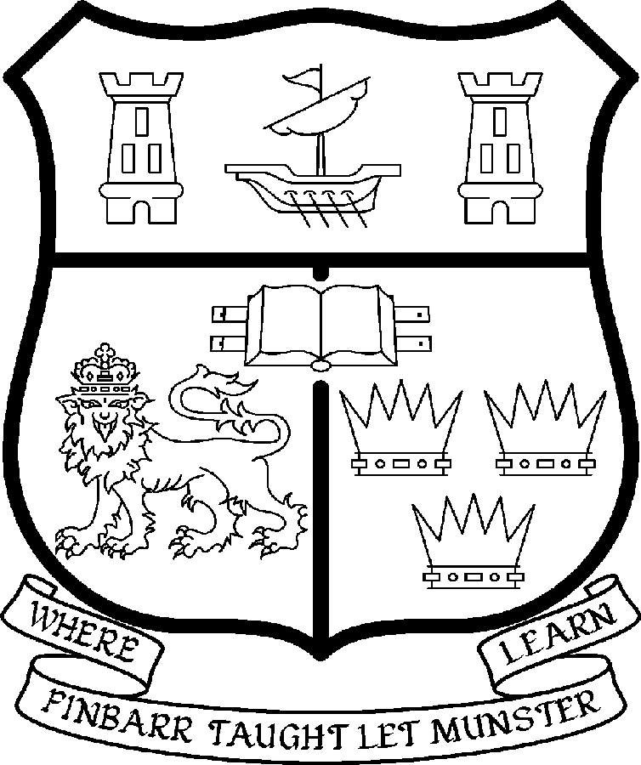 | UNIVERSITY COLLEGE CORK  Coláiste na hOllscoile Corcaigh
PROFESSORSHIP OF MEDIEVAL HISTORY

Particulars of Post

- The Professorship of History is a permanent full-time office. The current annual stipend of the Professorship – [new entrants] - is as follows:

€
Minimum 109,104
Second Point 115,359
Third Point 121,614
Fourth Point 127,871
Fifth Point 134,127
Maximum 140,385

- The salary includes a premium of 1/19th for pensionable staff paying contributions. Class A1 rate of Pay Related Social Insurance (PRSI) applies to the post. The rate is currently 4% on the first €48,800 of annual earnings.

- Duties of the Post: The duties of the Professor shall be to lecture in History for all relevant degrees, diplomas and certificates of the University. S/he shall examine in History for the University and shall carry out such other duties appropriate to the post. In addition the Professor of Medieval History will be expected:

- To be responsible for providing leadership in the development and the discipline of History and the Department of History;

- To represent the discipline both inside and outside the University;

- To support and inspire departmental colleagues;

- To initiate research projects and to participate in existing departmental projects relevant to his/her areas of specialisation;

- To act as Head of Department subject to relevant legislation, University Statutes and management requirements;

- Selection Criteria.

- The successful candidate will have a doctorate in History;

- The successful candidate will have the expertise to develop further the Department’s established research and postgraduate teaching interests in the period before c. 1200, within the area of Irish history, its insular and continental contexts, and the insular reception of the cultural legacy of Late Antiquity.

- The successful candidate will have an internationally established scholarly and research reputation in Medieval History with a specialisation in the area outlined immediately above;

- The successful candidate will have a successful record of postgraduate supervision;

- The successful candidate will have interpersonal skills commensurate with leading and supporting a team of committed academic and administrative colleagues;

- The successful candidate will have a capacity to act as Head of Department together with the requisite communication, management, administrative and leadership skills;

- The successful candidate will have the skills to represent the Department and the discipline both inside and outside the University

- The successful candidate will have a willingness to participate in and contribute to the overall life of the College of Arts, Celtic Studies and Social Sciences and the University.

- The “Statutory and other provisions relating to full-time Professorships” as set out in the attached shall also apply to the post.

- Each candidate must complete an application form for the post.

- Applications must reach the Recruitment Office, Department of Human Resources, University College, Cork or E-mail at recruitment@per.ucc.ie on or before 5pm on 11 January 2008

UNIVERSITY COLLEGE CORK IS AN EQUAL OPPORTUNITIES EMPLOYER

18/10/2007
DEPARTMENT OF HISTORY

Professorship of Medieval History

Note on the Department of History
from Prof. Dermot Keogh, Head of Department

The Department has a strong research ethos covering specialisations from early Ireland to the twentieth-century. The research profile, which can be accessed on the departmental website, displays the breadth and range of topics being actively researched by the staff in Irish, European and international history.

The publication record of the Department is very strong. A list of the recent monographs and edited works may be found on the website.

A number of departmental staff have been the recipients of international awards and fellowships including IRCHSS, Fulbright, Woodrow Wilson Centre and other awards.

The research and teaching excellence of the Department has been acknowledged in a recent quality review. That report may also be found on the college website.

The teaching staff of the Department of History normally includes two professors, and twenty two full-time and part-time lecturers. In recent years about 350 students have taken History as one of four subjects in the first year of the three-year BA Degree, and about 260 have continued into the two-subject second and third year, including up to 400 ‘non-traditional’ students. In addition, about 30 students have pursued a four-year BA Evening Degree. The Department also participates in the teaching of the following four-year degree programmes:

- European Integration Studies
- Language and Cultural Studies

Departmental staff also contribute to the teaching of the degree subjects:

- History of Art
- Politics
- Diplomas in Adult and Continuing Education
- The Department of History coordinates the subject Politics.

At Postgraduate level, the Department offers MPhil, MA and PhD programmes in the following areas:

- European Integration Studies
- Government & Politics in Twentieth-Century Ireland
- History of Irish Media and Journalism
- State, Culture and Identity in Ireland, 1500-1900
- The United States, Latin America and Europe
- History of the Irish Diaspora and Settlement
- International Relations
- Medieval History
- Local History

Departmental staff also participate in MA programmes in:

- Women Studies
- Medieval Monastic Culture
- Politics

Staff in the Department of History also run:

The Irish National Institute for Historical Research (INIHR).

The activities of the institute builds upon the fine traditions and practice of research and innovation within the Department. Set up by Professor Dermot Keogh, its initial programme has focused upon:

- Irish Identity and Ireland in the International System
- Imagining Ireland
- Tolerance, Intolerance and Sectarianism
- Aliens, Minorities and Outsiders in Irish History
- Hidden Histories
- Servants and Subverters of Empire
- History of Irish Migration

The INIHR also hosts conferences and helps extend the network of contacts with countries within the enlarged EU, India, the United States and Latin America.

The ArCH project, which will produce facsimiles of great Irish manuscripts together with commentaries, is also situated in the History Department.

In recent years, there have been about 50 MA students, 20 MPhils and 30 PhDs in any given year (plus 10 MA in Politics students in 2007). Graduate teaching and supervision therefore absorb a high proportion of staff time.

Apart from the personal contacts of staff members, many of whom have taught or researched abroad, the Department has a wide range of institutional international contacts. It was a founder member of the ERASMUS European Credit transfer System, which links it with more than twenty other European Universities. A year abroad in an appropriate university in France, Spain, Germany or Italy is a required part of the European Integration Studies Degree. The Department also participates in other Socrates/Tempus programmes, and in the Junior Year Abroad programmes of several American universities. Usually each year about 400 foreign students from fifteen countries attend our courses.

All staff are expected to engage in regular research and publication, as well as to foster the research interests of students. As core courses rely on team teaching, and as all staff are required to participate in joint teaching in seminars, an ability to cooperate with colleagues ranks as a high departmental priority.

As a Department of this size and complexity generates a great deal of administrative work, all members are expected to contribute to, and cooperate in, departmental administration, as well as participate in accordance with the policy of the university in relevant College and extra-collegial activities.

Prof. Dermot Keogh.
August 2007.

