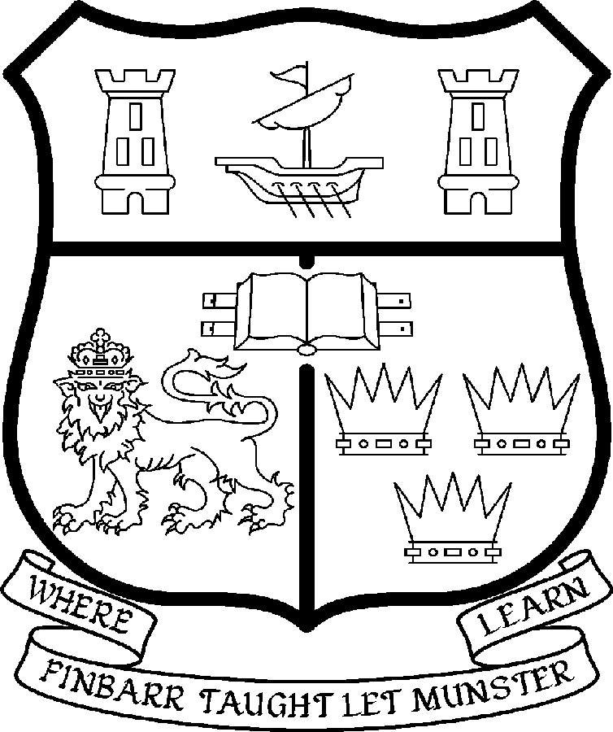 | UNIVERSITY COLLEGE CORK  Coláiste na hOllscoile Corcaigh
POST OF LECTURESHIPS IN LAW

Particulars of Post

1. The Lectureships in Law are permanent and whole-time posts, based in the Department of Law in the College of Business & Law. The appointees shall work under the direction of the Head of the Department of Law and shall discharge such duties as shall be assigned to him/her by the said Head.

The current remuneration – [new entrants] – is as detailed below. The appointment to the posts of Lecturer in Law will be made at a point on the following scale in accordance with qualifications and experience to date. There is provision for subsequent progression beyond the BAR in accordance with the terms of the Academic Promotions Scheme to a salary scale segment with a maximum of €85,592 – [new entrants]

 | € |  | €
Minimum | 36,500 | Eighth Point | 51,656
Second Point | 38,616 | Ninth Point | 53,956
Third Point | 41,037 | Tenth Point | 55,707
Fourth Point | 43,120 | Eleventh Point | 57,497
Fifth Point | 45,308 | Maximum | 59,293
Sixth Point | 47,614
Seventh Point | 49,452

The salary includes a premium of 1/19th for pensionable staff paying contributions. Class A1 rate of Pay Related Social Insurance (PRSI) applies to the post which is currently 4% with an earnings ceiling of €50,700.

- Duties of the Post:

The duties of the Lecturers shall be to teach Law under the direction of the Head of the Department of Law for all degrees, diplomas and certificates of the University. They shall, in addition, discharge such other duties (including examining) appropriate to the office as shall be assigned to them by the Head of the Department of Law. In particular, the post-holder shall be required to undertake the following responsibilities-:

- To teach and examine on existing courses at undergraduate and postgraduate level;

- To participate fully in the work of the Department, including postgraduate supervision at Masters and PhD level;

- To engage in individual research, participate in the Department’s research activities and play an active role in generating research income;

- To carry out other duties as appropriate, including administration and participate in the running of the Department and Faculty of Law.

The above listing is not exclusive or exhaustive and the post holder may be required to undertake any such duties as may reasonably be expected. All staff are required to be flexible and co-operative and professional within the needs of the post and the Department/School, College and University. The University is undertaking a major reform of its internal structures which may necessitate changes in the organisation of its activities.

3. Selection Criteria:

Decisions made at shortlisting, presentation and interview will be made based on the following criteria:

Essential Criteria
- Applicants must hold a post-graduate qualification in law, or be near completion of a PhD or equivalent (that is, within 6 months of a firm date of submission).

- Candidates should demonstrate:

- A research profile in any major field of law, relevant to the department.

- A commitment to excellence in teaching at all levels.

- Administrative skills and an ability to represent the Department, both inside and outside the University.

- An ability to strengthen existing programmes at undergraduate and postgraduate level, and to contribute to the development of new programmes.

Candidates are requested to make a personal assessment of these criteria against their own qualifications, skills and abilities to assess whether they should apply for the post.

- The normal Statutory or other provisions relating to full-time Lectureships and Senior Lectureships shall apply to the post.

- Each candidate must complete an application form, which can be downloaded at:
http://www.ucc.ie/en/hr/FormsContractDocuments/DocumentFile,35042,en.doc

- Candidates shortlisted for posts shall be required to appear in person before a Board of Assessors in Cork, in which case travelling and subsistence expenses at approved rates will be paid.

- A successful candidate will be required to submit a birth certificate, documentary evidence confirming academic qualifications, and to undergo a medical examination.

- References will be sought in relation to all candidates invited to attend for interview

- An offer of appointment to a candidate who is not EU nationality is subject to the granting of a Work Permit by the Department of Enterprise Trade & Employment.

- Candidates may be required to produce documentary evidence to support any statements made by them on their application form or any supporting documentation. Candidates should note that inaccurate information will invalidate their application.

- Completed application forms must reach Recruitment Office, Department of Human Resources, University College, Cork, Ireland, on or before Friday, 11th April 2008. Tel: +353-21-4902671 Email: recruitment@per.ucc.ie. Fax. +353-21-4276995.

UNIVERSITY COLLEGE CORK IS AN EQUAL OPPORTUNITIES EMPLOYER
GENERAL INFORMATION FOR CANDIDATES

Introduction to University College Cork

University College Cork, a constituent University of the National University of Ireland, is a collegiate, progressive, dynamic research-led university developing a reputation as a world class regional university, built on the history of significant achievements in teaching and learning and research, and strong academic and professional leadership.

The University has a current enrolment of over 17,000 students with a strategic objective of 21,000 by 2011. UCC currently has 1,400 academic and research staff within a total staff compliment of 2,500.

Founded in 1845, as Queen’s College, Cork, UCC is one of Ireland’s oldest institutions of higher learning. The rich history and tradition of UCC is reflected in the imposing limestone buildings of the Main Quadrangle and the mature grounds. UCC’s scenic city centre campus, boasting award-winning architecture, provides a pleasant and vibrant learning environment, which is given an international dimension by the presence of 2,000 international students and many staff from over 75 countries around the world.

UCC is one of the premier research institutions in the State and its research income is consistently one of the highest in the country. The University earns peer-reviewed research income in excess of €60m per annum, has strategic research partnerships with leading multinationals in the agri-food, microelectronics, and pharmaceutical sectors, and is home to 5 of Ireland’s 8 ISI Most Highly Cited authors. The university’s research reputation spans across the broad range of disciplines, strategically built around a number of internationally-recognised Research Institutes, Centres and Departments.

UCC is fully committed to the development of 4th level training and research through the introduction of Graduate Schools and structured PhD programmes and the provision of a wide range of generic and discipline-specific modules supporting the research activity of PhD students. The University offers an innovative, research-led curriculum, taught by world-class academics who consistently attract a quality student intake.
Recent institutional reorganisation has established four Colleges; Arts, Celtic Studies and Social Sciences; Business and Law; Medicine and Health; Science, Engineering and Food Science. The Colleges offer over 120 degree and professional programmes that consistently attract the highest proportion of top school leavers in the country and supports a rapidly growing postgraduate and international student body.

The University has embarked on a programme of development for UCC to firmly establish it as a world-class regional university building on the guiding principles in the University’s Strategic Framework 2006-2011 of excellence in teaching, learning, research and contribution to community and society. UCC will focus on research performance, the quality of the student experience and the manner in which the institution discharges its regional role.

Having twice being designated as the Sunday Times “Irish University of the Year” in the past four years, UCC is also a recent proud recipient of the “Excellence Through People” Gold Standard.

The last five years have seen exceptional growth in student numbers, award winning capital developments supporting science, technology and the arts and significant success in winning research funding, making it in that time the most research active institution in the country.

UCC enjoys excellent links with local business and enterprise along with strong partnerships with some of the world’s most highly valued companies. Relationships with professional and public bodies across a wide range of disciplines are equally a key feature of the University.

Internationalisation of the campus continues to be a key strategic objective of UCC. International enrolment at UCC is among the highest in the sector creating a multi- cultural and ethnically diverse student body and measures taken by UCC to enhance conditions for international student recruitment are regarded as among the best practices by peer institutions. UCC also provides opportunities for Irish students to study overseas making them competitive in a global market. In recent years new exchange opportunities include academic placements in a diverse range of European, US, Canadian and Australian universities, with new developments targeting China.

Staff are essential to the achievement of our mission and UCC places a special emphasis on quality improvement strategies in Human Resource Management. A key objective of the UCC Strategic Framework 2006-2011 is to attract, develop and retain outstanding staff through the development and implementation of best practice HR policies and procedures. We seek to develop staff capable of keeping the University at the forefront in all that it does. The University has committed to establishing a supportive working environment in which the needs of all staff are recognised and their contributions valued and rewarded.

Web Links
UCC website
http://www.ucc.ie/en/

Further information on the Department of Law can be found online on
www.ucc.ie/law

UCC Strategic Plan 2006-2011
http://www.ucc.ie/en/PresidentsOffice/UCCsStrategicPlan/DocumentFile,1005,en.pdf

University College Cork is an Equal Opportunities Employer

Department and Faculty of Law

As one of the founding faculties of University College Cork, the Faculty of Law has been a vibrant and dynamic research and teaching environment for many years, with a proud tradition within the University. It has established itself as a leader in legal education in Ireland, with a record of providing innovation and excellence in legal education and research, including a contribution to policy development and society.

As the single largest department in University College Cork, and the principal department within the Faculty, the Department of Law has a distinguished history over many decades in attracting high quality students and recruiting high quality staff nationally and internationally. The agreed mission of the Law Department is “to provide excellence in legal education for our students and to produce high quality legal research, including a contribution to policy development and society”.

The Department of law operates with a complement of 25 full-time academic staff and twenty two part-time staff. Staff members have a strong research record and contribute actively to legal scholarship and to the discussion of legal issues nationally and internationally. Most staff also hold practice qualifications. Staff profiles can be viewed at http://www.ucc.ie/en/lawsite/staff/ .

The Department has developed a very strong research profile, and continues to be a centre of excellence in this area. Research funding has been obtained from such diverse sources as the EU, the Heritage Council, the EPA, Department of Justice, National Children’s Office and the Equality Agency, and staff have been successful in sourcing funding in important fields, including medical and environmental law, etc. Members of the staff are widely published and have been responsible for some of the definitive texts in Irish law.

The Department offers seven undergraduate law programmes. The Bachelor of Civil Laws (BCL) degree has been available since the since the inception of the University, and entry to the three year BCL degree course is highly sought after. Law has a proud tradition of partnership with other academic departments within the university and offers the BCL (Law and French) and the BCL (Law and German) and BCL (Law and Irish). These four year degree courses allow students to combine the study of law with language and cultural studies and include student placement outside UCC in the third year. The BCL (Law and Irish) is the only one of its kind in Ireland and its unique offering is reflected in the consistently high demand for places. The Faculty also offers a four year BCL (International) degree where students spend an academic year at one of a number of partner universities in the US or Europe. Innovative legal education is a key element of the mission of the Department of Law, and so we continue to expand clinical and skills based programmes in the undergraduate law degrees. The four year BCL (Clinical) degree combines the study of the theory of law with the experience and observation of its application in the professional and legal environment through placements with national and international agencies. The part-time Evening BCL degree was first introduced in 1987 and is the longest running and most successful programme of its kind in Ireland. It continues to grow in popularity, offering second chance legal education to those who have not yet had the opportunity to pursue third level education, as well as graduates in other disciplines.
In addition to teaching on law programmes, the Law Department contributes law modules across a range programmes in all other Colleges across the university. In total, some 2000 undergraduate students are currently registered for approx. 75 law modules.

At postgraduate level, the Department of Law offers five taught postgraduate programmes which give students the opportunity to choose from a wide range of subjects and to prepare a minor thesis on a topic of their choice. These include the Postgraduate Diploma in Law, the LLM, the LLM (Criminal Justice), the LLM (e-Law), and the postgraduate LLB. The postgraduate student body continues to expand as demonstrated by the continued success of the LLM in Criminal Justice, unique in Ireland, which relies on co-operation with outside agencies to pursue the study of criminal policy and its implementation. The e-Law LLM is at the cutting edge of law and technological developments.
In keeping with its strong emphasis on research and publication, the Law Department offers an LLM by Research and an international PhD programme with over 60 research students from a dozen countries: Ireland, Lebanon, Namibia, USA, Turkey, Spain, France, United Kingdom, Israel, Nigeria, Iran and Malawi. The Department has had the highest relative growth in PhD students of any Department in UCC in recent years and has an outstanding record in attracting Government of Ireland scholars, with 8 Government of Ireland scholars currently in the Department. The Faculty and Department of Law is now a destination of choice for young researchers pursuing a career in academia. Profiles of current LLM by Research and PhD students are available at http://www.ucc.ie/en/lawsite/postgrad/

The Law Society of Ireland operates a professional training course for Solicitors in Cork, in collaboration with the Department and Faculty of Law, UCC. This demonstrates the commitment of the Department to enhance the provision of education to its students and to bridge the gap between the practice and theory of law, which has long been part of its distinctive mission. This is further evidenced in the provision of a programme of Continuing Professional Development events by the Department, in consultation with the local professional bodies.

Centre for Criminal Justice and Human Rights
The Centre for Criminal Justice and Human Rights (CCJHR) was established by the Faculty of Law in 2006. The study of crime, justice and human rights raises complex and often challenging questions for lawyers and policy makers. The Centre seeks to contribute to national and international debates on these questions, through the promotion of cutting edge interdisciplinary research, innovative programmes of legal education and training, and key partnerships with Government, statutory bodies, civil society organisations worldwide.
Research at the Centre is informed by legal practice and clinical education underpins the mission of the Centre. The Centre builds on the success of the LLM Criminal Justice (Clinical) programme and the Faculty’s growing international reputation for excellence in teaching and research in the fields of crime, justice and human rights. Further information on staff and activities undertaken by the CCJHR are available at http://www.ucc.ie/en/ccjhr/

For further information on the Department and Faculty of Law, visit http://www.ucc.ie/en/lawsite/

