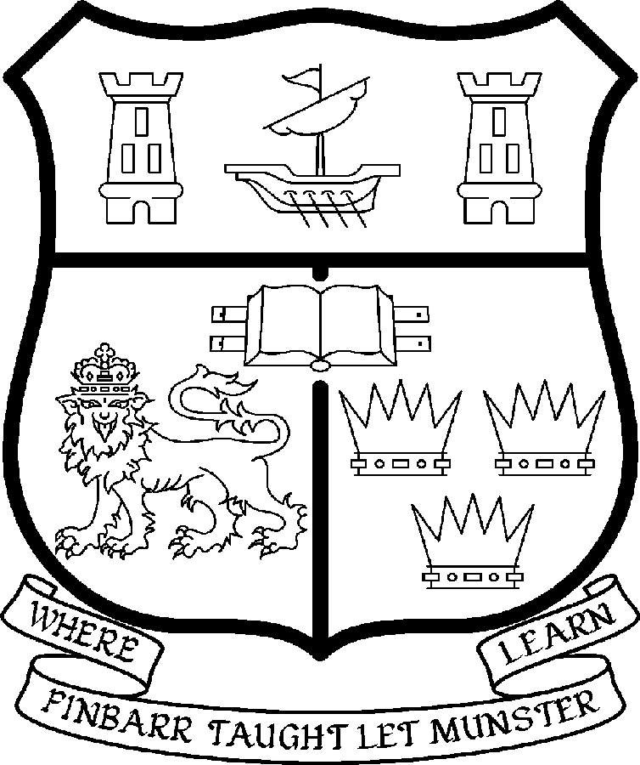 | UNIVERSITY COLLEGE CORK  Coláiste na hOllscoile Corcaigh
LECTURESHIP IN ITALIAN

Particulars of Post

- The Lectureship in Italian is a whole-time, permanent post, based in the Department/Discipline of Italian in the College of Arts, Celtic Studies and Social Science (CACSSS). Specialists in any area of Italian studies will be considered, but the successful applicant will be capable of teaching language, literature and culture at all levels, and of contributing to the Department’s/Discipline’s taught Master’s programme. The research specialisation of the appointee will be in an area complementary to the Department’s existing profile. Research interests of current staff members include: nineteenth-century to contemporary Italian literature, with special reference to Sicilian and Tuscan writers; Italian cultural studies; detective fiction; twentieth-century women writers; travel writing; space in literature and cinema; Italian and European cinema; non-fiction and art film. The ability to contribute to the teaching at undergraduate level of Medieval and/or Renaissance literature is essential. The expected start date for the post is 1 September 2008.

The current remuneration – [new entrants] – is as detailed below. The appointment to the post of Lecturer in Italian will be made at a point on the following scale in accordance with qualifications and experience to date. There is provision for subsequent progression beyond the BAR in accordance with the terms of the Academic Promotions Scheme to a salary scale segment with a maximum of €85,592 – [new entrants]

 | € |  | €
Minimum | 36,500 | Eighth Point | 51,656
Second Point | 38,616 | Ninth Point | 53,956
Third Point | 41,037 | Tenth Point | 55,707
Fourth Point | 43,120 | Eleventh Point | 57,497
Fifth Point | 45,308 | Maximum | 59,293
Sixth Point | 47,614
Seventh Point | 49,452

The salary includes a premium of 1/19th for pensionable staff paying contributions. Class A1 rate of Pay Related Social Insurance (PRSI) applies to the post which is currently 4% with an earnings ceiling of €50,700.

- Duties of the Post:

The duties of the Lecturer shall be to lecture in Italian under the direction of the Head of the Department/Discipline of Italian for all degrees, diplomas and certificates of the University. S/he shall, in addition, discharge such other duties (including examining) appropriate to the office as shall be assigned to her/him by the Head of the Department/Discipline of Italian. In particular, the post-holder shall be required to undertake the following responsibilities-:

- to teach and examine on existing courses at undergraduate and postgraduate level;
- to assist in the development of new courses as appropriate;
- to participate fully in the work of the Department, including teaching language, literature and culture at undergraduate and postgraduate levels;
- to contribute to Departmental administration and to the promotion of the discipline;
- to provide postgraduate supervision;
- to engage in research in Italian studies, publish the results of such research, participate in the Department’s research activities, and otherwise contribute to the Department’s research profile.

The above list is not exclusive or exhaustive and the post-holder may be required to undertake any such duties as may reasonably be expected. All staff are required to be flexible and co-operative and professional within the needs of the post and the Department/Discipline, College and University. The University is undertaking a major reform of its internal structures which may necessitate changes in the organization of its activities.

4. Selection criteria:
Decisions made at shortlisting, presentation and interview will be based on the following criteria:

Essential criteria
- Doctorate in Italian studies, with a specialisation which will complement the Department’s existing research profile. Applications will be considered from candidates who have recently submitted their dissertation: however, appointment will be conditional on official confirmation of the award of the doctorate;
- Native speaker or near-native knowledge of Italian;
- Active and good record of research and publications in Italian studies;
- Potential to attract high-quality doctoral students;
- Demonstrated commitment to teaching language, literature and culture;
- Evidence of a personal contribution and commitment to excellence in teaching;
- Ability to contribute to the teaching at undergraduate level of Medieval and/or Renaissance literature, and other areas as required by the Head of Department/Discipline;
- Ability to communicate effectively and evidence of competence in spoken and written English;
Desirable criteria
- Demonstrated ability and willingness to work in a collaborative environment;
- Evidence of administrative ability;
- Commitment to the long term development of the discipline in UCC;
- Potential to attract research funding and to participate in interdisciplinary initiatives.

Candidates are requested to make a personal assessment of these criteria against their own qualifications, skills and abilities to assess whether they should apply for the post.

- The normal Statutory or other provisions relating to full-time Lectureships and Senior Lectureships shall apply to the post.

- Each candidate must complete an application form, which can be downloaded at:
http://www.ucc.ie/en/hr/FormsContractDocuments/DocumentFile,35042,en.doc

- Candidates shortlisted for posts shall be required to appear in person before a Board of Assessors in Cork, in which case travelling and subsistence expenses at approved rates will be paid.

- A successful candidate will be required to submit a birth certificate, documentary evidence confirming academic qualifications, and to undergo a medical examination.

- References will be sought in relation to all candidates invited to attend for interview

- An offer of appointment to a candidate who is not EU nationality is subject to the granting of a Work Permit by the Department of Enterprise Trade & Employment.

- Candidates may be required to produce documentary evidence to support any statements made by them on their application form or any supporting documentation. Candidates should note that inaccurate information will invalidate their application.

- Completed application forms must reach Recruitment Office, Department of Human Resources, University College, Cork, Ireland, on or before Friday, 02nd May 2008. Tel: +353-21-4902671 Email: recruitment@per.ucc.ie. Fax. +353-21-4276995.

UNIVERSITY COLLEGE CORK IS AN EQUAL OPPORTUNITIES EMPLOYER
GENERAL INFORMATION FOR CANDIDATES

Introduction to University College Cork

University College Cork, a constituent University of the National University of Ireland, is a collegiate, progressive, dynamic research-led university developing a reputation as a world class regional university, built on the history of significant achievements in teaching and learning and research, and strong academic and professional leadership.

The University has a current enrolment of over 17,000 students with a strategic objective of 21,000 by 2011. UCC currently has 1,400 academic and research staff within a total staff compliment of 2,500.

Founded in 1845, as Queen’s College, Cork, UCC is one of Ireland’s oldest institutions of higher learning. The rich history and tradition of UCC is reflected in the imposing limestone buildings of the Main Quadrangle and the mature grounds. UCC’s scenic city centre campus, boasting award-winning architecture, provides a pleasant and vibrant learning environment, which is given an international dimension by the presence of 2,000 international students and many staff from over 75 countries around the world.

UCC is one of the premier research institutions in the State and its research income is consistently one of the highest in the country. The University earns peer-reviewed research income in excess of €60m per annum, has strategic research partnerships with leading multinationals in the agri-food, microelectronics, and pharmaceutical sectors, and is home to 5 of Ireland’s 8 ISI Most Highly Cited authors. The university’s research reputation spans across the broad range of disciplines, strategically built around a number of internationally-recognised Research Institutes, Centres and Departments.

UCC is fully committed to the development of 4th level training and research through the introduction of Graduate Schools and structured PhD programmes and the provision of a wide range of generic and discipline-specific modules supporting the research activity of PhD students. The University offers an innovative, research-led curriculum, taught by world-class academics who consistently attract a quality student intake.
Recent institutional reorganisation has established four Colleges; Arts, Celtic Studies and Social Sciences; Business and Law; Medicine and Health; Science, Engineering and Food Science. The Colleges offer over 120 degree and professional programmes that consistently attract the highest proportion of top school leavers in the country and supports a rapidly growing postgraduate and international student body.

The University has embarked on a programme of development for UCC to firmly establish it as a world-class regional university building on the guiding principles in the University’s Strategic Framework 2006-2011 of excellence in teaching, learning, research and contribution to community and society. UCC will focus on research performance, the quality of the student experience and the manner in which the institution discharges its regional role.

Having twice being designated as the Sunday Times “Irish University of the Year” in the past four years, UCC is also a recent proud recipient of the “Excellence Through People” Gold Standard.

The last five years have seen exceptional growth in student numbers, award winning capital developments supporting science, technology and the arts and significant success in winning research funding, making it in that time the most research active institution in the country.

UCC enjoys excellent links with local business and enterprise along with strong partnerships with some of the world’s most highly valued companies. Relationships with professional and public bodies across a wide range of disciplines are equally a key feature of the University.

Internationalisation of the campus continues to be a key strategic objective of UCC. International enrolment at UCC is among the highest in the sector creating a multi- cultural and ethnically diverse student body and measures taken by UCC to enhance conditions for international student recruitment are regarded as among the best practices by peer institutions. UCC also provides opportunities for Irish students to study overseas making them competitive in a global market. In recent years new exchange opportunities include academic placements in a diverse range of European, US, Canadian and Australian universities, with new developments targeting China.

Staff are essential to the achievement of our mission and UCC places a special emphasis on quality improvement strategies in Human Resource Management. A key objective of the UCC Strategic Framework 2006-2011 is to attract, develop and retain outstanding staff through the development and implementation of best practice HR policies and procedures. We seek to develop staff capable of keeping the University at the forefront in all that it does. The University has committed to establishing a supportive working environment in which the needs of all staff are recognised and their contributions valued and rewarded.

Web Links
UCC website
http://www.ucc.ie/en/

Further information on the Department of Italian can be found online on
http://www.ucc.ie/en/italian/

UCC Strategic Plan 2006-2011
http://www.ucc.ie/en/PresidentsOffice/UCCsStrategicPlan/DocumentFile,1005,en.pdf

University College Cork is an Equal Opportunities Employer

Information on the Department of Italian
The Department of Italian, UCC, is committed to teaching and research. Its educational mission includes: (i) the formation of students able to communicate in a competent and correct Italian, both oral and written; (ii) the dissemination of knowledge of Italian culture and the development of students’ transferable critical skills through the study of aspects of Italian culture; (iii) the transmission of research skills to a new generation of academics. In all its activities, the Department seeks to instil in its graduates intellectual curiosity in general and to cultivate their enthusiasm for Italian language and culture in particular.

Undergraduate teaching
The Department is fully involved in the BA programmes, which are of three or four years duration and, in the latter case, involve a year spent studying at a partner institution abroad, be it in Italy or in the country of a second language studied. The Department also participates in the BComm (International) - Italian degree programme, in which students study Commerce subjects together with courses in Italian language and culture, and spend the Third Year of their four-year programme studying at an Italian university. Italian language courses are also offered in a number of other degree programmes, including Law, Engineering, Medicine and Government. Most of the Department’s intake are beginners in Italian, but can achieve the highest linguistic standards during their study. A high percentage of our students are mature students (over 21 years of age on matriculation).

In First Year, students take an intensive language course, taught in classes of fifteen to eighteen students. Students in the BA and BComm (International) programmes also take IT1201 ‘Post-Unification Italian Culture and Society’, a complementary team-taught course, devised by the Department with the dual purpose of providing a stand-alone, survey course for students taking only one year of Italian and a general introduction to Italian culture for full-degree students. Students continuing Italian beyond First Year study a range of courses on Italian culture, in addition to an Italian language module. The Department capitalizes on its research strengths in modern and contemporary cultural issues, but is also committed to the teaching of key texts from the Italian (and therefore European) literary tradition.

Staff are also heavily involved in interdisciplinary teaching in film studies and travel writing.

Postgraduate teaching
The Department offers an MA programme with two streams: (i) Modern and Contemporary Italian Culture: New Approaches; and (ii) Italian Language and Translation Studies. The MA is taught entirely through Italian.

The Department has twelve doctoral students in the current academic session, working on film studies and on twentieth-century and contemporary Italian literature. It recently organized a Graduate Conference in Italian Studies, principally for students in Ireland, but which also attracted students from Britain.

Dr Silvia Ross has a special interest in postgraduate training and has coordinated and run courses for MA and doctoral students in languages and the humanities in general.

Research
The three full-time, permanent academic staff members are active researchers in the following fields:
- Dr Mark Chu, BA, PhD (Hull): nineteenth-century to contemporary Italian literature, with special reference to Sicilian writers; Italian cultural studies; detective fiction;
- Dott. Laura Rascaroli, Dott. Lett. Fil. (Cattolica, Milano): Italian and European cinema; space and cinema; non-fiction and art film;
- Dr Silvia Ross, BA (Toronto); MA, PhD (Johns Hopkins): nineteenth-century to contemporary Italian literature, with special reference to Tuscan writers; space in literature; twentieth-century women writers; travel writing.

Other staff in the Department
In addition to the three staff members above, there are three full-time College Language Teachers, a part-time lecturer and a full-time administrator.

Restructuring
In the current restructuring, the Department is likely to become part of the School of Languages, Literatures and Cultures. The Department welcomes the opportunities for further interdisciplinary developments which this change will provide.

