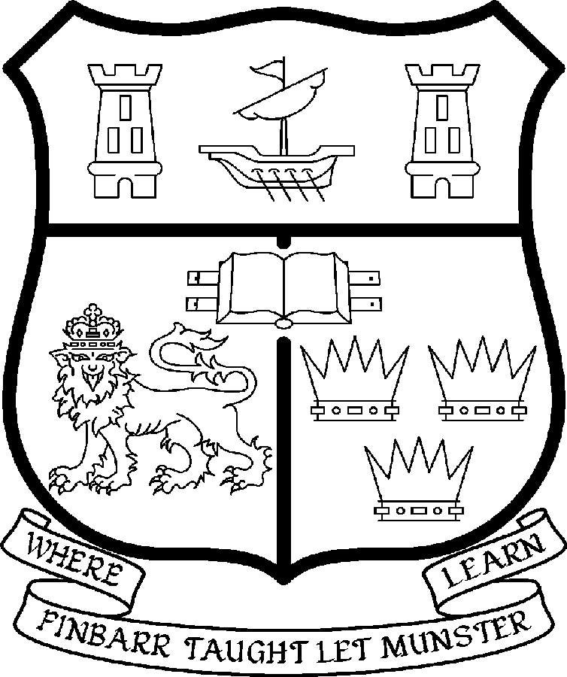 | UNIVERSITY COLLEGE CORK  Coláiste na hOllscoile Corcaigh
LECTURER IN BEHAVIOURAL SCIENCE [ Dentistry ]

Particulars of Post

- The post is full-time and permanent. The appointee to the post shall work under the direction of the Head of the Dental School and shall discharge such duties as shall be assigned to him/her by the said Head.

- The current remuneration – [new entrants] – is as detailed below. The appointment to the post of Lectureship in Behavioural Science [Dentistry] will be made at a point on the following scale in accordance with qualifications and experience to date.

 | € |  | €
Minimum | 35,610 | Eighth Point | 50,396
Second Point | 37,674 | Ninth Point | 52,640
Third Point | 40,036 | Tenth Point | 54,348
Fourth Point | 42,068 | Eleventh Point | 56,095
Fifth Point | 44,203 | Maximum | 57,847
Sixth Point | 46,453
Seventh Point | 48,246

BAR

Minimum | €63,389
Second Point | €67,756
Third Point | €72,131
Fourth Point | €76,488
Maximum Point | €83,504

- The salary includes a premium of 1/19th for pensionable staff paying contributions. Class A1 rate of Pay Related Social Insurance (PRSI) applies to the post which is currently 4% with an earnings ceiling of €48,800.

- Job Responsibilities:

The duties of the Lecturer shall be to lecture in Communication Skills and Clinical topics under the direction of the Head of the Dental School for all degrees, diplomas and certificates of the University. They shall, in addition, discharge such other duties (including examining) appropriate to the office as shall be assigned to them by the Head of the Dental School. In particular, the post holder shall be required to undertake the following responsibilities-:

- Develop the curriculum for Interpersonal and Communication Skills in conjunction with the relevant departments of the Dental school.
- Undertake and direct communication skills teaching throughout all five years of the Dental curriculum at the Dental School.
- Develop a research profile with a relevant cognate department/discipline. To this end the Dental School will facilitate affiliation with an appropriate department/discipline.
- Undertake and direct communication skills teaching on other school programmes as agreed with the Head of the Dental School.
- Develop, implement, and ensure consistency in, the assessment of communication skills for the Dental School.
- Act as a resource for Dental School staff in all areas relating to interpersonal and communication skills.
- Participate in the Dental School Student Mentoring Programme.

The above listing is not exclusive or exhaustive and the post holder may be required to undertake any such duties as may reasonably be expected. All staff are required to be flexible and co-operative and professional within the needs of the post and the School and University.

5. Selection Criteria:
Decisions made at shortlisting, presentation and interview will be made based on the following criteria:

Essential Criteria
- The candidate must be clinically qualified and/or have a professional background in Healthcare, Behavioural Science or relevant discipline.
- Show evidence of engagement in communication skills and/or clinical interviewing training.
- Show a clear understanding of the curricular strategy of the Dental School.
- Possess IT skills commensurate with the post
- Be willing to undertake further training if necessary

Desirable Criteria
- The candidate should have a research interest in communication/interpersonal skills and clinical practice.
- Show experience in the education and assessment of undergraduate and/or postgraduate Dental students
- Have experience of managing or interacting regularly with a wide range of Healthcare professionals.
- Demonstrate evidence of strong interpersonal skills
- Demonstrate evidence of strong organisational skills

Candidates are requested to assess their own qualifications skills and abilities against these criteria

The "Provisions relating to full-time posts as Lecturer" as set out in the attached document also apply to the post.

- Each candidate must complete an application form for the post. Application forms must be completed and returned to: Department of Human Resources, University College Cork Tel: +353-21-4902671, Email:recruitment@per.ucc.ie. Fax. +353-21-4276995.

- Candidates may be required to produce documentary evidence to support any statements made by them on their application form or any supporting documentation. Candidates should note that any inaccurate information will invalidate their application.

- Completed application forms must reach the Recruitment Office, Department of Human Resources, University College, Cork, Ireland, before 5pm on Friday 31st August 2007

UNIVERSITY COLLEGE CORK IS AN EQUAL OPPORTUNITIES EMPLOYER

