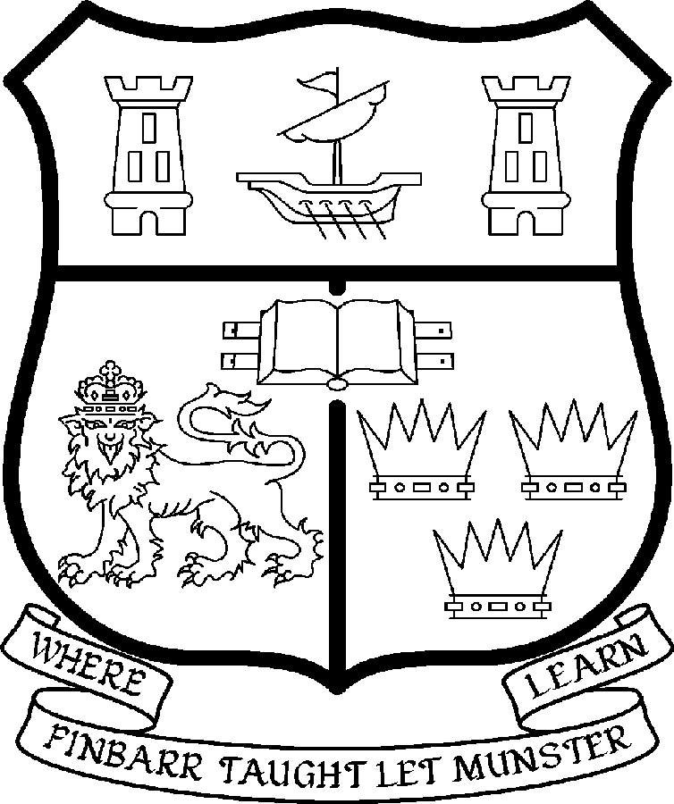 | UNIVERSITY COLLEGE CORK  Coláiste na hOllscoile Corcaigh
ASSOCIATE PROFESSORSHIP OF PHYSIOLOGY
COLLEGE OF MEDICINE AND HEALTH

Introduction to Post

The Department of Physiology is a dynamic and expanding Department with a strongly developing research base in Cell and Integrative Physiology. Teaching is delivered to undergraduate programmes within the College of Medicine & Health to the Schools of Medicine, Dentistry, Pharmacy, Clinical Therapies and Nursing & Midwifery and to the Physiology BSc programme in the College of Science, Engineering and Food Science. There is an increasing core of post-graduate research PhD students who are supervised by academic staff, together with post-doctoral fellows, and form a research base within the Department.

The research focus of the Department of Physiology falls into two broad streams which reside within the research theme of Cell Signalling and Cardiovascular Health of the Biosciences Institute and that of Vascular Health, Diabetes and Stem Cell Biology of the College of Medicine and Health. This new appointment is in the area of metabolic physiology

Research projects currently ongoing are investigating the functioning of nerve, muscle and epithelial cells, at molecular, cellular, organ and whole animal levels. They are focussed on: manipulation of the genome using viral mechanisms; the role of calcium and kinase signalling pathways; the control of ion channels in sensory nerves and pain; intracellular shuttling of ion transporters in epithelial cells and the deficiencies in hypertension; in vivo studies into the neural control of the kidney; the significance of the endothelium in the vascular system and heart in relation to atherosclerosis.

All these areas of research impact, to a greater or lesser degree, on the cardiovascular system and its regulation and may contribute to understanding the progression of a range of cardiac, vascular and metabolic diseases. They will form the basis of novel developments in translational research.

Particulars of Post

- The Associate Professorship of Physiology is a full-time office. The current annual stipend of the Associate Professorship – [new entrants] - is as follows:
€
Minimum 99,287
Second Point 103,629
Third Point 107,968
Fourth Point 112,297
Fifth Point 113,756
Maximum 116,607

- The salary includes a premium of 1/19th for pensionable staff paying contributions. Class A1 rate of PRSI applies to the post. Class A1 rate of Pay Related Social Insurance (PRSI) applies to the post which is currently 4.0% with an earnings ceiling of €48,800.

Responsibilities of the Post: The duties of the Associate Professor are to lecture in Physiology for all degrees, diplomas and certificates of the University under the direction of the Head of Department. The Associate Professor will be expected to contribute to the research and teaching activities of the Department and to attract external research funding. The Associate Professor will have a significant leadership role within the Department and will be expected to make a substantial contribution to the consolidation and further development of the Department’s research output, working as necessary with colleagues in cognate disciplines in the Department, the College of Medicine & Health and the wider University. He/she shall examine in Physiology for the University and shall carry out the other duties appropriate to the post, among them those which are implicit in the selection criteria.

The above listing is not exclusive or exhaustive and the post holder may be required to undertake any such duties as may reasonably be expected. All staff are required to be flexible and co-operative and professional within the needs of the post and the Department, College and University.

- Selection Criteria. Decisions made at shortlisting, presentation and interview will be made based on the following criteria

Essential Criteria:
- PhD or equivalent qualification;

- An international research profile based on an outstanding record of achievement in Metabolic Physiology;

- A Commitment to teaching and training excellence at undergraduate and post-graduate level in the area of systems Physiology with an emphasis on metabolic regulation;

- A record of supervising and mentoring students to PhD level;

- An Outstanding track record of research funding and publications in the area pf Metabolic Physiology;

- An international reputation recognised as invitations to act as consultant for grant awarding bodies and as an Editorial Board member of international journals;

- The appointee will have a record of developing interactions and collaborations with Industry, Clinical Research Units and seeking funding from grant awarding bodies;

- The skills and competencies necessary to take a leadership role in the research development at an integrated and translational level within the Department, School of Medicine and the College of Medicine and Health;

Desirable Criteria:
A strong interest in development of scientific and medical research education;
Demonstrable evidence of strong inter-personal skills;

Demonstrable evidence of strong organizational skills;

A profile which fits within the strategic research areas of the Department of Physiology.

- The normal Statutory or other provisions relating to full-time Associate Professorships as set out in the attached document shall apply to the post.

- Each candidate must complete an application form and are requested to state clearly the name of the post which is being applied for.

- Completed application forms must reach the Recruitment Office, Department of Human Resources, University College, Cork, Ireland, on or before Friday, 21 2007.

