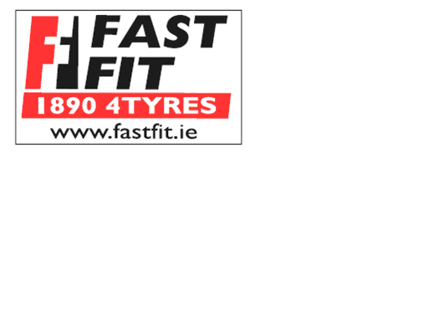
UCC STAFF DISCOUNT SCHEME 2011
CONTACT: RICHIE @ 021 4961022

- €5 OFF ONE TYRE

- €25 OFF ANY SET OF FOUR TYRES

- €5 OFF ANY BATTERY

- €10 OFF ANY SHOCK ABSORBER

- €10 OFF ANY EXHAUST PART

- ALL BRAKE PADS €60 (while stocks last)

- €40 Inc Vat for Four Wheel Alignment
- €20 Inc Vat for Front Wheel Alignment
- €20 Inc Vat for Headlight Alignment

- FREE SAFETY CHECK
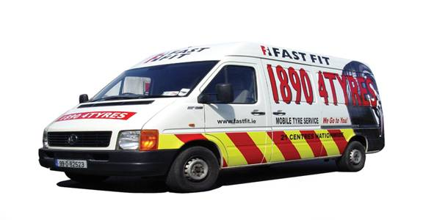

Mobile Service also available – please ring for enquires.

