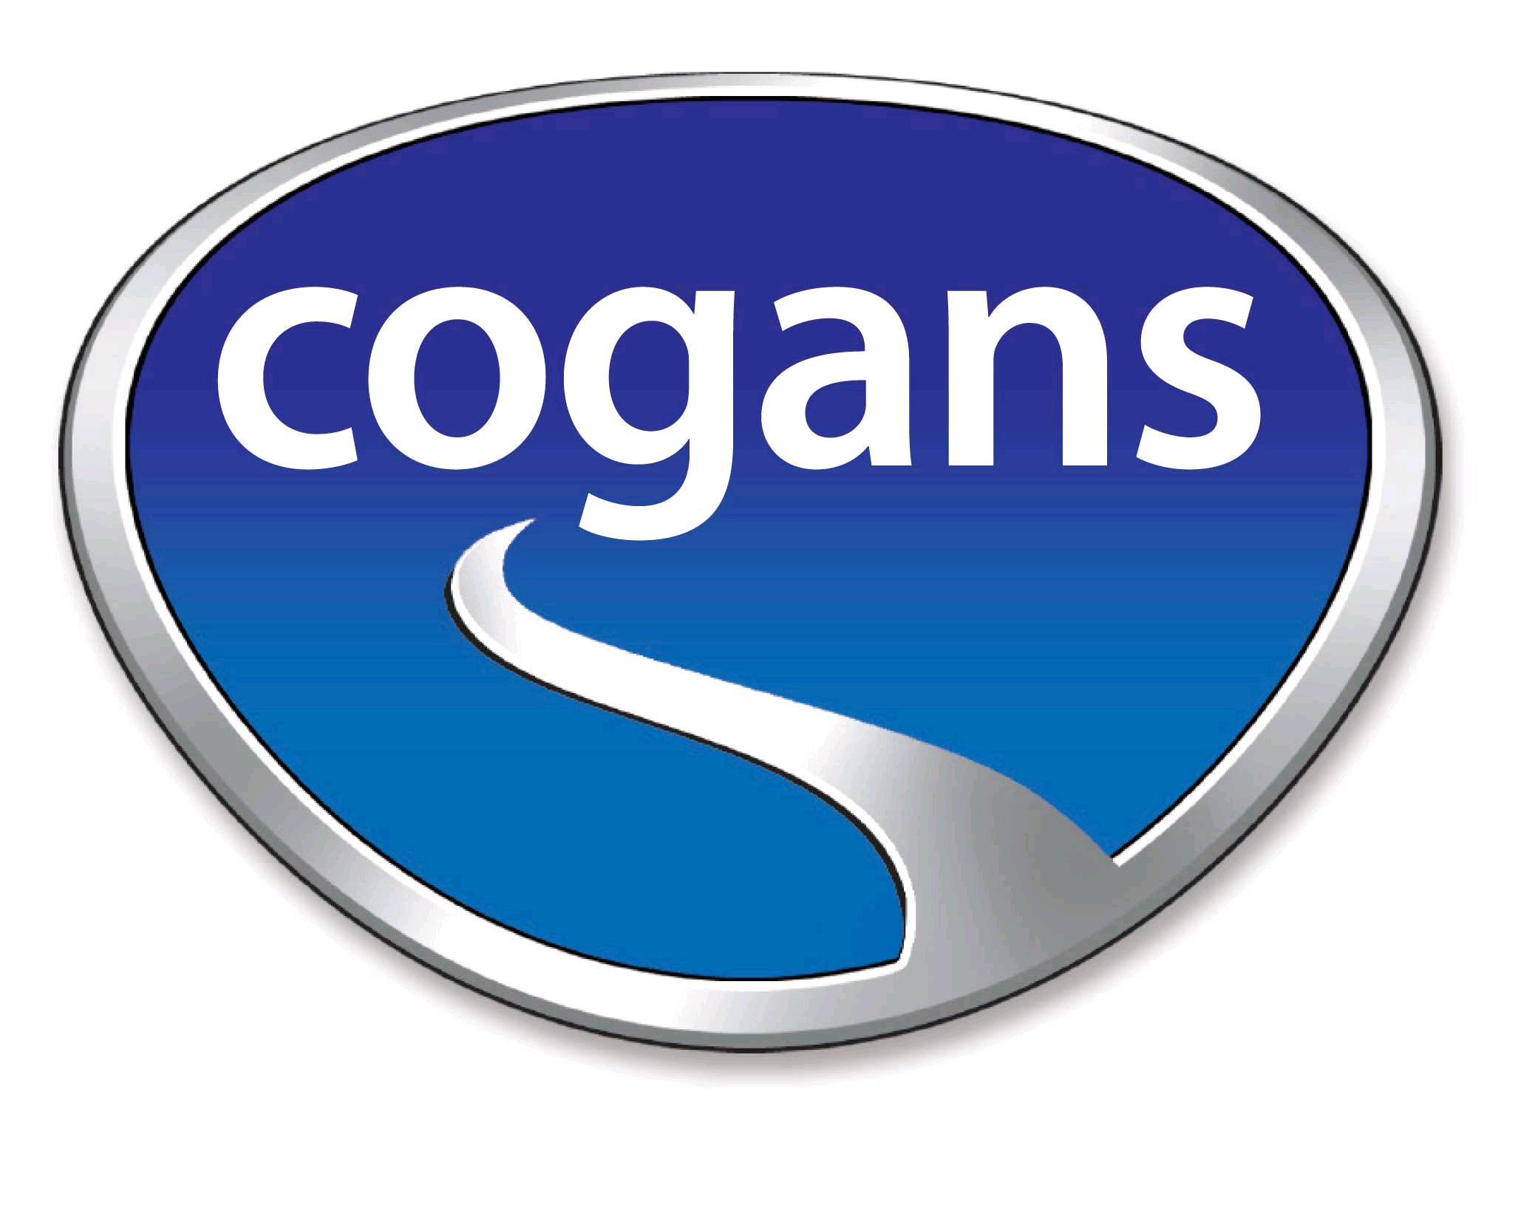

Cogans Carrigaline, Toyota Dealership,
Cork Road, Carrigaline
Tel : 021 4852500

Email: info@cogans.ie
Web: www.cogans.ie
Discount: €75 cash reward when you come to Cogans Carrigaline or introduce a friend to us.

Find a car with Cogans, for yourself or help your friend find their new car and we will reward you, it’s a win win situation. Are you, family or friends looking to change their car? Come to Cogans Carrigaline, Toyota dealership and if a new or used car is bought from us we will give you a cash reward of €75.00, it’s our way of saying thank you.

With over 75 years’ experience in the motor industry, we can ensure that your family and friends are well looked after by our dedicated sales team. Selling new Toyotas and a large variety of quality second hand cars, we can help you; friends and family find the right car at the right price.

To claim your €75, complete the following details:

Your name ………………………………………..
Address ………………………………………..
………………………………………..
Telephone Number ………………………………………..
Customer Introduced ………………………………………..
Details of car purchased ………………………………………..
Send to: Managing Director, Cogans, Carrigaline, Co. Cork or email info@cogans.ie

For details of all our used cars, see www.cogans.ie

There are some terms & conditions:
- The customer must be a new customer to Cogans, someone who has not bought a car here before
- The new customer must mention to the salesperson, the name of person who introduced them on or before they collect their car not subsequently. Alternatively, you can contact one of our sales people directly and advise them that you will be sending a new customer to Cogans or email info@cogans.ie
- The claim must be returned by you within 2 weeks of the car purchase.

At Cogans Carrigaline, located just 8kms from the South Ring Road Cork, we can help when it comes to all aspects of motoring needs from Sales, Service, Parts and Finance.

We look forward to welcoming you to Cogans Carrigaline, where you can join the generations who are happy to be Cogans Customers.

Sales Opening Hours: Monday- Friday 9am-5.30pm & Sat 10am-4pm
Parts & Servicing Hours: Monday- Friday 9am- 5.30pm & Sat 10am-1pm

Cogans Sales Team:

Robert Cogan
Director
021-4852521 – Direct
086-8200521– Mobile
rcogan@cogans.ie
Ken O’Neill
Ken O’Neill
Sales Director
021-4852509 – Direct
086-8200272 – Mobile
koneill@cogans.ie

koneill@cogans.ie
Ken O’Neill
Sales Director
021-4852509 – Direct
086-8200272 – Mobile
koneill@cogans.ie

koneill@cogans.ie
Sales Director

021-4852509 – Direct
086-8200272 – Mobile
koneill@cogans.ie

Pat Glavin
Business Manager
021-4852522 – Direct
086-8200522 – Mobile
pglavin@cogans.ie
Anthony Horgan
Sales Executive
021-4852523 – Direct
087-8345814 - Mobile
ahorgan@cogans.ie
Anthony Horgan
Sales Executive
021-4852523– Direct
087-8345814 – Mobile
ahorgan@cogans.ie

Alan O’Shea
Service Manager
021-4852530 – Service aoshea@cogans.ie
Alan O’Shea
Service Manager
021-4852530 – Service aoshea@cogans.ie

