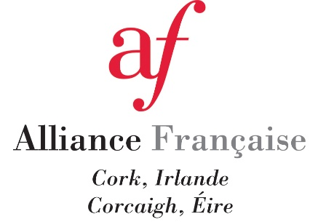

Alliance Française de Cork is offering a 10 % for all members of UCC staff and their families

It is understood that the term "their families" only refers to the staff member, spouse/partner, and children.

The Discount is applicable on all our relevant french classes at Alliance Française de Cork. A list of all our french classes is available at: https://www.alliancefrancaisecork.com

How enrol in a french class and benefit from the Discount:
- Online: Through the Alliance Française de Cork website. Enter the Discount code UCCAFC
- Over the phone: Through the phone number (021) 431 0677. Quote the Discount code UCCAFC
- In person: At our front desk, Enterprise House, 2nd Floor, 36 Mary Street, T12 RCY9 Cork.
Please do not disclose the Discount code. UCC staff ID may be required at the first class (if enroled online or over the phone) or at the enrolment (if enroled in person).

