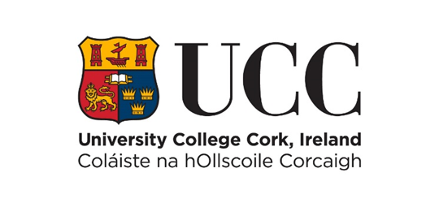

Internal Progression Process Scheme
Stage 2 - Invited Full Application for Promotion to SL - 2026 Cycle
COVER PAGE – PLEASE READ CAREFULLY
Name: Year of appointment to current post:
School: Discipline:
Please indicate whether part-time or full-time:
Link to Pure profile (or equivalent):
Typed forms must be submitted online using this template only via e-recruitment using Employee Self Service (ESS) – handwritten forms will not be considered. Please use font type Calibri, Size 11, single spaced, portrait orientation only, on this form.
Before proceeding, please ensure that you have carefully read the Regulation on Academic Promotions to Senior Lectureship.
Please ensure that the information and summary of achievements listed in each section of this form can be supported by evidence. You must evidence here how you have satisfied the relevant essential criteria requirements as found in Appendix C of the Regulations to establish a case for Promotion. Please structure your portfolio sections in line with the criteria categories as set out on page 14 of the Regulation.
The Board reserves the right to verify the information supplied by applicants. Candidates should note that any inaccurate or surplus information will render the application null and void.
Details submitted as part of this promotion process (including for example, any details submitted as part of this Stage 2 application) will be shared with the candidate’s Head of College, candidate’s Head of School, the College Level Board members, Senior Lecturer Promotions Board members, the People and Culture Department and where applicable, if shortlisted, External Reviewers and members of the Appeals Board. Full details of how your personal data is processed by the University are available at https://www.ucc.ie/en/ocla/comp/data/

Please note that there is a Teaching Profile Summary Template available at: https://www.ucc.ie/en/hr/seniorlectureship/ This Template should be embedded into your application form within its existing page limits.

NB: This template may not be altered. CVs exceeding the specified page limit will not be considered.

- Learning and Teaching (Font Calibri, size 11, single spaced only)
This should reflect teaching activity and be organised in sections corresponding to the Learning and Teaching criteria detailed in Appendix C. Answers must not exceed the three-page limit.

- Research and Innovation (Font Calibri, size 11, single spaced only)
This should reflect the research approach and profile of the candidate and be organised in sections corresponding to the Research and Innovation criteria detailed in Appendix C. Please link to your top 5 publications/outputs on last page of this form. Answers must not exceed the five-page limit.

- Contribution to Academic Citizenship and Engagement (Font Calibri, size 11, single spaced only)
This should be reflective of the level of contribution made by the candidate to academic citizenship and should be organised in sections corresponding to the Contribution to Academic Citizenship and Engagement criteria detailed in Appendix C. Answers must not exceed the two-page limit.

Top Five Research Publications /Outputs
Please provide links for your top five research publications or outputs below. Candidates may choose to outline why they chose these publications / outputs. In exceptional circumstances, where links cannot be made available, hardcopies may be considered. Please email slqueries@ucc.ie to arrange same. Answers must not exceed the one-page limit.

